**Configuring Microsoft Defender for Office 365 Security Policies**

**Present Security Policies**

* Go to policies and rules.

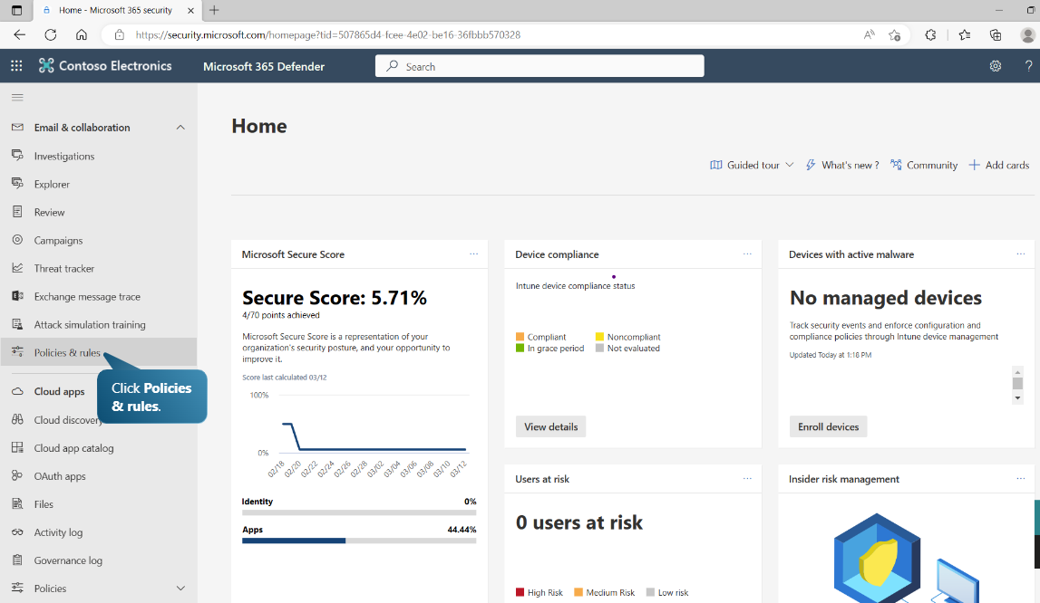

* Select Threat Policies.
* Select Present security policies.

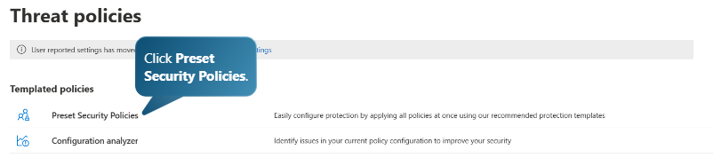

* Manage protection settings.

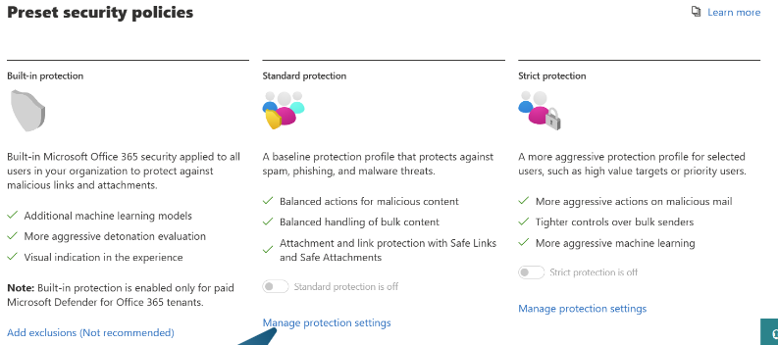

* Select specific recipients and enter the domain name (e.g., WWLx512342.onmicrosoft.com).

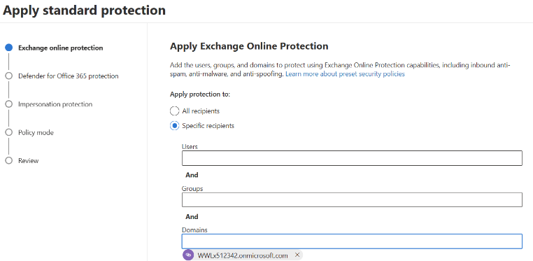

* Click Next and repeat the same step for additional recipients.

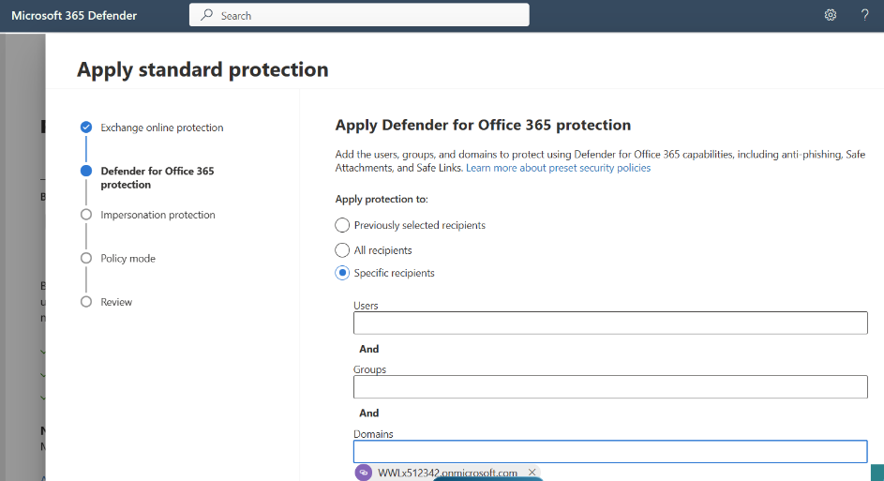

* In Impersonation Protection, click Next.
* Under Policy Mode, select Turn on policy after I finish, then click Next.

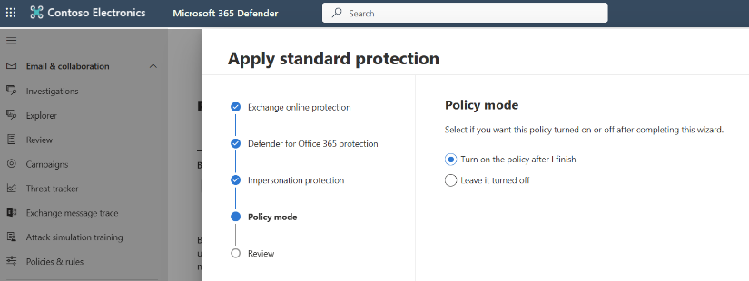

* Review the settings and click Confirm to apply changes.
* Click Done to complete the setup.

**Strict Protection**

* Under Strict Protection, select Manage Protection Settings.

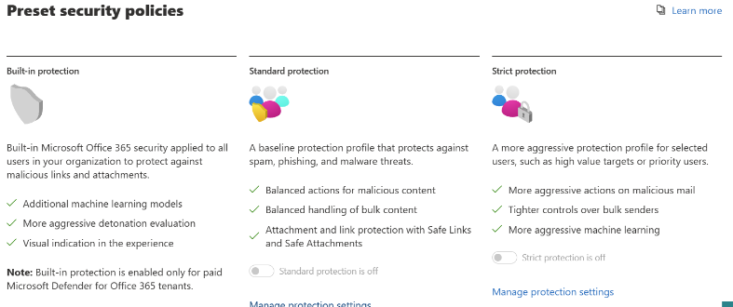

* In Exchange Online Protection, select specific recipients and enter groups (e.g., Leadership). Click Next.

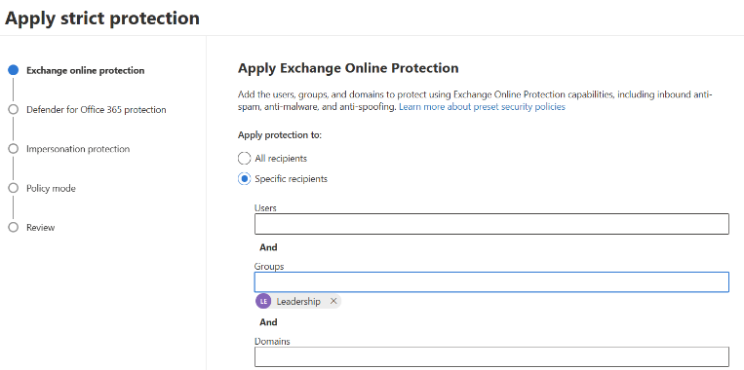

* In Apply Defender for Office 365 Protection, use the same settings as in the previous steps. Click Next.

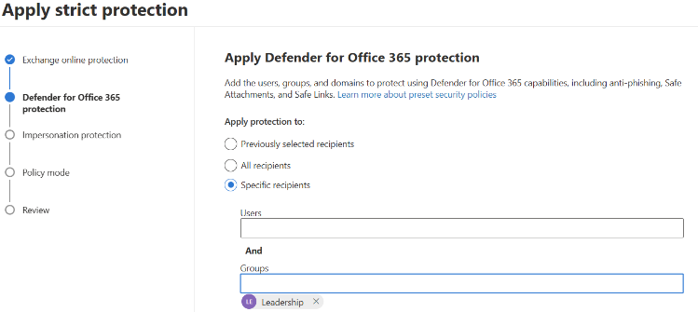

* Continue through the wizard.
* Under Policy Mode, select Turn on the policy after I finish, then click Next.

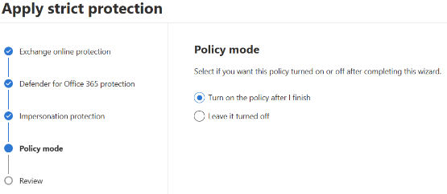

* Click Confirm to apply the changes.
* Click Done to finalize the setup.

**Accessing Microsoft 365 Defender Settings**

* Scroll down and go to Settings.
* Select Microsoft 365 Defender.

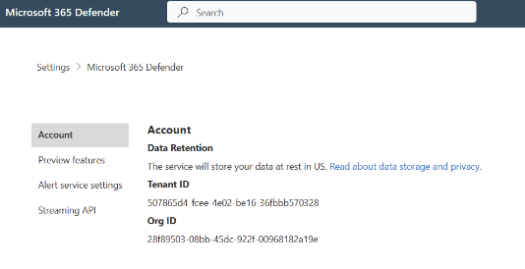

* The new space has been prepared successfully.