Project Identification

Project: | T18
Prepared By: | Nicole Tosello
Document Version: | 1.0
Published Date: | September 29^{th,} 2021

Contributors
The following individuals contributed to this document.
Name | Title
Nicole Tosello

Distribution
This document is distributed to all the following people.
Name | Title

Referenced Documents
This document refers to the following materials
Version number | Title | Author | Date | Source / Location

Revision History

Version Number | Revision Date | Summary of Changes | Modified by
[Note: It is recommended that drafts be numbered 0.1 to 0.9, and that the first approved version be numbered 1.0. Thereafter, new version numbers will depend upon changes: 1.01, 1.1, etc for minor updates, 2.0, 3.0 etc for major changes.]

TABLE OF CONTENTS
1. Business Context Diagram 3
2. REquirements Scope Statements 4
3. High Level Business Requirements (HLR) Traceability 4
4. High Level Business Requirements Sign-Off 5

- Business Context Diagram
<Insert Diagram> ( Refer slides posted on Blackboard → Lecture Review)

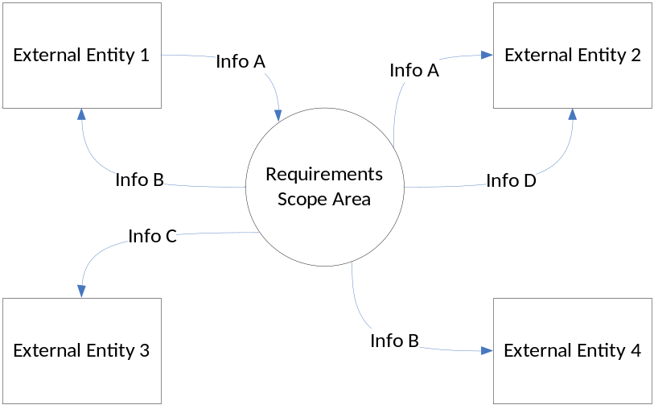

(from slide 20 of Delivering_Business)

Requirement Scope Area | Description
IT department | Area is responsible for ensuring the company employees are able to perform routine tasks, communicate, collaborate, and provides teams with functionality.

External Entity | Description
Client | Someone who uses our app.
Sponsor | Person or organization that will promote app or want their service advertised on our app.
Competitors | Person or company who is making a similar app that would be competition to our company.
Investors | Person or organization that will put their money into our company.
Government Regulators | Governmental authority which regulate privacy practices for developing mobile apps.

Information Flows | Description
Client preferences | Any preferences a client may have about the application such as storage capacity and language preference.
Games | Input and output that is stored from the game the user will decide to play when using the application and the results of the game.
Language | Input of which language the user will pick to learn.
Quizzes | Input and output that is stored from the quiz the user will decide to complete when using the application and results of the quiz.
Flashcards | Input and output that is stored from the series of flash cards the user will use when using the application.
Any information stored in the app | Which options the user chooses from.
- Requirements Scope Statements
HLR# | Description | Priority  (H, M, L)
 | User is able to select which language they would like to learn | H
 | User is able to choose from different games they can play | M
 | User is able to choose between quizzes they can play that will test their knowledge | H

- High Level Business Requirements Sign-Off
The undersigned acknowledge their agreement with the contents of Version <x.x> of the High-Level Requirements document for the Language Learning App.

Following approval of this document, requirements changes will be governed by the project’s change management process, including impact analysis and appropriate reviews and approvals, under the general control of the Project Plan and according to company policy. Approved Change Request Documents, if present, will be attached to this Requirements Document as updates.

Name | Project Role and  Functional Area | Date Signed
Nicole Tosello

* Note: physical signatures are not required. Email approvals are acceptable and should be appended to project documents.

