- Write a C program to simulate SJF scheduling algorithm non preemptive.
#include<stdio.h>
#include<stdbool.h>

struct process {
int pid;
int bt;
int at;
int wt;
int tat;
int rt;
int ct;
};

int main() {
struct process p[10];
int n, i, completed = 0, current_time = 0;
bool is_completed[10] = {false};
float avg_wt = 0, avg_tat = 0, avg_rt = 0;

printf("Enter number of processes: ");
scanf("%d", &n);

for(i = 0; i < n; i++) {
p[i].pid = i + 1;
printf("Enter Arrival Time and Burst Time for P%d: ", p[i].pid);
scanf("%d %d", &p[i].at, &p[i].bt);
}

while (completed != n) {
int idx = -1;
int min_bt = 1e9;
for (i = 0; i < n; i++) {
if (p[i].at <= current_time && !is_completed[i]) {
if (p[i].bt < min_bt) {
min_bt = p[i].bt;
idx = i;
}

if (p[i].bt == min_bt) {
if (p[i].at < p[idx].at) {
idx = i;
}
}
}
}

if (idx != -1) {
// Calculate timing values
p[idx].rt = current_time - p[idx].at;
p[idx].ct = current_time + p[idx].bt;
p[idx].tat = p[idx].ct - p[idx].at;
p[idx].wt = p[idx].tat - p[idx].bt;

avg_wt += p[idx].wt;
avg_tat += p[idx].tat;
avg_rt += p[idx].rt;

current_time = p[idx].ct;
is_completed[idx] = true;
completed++;
} else {

current_time++;
}
}

printf("\nPID\tAT\tBT\tCT\tTAT\tWT\tRT\n");
for(i = 0; i < n; i++) {
printf("%d\t%d\t%d\t%d\t%d\t%d\t%d\n",
p[i].pid, p[i].at, p[i].bt, p[i].ct, p[i].tat, p[i].wt, p[i].rt);
}

printf("\nAverage WT = %.2f", avg_wt / n);
printf("\nAverage TAT = %.2f", avg_tat / n);
printf("\nAverage RT = %.2f", avg_rt / n);

return 0;
}
Output:-
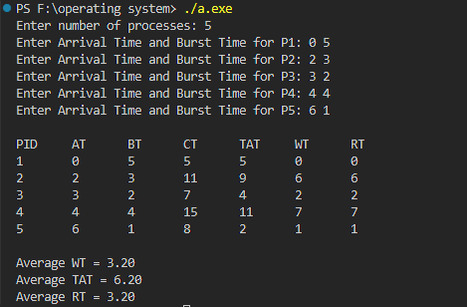

- Write a C program to simulate SJF scheduling algorithm preemptive
#include<stdio.h>

struct process
{
int pid;
int bt;
int at;
int rt;
int pr;
int wt;
int tat;
int response;
int started;
};

int main()
{
struct process p[10];
int n, i, time = 0, remain, highest;
float avg_wt = 0, avg_tat = 0, avg_rt = 0;

printf("Enter number of processes: ");
scanf("%d", &n);

for(i = 0; i < n; i++)
{
p[i].pid = i + 1;
printf("Enter Arrival Time, Burst Time, and Priority for P%d: ", p[i].pid);
scanf("%d %d %d", &p[i].at, &p[i].bt, &p[i].pr);

p[i].rt = p[i].bt;
p[i].started = 0;
}

remain = n;

while(remain != 0)
{
highest = -1;

for(i = 0; i < n; i++)
{
if(p[i].at <= time && p[i].rt > 0)
{
if(highest == -1 || p[i].pr < p[highest].pr)
highest = i;
}
}

if(highest == -1)
{
time++;
continue;
}

if(p[highest].started == 0)
{
p[highest].response = time - p[highest].at;
p[highest].started = 1;
}

p[highest].rt--;
time++;

if(p[highest].rt == 0)
{
remain--;
p[highest].tat = time - p[highest].at;
p[highest].wt = p[highest].tat - p[highest].bt;

avg_wt += p[highest].wt;
avg_tat += p[highest].tat;
avg_rt += p[highest].response;
}
}

printf("\nPID\tAT\tPR\tBT\tWT\tTAT\tRT\n");
for(i = 0; i < n; i++)
printf("%d\t%d\t%d\t%d\t%d\t%d\t%d\n",
p[i].pid, p[i].at, p[i].pr, p[i].bt, p[i].wt, p[i].tat, p[i].response);

printf("\nAverage WT = %.2f", avg_wt / n);
printf("\nAverage TAT = %.2f", avg_tat / n);
printf("\nAverage RT = %.2f", avg_rt / n);

return 0;
}
Output:-
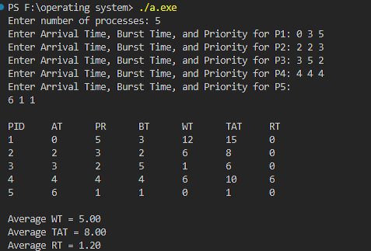
- Write a C program to simulate priority scheduling algorithm non preemptive.

#include<stdio.h>
#include<stdbool.h>

struct process {
int pid;
int bt;
int at;
int pr;
int wt;
int tat;
int rt;
int ct;
};

int main() {
struct process p[10];
int n, i, completed = 0, current_time = 0;
bool is_completed[10] = {false};
float avg_wt = 0, avg_tat = 0, avg_rt = 0;

printf("Enter number of processes: ");
scanf("%d", &n);

for(i = 0; i < n; i++) {
p[i].pid = i + 1;
printf("Enter Arrival Time, Burst Time, and Priority for P%d: ", p[i].pid);
scanf("%d %d %d", &p[i].at, &p[i].bt, &p[i].pr);
}

while (completed != n) {
int idx = -1;
int max_priority = 1e9;

for (i = 0; i < n; i++) {
if (p[i].at <= current_time && !is_completed[i]) {
if (p[i].pr < max_priority) {
max_priority = p[i].pr;
idx = i;
}
if (p[i].pr == max_priority) {
if (p[i].at < p[idx].at) {
idx = i;
}
}
}
}

if (idx != -1) {
p[idx].rt = current_time - p[idx].at;
p[idx].ct = current_time + p[idx].bt;
p[idx].tat = p[idx].ct - p[idx].at;
p[idx].wt = p[idx].tat - p[idx].bt;

avg_wt += p[idx].wt;
avg_tat += p[idx].tat;
avg_rt += p[idx].rt;

current_time = p[idx].ct;
is_completed[idx] = true;
completed++;
} else {
current_time++;
}
}

printf("\nPID\tAT\tPR\tBT\tCT\tTAT\tWT\tRT\n");
for(i = 0; i < n; i++) {
printf("%d\t%d\t%d\t%d\t%d\t%d\t%d\t%d\n",
p[i].pid, p[i].at, p[i].pr, p[i].bt, p[i].ct, p[i].tat, p[i].wt, p[i].rt);
}

printf("\nAverage WT = %.2f", avg_wt / n);
printf("\nAverage TAT = %.2f", avg_tat / n);
printf("\nAverage RT = %.2f", avg_rt / n);

return 0;
}
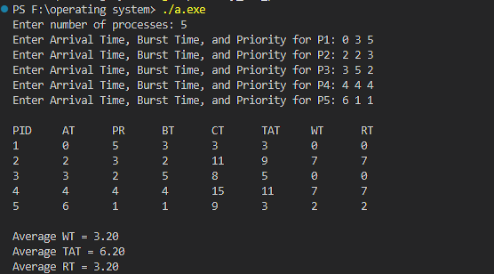

- Write a C program to simulate priority scheduling algorithm preemptive.
#include<stdio.h>

struct process
{
int pid;
int bt;
int at;
int rt;
int pr;
int wt;
int tat;
int response;
int started;
};

int main()
{
struct process p[10];
int n, i, time = 0, remain, highest;
float avg_wt = 0, avg_tat = 0, avg_rt = 0;

printf("Enter number of processes: ");
scanf("%d", &n);

for(i = 0; i < n; i++)
{
p[i].pid = i + 1;
printf("Enter Arrival Time, Burst Time, and Priority for P%d: ", p[i].pid);
scanf("%d %d %d", &p[i].at, &p[i].bt, &p[i].pr);

p[i].rt = p[i].bt;
p[i].started = 0;
}

remain = n;

while(remain != 0)
{
highest = -1;

for(i = 0; i < n; i++)
{
if(p[i].at <= time && p[i].rt > 0)
{
if(highest == -1 || p[i].pr < p[highest].pr)
highest = i;
}
}

if(highest == -1)
{
time++;
continue;
}

if(p[highest].started == 0)
{
p[highest].response = time - p[highest].at;
p[highest].started = 1;
}

p[highest].rt--;
time++;

if(p[highest].rt == 0)
{
remain--;
p[highest].tat = time - p[highest].at;
p[highest].wt = p[highest].tat - p[highest].bt;

avg_wt += p[highest].wt;
avg_tat += p[highest].tat;
avg_rt += p[highest].response;
}
}

printf("\nPID\tAT\tPR\tBT\tWT\tTAT\tRT\n");
for(i = 0; i < n; i++)
printf("%d\t%d\t%d\t%d\t%d\t%d\t%d\n",
p[i].pid, p[i].at, p[i].pr, p[i].bt, p[i].wt, p[i].tat, p[i].response);

printf("\nAverage WT = %.2f", avg_wt / n);
printf("\nAverage TAT = %.2f", avg_tat / n);
printf("\nAverage RT = %.2f", avg_rt / n);

return 0;
}
Output:-
