dining philosopher problem
#include <stdio.h>
#include <stdlib.h>
#include <pthread.h>
#include <unistd.h>
#define NUM_PHILOSOPHERS 5
pthread_mutex_t chopsticks[NUM_PHILOSOPHERS];
void* philosopher(void* arg) {
int id = *(int*)arg;
int left_chopstick = id;
int right_chopstick = (id + 1) % NUM_PHILOSOPHERS;
for (int i = 0; i < 2; i++) {
printf("Philosopher %d is thinking.\n", id);
sleep(rand() % 2 + 1);
if (id % 2 == 0) {
pthread_mutex_lock(&chopsticks[left_chopstick]);
pthread_mutex_lock(&chopsticks[right_chopstick]);
} else {
pthread_mutex_lock(&chopsticks[right_chopstick]);
pthread_mutex_lock(&chopsticks[left_chopstick]);
}
printf("Philosopher %d picked up chopsticks %d and %d and is EATING.\n", id, left_chopstick, right_chopstick);
sleep(rand() % 2 + 1);
pthread_mutex_unlock(&chopsticks[left_chopstick]);
pthread_mutex_unlock(&chopsticks[right_chopstick]);

printf("Philosopher %d finished eating and put down chopsticks.\n", id);
}

return NULL;
}

int main() {
pthread_t philosophers[NUM_PHILOSOPHERS];
int ids[NUM_PHILOSOPHERS];
srand(time(NULL));
for (int i = 0; i < NUM_PHILOSOPHERS; i++) {
if (pthread_mutex_init(&chopsticks[i], NULL) != 0) {
printf("Mutex initialization failed.\n");
return 1;
}
}
for (int i = 0; i < NUM_PHILOSOPHERS; i++) {
ids[i] = i;
if (pthread_create(&philosophers[i], NULL, philosopher, &ids[i]) != 0) {
printf("Thread creation failed.\n");
return 1;
}
}
for (int i = 0; i < NUM_PHILOSOPHERS; i++) {
pthread_join(philosophers[i], NULL);
}
for (int i = 0; i < NUM_PHILOSOPHERS; i++) {
pthread_mutex_destroy(&chopsticks[i]);
}

printf("All philosophers have finished dining.\n");
return 0;
}
Output:-
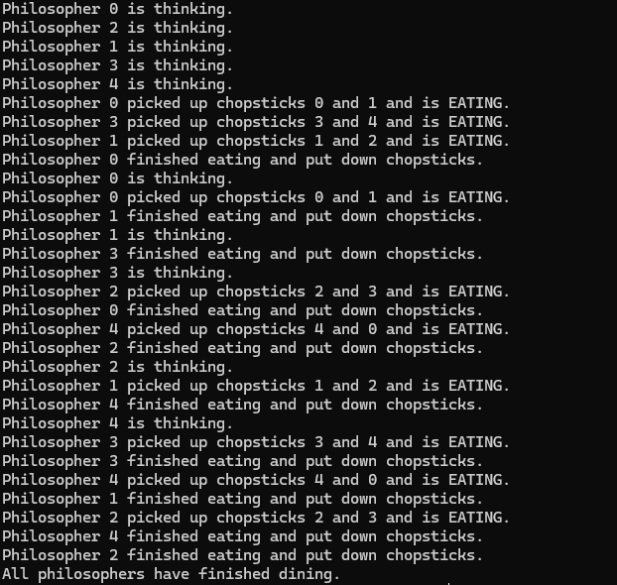

deadlock detection algorithm
#include <stdio.h>
#include <stdbool.h>

void detectDeadlock(int P, int R, int processes[], int available[], int allocation[][R], int request[][R]) {
int work[R];
bool finish[P];
int deadlocked_processes[P];
int safe_sequence[P];
int deadlock_count = 0;
int safe_count = 0;
for (int i = 0; i < R; i++) {
work[i] = available[i];
}
for (int i = 0; i < P; i++) {
bool has_allocation = false;
for (int j = 0; j < R; j++) {
if (allocation[i][j] != 0) {
has_allocation = true;
break;
}
}
finish[i] = !has_allocation;
}

bool progress = true;
while (progress) {
progress = false;
for (int i = 0; i < P; i++) {
if (!finish[i]) {
bool can_allocate = true;
for (int j = 0; j < R; j++) {
if (request[i][j] > work[j]) {
can_allocate = false;
break;
}
}
if (can_allocate) {
for (int j = 0; j < R; j++) {
work[j] += allocation[i][j];
}
finish[i] = true;
safe_sequence[safe_count++] = processes[i];
progress = true;
}
}
}
}
for (int i = 0; i < P; i++) {
if (!finish[i]) {
deadlocked_processes[deadlock_count++] = processes[i];
}
}

printf("\n--- RESULTS ---\n");
if (deadlock_count > 0) {
printf("System is in a DEADLOCK state.\n");
printf("Deadlocked processes: ");
for (int i = 0; i < deadlock_count; i++) {
printf("P%d ", deadlocked_processes[i]);
}
printf("\n");
} else {
printf("System is SAFE. No deadlock detected.\n");
printf("Safe Sequence: ");
for (int i = 0; i < safe_count; i++) {
printf("P%d", safe_sequence[i]);
if (i < safe_count - 1) printf(" -> ");
}
printf("\n");
}
}

int main() {
int P, R;
printf("Enter the number of processes: ");
scanf("%d", &P);
printf("Enter the number of resource types: ");
scanf("%d", &R);

int processes[P];
for(int i = 0; i < P; i++) {
processes[i] = i;
}

int available[R];
printf("\nEnter the Available instances of each resource (space-separated):\n");
for (int i = 0; i < R; i++) {
scanf("%d", &available[i]);
}

int allocation[P][R];
printf("\nEnter the Allocation Matrix (%d rows, %d columns):\n", P, R);
for (int i = 0; i < P; i++) {
for (int j = 0; j < R; j++) {
scanf("%d", &allocation[i][j]);
}
}
int request[P][R];
printf("\nEnter the Request Matrix (%d rows, %d columns):\n", P, R);
for (int i = 0; i < P; i++) {
for (int j = 0; j < R; j++) {
scanf("%d", &request[i][j]);
}
}

printf("\nRunning Deadlock Detection Algorithm...\n");
detectDeadlock(P, R, processes, available, allocation, request);
return 0;
}

Output:-
