Week 3
USN:-1BM25CS470

Round Robin CPU scheduling(Experiment with different quantum sizesfor RR algorithm)
#include <stdio.h>
#include <string.h>
#define MAX 10
#define QUEUE_SIZE (MAX * 10)
typedef struct {
int pid;
int at;
int bt;
int rt;
int ct;
int tat;
int wt;
} Process;

typedef struct {
int data[QUEUE_SIZE];
int front;
int rear;
} Queue;

void initQueue(Queue *q) {
q->front = 0;
q->rear = 0;
}

int isEmpty(Queue *q) {
return q->front == q->rear;
}

void enqueue(Queue *q, int val) {
q->data[q->rear++] = val;
}

int dequeue(Queue *q) {
return q->data[q->front++];
}

void addArrivals(Process procs[], int n, Queue *q, int inQueue[], int currentTime) {
for (int i = 0; i < n; i++) {
if (!inQueue[i] && procs[i].rt > 0 && procs[i].at <= currentTime) {
enqueue(q, i);
inQueue[i] = 1;
}
}
}

int main() {
Process procs[MAX];
Queue readyQueue;
int inQueue[MAX];
int n, tq;
int completed = 0, time = 0;

printf("=== Round Robin CPU Scheduling ===\n\n");

printf("Enter number of processes: ");
scanf("%d", &n);

for (int i = 0; i < n; i++) {
procs[i].pid = i + 1;
printf("Enter Arrival Time and Burst Time for P%d: ", i + 1);
scanf("%d %d", &procs[i].at, &procs[i].bt);
procs[i].rt = procs[i].bt;
}

printf("Enter Time slice: ");
scanf("%d", &tq);

initQueue(&readyQueue);
memset(inQueue, 0, sizeof(inQueue));

addArrivals(procs, n, &readyQueue, inQueue, time);

printf("\nGantt Chart:\n|");

while (completed < n) {
if (isEmpty(&readyQueue)) {
time++;
addArrivals(procs, n, &readyQueue, inQueue, time);
continue;
}

int idx = dequeue(&readyQueue);
Process *p = &procs[idx];

if (p->rt > tq) {
printf(" P%d |", p->pid);
time += tq;
p->rt -= tq;
addArrivals(procs, n, &readyQueue, inQueue, time);
enqueue(&readyQueue, idx);
} else {
printf(" P%d |", p->pid);
time += p->rt;
p->rt = 0;
p->ct = time;
completed++;
addArrivals(procs, n, &readyQueue, inQueue, time);
}
}

printf("\n\n");

float totalTAT = 0, totalWT = 0;

printf("%-8s %-8s %-8s %-8s %-8s %-8s\n",
"Process", "AT", "BT", "CT", "TAT", "WT");
printf("--------------------------------------------------\n");
for (int i = 0; i < n; i++) {
procs[i].tat = procs[i].ct - procs[i].at;
procs[i].wt = procs[i].tat - procs[i].bt;
totalTAT += procs[i].tat;
totalWT += procs[i].wt;
printf("P%-7d %-8d %-8d %-8d %-8d %-8d\n",
procs[i].pid, procs[i].at, procs[i].bt,
procs[i].ct, procs[i].tat, procs[i].wt);
}
printf("--------------------------------------------------\n");
printf("Average Turnaround Time : %.2f\n", totalTAT / n);
printf("Average Waiting Time : %.2f\n", totalWT / n);
return 0;
}
Output :-

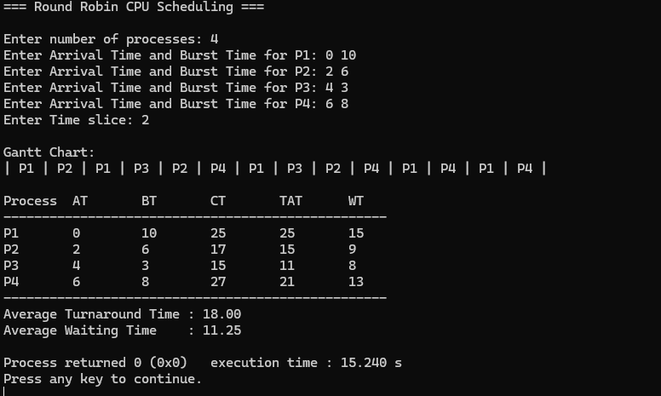

02 Write a C program to simulate multi-level queue schedulingalgorithm considering the following scenario. All the
processes in the system are divided into two categories –
system processes and user processes. System processes are
to be given higher priority than user processes. Use FCFS
scheduling for the processes in each queue.

#include <stdio.h>
#define MAX 10
typedef struct {
int pid, at, bt, type, start, ct, tat, wt, rt;
} Process;
void sortByAT(Process proc[], int idx[], int count) {
for (int i = 0; i < count - 1; i++)
for (int j = 0; j < count - i - 1; j++)
if (proc[idx[j]].at > proc[idx[j + 1]].at) {
int tmp = idx[j];
idx[j] = idx[j + 1];
idx[j + 1] = tmp;
}
}
int main() {
int n;
Process proc[MAX];
int sysQ[MAX], sysCount = 0;
int usrQ[MAX], usrCount = 0;
printf("=== Multilevel Queue Scheduling (System > User, FCFS) ===\n\n");
printf("Enter number of processes: ");
scanf("%d", &n);
for (int i = 0; i < n; i++) {
printf("\nProcess %d (PID AT BT): ", i + 1);
scanf("%d %d %d", &proc[i].pid, &proc[i].at, &proc[i].bt);
printf(" Type (0=System, 1=User): "); scanf("%d", &proc[i].type);
if (proc[i].type == 0) sysQ[sysCount++] = i;
else usrQ[usrCount++] = i;
}
sortByAT(proc, sysQ, sysCount);
sortByAT(proc, usrQ, usrCount);
int time = 0;
printf("\nGantt Chart:\n|");
for (int i = 0; i < sysCount; i++) {
int p = sysQ[i];
if (time < proc[p].at) time = proc[p].at;
proc[p].start = time;
proc[p].rt = proc[p].start - proc[p].at;
printf(" P%d(S) |", proc[p].pid);
time += proc[p].bt;
proc[p].ct = time;
proc[p].tat = proc[p].ct - proc[p].at;
proc[p].wt = proc[p].tat - proc[p].bt;
}
for (int i = 0; i < usrCount; i++) {
int p = usrQ[i];
if (time < proc[p].at) time = proc[p].at;
proc[p].start = time;
proc[p].rt = proc[p].start - proc[p].at;
printf(" P%d(U) |", proc[p].pid);
time += proc[p].bt;
proc[p].ct = time;
proc[p].tat = proc[p].ct - proc[p].at;
proc[p].wt = proc[p].tat - proc[p].bt;
}
printf("\n\n");
float totalTAT = 0, totalWT = 0, totalRT = 0;
printf("%-6s %-6s %-6s %-8s %-6s %-6s %-6s %-6s\n",
"PID", "AT", "BT", "Type", "CT", "TAT", "WT", "RT");
printf("----------------------------------------------------\n");
for (int i = 0; i < sysCount; i++) {
int p = sysQ[i];
printf("%-6d %-6d %-6d %-8s %-6d %-6d %-6d %-6d\n",
proc[p].pid, proc[p].at, proc[p].bt,
"System", proc[p].ct, proc[p].tat, proc[p].wt, proc[p].rt);
totalTAT += proc[p].tat;
totalWT += proc[p].wt;
totalRT += proc[p].rt;
}
for (int i = 0; i < usrCount; i++) {
int p = usrQ[i];
printf("%-6d %-6d %-6d %-8s %-6d %-6d %-6d %-6d\n",
proc[p].pid, proc[p].at, proc[p].bt,
"User", proc[p].ct, proc[p].tat, proc[p].wt, proc[p].rt);
totalTAT += proc[p].tat;
totalWT += proc[p].wt;
totalRT += proc[p].rt;
}
printf("----------------------------------------------------\n");
printf("Average Turnaround Time : %.2f\n", totalTAT / n);
printf("Average Waiting Time : %.2f\n", totalWT / n);
printf("Average Response Time : %.2f\n", totalRT / n);
return 0;
}

Output:-

