42. generate this pattern
****
* *
* *
* *
Algorithm
Step 1: Start the program.
Step 2: Initialize a loop variable i from 0 to 3 (for 4 rows).
Step 3: For each iteration of the loop:
If i is 0 (i.e., the first row), print ****.
Else, print * * (a star, two spaces, and a star).
Step 4: Repeat until all 4 rows are printed.
Step 5: End the program.

Code:
#include <stdio.h>
int main() {
for (int i = 0; i < 4; i++) {
if (i == 0) {
printf("****\n");
} else {
printf("* *\n");
}
}
return 0;
}
Output:
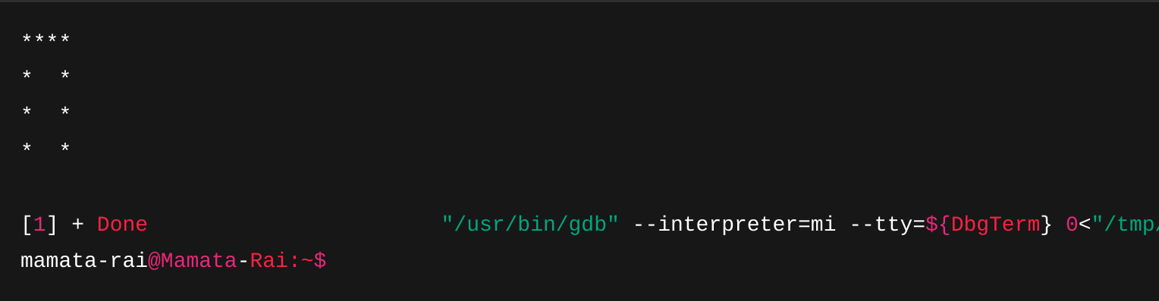43. generate this pattern
1
1 2
1 2 3
1 2 3 4
1 2 3 4 5
Algorithm
Step 1: Start the program.
Step 2: Use an outer loop from i = 1 to 5 (each line number).
Step 3: Inside the outer loop, use an inner loop from j = 1 to i.
Step 4: Print the value of j followed by a space.
Step 5: After the inner loop ends, print a newline.
Step 6: Repeat until 5 rows are printed.
Step 7: End the program.
Code:
#include <stdio.h>
int main() {
for (int i = 1; i <= 5; i++) {
for (int j = 1; j <= i; j++) {
printf("%d ", j);
}
printf("\n");
}
return 0;}
Output:
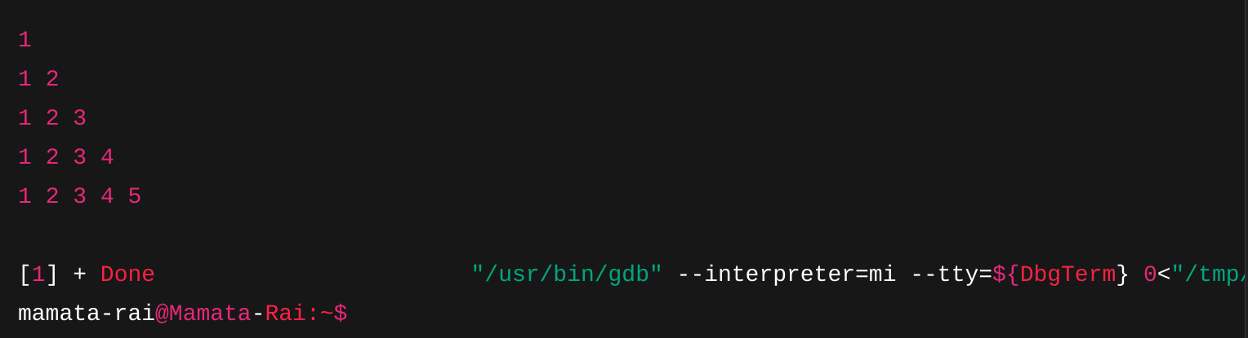
44. generate this pattern
1 2 3 4 5
1 2 3 4
1 2 3
1 2
1
Algorithm:
Step 1: Start the program.
Step 2: Use a loop from i = 5 to 1.
Step 3: For each i, run an inner loop from j = 1 to i.
Step 4: Print j with a space.
Step 5: Print a newline after the inner loop.
Step 6: End the program.
Code:
#include <stdio.h>
int main() {
int i, j, num;
for (i = 0; i < 5; i++) {
num = 1;
for (j = 0; j <= i; j++) {
printf("%d ", num);
num = num * (i - j) / (j + 1);
}
printf("\n");
}
return 0;
}
Output:
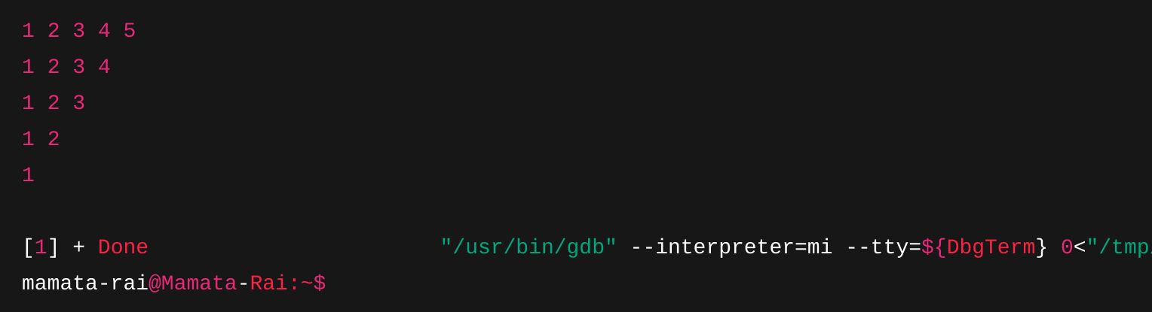

45. generate this pattern
1
1 1
1 2 1
1 3 3 1
1 4 6 4 1
Algorithm:
Step 1: Start program.
Step 2: Loop through rows i = 0 to 4.
Step 3: Set num = 1.
Step 4: Loop j = 0 to i, print num.
Step 5: Update num = num * (i - j) / (j + 1).
Step 6: Print newline after each row.

Code:
#include <stdio.h>
int main() {
int i, j, num;
for (i = 0; i < 5; i++) {
num = 1;
for (j = 0; j <= i; j++) {
printf("%d ", num);
num = num * (i - j) / (j + 1);
}
printf("\n");
}
return 0;
}
Output:
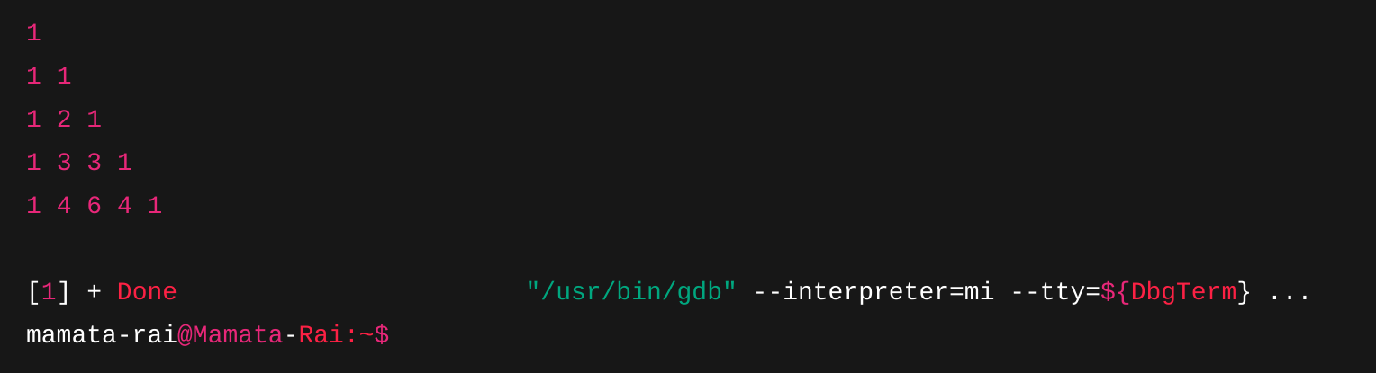
46. generate this pattern
1
2 3
4 5 6
7 8 9 10
11 12 13 14 15

Algorithm:
Step 1: Initialize count = 1.
Step 2: Loop i = 1 to 5 (rows).
Step 3: For each row, print i numbers starting from count.
Step 4: Increment count.
Code:
#include <stdio.h>
int main() {
int count = 1;
for (int i = 1; i <= 5; i++) {
for (int j = 1; j <= i; j++) {
printf("%d ", count++);
}
printf("\n");
}
return 0;
}
Output:
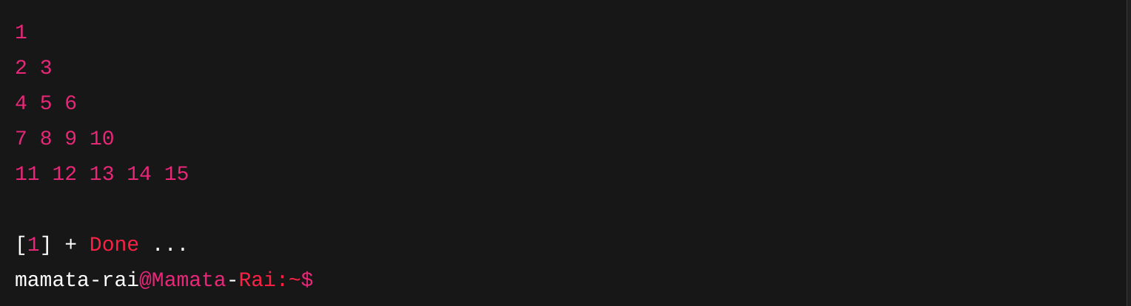
47. generate this pattern
* *
* *
* *
*
* *
* *
* *
Algorithm:
Step 1: Start the program.
Step 2: Set n = 4 (middle row index).
Step 3: Loop from i = 0 to 2*n - 2 (i.e., 0 to 6).
Step 4: For each row, calculate number of spaces before the first *.
Step 5: Print a *, then inner spaces, then another * (except middle row has only one *).
Step 6: Move to next line.
Step 7: End program.

Code:
#include <stdio.h>
int main() {
int n = 4;
int totalRows = 2 * n - 1;
for (int i = 0; i < totalRows; i++) {
int spaces = i < n ? i : totalRows - i - 1;
int innerSpaces = (n - 1 - spaces) * 2 - 1;
for (int j = 0; j < spaces; j++) {
printf(" ");
}
printf("*");
if (innerSpaces >= 1) {
for (int j = 0; j < innerSpaces; j++) {
printf(" ");
}
printf("*");
}
printf("\n");
}

return 0;
}

Output:
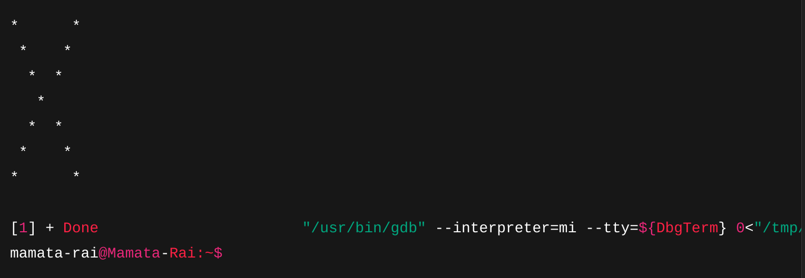
48. generate this pattern
*****
***
*
***
Algorithm:
Step 1: Create array: {5, 3, 1, 3}
Step 2: Loop over each number and print that many stars.
Code:
#include <stdio.h>
int main() {
int lines[] = {5, 3, 1, 3};
for (int i = 0; i < 4; i++) {
for (int j = 0; j < lines[i]; j++) {
printf("*");
}
printf("\n");
}
return 0;
}
Output:
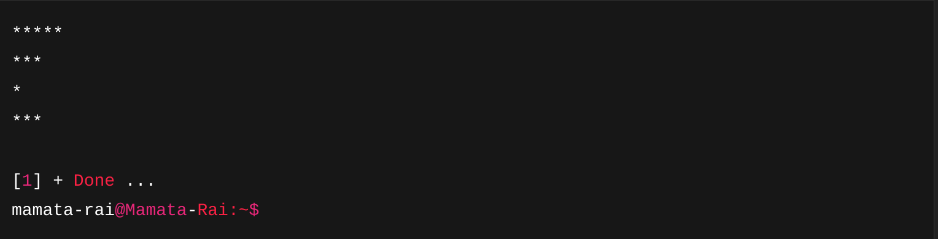
49. generate this pattern
* * * *
* * *
* *
*
* *
* * *
* * * *
Algorithm:
Step 1: Start the program.
Step 2: Set n = 4 (total rows in half).
Step 3: Loop from i = 0 to 2*n - 1 (i.e., 0 to 7 exclusive).
Step 4: For the upper part (i < n), increase spaces and decrease stars.
Step 5: For the lower part (i ≥ n), decrease spaces and increase stars.
Step 6: Use nested loops to print spaces and * pattern.
Step 7: Move to the next line after each row.
Step 8: End the program.
Code:
#include <stdio.h>
int main() {
int n = 4;
for (int i = 0; i < 2 * n - 1; i++) {
int spaces = i < n ? i : 2 * n - 2 - i;
int stars = i < n ? n - i : i - n + 2;
for (int s = 0; s < spaces; s++) {
printf(" ");
}
for (int j = 0; j < stars; j++) {
printf("* ");
}
printf("\n");
}
return 0;
}

Output:
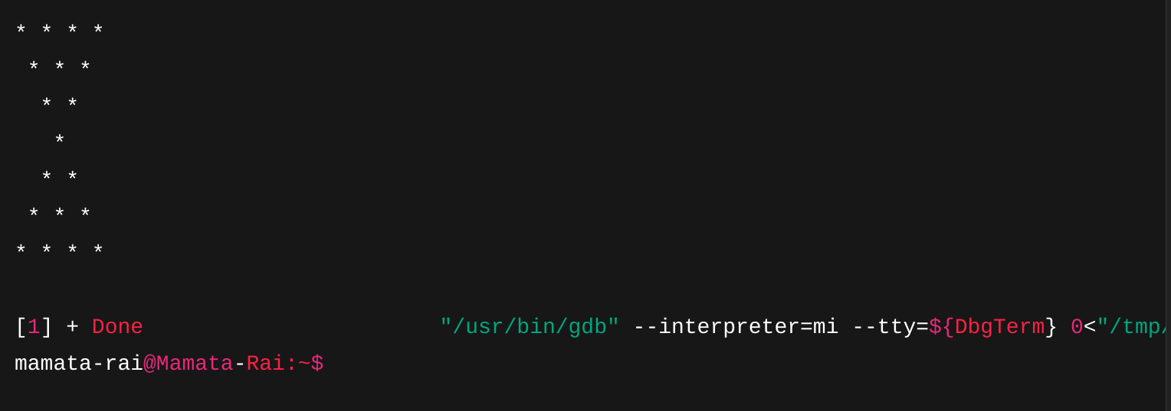
50. generate this pattern
*
**
***
****
*****
****
***
**
*
Algorithm:
Step 1: Loop i = 1 to 5, print i stars.
Step 2: Loop i = 4 to 1, print i stars.

Code:
#include <stdio.h>
int main() {
for (int i = 1; i <= 5; i++) {
for (int j = 1; j <= i; j++) {
printf("*");
}
printf("\n");
}
for (int i = 4; i >= 1; i--) {
for (int j = 1; j <= i; j++) {
printf("*");
}
printf("\n");
}
return 0;
}
Output:

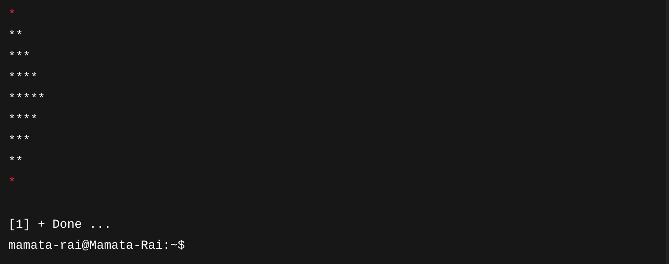

51. Write a program that reads integers from the user until a zero is entered.Use a while loop to read the integers.Use break to exit the loop when zero is entered.Calculate and print the sum of all the entered numbers.
Algorithm:
Step 1: Start
Step 2: Initialize sum = 0
Step 3: Loop forever
Read a number
If number is 0, break the loop
Else, add it to sum
Step 4: Print the total sum
Step 5: End
Code:
#include <stdio.h>
int main() {
int num, sum = 0;
while (1) {
printf("Enter a number (0 to stop): ");
scanf("%d", &num);
if (num == 0)
break;
sum += num;
}
printf("Sum = %d\n", sum);
return 0;
}
Output:
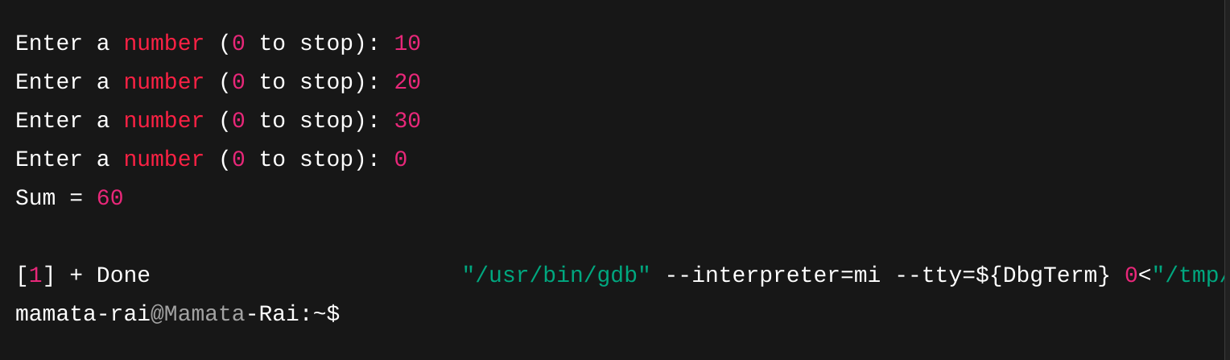

52. Write a program that reads 10 integers from the user.Use a for loop to read the integers.Use continue to skip the processing of any negative numbers.Calculate and print the sum of all the positive numbers.
Algorithm:
Step 1: Start
Step 2: Initialize sum = 0
Step 3: Loop 10 times
Read a number
If number < 0, use continue
Else, add to sum
Step 4: Print the sum
Step 5: End

Code:
#include <stdio.h>
int main() {
int num, sum = 0;
for (int i = 0; i < 10; i++) {
printf("Enter number %d: ", i + 1);
scanf("%d", &num);
if (num < 0)
continue;
sum += num;
}
printf("Sum of positive numbers = %d\n", sum);
return 0;
}
Output:
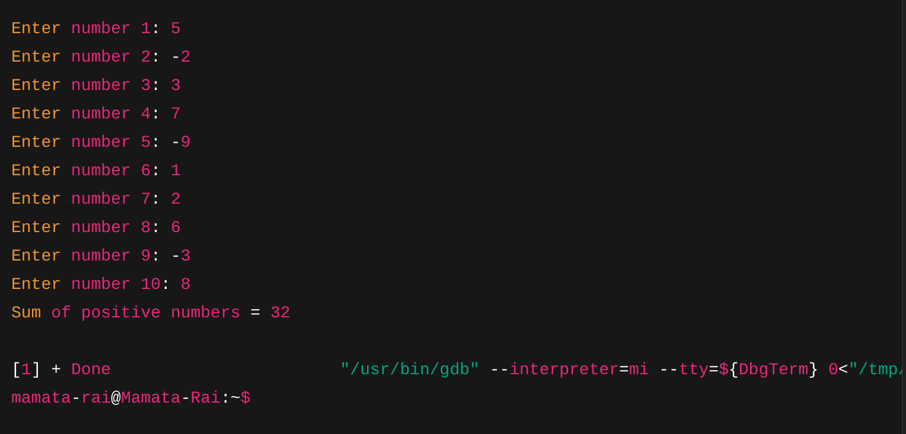

53. Write a program to print a multiplication table for numbers from1 to 5.Use nested for loops to generate the table. Use continue to skip printing the multiples of 3.
Algorithm:
Step 1: Start
Step 2: Loop from i = 1 to 5
Loop from j = 1 to 10
f i*j is multiple of 3, continue
Print i * j
Step 3: End
Code:
#include <stdio.h>
int main() {
for (int i = 1; i <= 5; i++) {
printf("Table of %d:\n", i);
for (int j = 1; j <= 10; j++) {
int product = i * j;
if (product % 3 == 0)
continue;
printf("%d x %d = %d\n", i, j, product);
}
printf("\n");
}
return 0;
}

Output:
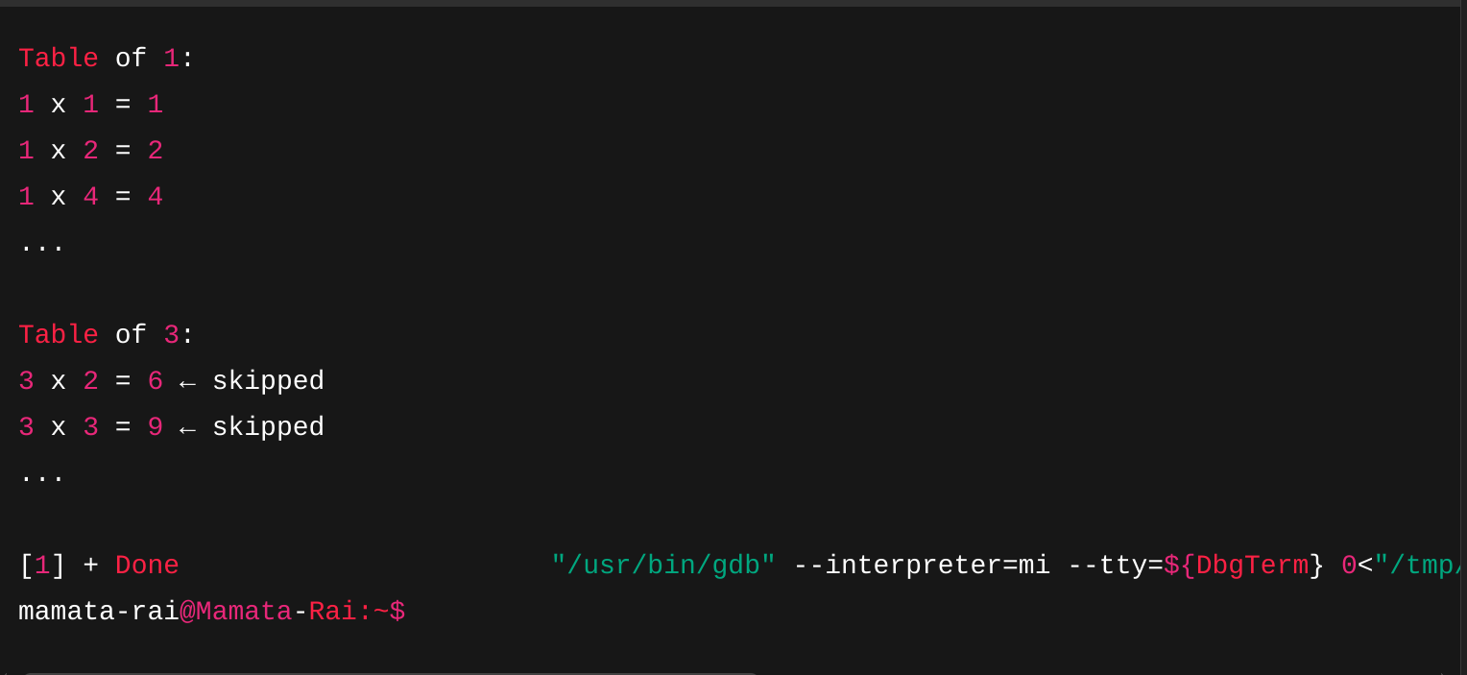
54. Write a program that reads a number from the user.Use if-else statements andloops to determine if the number is prime.Implement the logic without using thegoto statement. Briefly explain why it's generally considered better to avoid gotostatements.
Algorithm:
Step 1: Start
Step 2: Read a number
Step 3: If number < 2 → Not prime
Step 4: Loop from i = 2 to sqrt(number)
If divisible, set flag to not prime
Step 5: Print result
Step 6: End
Code:
#include <stdio.h>
int main() {
int num, isPrime = 1;
printf("Enter a number: ");
scanf("%d", &num);
if (num < 2)
isPrime = 0;
else {
for (int i = 2; i <= num / 2; i++) {
if (num % i == 0) {
isPrime = 0;
break;
}
}
}

if (isPrime)
printf("%d is a prime number\n", num);
else
printf("%d is not a prime number\n", num);

return 0;
}
Output:
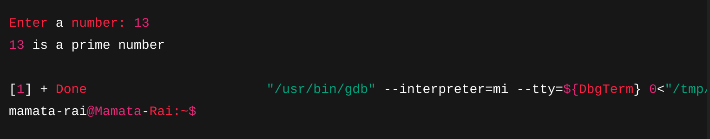
dcks
sdvsd
55. rite a menu driven program according to user choice, if user press
1. Calculate factorial of a number
2. Find the sum of natural numbers
3. Check for prime number
4. Calculate area of a circle
5. Calculate power of a number
6. Exit
Algorithm:
Step 1: Start
Step 2: Display menu options
Step 3: Read user choice
Step 4: Use switch-case to call:
Case 1: Factorial
Case 2: Sum of natural numbers
Case 3: Prime check
Case 4: Area of circle
Case 5: Power of number
Case 6: Exit
Step 5: End
Code:
#include <stdio.h>
#include <math.h>
int main() {
int choice, n, i, fact = 1, sum = 0, isPrime = 1;
float radius, area, base, power;

printf("Menu:\n");
printf("1. Factorial\n2. Sum of natural numbers\n3. Prime check\n4. Area of circle\n5. Power\n6. Exit\n");
printf("Enter your choice: ");
scanf("%d", &choice);

switch (choice) {
case 1:
printf("Enter number: ");
scanf("%d", &n);
for (i = 1; i <= n; i++) fact *= i;
printf("Factorial = %d\n", fact);
break;
case 2:
printf("Enter number: ");
scanf("%d", &n);
sum = n * (n + 1) / 2;
printf("Sum = %d\n", sum);
break;
case 3:
printf("Enter number: ");
scanf("%d", &n);
if (n < 2) isPrime = 0;
else {
for (i = 2; i <= n / 2; i++)
if (n % i == 0) { isPrime = 0; break; }
}
printf(isPrime ? "Prime\n" : "Not Prime\n");
break;
case 4:
printf("Enter radius: ");
scanf("%f", &radius);
area = 3.14 * radius * radius;
printf("Area = %.2f\n", area);
break;
case 5:
printf("Enter base and exponent: ");
scanf("%f %f", &base, &power);
printf("Result = %.2f\n", pow(base, power));
break;
case 6:
printf("Exiting...\n");
break;
default:
printf("Invalid choice\n");
}
return 0;
}

Output:
