**Work Instance 1: Read in entries from the database followed by listing.**

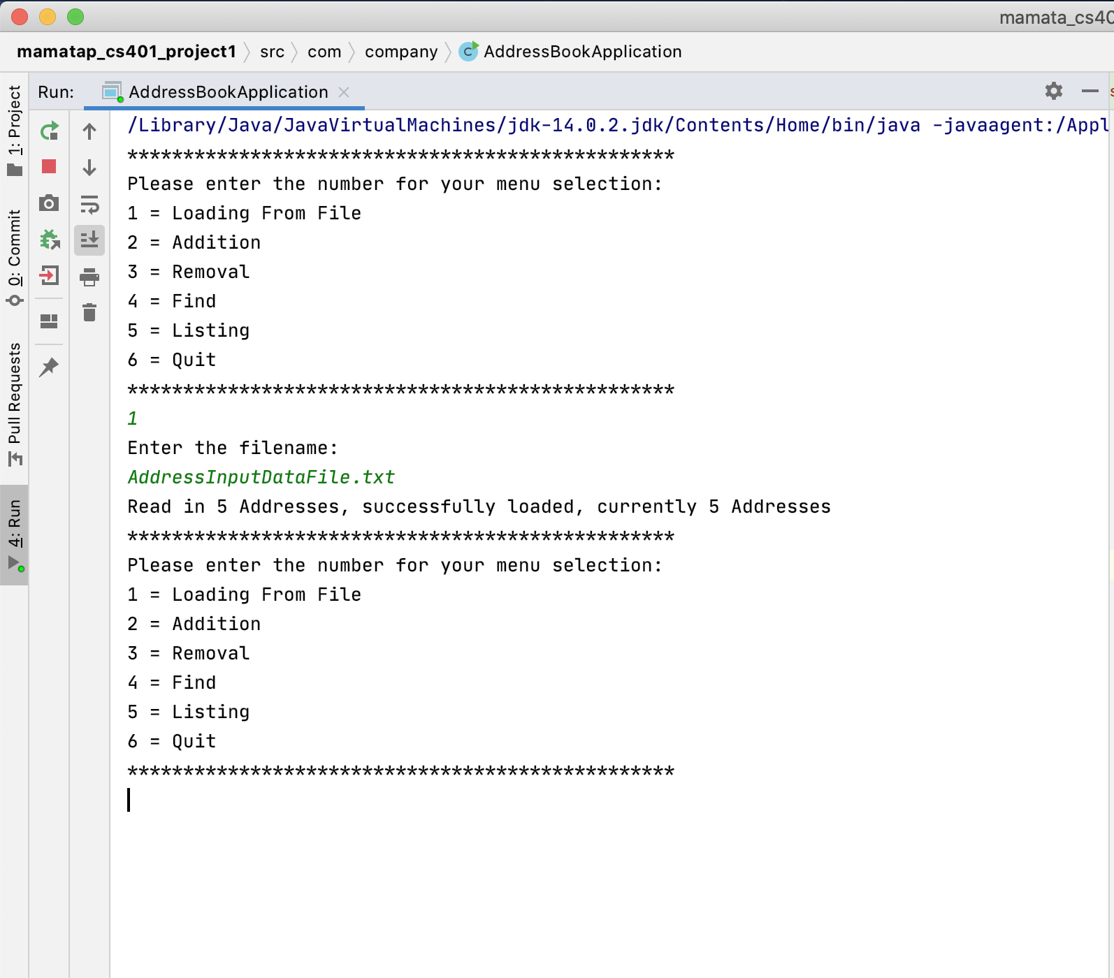

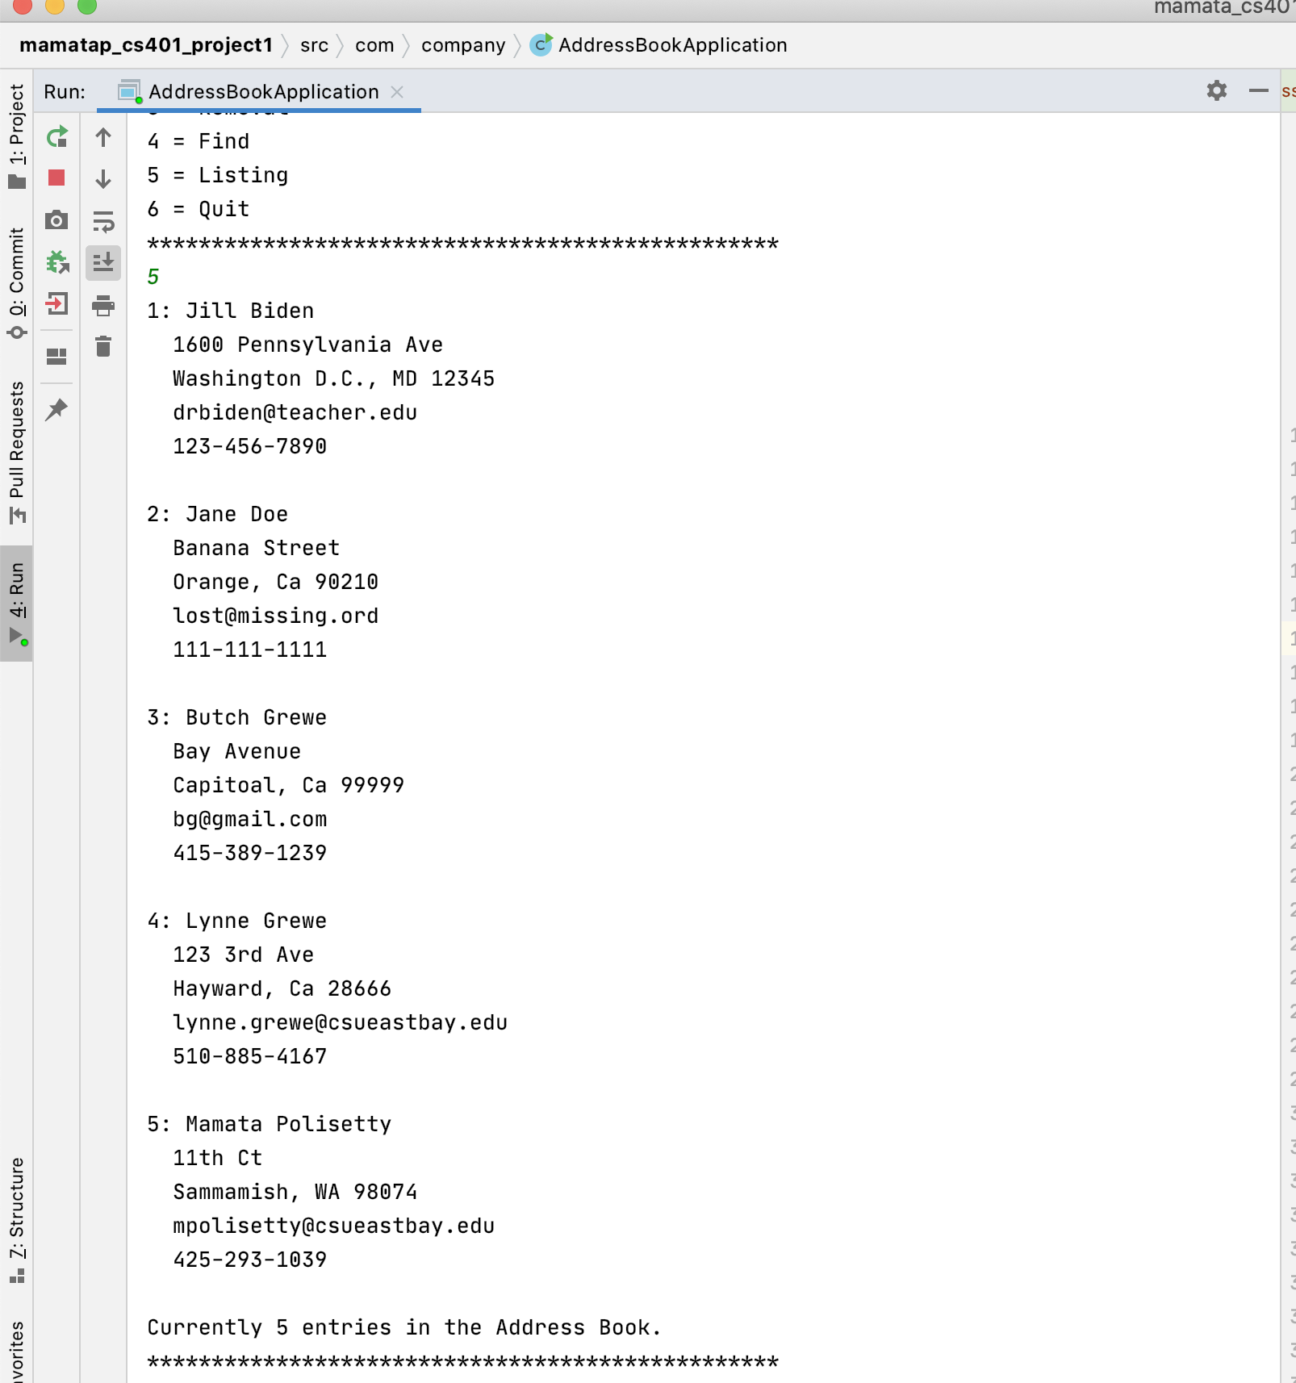

**Work Instance 2: Addition of new AddressEntry object followed by listing**

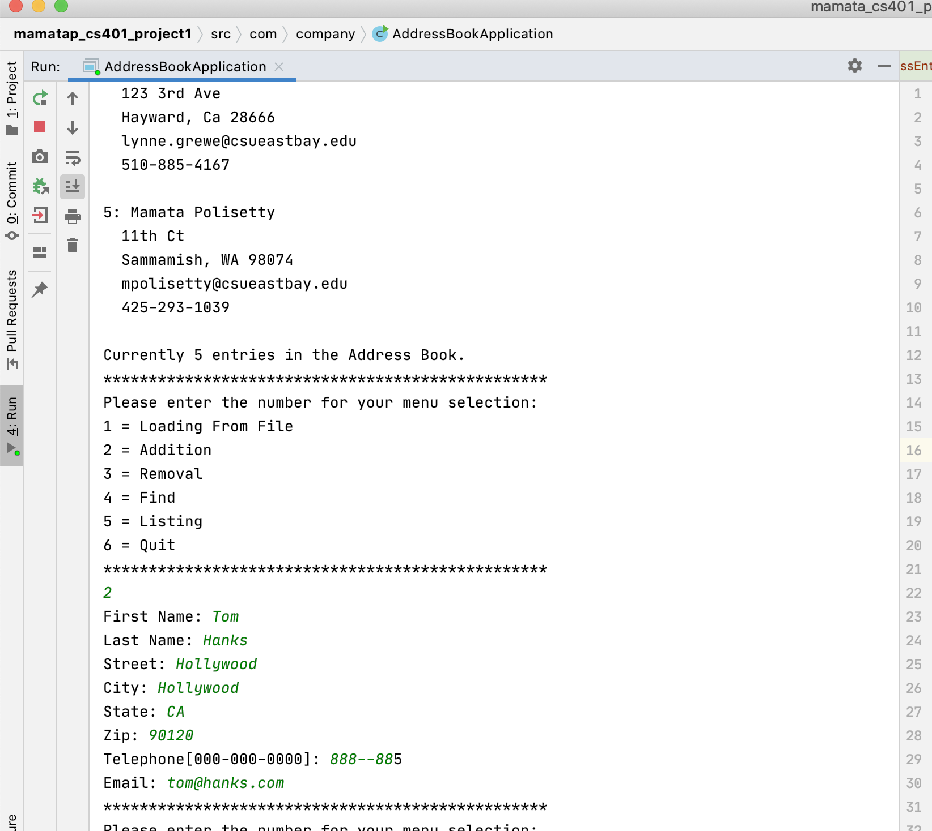

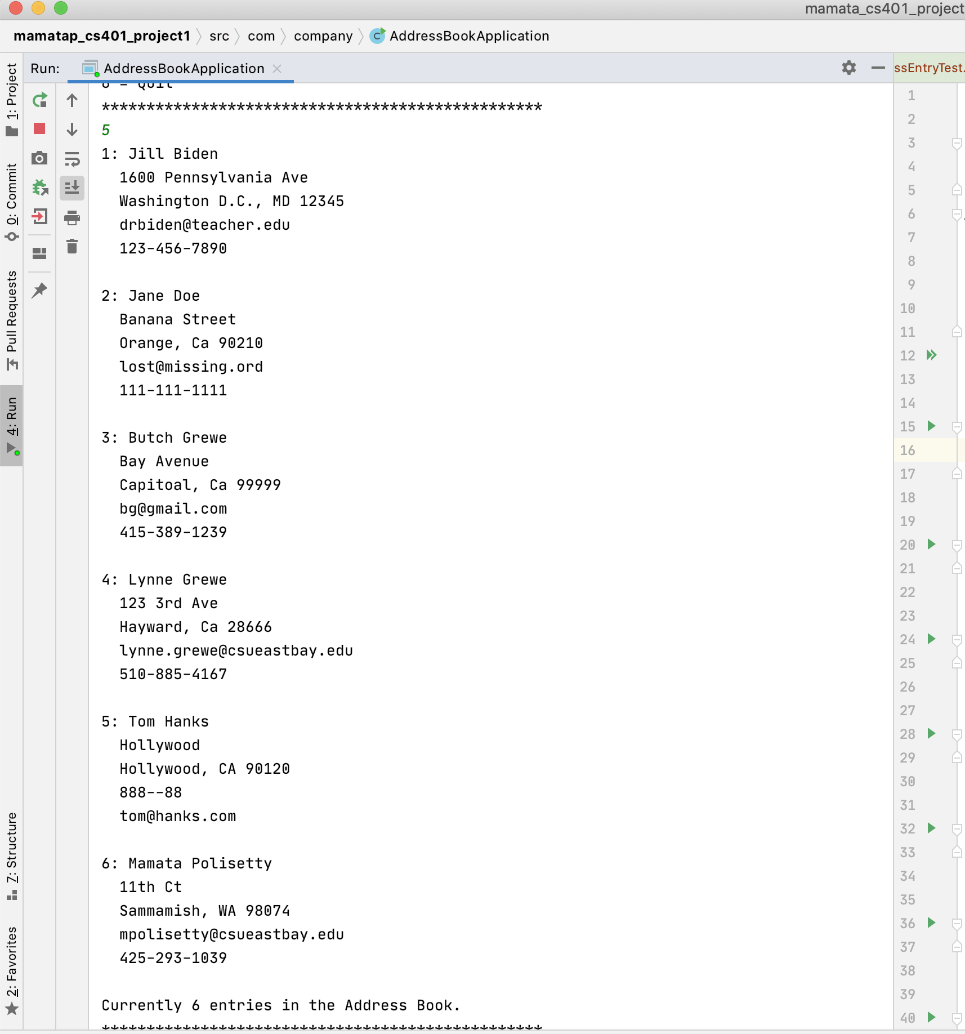

**Work Instance 3: Do a removal of an entry followed by a listing**

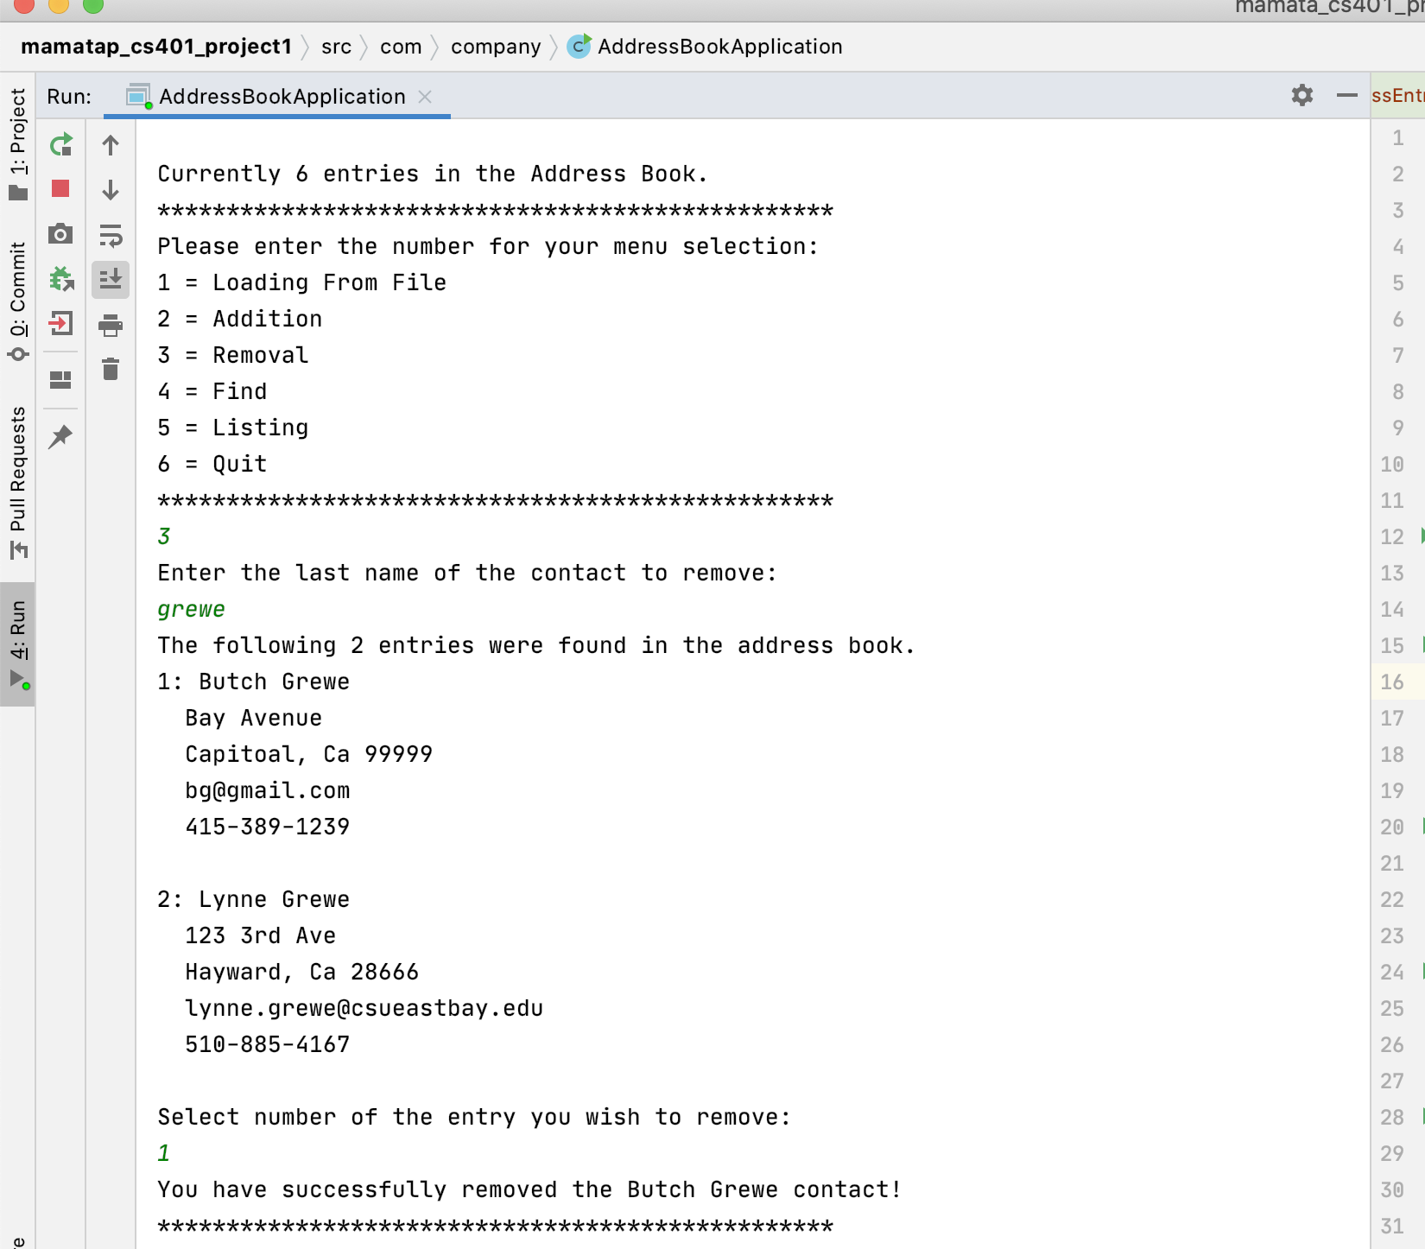

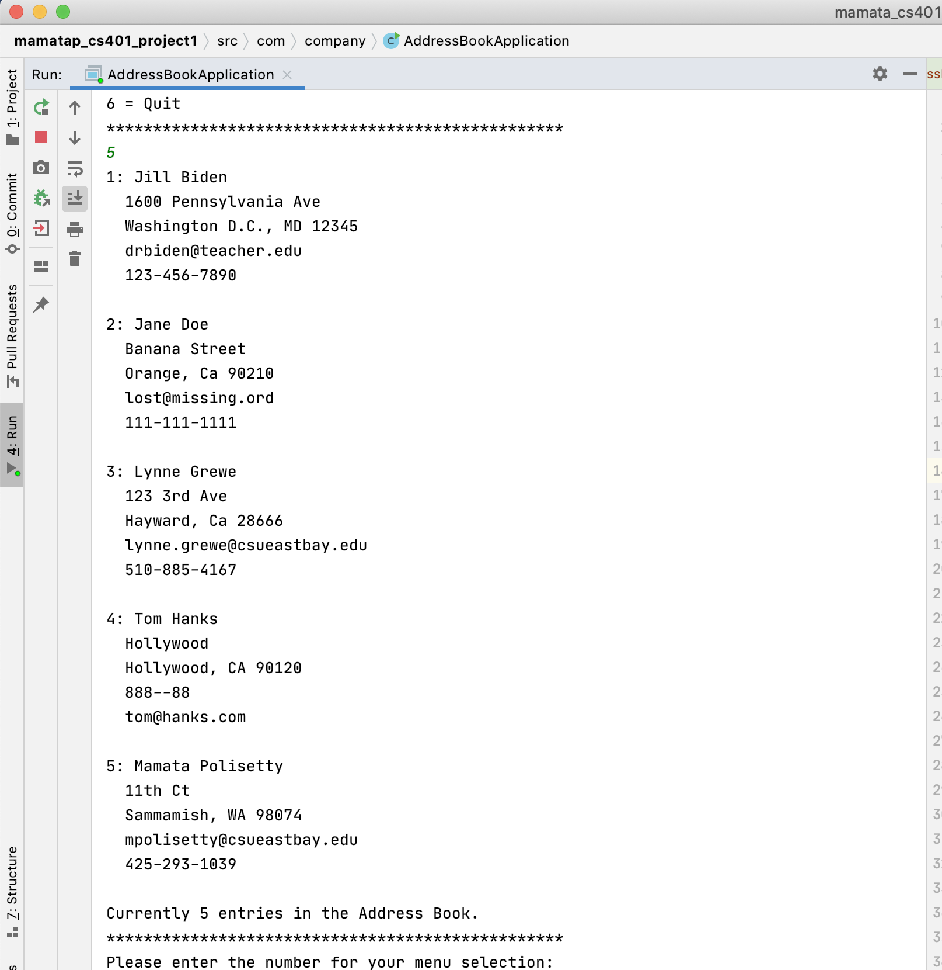

**Work Instance 4: Do a find using input that should retrieve at least one entry. And then do a find using input that should retrieve no entries.**

