Mamatha G

Abstract:

By using of R Language cleaning Data, Deletion of duplicate values. Importing cleaned CSV file into Power BI to build DashBoard.

R AND POWER BI Project

Dashboard

Contents

Step1: Initial Exploratory Analysis 2

Step 2: Clean Data 3

Step 3: Exploratory Data Analysis 7

Step 4: Export data 8

Step 5: Create Power BI Dashboard 10

**Objective:** To analyze the performance of Hollywood movies Site

**Data:** Title, genre, studio, profitability, and ratings for movies released 2007-2012.

# Step1: Initial Exploratory Analysis

​ #Load data ​

df<read.csv

("/cloud/project/HollywoodsMostProfitableStories.csv") ​

#Take a look at the data: ​

View(df) ​

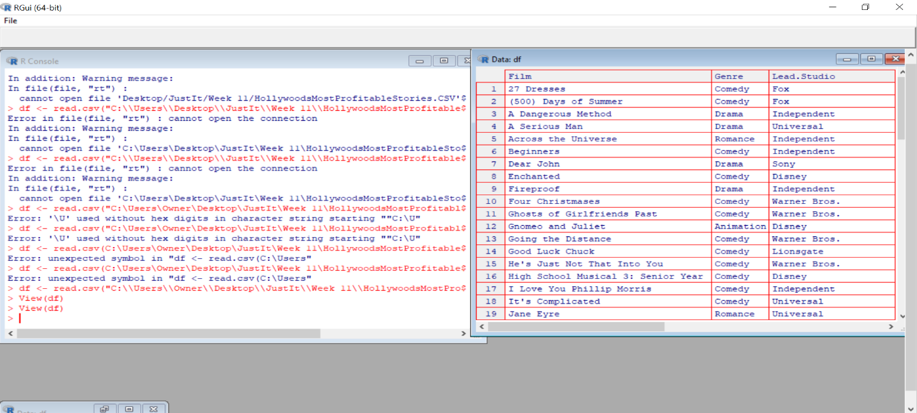

​

#Load library: ​

install.packages("tidyverse") ​

#Import library

library(tidyverse) ​

​# Check data types: ​str(df) ​​

# Step 2: Clean Data

# Check for missing values: ​

colSums(is.na(df)) ​

#Drop missing values ​

na.omit(df) ​

# check to make sure that the rows have been removed ​

colSums(is.na(df))​

​

​

#Check for duplicates ​

dim(df[duplicated(df$Film),])[1] ​

#round off values to 2 places ​

df$Profitability <- round(df$Profitability ,digit=2) ​

​df$Worldwide.Gross <- round(df$Worldwide.Gross ,digit=2) ​

​#View(df) ​

​dim(df) ​

* Step 2.1: Outlier removal

#Check for outliers using a boxplot ​

​library(ggplot2) ​

#Create a boxplot that highlights the outliers ​

ggplot(df, aes(x=Profitability, y=Worldwide.Gross)) + geom_boxplot(outlier.colou​

r = "red", outlier.shape = 1)+ scale_x_continuous(labels = scales::comma)+coord_cartesian(ylim = c(0, 1000)) ​

**S #Remove outliers in 'Profitability' ​ Initial Exploratory Analysis**

#Remove outliers in 'Profitability' ​

Q1 <- quantile(df$Profitability, .25) ​

Q3 <- quantile(df$Profitability, .75) ​

IQR <- IQR(df$Profitability) ​

no_outliers <- subset(df, df$Profitability> (Q1 - 1.5*IQR) & df$Profitability< (Q3 + 1.5*IQR)) ​

​dim(no_outliers)

# Remove outliers in 'Worldwide.Gross' ​

Q1 <- quantile(no_outliers$Worldwide.Gross, .25) ​

Q3 <- quantile(no_outliers$Worldwide.Gross, .75) ​

IQR <- IQR(no_outliers$Worldwide.Gross) ​

​df1 <- subset(no_outliers, no_outliers$Worldwide.Gross> (Q1 - 1.5*IQR) & no_outliers$Worldwide.Gross< (Q3 + 1.5*IQR)) ​ ​dim(df1) ​

**

# Step 3: Exploratory Data Analysis

#Summary Statistics/Univariate Analysis: ​

summary(df1) ​

#bivariate analysis ​

#scatterplot ​

ggplot(df1, aes(x=Lead.Studio, y=Rotten.Tomatoes..)) + geom_point()+ scale_y_continuous(labels = scales::comma)+coord_cartesian(ylim = c(0, 110))+theme(axis.text.x = element_text(angle = 90)) ​

​#bar chart ​

ggplot(df1, aes(x=Year)) + geom_bar() ​

# Step 4: Export data

#Export clean data ​

write.csv(df1, "clean_df.csv") ​

Import clean_df in Power BI.

* Feel free to add more charts apart from the ones mentioned in the next slide.
* For the dashboard, the company would like you to use their brand colors which are blue, green and brown. You can use light or dark shades of each color. For example, light blue and dark blue are acceptable.

# Step 5: Create Power BI Dashboard

The average Rotten Tomatoes ratings of each genre​

* The number of movies produced per year ​

The audience scores for each film.

The profitability per studio

The worldwide gross per genre

Finally, Movies Analysis Report

