FILE STORAGE

By

MAMATHA GUNTU

ABSTRACT:

This project demonstrates a web application, where users can register and sign-In to upload files and perform other operations such as edit, delete and download.

Prerequisites:

* Aws account
* Technical Details :
  + Front end: React (Visual studio code)
  + Back end: Spring boot (Spring Tool Suite)

GitHub link: <https://github.com/mamathaguntu/281FSProj/blob/main/WebApp/src/Components/S3ServiceAPI>

## Website link:

https://www.fs.mamatha-guntu.com

## Demo screenshots:

Welcome page:

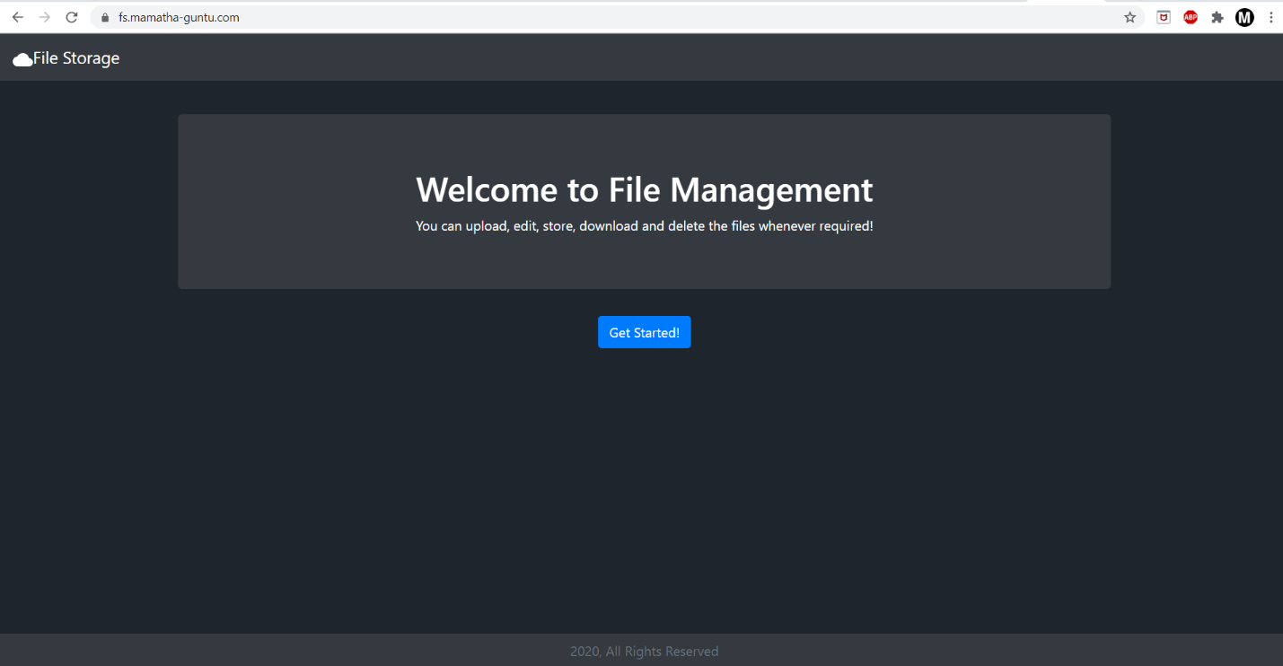

Click ‘Get started!’ and you will be redirected to Login Page

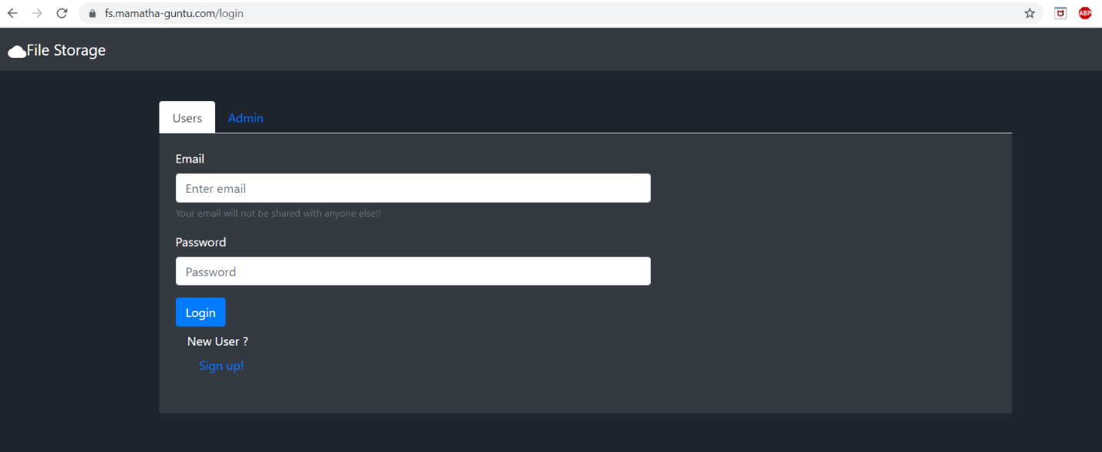

Click ‘sign-up’ to register the account

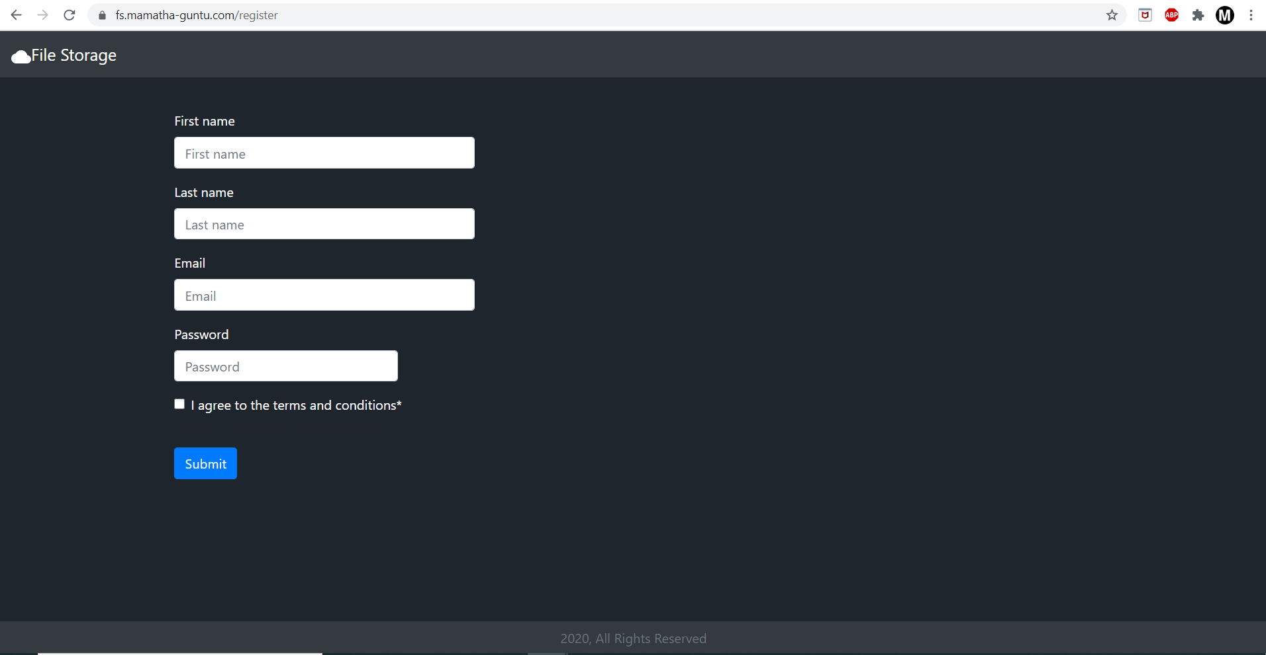

Fill in the details and click submit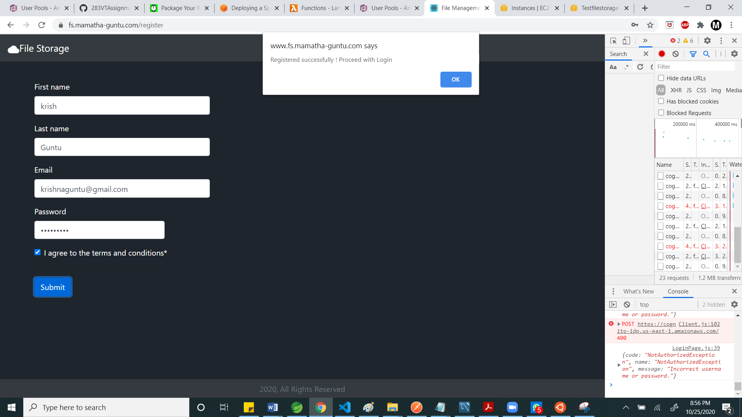

Click ok and the page will be redirected for login

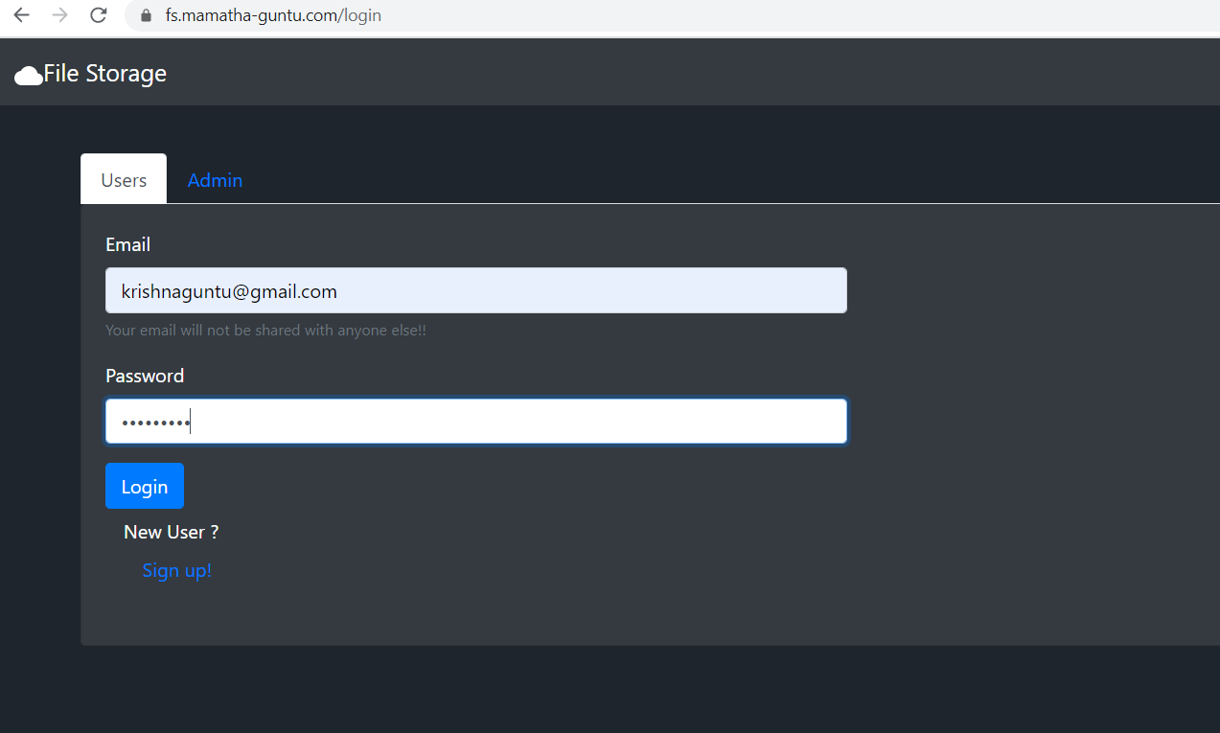

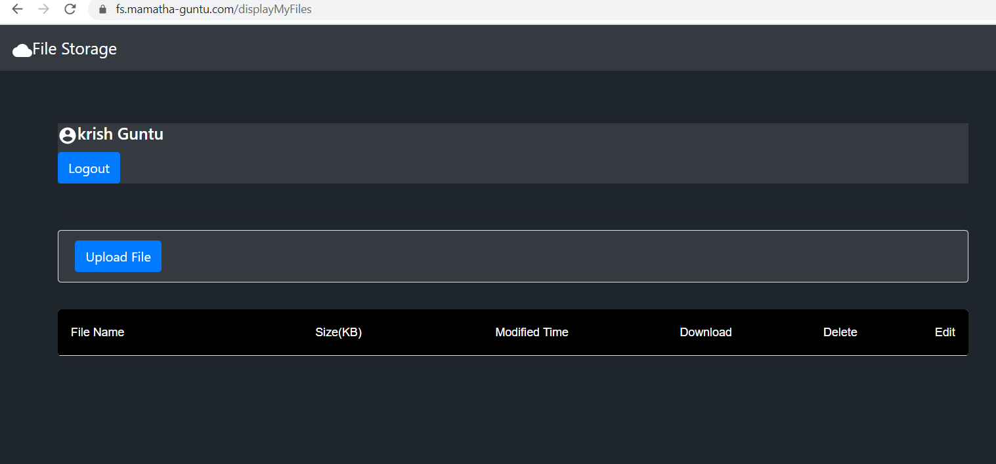

Upload a file

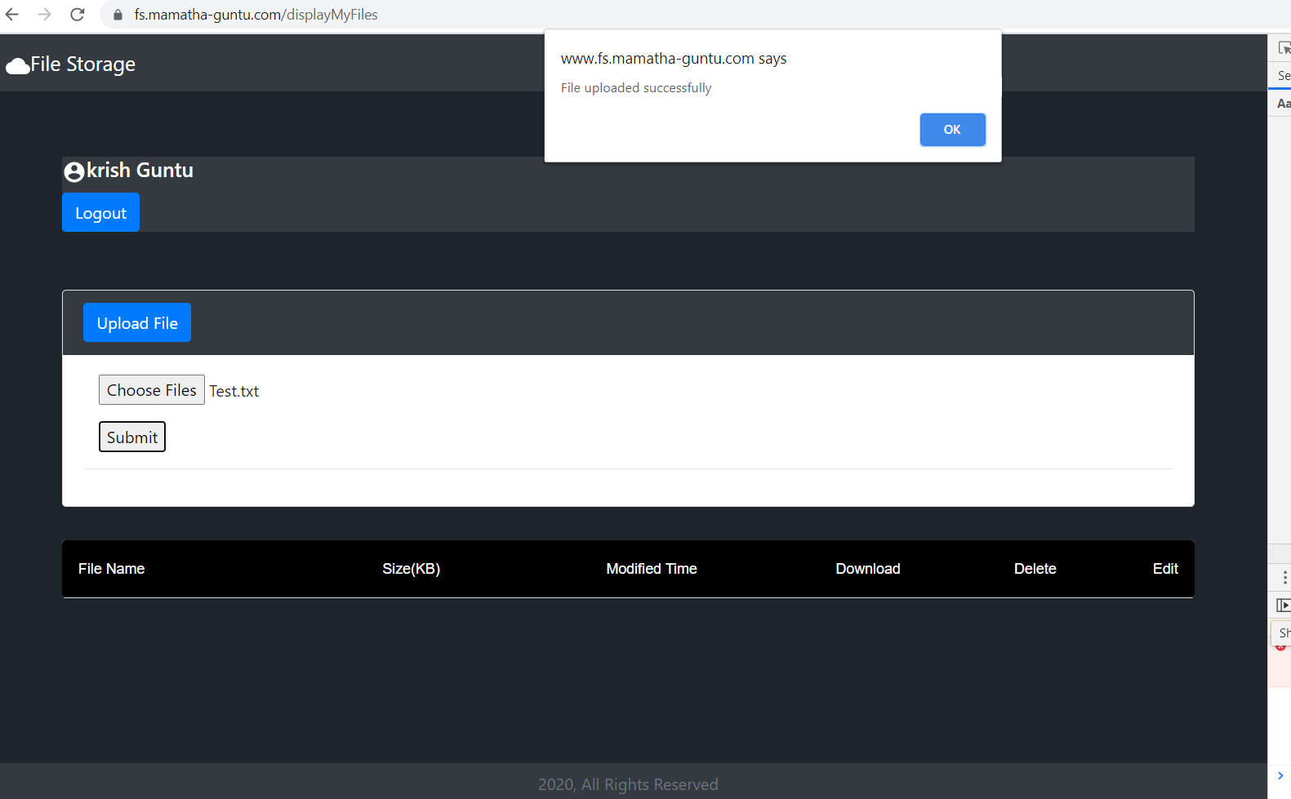

Verify Uploaded file is displayed in the Grid

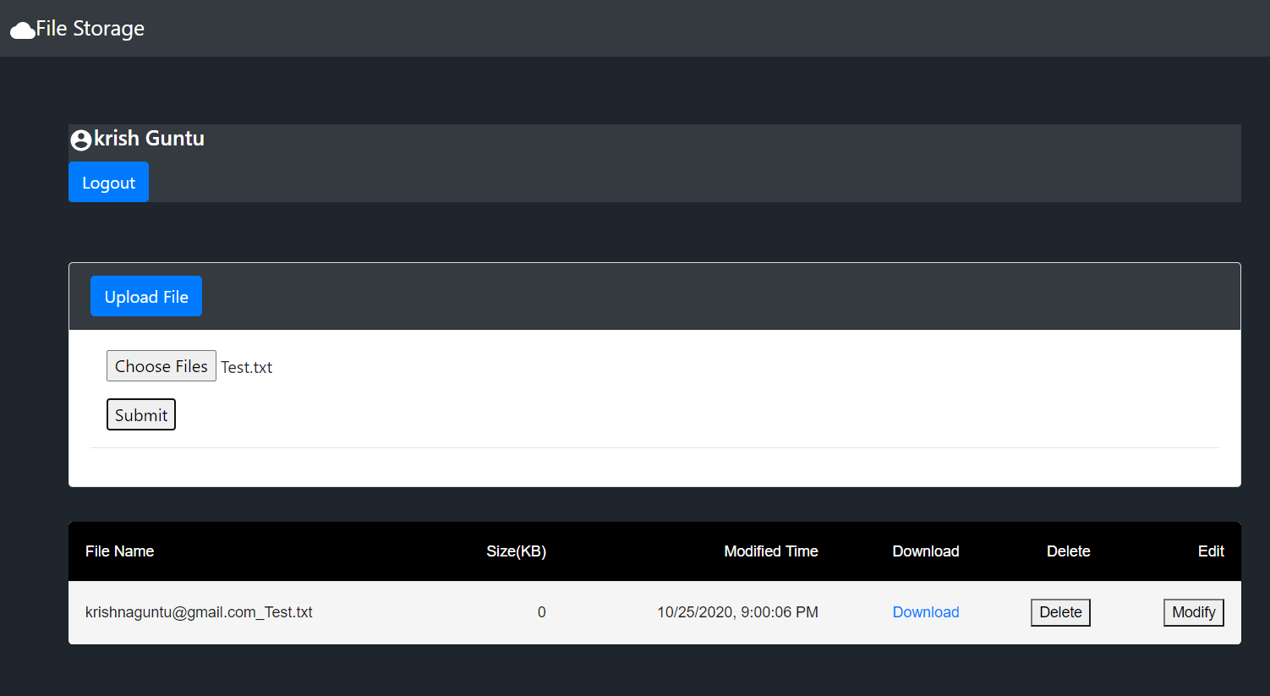

Download the file

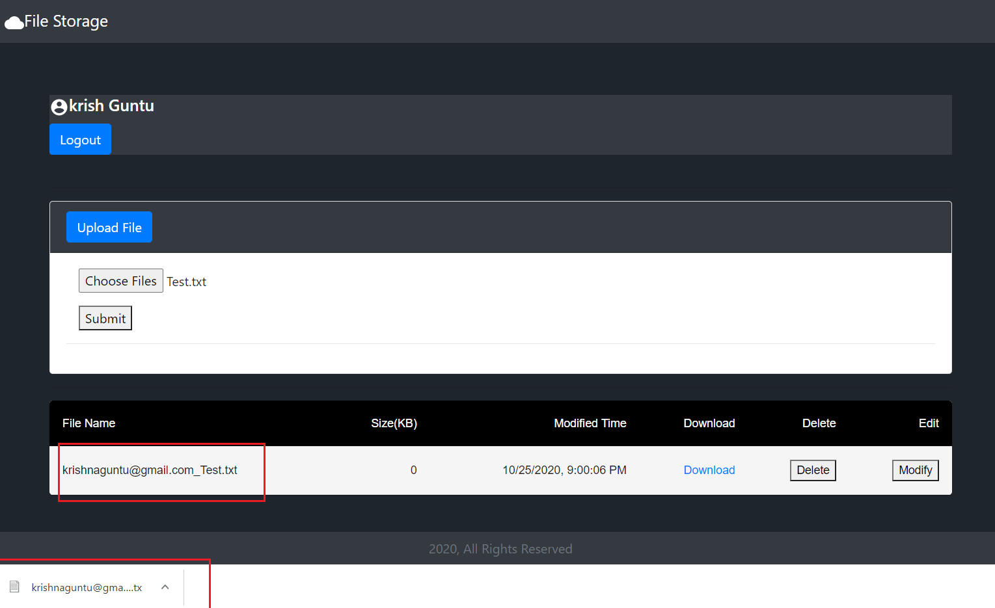

Modify the file

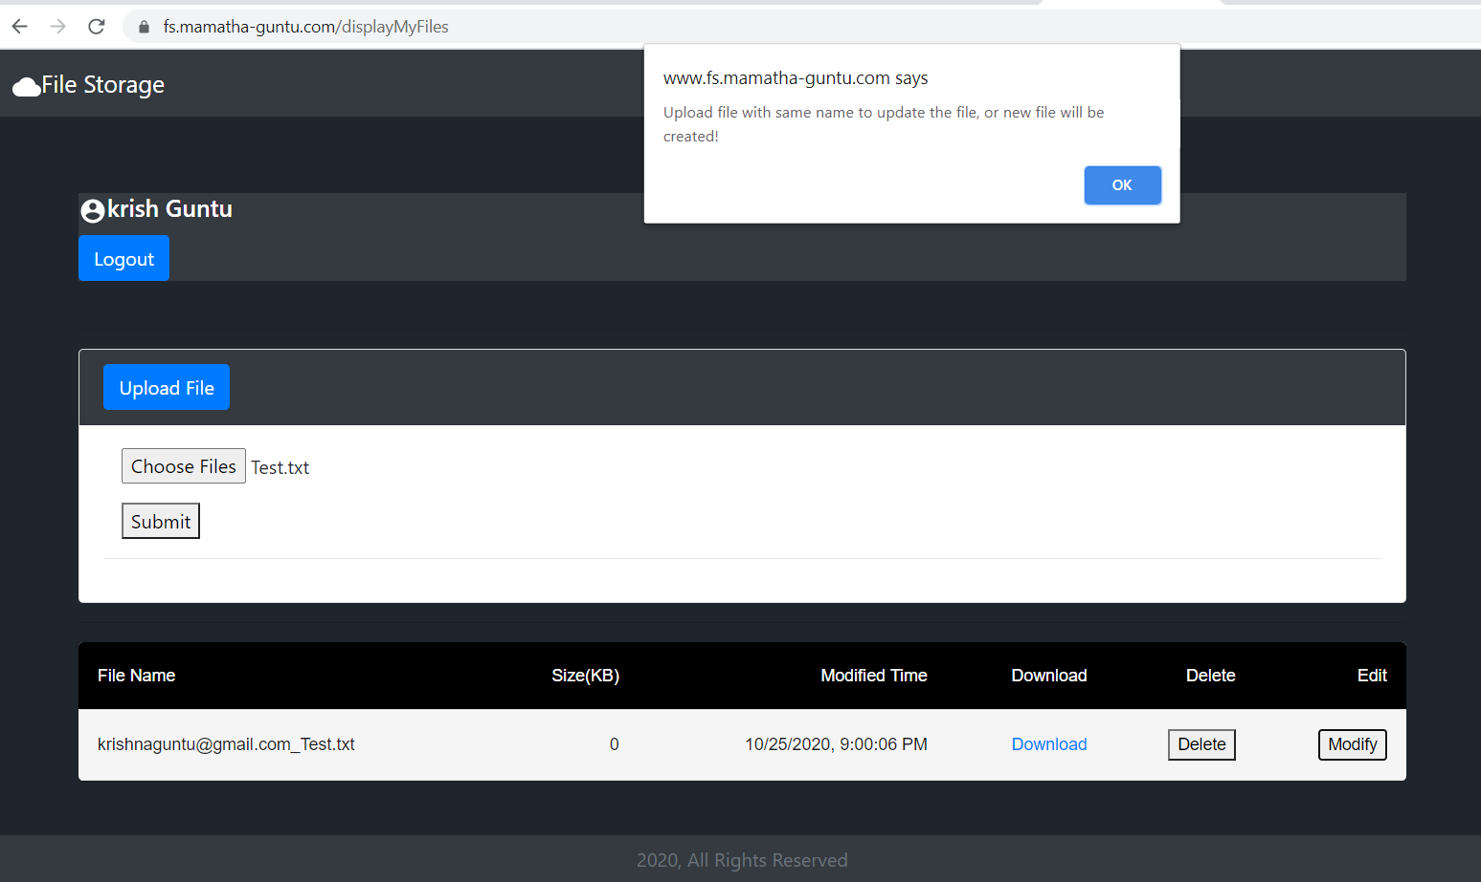

Upload Modified contents file with the same name, else a new one will be created. This is to maintain version control for the file.

After update , Observe that the date and time is changed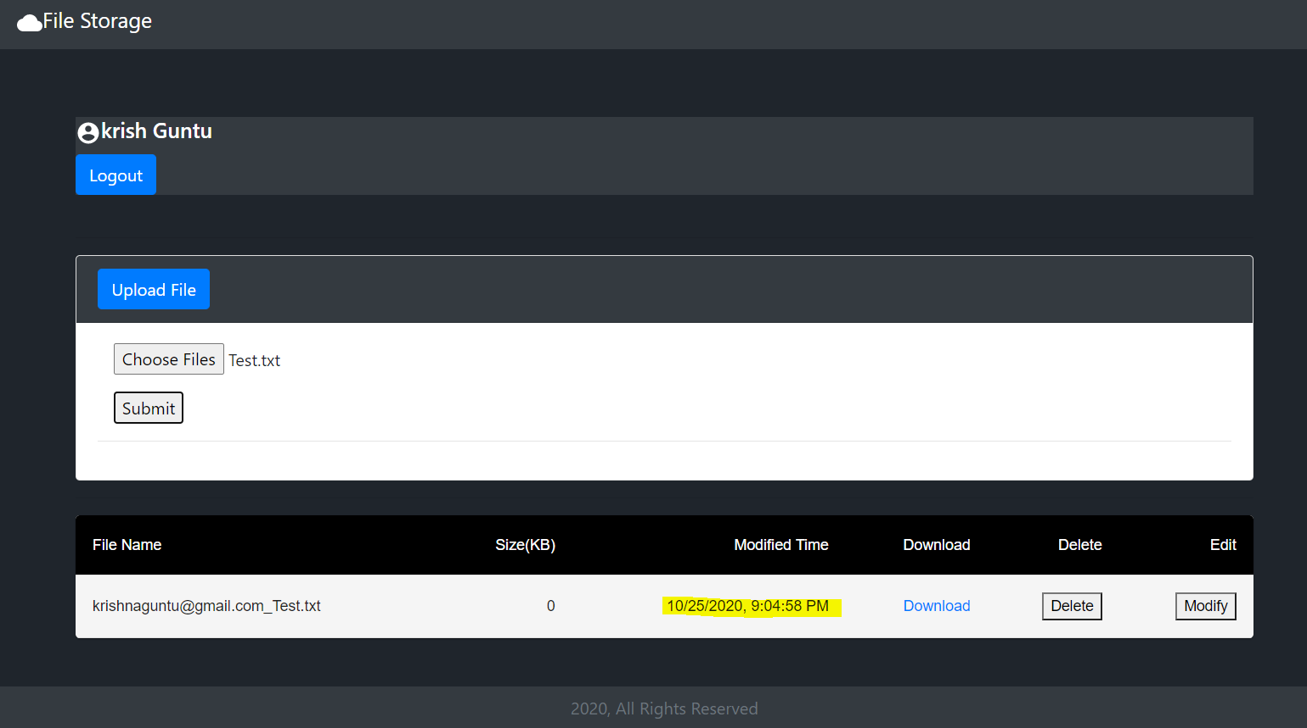

Click delete and you can see the file getting deleted

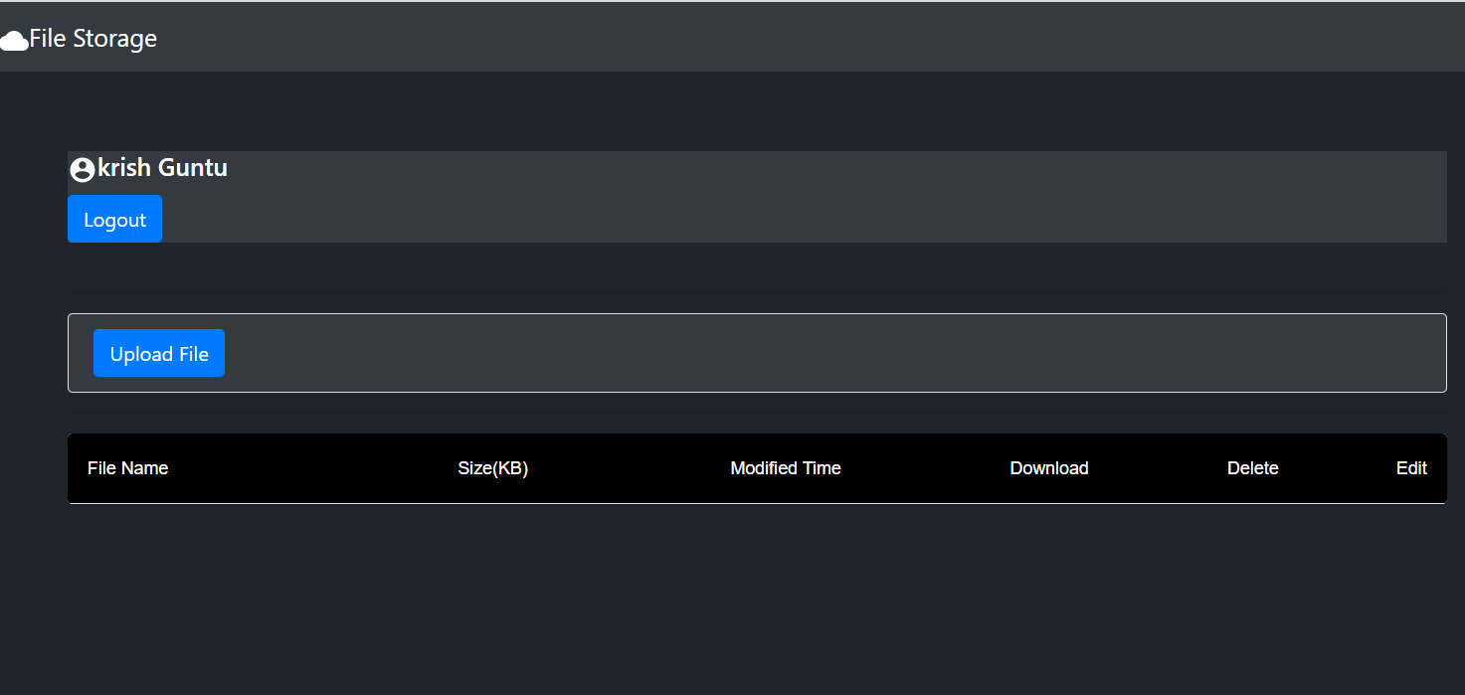

Log out of the account

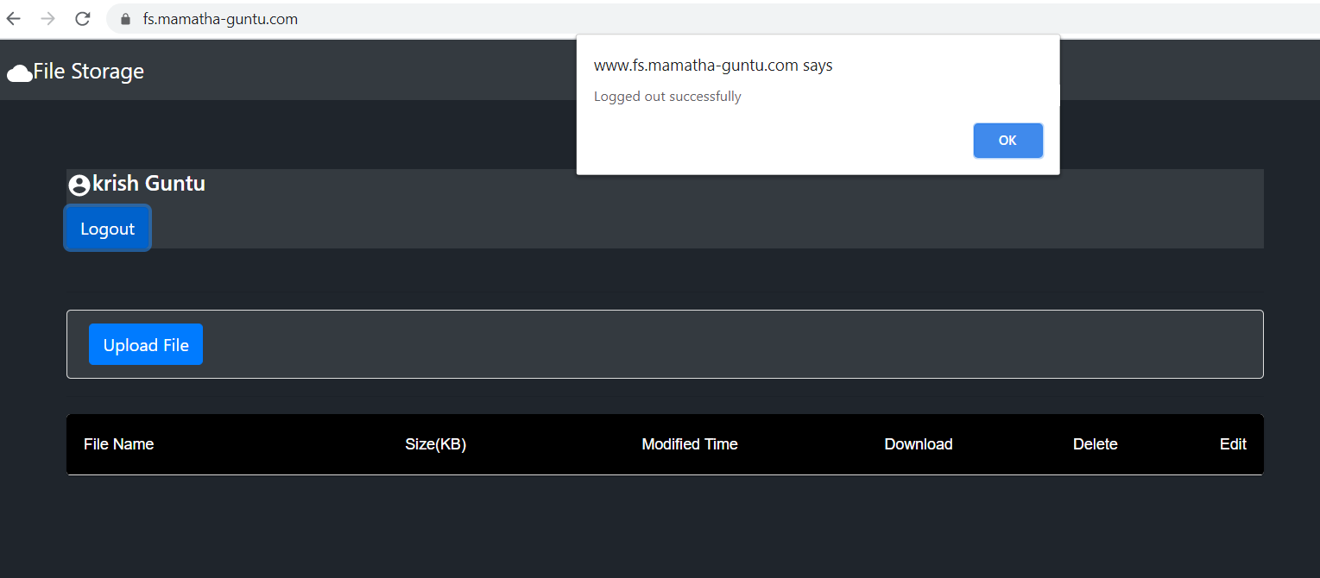

It will be redirected to the home page once , ok is clicked on the alert

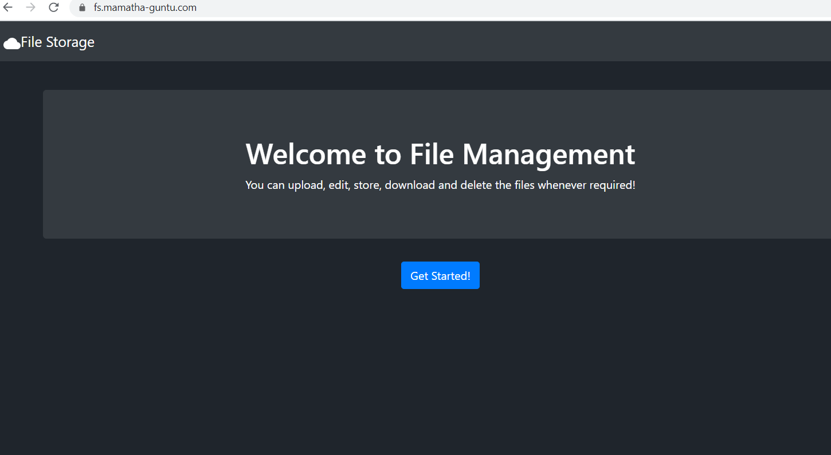

Click get started to get into admin account, select admin tab, and enter credentials

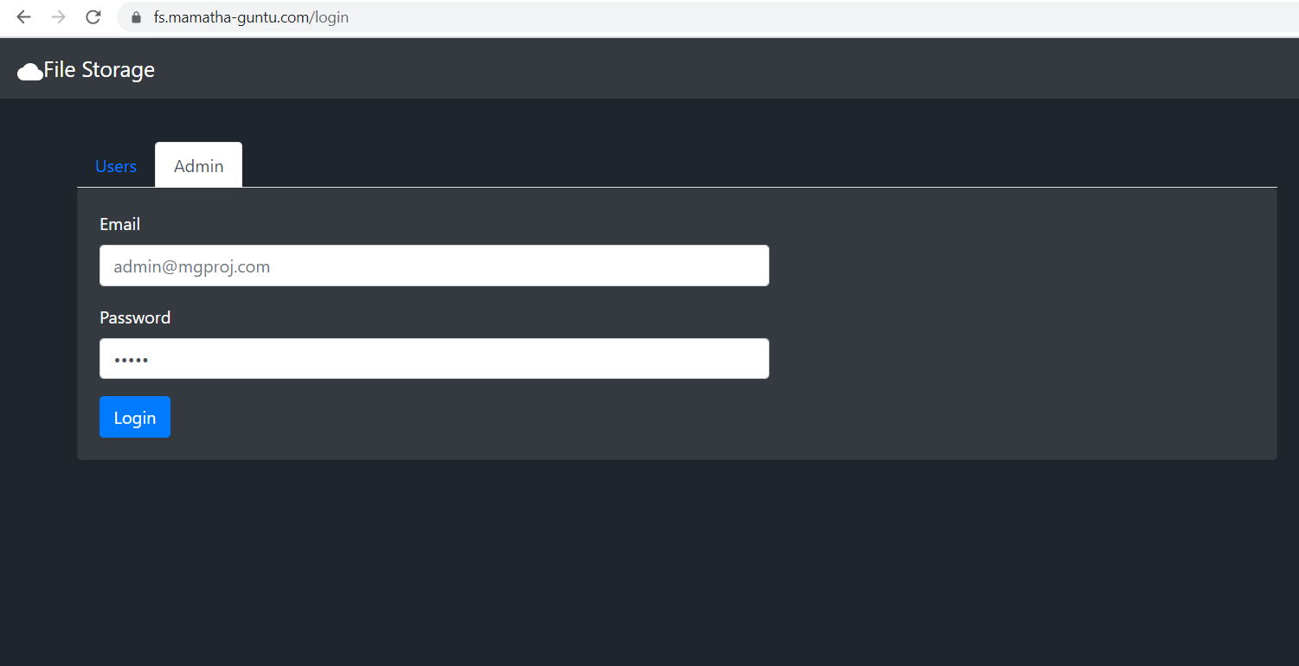

View all the user details

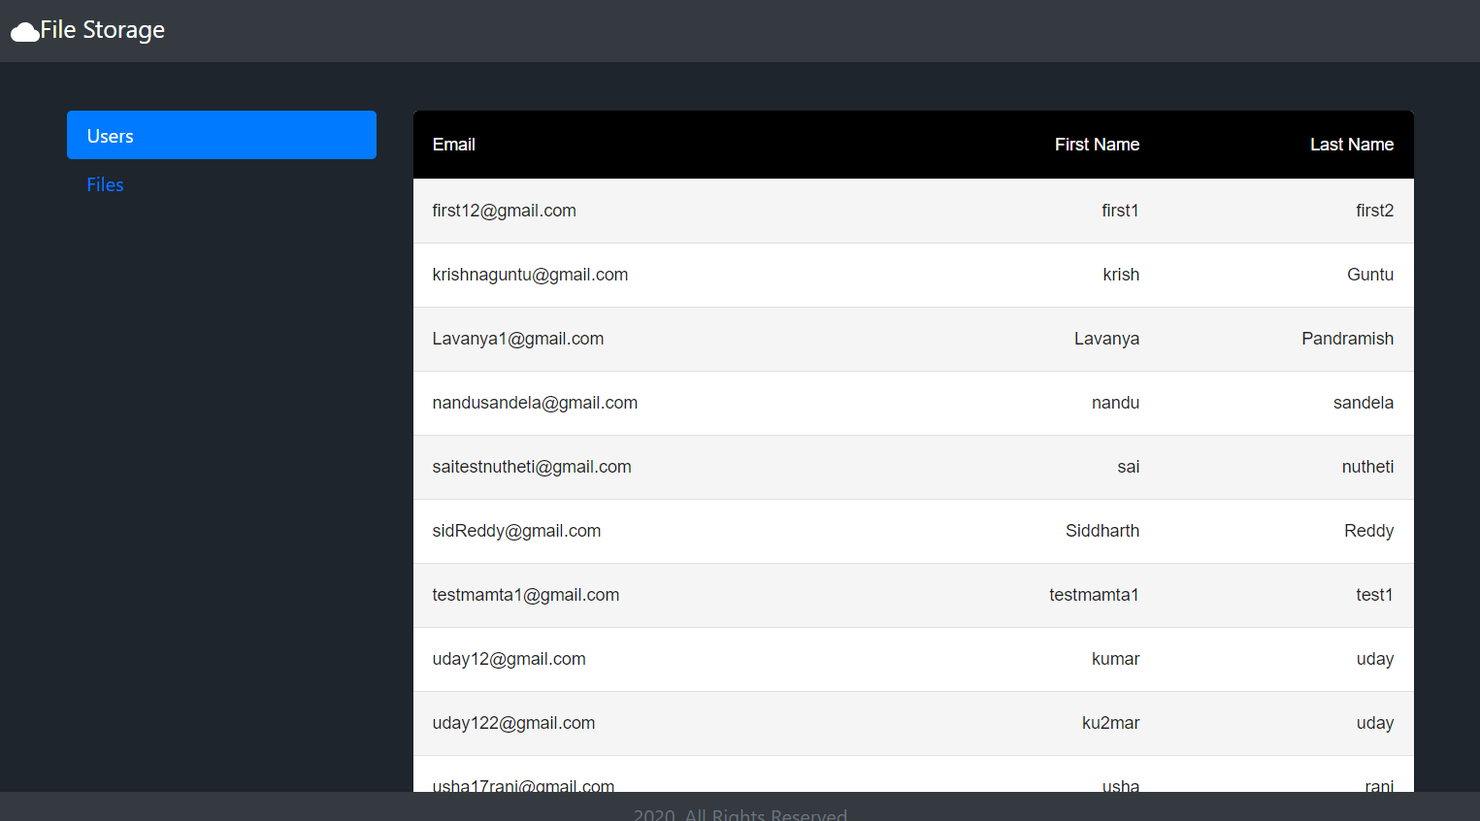

Click on the files tab and View all the files uploaded

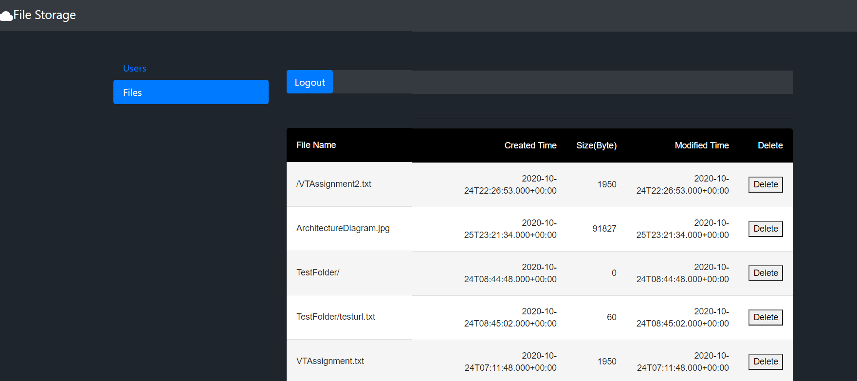

Delete

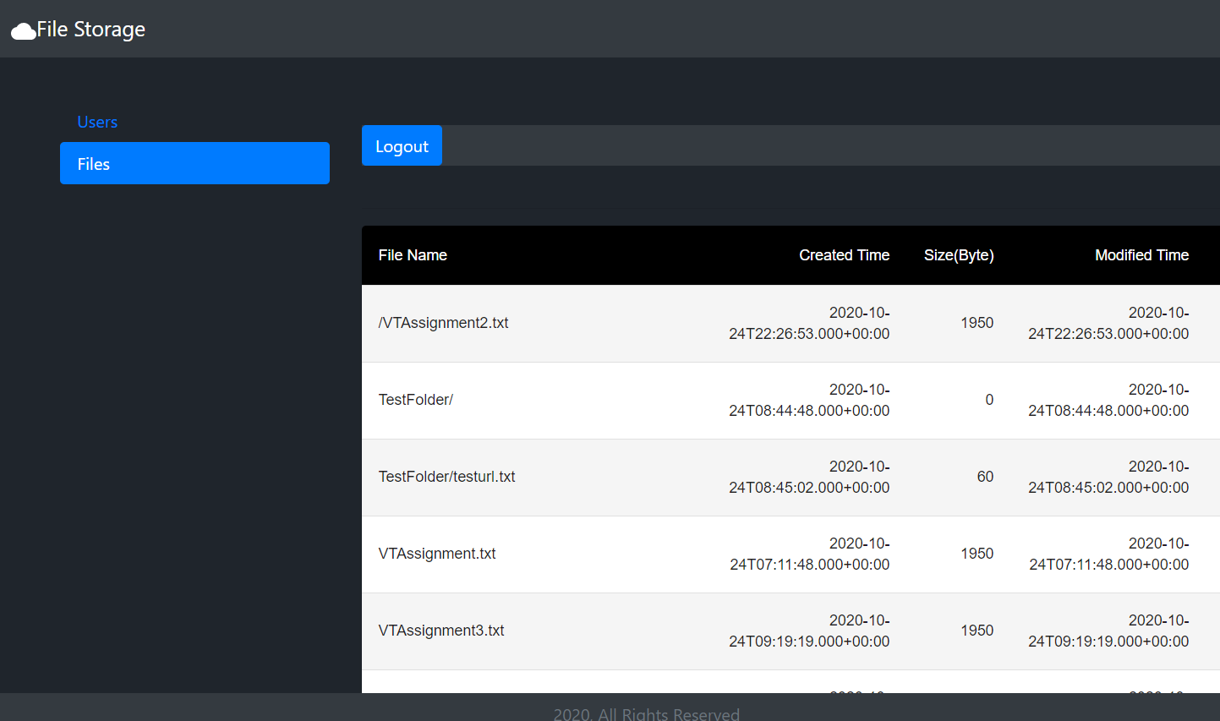

Logout will take to the home page

AWS Services and configuration

* Create R53 domain

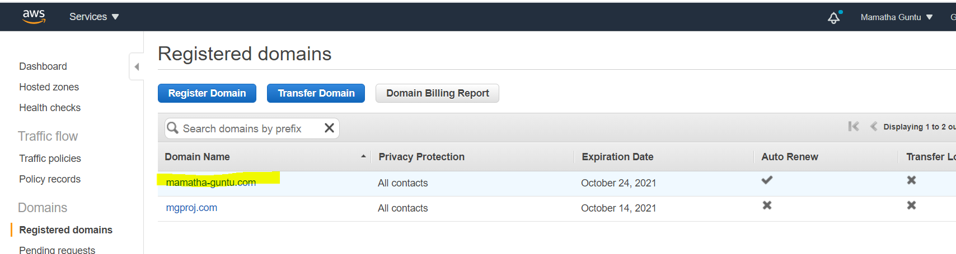

and create SSL certificate for the domain created

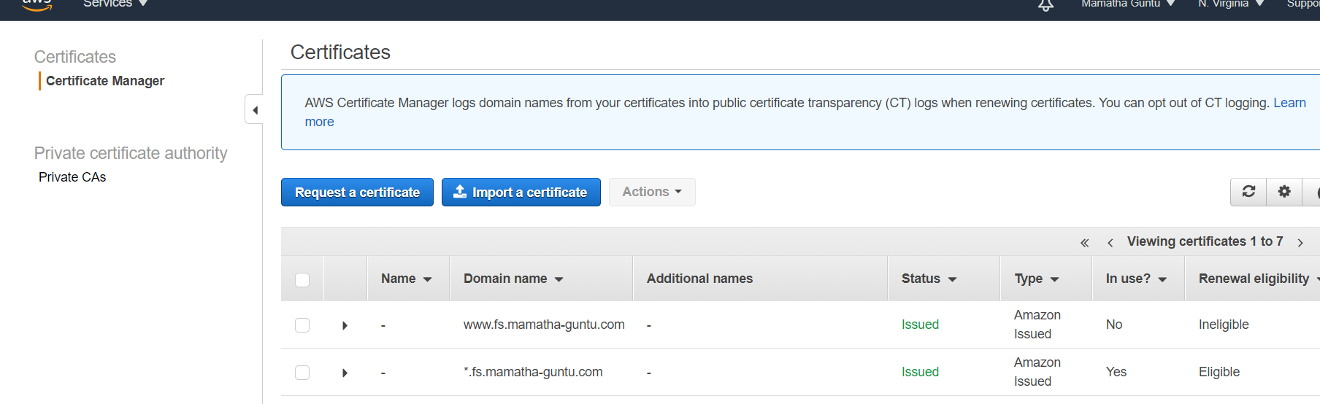

* Classic load balancer

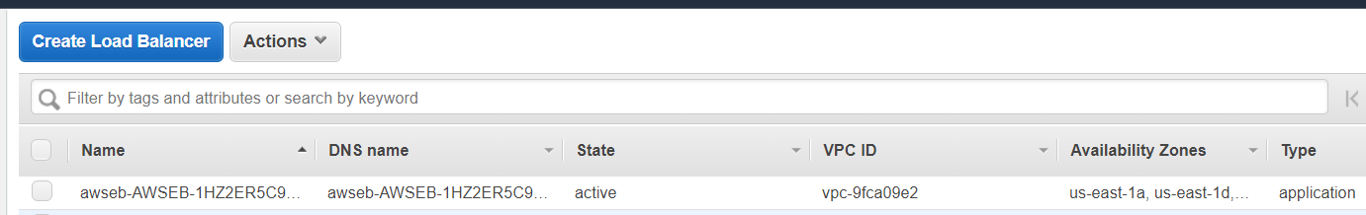

* Auto scaling group

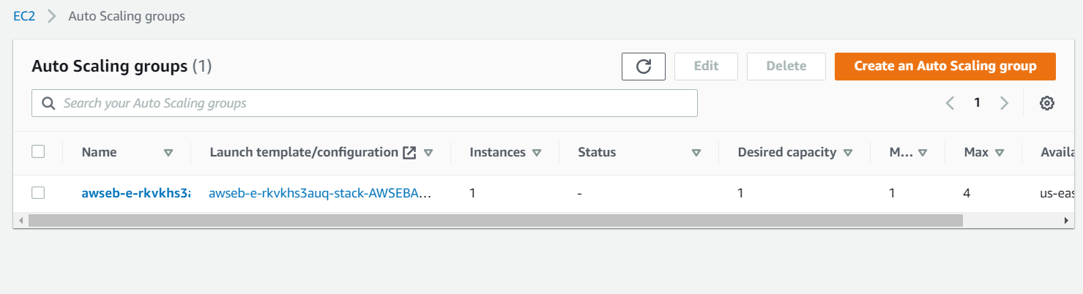

* S3 bucket with Replication for disaster recovery

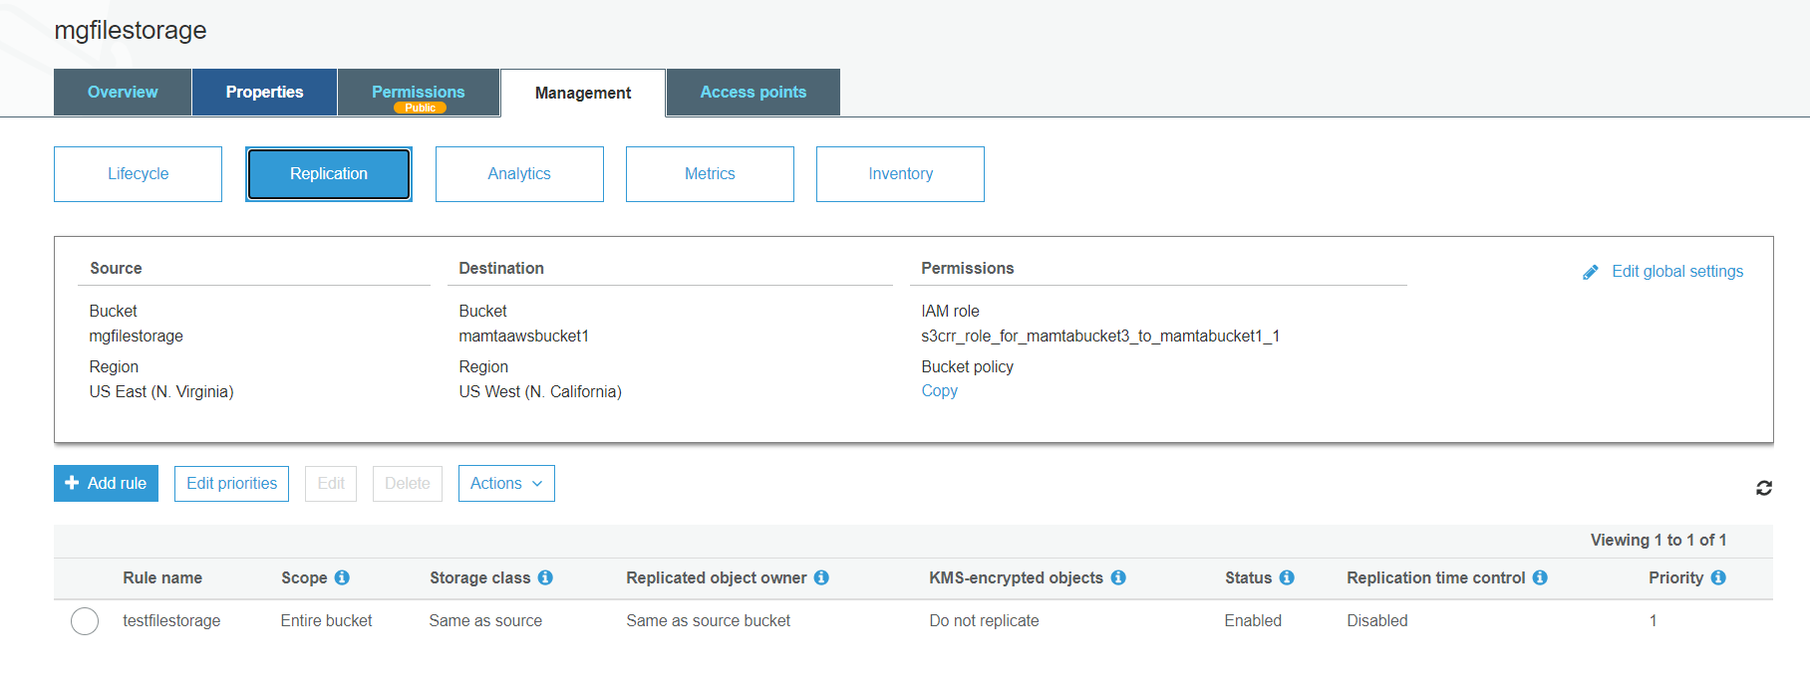

Lifecycle policy

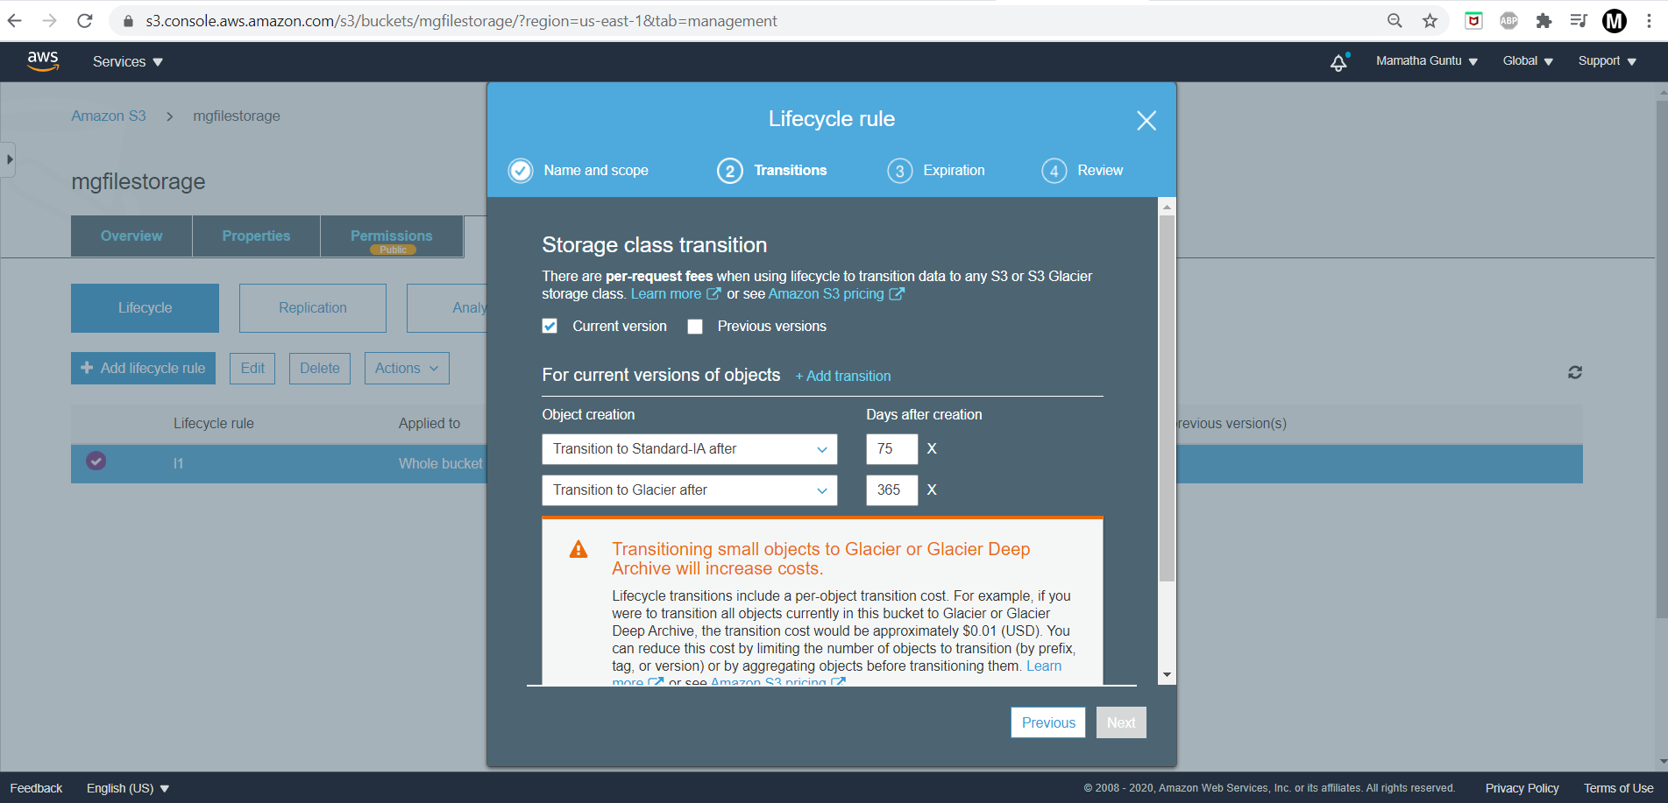

* Lambda for Post operation

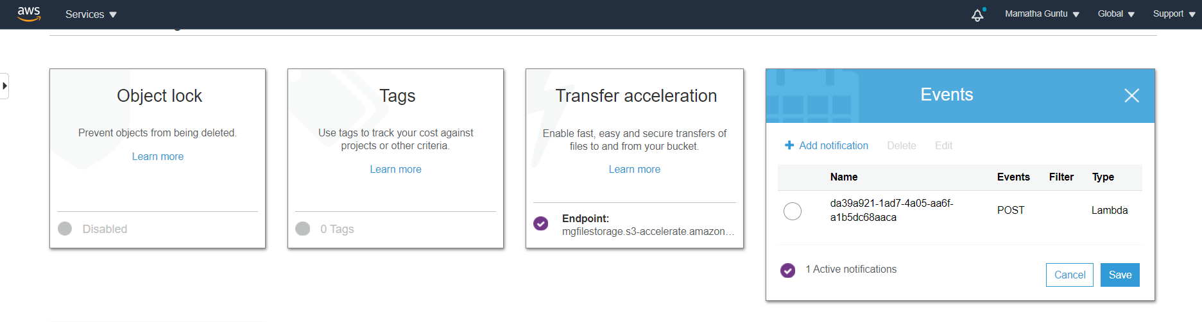

* Cloudfront distribution to access the S3 files for download quickly

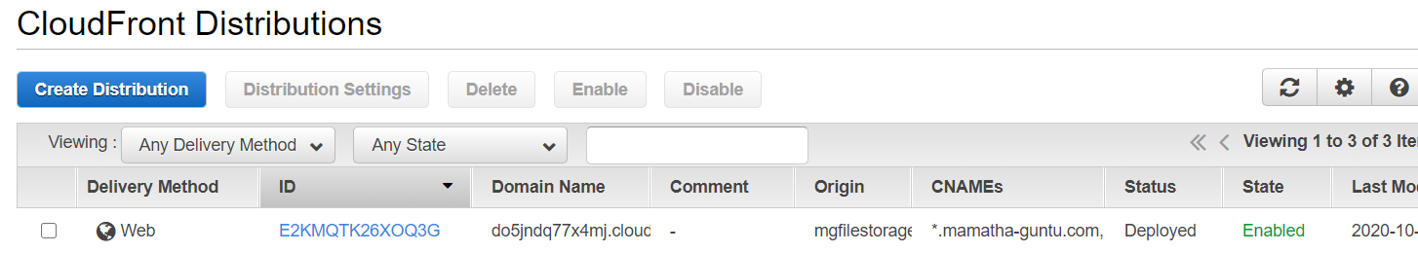

* RDS- MYSQL to maintain user data

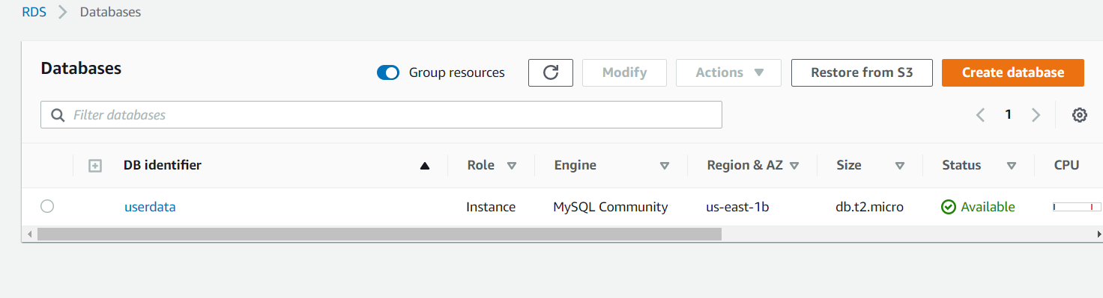

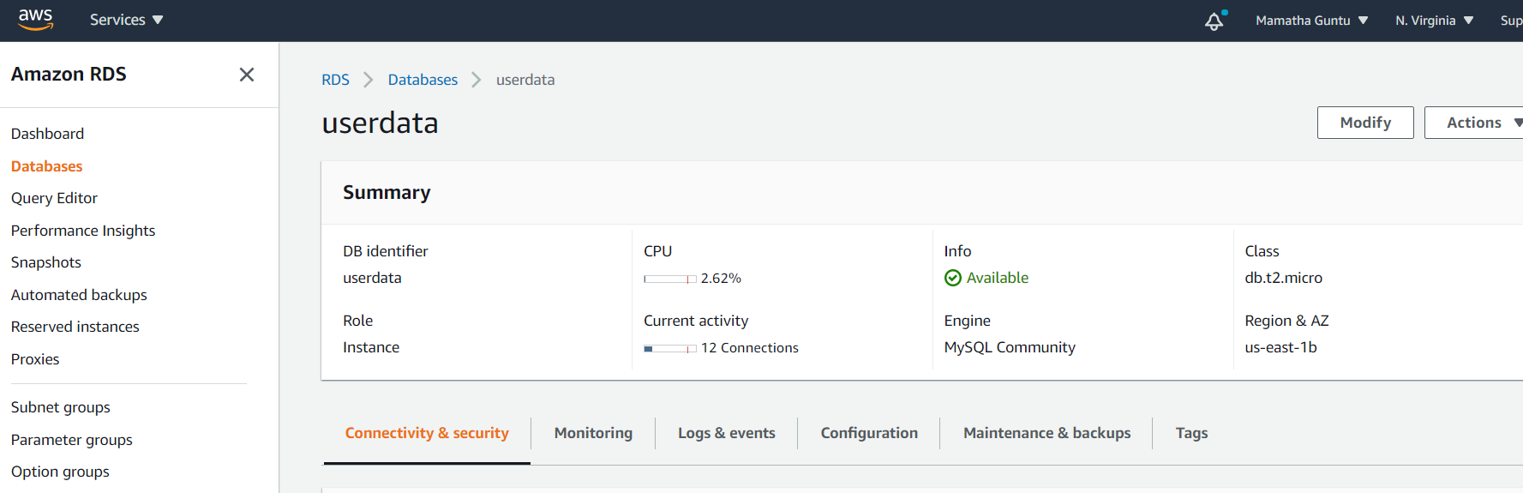

RDS Multi AZ deployment

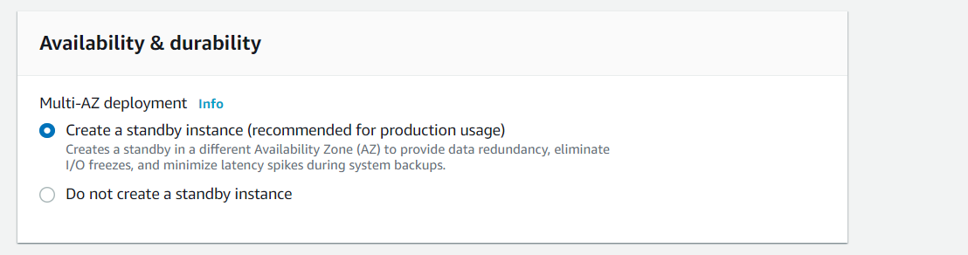

SNS for Deployed environment status

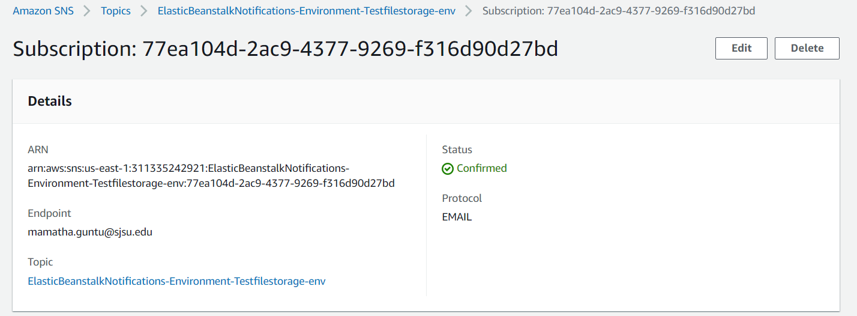

Deployment steps:

* Clone the github repo
* npm install
* maven clean
* maven install
* verify .jar file is uploaded in target folder
* create Elastic beanstalk web application with Java and upload the jar file
* Wait till the environment is created

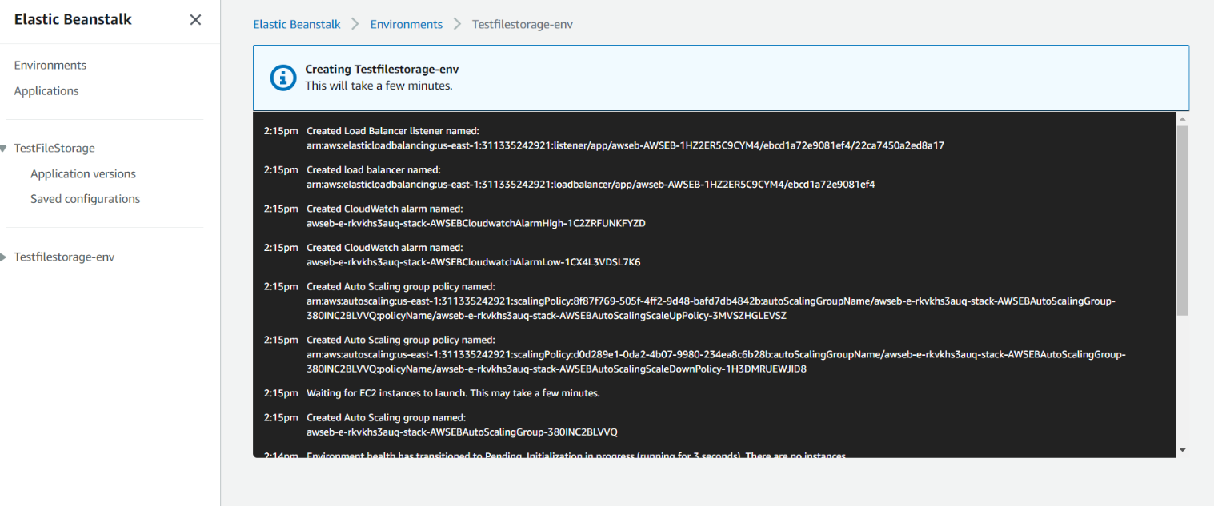

Once the environment is ready, we can see the url with which we can access webapp

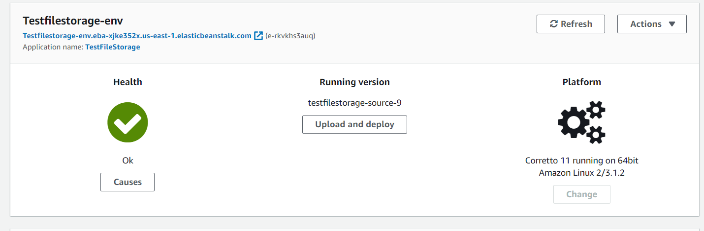

Create a simple routing policy record with our registered domain to use custom domain instead of beanstalk url 