Zomato Bangalore Restaurant Market Analysis
End-to-End Data Analyst / Business Analyst Project
Complete Process Documentation: Business Understanding → Data Cleaning → EDA
→ Power BI Dashbaords→ Insights & Recommendations
Data source: Kaggle — Zomato Bangalore Restaurants Dataset (51,717 listings)
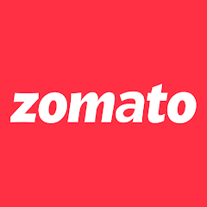

Table of Contents
Table of Contents 2
1. Project Overview & How We Approached It 3
2. Business Understanding 3
Business Problem 3
Key Business Questions 3
KPIs Tracked 3
3. Data Understanding 4
Key Data Quality Issues Found & Fixed 4
4. Data Cleaning Pipeline 4
5. Exploratory Data Analysis 5
5.1 Market Concentration 5
5.2 Ratings Landscape 5
5.3 Service Features Drive Engagement 6
5.4 Cuisine & Format Trends 6
5.5 Cost vs. Rating 7
5.6 Listing Type Mix 8
5.7 Top Performers 9
6. BI Data Modeling (Star Schema) 9
7. Power BI Dashboard (Built Live) 9
Page 1 — Executive Summary 9
Page 2 — Market Overview 9
Page 3 — Ratings & Quality 9
Page 4 — Service Features Impact 10
Page 5 — Locality Deep Dive 10
8. Key Findings & Recommendations 10
Key Findings 10
Recommendations 10
9. Deliverables & Project Structure 11

1. Project Overview & How We Approached It
This project follows the standard workflow a data analyst / business analyst uses inside a company when handed a raw dataset and a business question. Each phase below produced a tangible artifact, all saved in the project folder.
- Business Understanding — define the problem, stakeholders, KPIs, and scope before touching data.
- Data Understanding — profile the raw file, build a data dictionary, flag quality issues.
- Data Cleaning — build a reproducible Python pipeline that fixes every issue found.
- Exploratory Data Analysis (EDA) — quantify patterns and generate a chart pack.
- BI Data Modeling — reshape the cleaned data into a star schema (fact + dimension/bridge tables) suitable for Power BI.
- Dashboard Build — construct an interactive, multi-page Power BI dashboard
- Insight Synthesis & Recommendations — translate findings into business actions.

Tools used: Python (pandas, matplotlib, seaborn) in a dedicated conda environment, Power BI Desktop.

2. Business Understanding

Business Problem
“Where and how should a restaurant operator position a new outlet in Bangalore, and what factors correlate with higher customer ratings and engagement (votes)?”

Key Business Questions
- Which localities have the most restaurants, and which are under-served?
- What is the average cost for two across localities and cuisines?
- Do online ordering / table booking correlate with higher ratings and votes?
- Which cuisines and restaurant types dominate, and which rate best?
- Is there a relationship between cost and rating?
- Who are the top-performing restaurants, and what do they have in common?

KPIs Tracked
KPI | Definition
Restaurant Count | Listings per locality / cuisine / type
Avg Rating | Mean of cleaned rating (out of 5)
Avg Cost for Two | Mean approx. cost for two, ₹
Avg Votes | Mean votes — engagement proxy
Online Order % | % of listings offering online ordering
Table Booking % | % of listings offering table booking

3. Data Understanding
Source file: zomato.csv — 51,717 rows × 17 columns, scraped Zomato listings for Bangalore, latin-1 encoded. Granularity: one row per restaurant listing-context (a restaurant can repeat once per listed_in(type) it is registered under — e.g. once for ‘Delivery’ and once for ‘Dine-out’). This is a structural feature of the source, not duplication.

Key Data Quality Issues Found & Fixed
Issue | Column(s) | Resolution
Rating stored as text “4.1/5”, inconsistent spacing, ‘NEW’/‘-’ placeholders | rate | Parsed to numeric float; NEW/- → null
Cost stored as text with commas | approx_cost(for two people) | Stripped commas, cast to numeric
Multi-valued fields | cuisines, rest_type | Derived primary_cuisine / primary_rest_type
High nulls (54%) | dish_liked | Dropped from core model
Encoding | whole table | Read latin-1, re-saved UTF-8
Irrelevant to KPIs | phone, menu_item, reviews_list | Dropped from core model

4. Data Cleaning Pipeline
Implemented in scripts/01_clean_data.py. Key steps:
- Dropped low-value columns (phone, menu_item, reviews_list, dish_liked).
- Renamed columns to clean snake_case (cost_for_two, listing_type, listing_city).
- Parsed rating → numeric; flagged 2,208 'NEW' listings as not-yet-rated.
- Cleaned cost_for_two: removed thousands separators, cast to numeric.
- Derived primary_cuisine and primary_rest_type from the first listed value.
- Flagged unique restaurants (12,499 of 51,717 rows) by name + address, since the same restaurant legitimately repeats per listing type.
- Created rating_band (Excellent / Good / Average / Poor / Not Rated) and cost_bucket (Budget / Mid / Premium / Luxury) for slicing.
- Dropped 21 rows with no location.
Result: 51,696 clean rows × 18 columns, saved to data/cleaned/zomato_cleaned.csv, with a full run log in docs/03_data_cleaning_log.md.

5. Exploratory Data Analysis
Implemented in scripts/02_eda.py. Below are the core findings, each backed by a chart in dashboards/eda_charts/.

5.1 Market Concentration
Listings are heavily concentrated in a handful of tech-corridor localities.
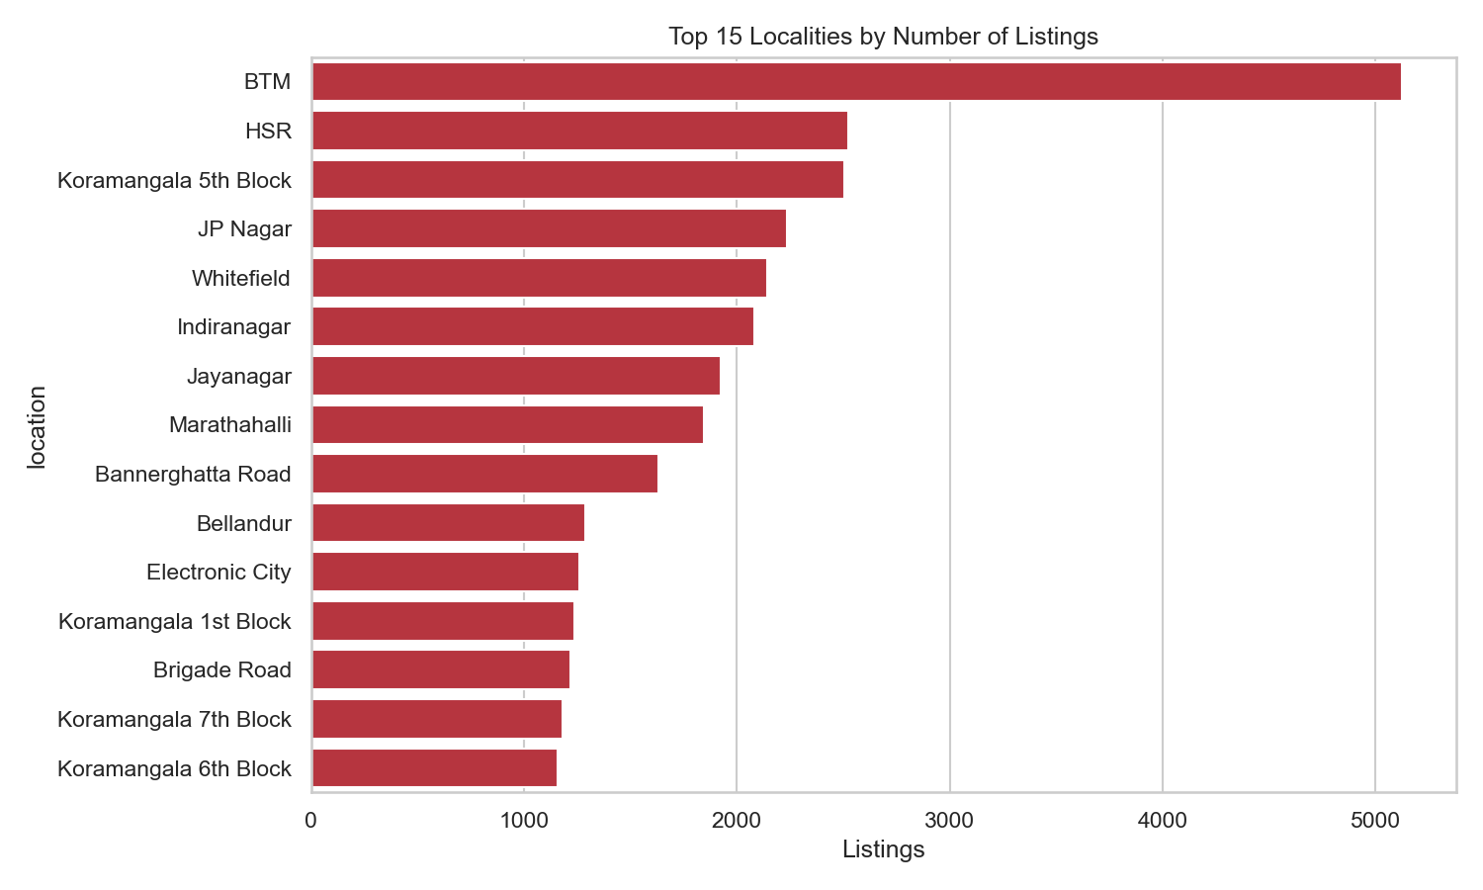
Top 15 localities by listing count — BTM (5,124), HSR, Koramangala 5th Block, JP Nagar, Whitefield lead.

5.2 Ratings Landscape
19% of listings are unrated ('NEW'). Of rated listings, mean rating is 3.70/5; most established restaurants cluster in the 'Good' band, not 'Excellent'.
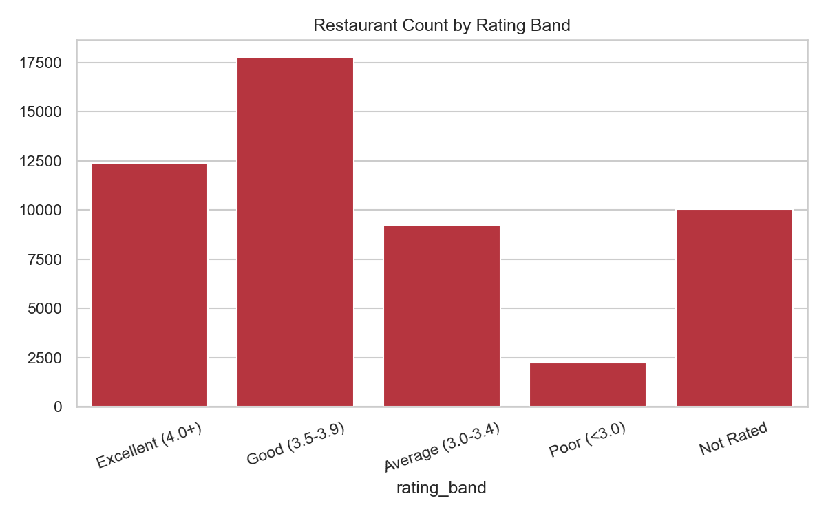
Rating band distribution across all 51,696 listings.

5.3 Service Features Drive Engagement
Table booking is the single strongest signal found in this dataset: restaurants offering it average 4.14★ vs 3.62★, and ~7x the votes (1,147 vs 161). Online ordering shows a smaller lift (3.72★ vs 3.66★).
Feature | Avg Rating | Avg Votes
Online Order = No | 3.66 | 251
Online Order = Yes | 3.72 | 307
Book Table = No | 3.62 | 161
Book Table = Yes | 4.14 | 1,147

5.4 Cuisine & Format Trends
Volume leaders (North Indian, South Indian) are mass-market staples but not top-rated. Niche/premium cuisines rate consistently higher.
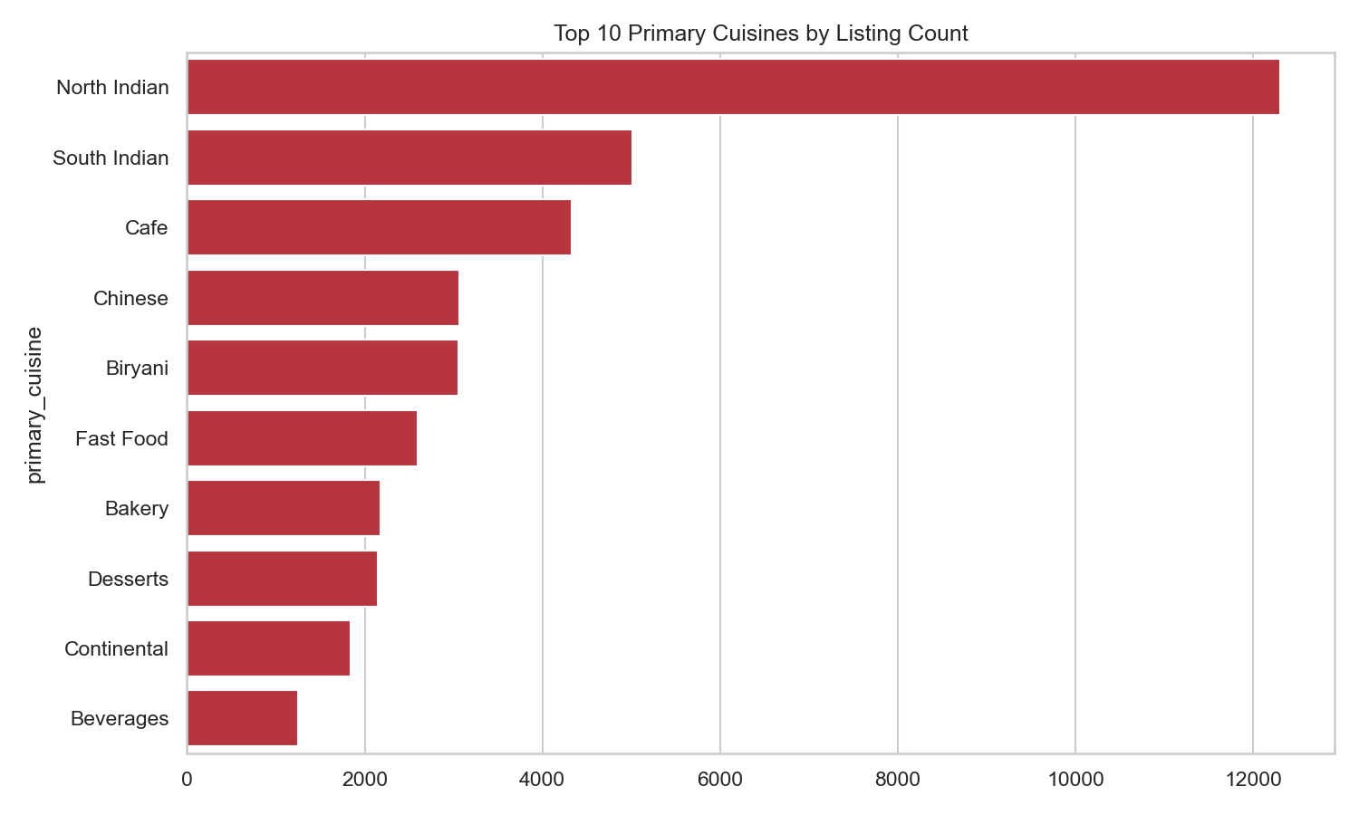
Top 10 primary cuisines by listing count.
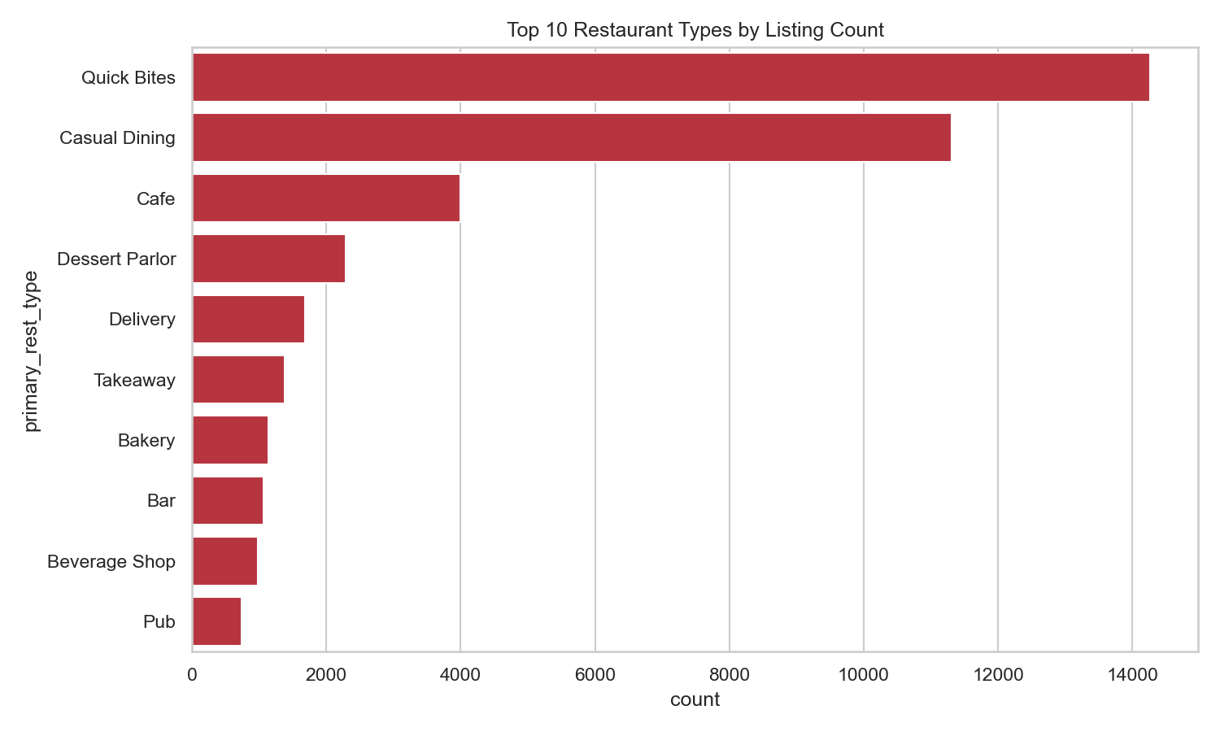
Top 10 restaurant types by listing count, with average rating per type.

5.5 Cost vs. Rating
Cost correlates moderately with rating (r ≈ 0.39) — pricier restaurants average meaningfully higher ratings, but plenty of budget options rate well too.
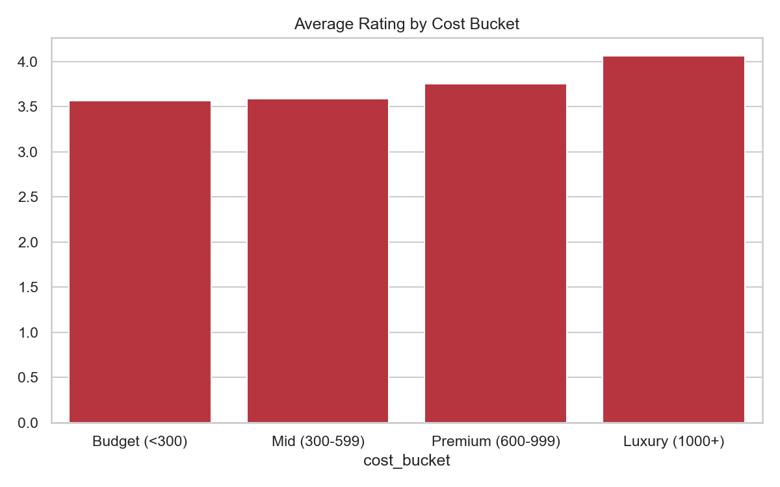
Average rating by cost bucket: Budget 3.56 → Mid 3.59 → Premium 3.76 → Luxury 4.06.

5.6 Listing Type Mix
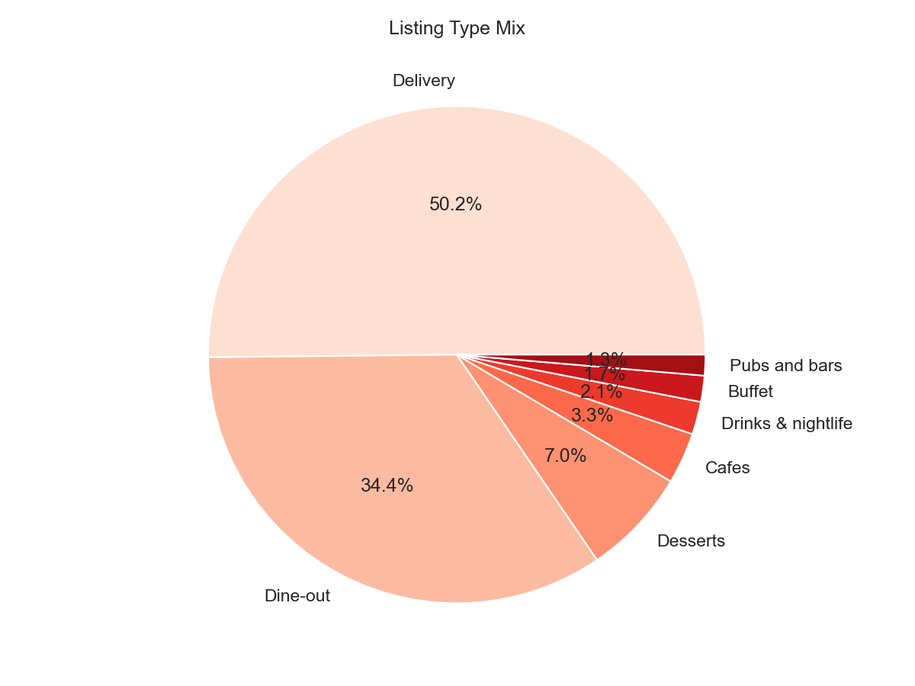
Delivery (50%) and Dine-out (34%) dominate listing contexts.

5.7 Top Performers
The most-voted unique restaurants are large-format breweries/dine-out venues, all with table booking, premium pricing, and 4.4★+ ratings:
Restaurant | Location | Votes | Rating | Cost for Two
Byg Brewski Brewing Company | Sarjapur Road | 16,345 | 4.9 | ₹1,600
Toit | Indiranagar | 14,956 | 4.7 | ₹1,500
Truffles | Koramangala 5th Block | 14,654 | 4.7 | ₹900
AB's – Absolute Barbecues | Marathahalli | 12,121 | 4.8 | ₹1,600
The Black Pearl | Koramangala 5th Block | 10,413 | 4.7 | ₹1,400

6. BI Data Modeling (Star Schema)
Implemented in scripts/03_prepare_bi_data.py, transforming the flat cleaned dataset into a star schema for Power BI:
- Fact_Listings.csv — 51,696 rows, one per listing, with a surrogate listing_id key.
- Bridge_Cuisines.csv — 126,819 rows, listing_id ↔ individual cuisine (handles multi-cuisine listings).
- Bridge_RestTypes.csv — 59,217 rows, listing_id ↔ individual restaurant type.
- Dim_Location_Summary.csv — 93 rows, one per locality, pre-aggregated metrics.

7. Power BI Dashboard (Built Live)
Built directly in Power BI Desktop: data imported, relationships auto-detected, 7 DAX measures written (Total Listings, Unique Restaurants, Avg Rating, Avg Cost for Two, Total Votes, Online Order %, Book Table %), and 5 report pages constructed. File: powerbi/Zomato_Bangalore_Dashboard.pbix.

Page 1 — Executive Summary
A combined overview page pulling the 6 headline KPI cards, the top-localities bar chart, the listing-type donut, and the rating-band distribution onto one screen for at-a-glance review.

Page 2 — Market Overview
6 KPI cards (Total Listings, Unique Restaurants, Avg Rating, Avg Cost for Two, Online Order %, Book Table %), a Top-15-Localities bar chart, and a Listing Type Mix donut chart.

Page 3 — Ratings & Quality
Rating band distribution, Avg Rating by Restaurant Type (filtered to types with ≥ 50 listings), and Avg Rating by Cuisine (same filter) — directly reproducing the EDA findings interactively.

Page 4 — Service Features Impact
Side-by-side Avg Rating comparisons for Online Order (Yes/No) and Book Table (Yes/No), plus a Top-10-by-votes restaurant table.

Page 5 — Locality Deep Dive
A full sortable table of all 93 localities with listing count, unique restaurant count, avg rating, avg cost, avg votes, online order %, and book table % — supports drill-down analysis by area.
Full design rationale and DAX formulas: docs/05_powerbi_design_and_build_guide.md

8. Key Findings & Recommendations

Key Findings
- Market concentration: competition is heavily concentrated in tech-corridor localities (BTM, HSR, Koramangala, JP Nagar, Whitefield).
- Table booking is the strongest performance signal found — 4.14★ vs 3.62★ rating, ~7x votes.
- Format and cuisine quality vary widely — Quick Bites rates lowest (3.55★); Pubs/Bars/Dessert Parlors rate highest (3.89–4.10★); niche cuisines outrate mass-market ones.
- Price correlates moderately with quality (r ≈ 0.39, cost vs rating).
- Top performers share a profile: large-format, table-booking, premium-priced dine-out/brewery venues.
- 19% of listings are unrated — a meaningful population of fresh entrants.

Recommendations
For | Recommendation
New restaurant launch | Avoid the most saturated localities unless differentiating strongly; consider table booking + a premium or niche-cuisine position from day one.
Existing Quick Bites / Delivery-only operators | Quality ceiling is structurally lower for this format; consider adding dine-in or booking to lift engagement.
Marketing / cuisine strategy | Promote niche cuisines (Japanese, European, Modern Indian, BBQ) as premium differentiators.
Zomato product team | Test whether promoting table-booking adoption among mid-tier restaurants lifts engagement — the correlation here justifies a controlled experiment.

9. Deliverables & Project Structure
Folder / File | Contents
docs/ | All process documentation (this report's source material, 01–07)
data/raw/, data/cleaned/ | Raw and cleaned datasets, star-schema BI tables
scripts/ | Python pipeline: profiling, cleaning, EDA, BI data prep
dashboards/eda_charts/ | 11 EDA charts + locality summary CSV
powerbi/ | Power BI dashboard (.pbix) and source CSVs

This document consolidates docs/01 through docs/07 into a single shareable record of the full project lifecycle.

