**Flipkart Pay Later**

Financing is a major unmet need in India. Less than 1% of Indians accept credit cards. Without credit cards, customers have no access to short-term credit. A very important use case is being able to continue making purchases even if you don't have the required balance in your savings account.

E-commerce companies also have to contend with the difficulty of fostering convenience and trust throughout the order to delivery process. The most popular method of online shopping in India is known as Cash On Delivery (COD).

Flipkart saw these gaps and developed a product called Flipkart Pay Later to fill the requirement for access to credit while also enhancing convenience and

With Flipkart Pay Later, the purchase and payment gets de-coupled. Customers can purchase goods on Flipkart throughout the month upto an enabled limit (Rs 5–10k) without having to go through the payment process every time. Instead, they can complete their purchase at one-click, receive the products, use them and validate their quality, and later pay.

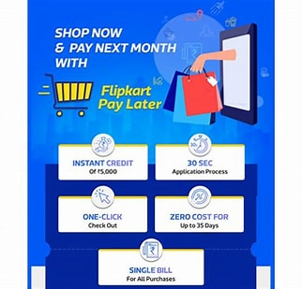

This is a truly India specific innovation, mimicking the trusted way of shopping at the retailer next door, where such a khaata keeping system is prevalent for recurring low value frequent purchases for the most loyal customer base of the retailer. Flipkart Pay Later aims at taking online shopping experience to an altogether different level by :

* Improving trust quotient for the customers as they have to pay after receiving/experiencing products
* Seamless checkout with 100% success rate on forward transactions
* Ease in order placement by having truly one-click payment solution
* Consolidated payback once a month
* Instant adjustments for any cancellations/ returns without the customer having to pay any money upfront

