Prompt:generate the image that family is working inth field and father is driving the tractor
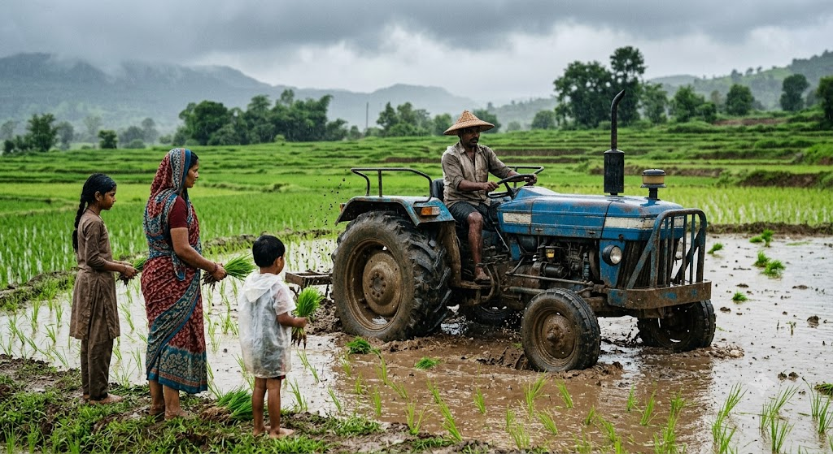
Prompt: business meeting of six people watching on MacBook on top of table,in minecraft
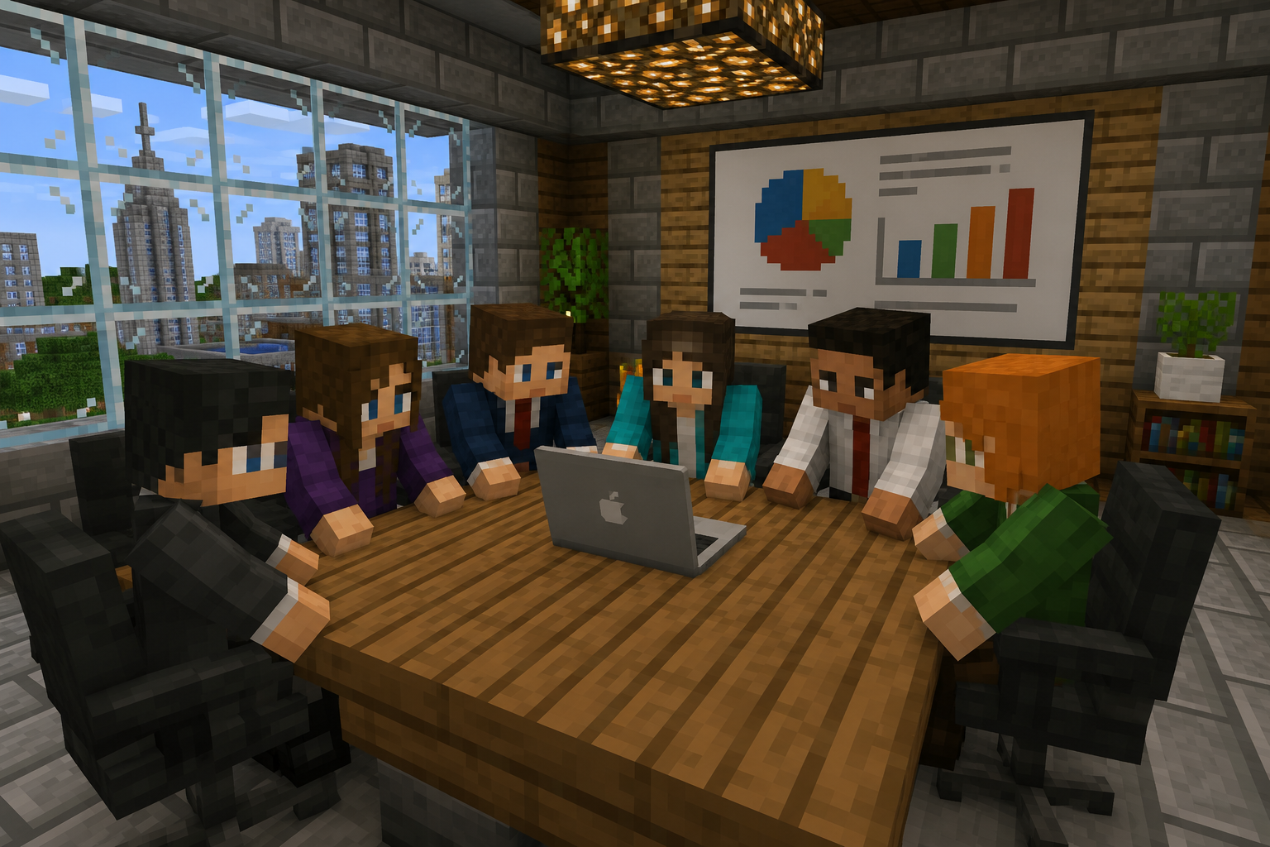

Prompt:generate the family that they are in marriage in traditonal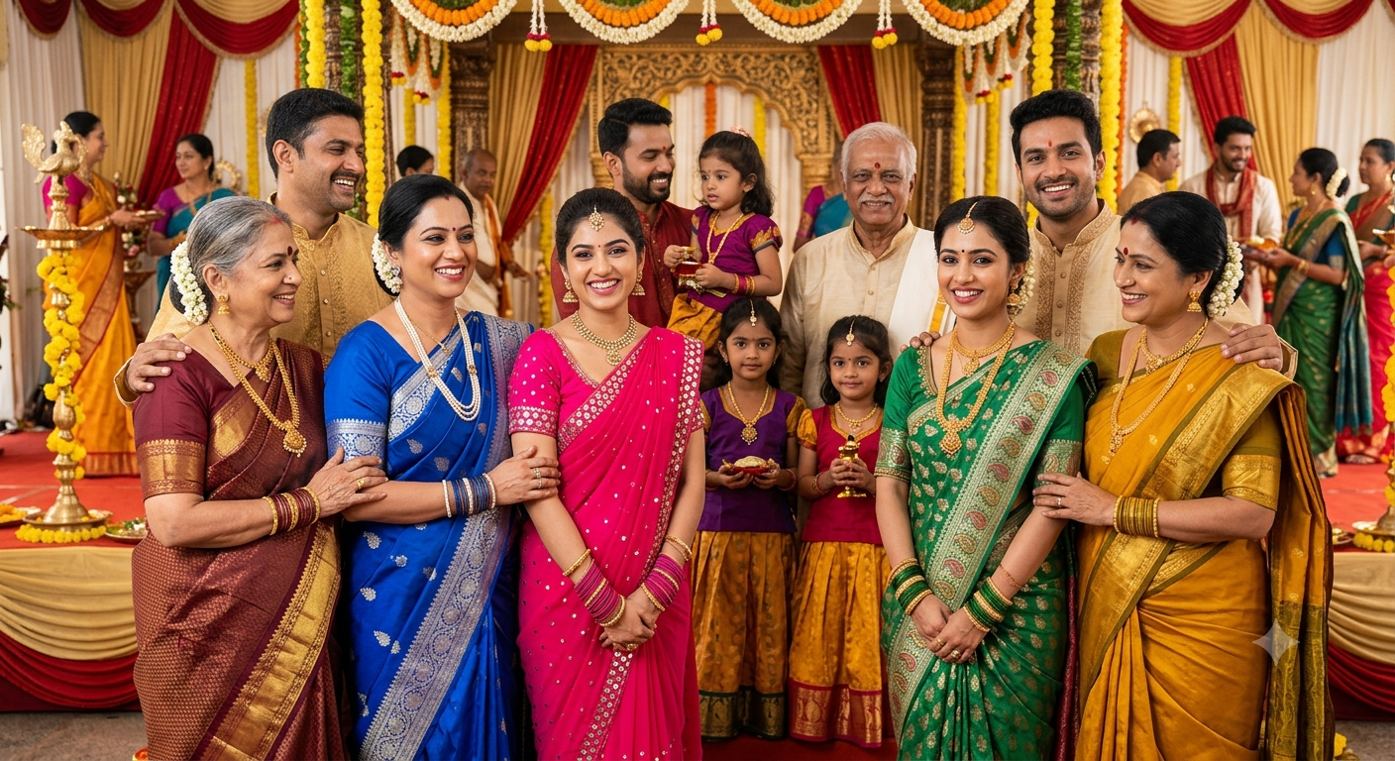
Prompt:generate the image that friends are tarveling in the flight
