Chalets and Caviar Documentation

In this document, you will find a set of simple instructions and steps to follow for the administration and edition of your website. Each chalet in this site is, easily displayed for the user’s comfort, as a post, making it easy for your clients to quickly access the endless possibilities your company offers. The chalets are divided in two sets: For rent and for sale.

If you are reading this document, you have been invited by email to be a page’s administrator or editor. Once you accept the invitation that gives you the abilities to add, edit or delete the pages or posts of your website.

The **site** is accessible at the following **address**: **dev-chalets-and-caviar-luxury-chalets.pantheonsite.io**. Just copy and paste this address in your browser to get there.

**Access the administration interface:**

In the address bar of your browser, add '**/admin**' or ‘**/editor**’ after the address of the site.

Example: **http://dev-chalets-and-caviar-luxury-chalets.pantheonsite.io/admin**

This will take you to the login page for administration access, as shown below

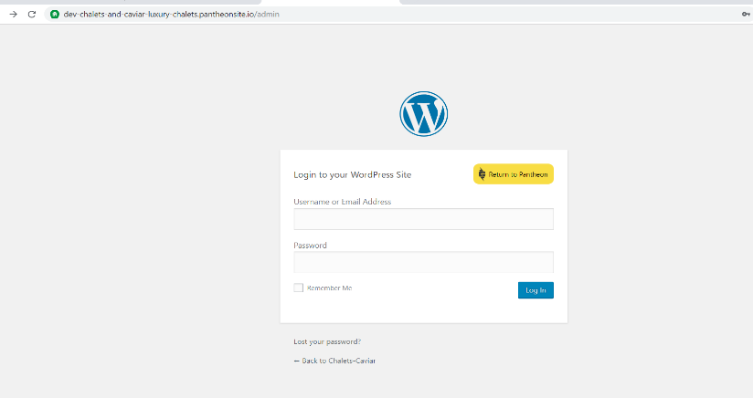

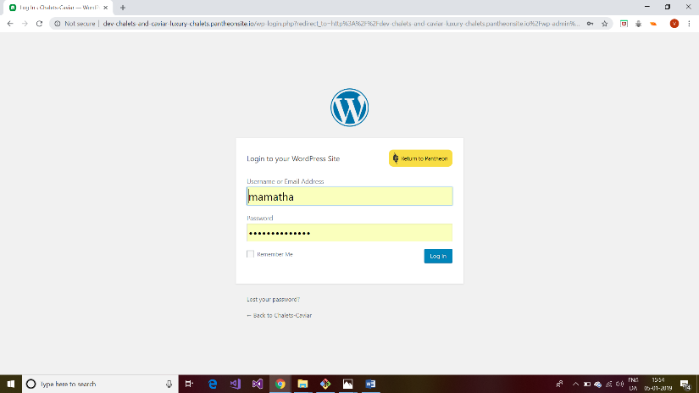

Enter your **username** and **password** (you have received them in your mail)and click on ‘**login'.**

Once you click on login, you will see a screen as below. At the top of the site there is a toolbar. Put the cursor of your mouse on 'Chalets and Caviar’

then click on' **Dashboard** 'in the menu that appears

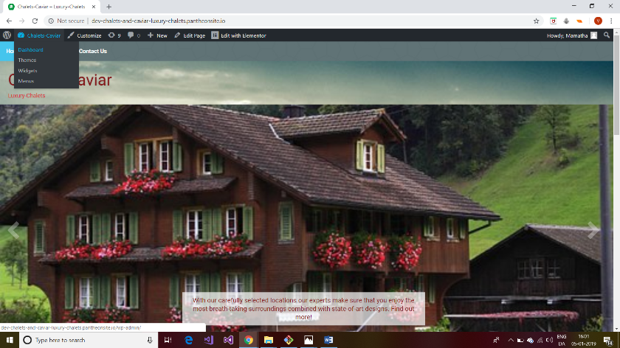

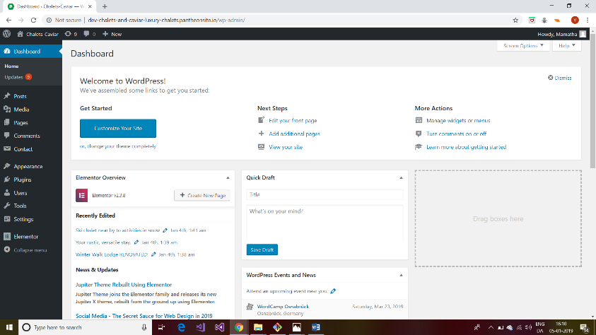

Once you click on dashboard it will take you to a new window, it is the place where you have the permission to add, delete and modify the layout. (as shown above)

**Creating a new page to the site:**

You can easily edit the pages of your site. This is useful for changing the text that appears or the layout of the elements of each page.

In the left-hand menu, **click on 'Pages'**.

Here you can see the pages **like**: **Home, Buy (and its child pages for each chalet), Rent (and its child pages for each chalet) and Contact us**.

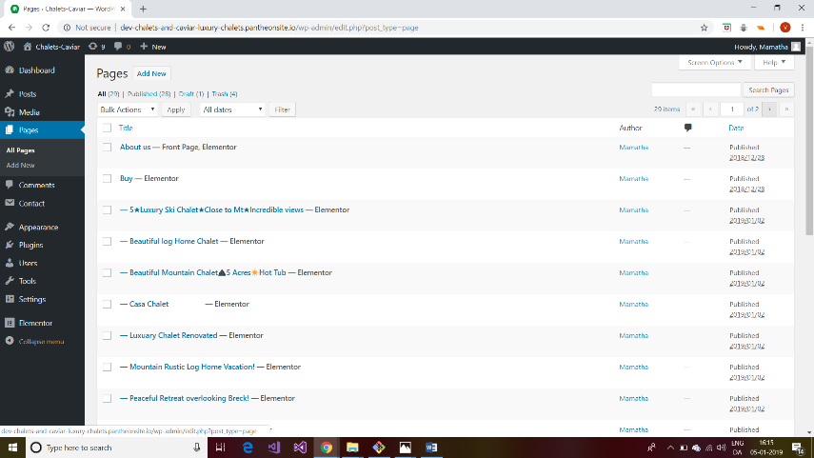

**Adding details page (child page) to your chalet**

In the **left-hand menu** click on **Pages**>**Add New or** Click on the **'Add New'** button at the **top of the page.**

In the new open window **add title** of the page and in the right-hand menu (lower right corner) **select the parent page>buy/rent** (i.e. for which category you want to want to add i.e. **Buy or sell.** And click on **publish** button.

Now click on **edit with elementor** in the page this will take you to elmentor page like below

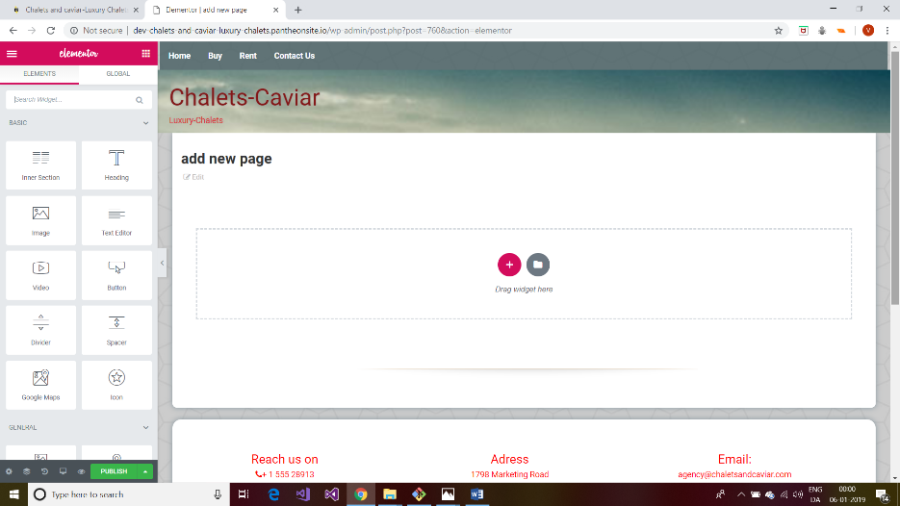

On left hand menu there are elementor widget like images, text editor…. now **drag and drop** **image gallery** into the box on your right-hand. Once you have image gallery widget you can see that menu for that widget on the left hand. Now click on **add the images** on the left-hand menu so that you can **select some images from the gallery** and click on **create gallery>insert gallery respectively** (you can also change image size>medium and no. of columns of the image gallery)

Similarly drag and drop **text editor** where you can add **some description of the chalet** like price, amenities and details of chalet in left-hand menu (delete lorem content and write your description)

Now drag and drop a **button widget** and in left hand menu set the properties of button as **text: back**, **alignment: centre** and in **link:** give the link to buy /rent page (parent page or collection of all chalets) i.e. **http://dev-chalets-and-caviar-luxury-chalets.pantheonsite.io/buy/** (for buy) or **http://dev-chalets-and-caviar-luxury-chalets.pantheonsite.io/rent/** (for rent)

Click on style in the menu and change **text color: black** and **background-color** of button to **dark yellow**

if you are done click on **publish** on left hand menu.

Note: go to pages>click on name of the page you have created just before and in the right-hand menu you can see a link in “preview “copy the address link so that we will use that in our next step.

**Adding a header image to your Chalet(buy/sell)**

Go to **dashboard** select **pages** >**buy /rent** you can see several links under the name. click on **edit with elementor** here you can add a header Image for your chalet

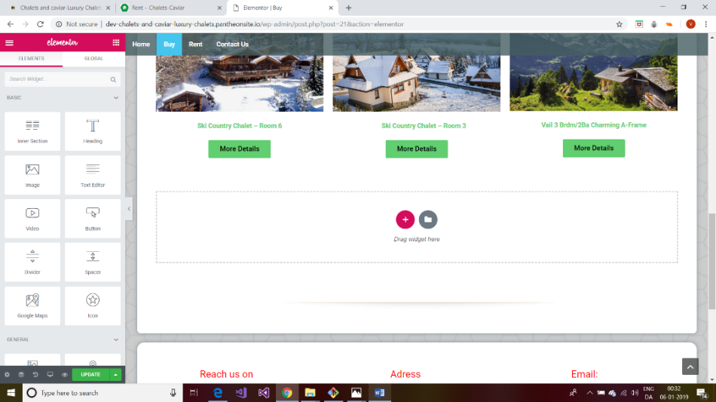

On left hand menu there are elementor widget, drag and drop inner section and add **image** widget (into +symbol)and click on **choose image**, now select an image from the gallery and click **on insert image** and select image size >large, in link to> give the path of your page created just before and click **on update**

similarly add **text box** and **butto**n give same name of page in text box and to button give text as **Read More** and link it to the page as we did before, and click on update button

Go back to your site and in buy/rent page check that if we click on the new page header image it should connect to new page what you have created before.

So now you have successfully created new page.

**To have column sidebars in your new child page**

To have aside bar in your page go to **dashboard>appearances>theme side bar** you have a screen shown as below

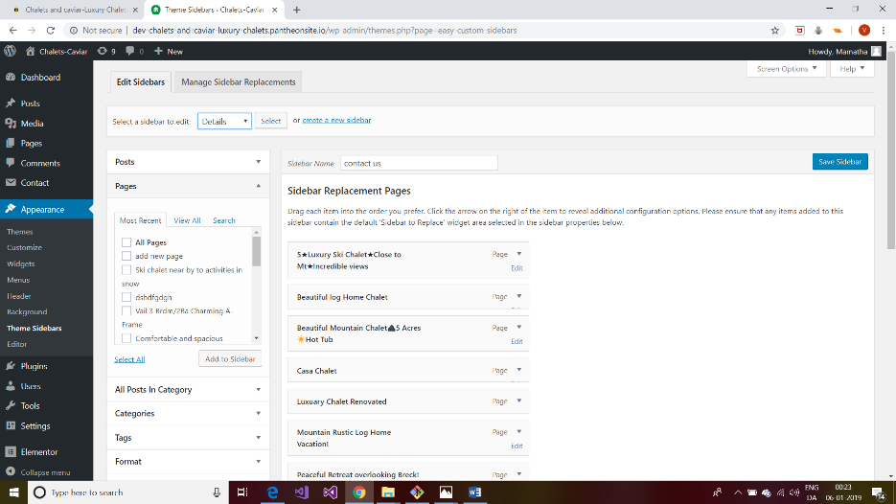

On left-hand top you can select a sidebar to edit: here select **contact us** if u have added a page **for buy** or select **Details** if added **for rent.**

and in **pages section** select the name of the page you created and click on **add to sidebar** and click on save sidebar. Go to your site and check for that page.

your new page is ready with header image and content with side bar in it.

**Modifying the chalets**

**Click** on the **name of the chalet** you wish to modify.

You can easily modify the chalet using the **edit with elementor** that displays under the chalet name.

When you have finished modifying your chalet, click on the '**Update**' button to the left of the elementor.

**Deleting the chalets from the site**

Place your mouse cursor on the name of the Chalet you wish to remove, a link in red: **Trash**. Click on it to move the chalet to the trash.

 At the very top of the page, under the 'Add' button there is **a trash link** (only if you have moved at least one chalet to the trash). Click on it to see the chalet you moved there.

Place the cursor of your mouse on the name of a chalet then click on the red link **'Permanently delete'** to completely remove the cottage from your site.

For further any queries write to me: mamathavangala1@gmail.com