**Chalets and Caviar Documentation**

In this document, you will find a set of simple instructions and steps to follow for the administration and edition of your website. Each chalet in this site is, easily displayed for the user’s comfort, as a post; making it easy for your clients to quickly access the endless possibilities your company offers. The chalets are divided in two sets: For rent and for sale. If you are reading this document, you have been invited by email to be a page’s administrator or editor. Once you accept the invitation that gives you the abilities to add, edit or delete the pages or posts of your website.

The **site** is accessible at the following **address**: **dev-chalets-and-caviar-luxury- chalets.pantheonsite.io** . Just copy and paste this address in your browser to get there.

**Access the administration interface:**

In the address bar of your browser, add ' **/admin**' or ‘ **/editor** ’ after the address of the site. Example: **http://dev-chalets-and-caviar-luxury-chalets.pantheonsite.io/admin**

This will take you to the login page for administration access, as shown below

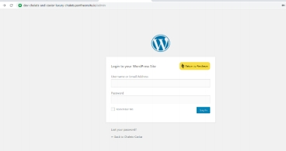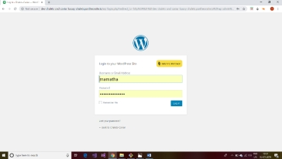

Enter your **username** and **password** (u have received them in your mail) and click on ‘**login'.**

Once u click on login, you will see a screen as below. At the top of the site is a toolbar. In this one, put the cursor of your mouse on 'Chalets and

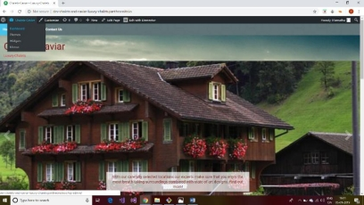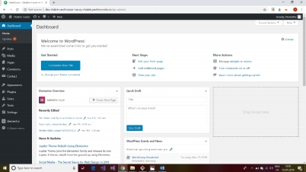

Caviar 'then click on' **Dashboard** 'in the menu that appears

Once you click on dashboard it will take u to a new window, it is the place which give you to permission to add, delete and modify the layout.

**Creating a new page to the site:**

You can easily edit the pages of your site. This is useful for changing the text that appears or the

layout of the elements of each page.

In the left-hand menu, **click on 'Pages'**.

So you can see the pages **like**: **Home, Buy (and its child pages for each chalet), Rent (and its child pages for each chalet) and Contact us**.

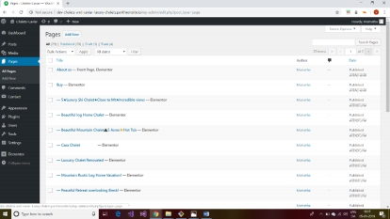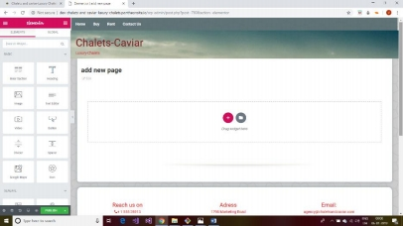

**Adding New Chalet to site**

In the **left-hand menu** click on **Add New or** Click on the **'Add New'** button at the **top of the page.**

In the new open window **add title** of the page(new) and in the right-hand side lower bottom **select the parent page** (i.e. for which category you want to want to add i.e. **Buy or sell.** And click on publish button.

Now click on **edit with elementor** in the page this will take you to elmentor page like below

On left hand side there are elementor widget like images, text editor…. now drag and drop image gallery and click on add the images so that u can select some images from the gallery and click on create gallery>insert gallery respectively.

Now you can drag and drop text editor where you can add some description of the chalet like price, animities and details of chalet

Once if you are done click on publish on left hand side corner.

Note: copy the page path and save some where because we must link this path to header image of page in next step