**FOLLOWING ARE THE RESULTS FROM OUR PROJECT:**

**Note:** Instead of proposed plan of using 4000 size of dataset, we used dataset of size 575 due to time constraint and unavailability of resources.

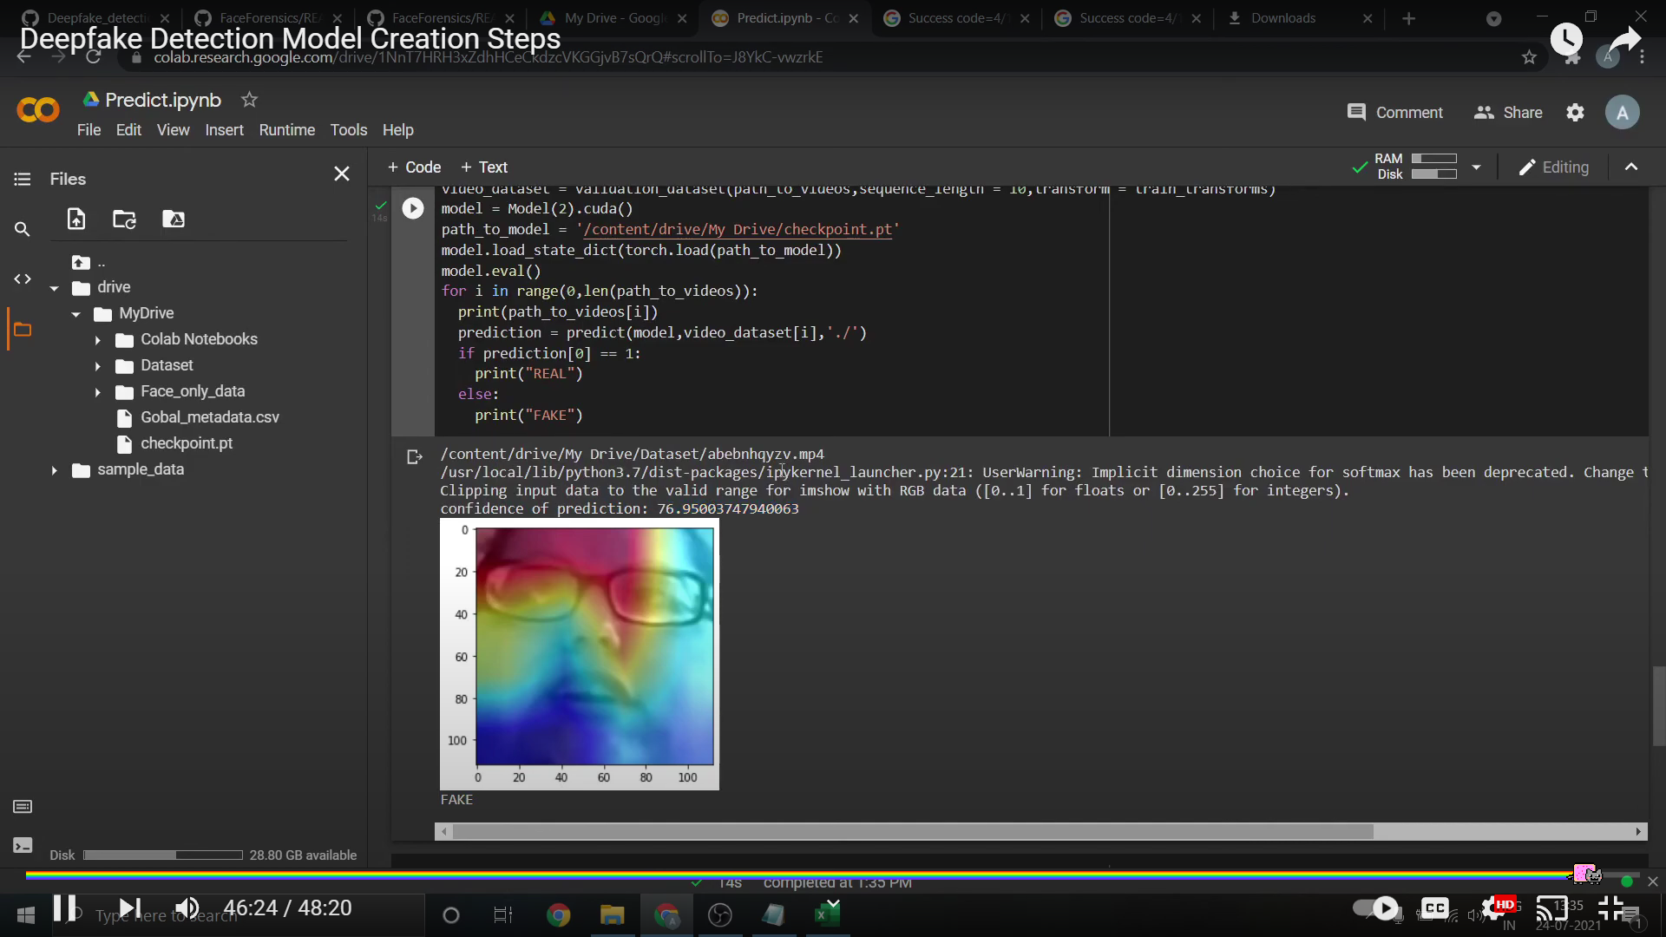

**Fig1:** Preprocessed image from the new raw dataset after extracting frames from the video.

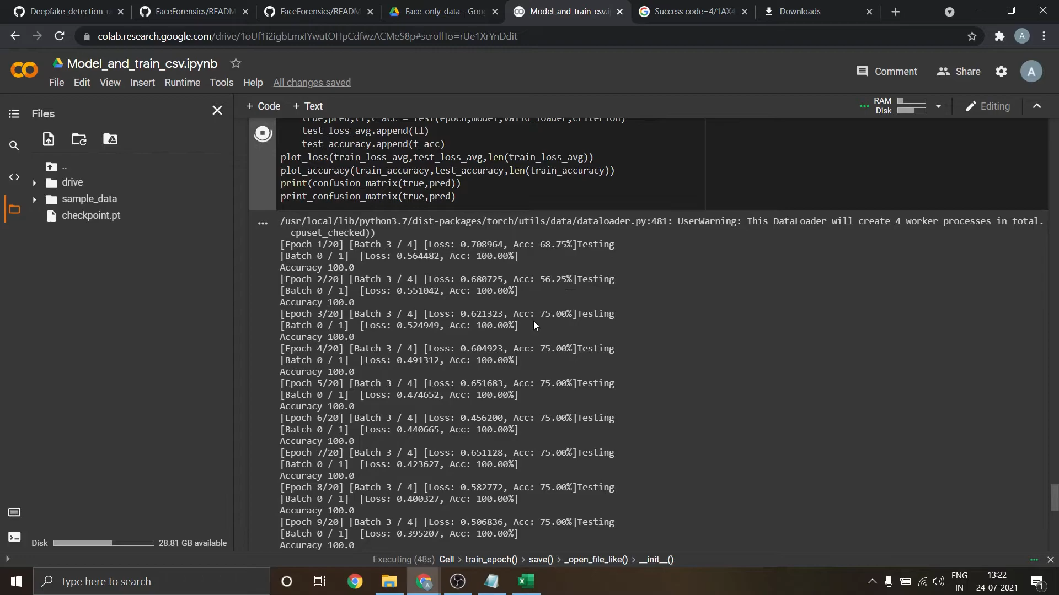

**Fig2:** Obtained Accuracy of our tested model, while adjusting different sequence length for constant accuracy. (Due to less training dataset, we got unbalanced accuracy where it is showing different accuracy.)

**VISUALISATION:**

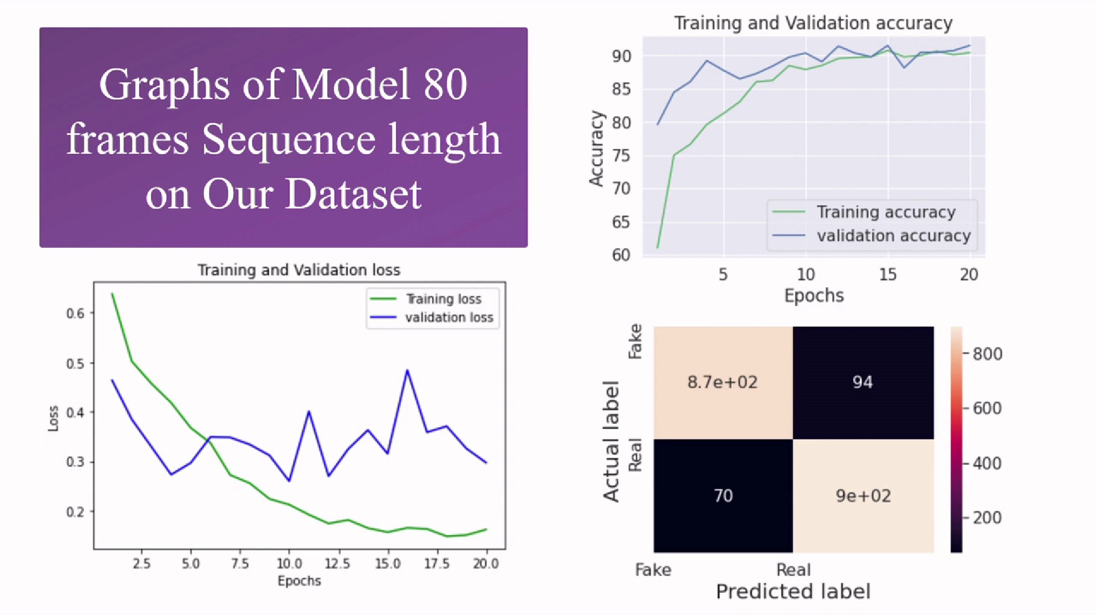

**Fig3 showing confusion matrix Fig4 Training loss vs. Validation loss**



**Fig5 Training accuracy vs. Validation accuracy**

**TABLE1** showing the accuracy difference of FaceForensic++ and Our Dataset

| **DATASET** | **NO. OF VIDEOS** | **SEQUENCE LENGTH** | **ACCURACY** |
| --- | --- | --- | --- |
| FaceForensic++ | 2000 | 20 | 90.95477 |
| Our Dataset | 586 | 20 | 87.79160 |
| Our Dataset | 586 | 10 | 84.21461 |
| Our Dataset | 586 | 40 | 89.34681 |
| Our Dataset | 586 | 60 | 89.98345 |