1. What is the result of the following code?

console.log(true && false);

* 1. true
  2. false
  3. undefined
  4. null

1. What does the following code output?

* console.log(false || true);
  1. true
  2. false
  3. undefined
  4. null

1. What is the value of result?

* const result = !true;  
  console.log(result);
  1. true
  2. false
  3. undefined
  4. null

1. What will be logged to the console?

* console.log(10 > 5 && 3 < 4);
  1. true
  2. false
  3. undefined
  4. null

1. What will the following code output?

* console.log(5 === 5 || 5 > 10);
  1. true
  2. false
  3. undefined
  4. null

1. What is the result of this code?

* const x = false;  
  const y = true;  
  console.log(x && y || !x);
  1. true
  2. false
  3. undefined
  4. null

1. What does this code evaluate to?

* console.log(!!(5 > 3));
  1. true
  2. false
  3. undefined
  4. null

1. What will result be?

* const result = false || 0 || "hello";  
  console.log(result);
  1. false
  2. 0
  3. "hello"
  4. undefined

1. What will the following code return?

* console.log(null && "JavaScript");
  1. null
  2. "JavaScript"
  3. true
  4. false

1. What does this code output?  
   console.log(true || false && false);
   1. true
   2. false
   3. undefined
   4. null
2. What is the result of the following expression?  
   console.log(!("hello" && 0));
   1. true
   2. false
   3. null
   4. undefined
3. What will be logged?  
   console.log(10 || 0 && 5);
   1. 10
   2. 0
   3. 5
   4. false
4. What will result be?  
   const result = "abc" && "def" || "";

console.log(result);

* 1. "abc"
  2. "def"
  3. ""
  4. undefined

1. What does this code evaluate to?  
   console.log(3 > 2 && 2 > 4);
   1. true
   2. false
   3. undefined
   4. null
2. What will the following code return?  
   console.log(false || NaN || undefined);
   1. false
   2. NaN
   3. undefined
   4. null

**#scenario-based questions**

### 1. Eligibility Check

Write a condition to check if a student is eligible for a scholarship. The criteria are:  
- The student’s grade is A or B.  
- The student’s attendance is above 75%.  
Use a ternary operator to assign "Eligible" or "Not Eligible" to a variable.

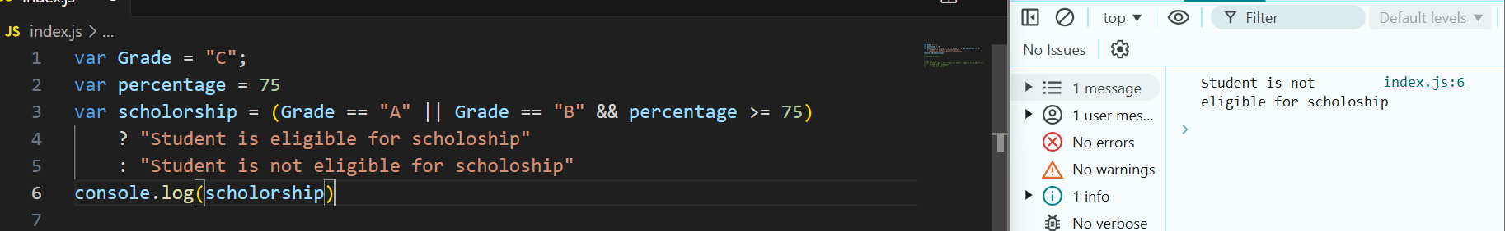

### 2. Age Group Classification

Classify a person based on their age:  
- If the age is less than 13, they are a “Child”.  
- If the age is between 13 and 19 (inclusive), they are a “Teenager”.  
- Otherwise, they are an “Adult”.  
Use nested ternary operators to determine the classification.

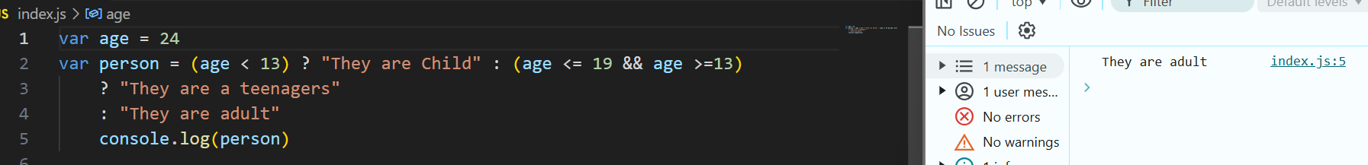

### 3. Login Status

Check the login status of a user. A user is considered logged in if:  
- isLoggedIn is true.  
- Their session is active (sessionActive is true).  
Use a ternary operator to log "Welcome Back" if the user is logged in and "Please Log In" otherwise.

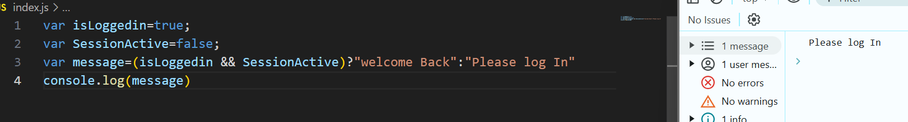



### 4. Grade Evaluation

Assign a letter grade based on a student’s score:  
- Scores 90 and above: "A".  
- Scores between 80 and 89: "B".  
- Scores between 70 and 79: "C".  
- Scores below 70: "Fail".  
Use nested ternary operators to determine the grade.

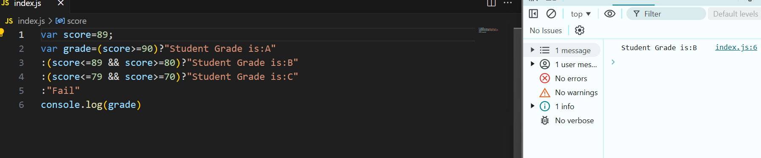

### 5. Product Discount Validation

Determine the discount for a product based on the following criteria:  
- If the product price is greater than $100, the discount is 20%.  
- Otherwise, the discount is 10%.  
Use a ternary operator to set the discount percentage.

