2.9 A common measure of transmission for digital data is the baud rate, defined as symbols (bits in our case) per second. As a minimum, transmission is accomplished in packets consisting of a start bit, a byte (8 bits) of information, and a stop bit. Using these facts, answer the following:

(a) \* How many seconds would it take to transmit a sequence of 500 images of size 1024 × 1024 pixels with 256 intensity levels using a 3 M-baud (106 bits/sec) baud modem? (This is a representative medium speed for a DSL (Digital Subscriber Line) residential line.

(b) What would the time be using a 30 G-baud (109 bits/sec) modem? (This is a representative medium speed for a commercial line.)

(a)

Per pixel with 256intensity levels means that per pixel has one byte of information.

And one pixel should transform in one packets.So one pixel in packets is 1+8+1=10bits.

The whole information of images is 500\*1024\*1024\*10=5.24288e9bits

It needs 5.24288e9/3e6=1.7476e3=1747.6seconds

(b)5.24288e9/30e9=1.75seconds

2.14 Consider the two image subsets, S1 and S2 in the following figure. With reference to Section 2.5, and assuming that V = {1}, determine whether these two subsets are:

(a) \* 4-adjacent.

(b) 8-adjacent.

(c) m-adjacent.

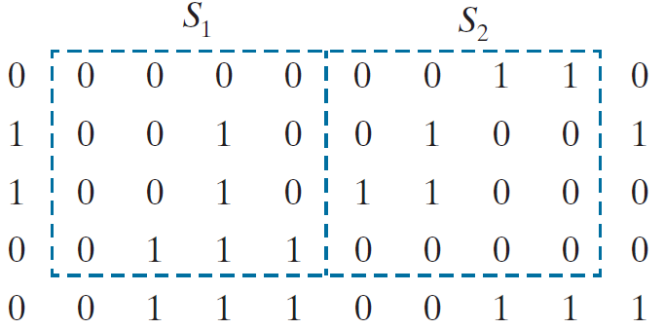

1. :none
2. 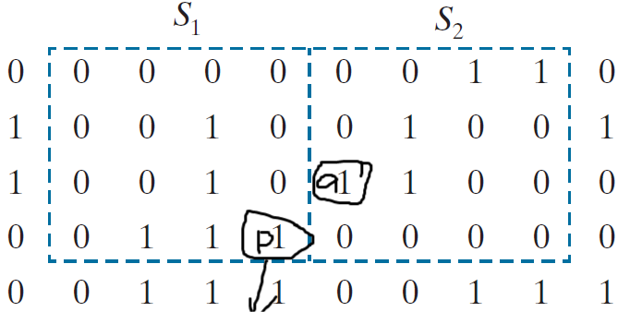

I have marked two points p and q .In the two subsets only these two points(p and q) are 8-adjacent.

1. The same points in(b) ,only the two points(p and q) are m-adjacent.

2.18 Consider the image segment shown in the figure that follows.

(a) \* As in Section 2.5, let V = {0,1} be the set of intensity values used to define adjacency. Compute the lengths of the shortest 4-, 8-, and m-path between p and q in the following image. If a particular path does not exist between these two points, explain why.

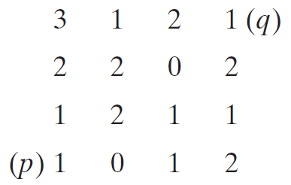

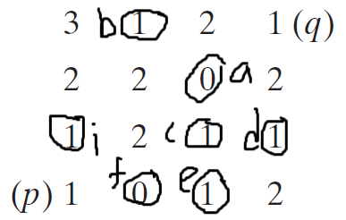

I have marked these points

If we want to find a path from p to q .the pionts in the path must be adjacent with q since V={0,1}

It is easy to say that only piont a is 8-adjacent and m-adjacent with q.

So it dose not exist a 4-path from p to q

The shortest 8-path can be p->f->e->c->a->q or p->f->e->d->a->q

The shortest lengths of 8-path is 5

The shortest 8-path can be p->f->e->c->a->q

The shortest lengths of 8-path is 5