In the 4h version.

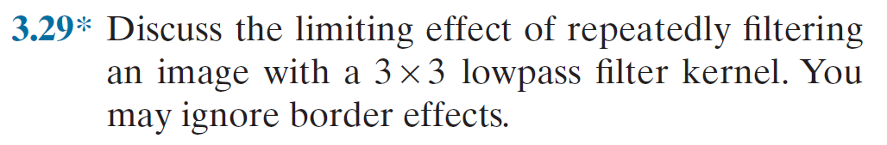

The 3\*3 lowpass filter is a process of average the grey level of pixel around the center point and around points.by repeatedly using ,the average effect will be significantly effective,which means the detal of image become less. The grey level between two adjacent points become numerical proximity.

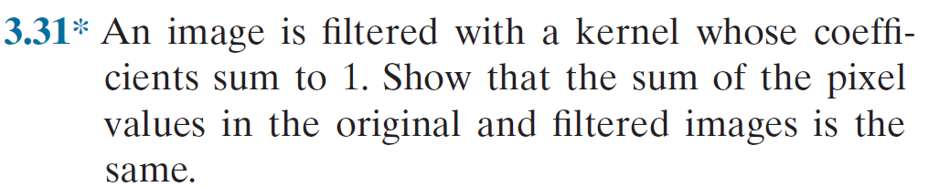

Suppose g(x,y) is the grey level of the image after filter,and h(x,y) is the grry level of initial image. And the size of kernel is a. the kernel is {b11,b12......b1a......baa} that b11+b12+b13+...baa=1.

g(x,y) =b11\*h(x-(a-1)/2,y-(a-1)/2)+b12\*h(x-(a-1)/2+1,y-(a-1)/2)+.......

g(x-1,y)=b11\*h(x-(a-1)/2-1,y-(a-1)/2)+b12\*h(x-(a-1)/2,y-(a-1)/2)+.......

The sum of g(x,y) is the sum of pixel values in the filtered images

=b11\*h(x-(a-1)/2,y-(a-1)/2)+b12\*h(x-(a-1)/2+1,y-(a-1)/2)+.......

+b11\*h(x-(a-1)/2-1,y-(a-1)/2)+b12\*h(x-(a-1)/2,y-(a-1)/2)+.......

=(b11+b12+b13+.....baa)\*the sum of h(x,y)

=the sum of h(x,y)

That because g(x,y) is devoted by h(x,y),every h(x,y) point devoted differently in g(x,y)

And {b11,b12......b1a......baa}is the Linear combination coefficient,one point g(x,y) is devoted in g(x,y) by {b11,b12......b1a......baa}through different points in the filtered image ,the whole values in the original image is become the whole values in the filtered image by this way.

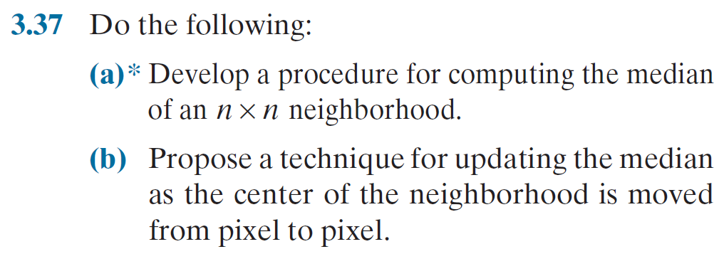

(a)

Wrtie by C++

Let h(x0,y0) is the top left corner grey level.

Int pix[n\*n];

for (int i=0;i<n;i++)

{

for (int j=0;j<n;j++)

{

pix[i\*n+j]=h(x0+i,y+j);

}

}

for (int i=0;i<n\*n;i++)

{

for (int j=0;j<n\*n-i;j++)

{

If (pix[j]>pix[j+1])

{

int temp=pix[j];

pix[j]=pix[j+1];

pix[j+1]=temp;

}

}

}

cout<<pix[int(n\*n/2)]<<endl;

(b)

delete the values in the trailing edge of the neighborhood and insert the values in the leading edge in the appropriate locations in the sorted array.

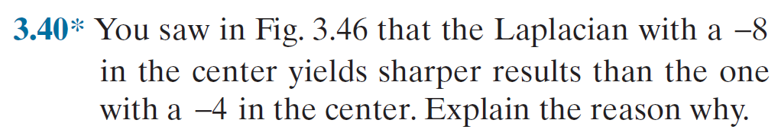

a-8 has considered eight directions of change around the center point ,but a-4 only four

So a-8 can detected more edge information from more directions than a-4.

So the sharpen effect a-8 is better than a-4.