In the 4h version.

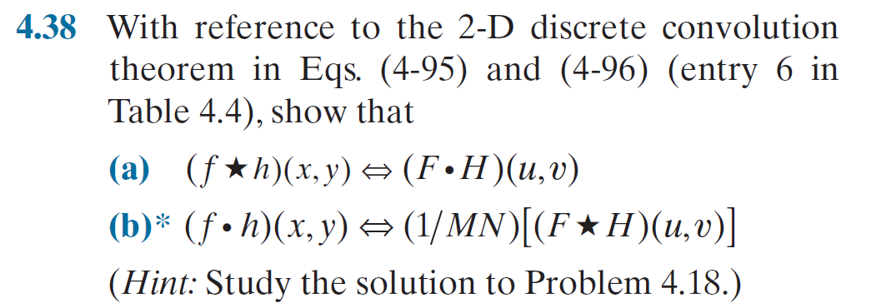

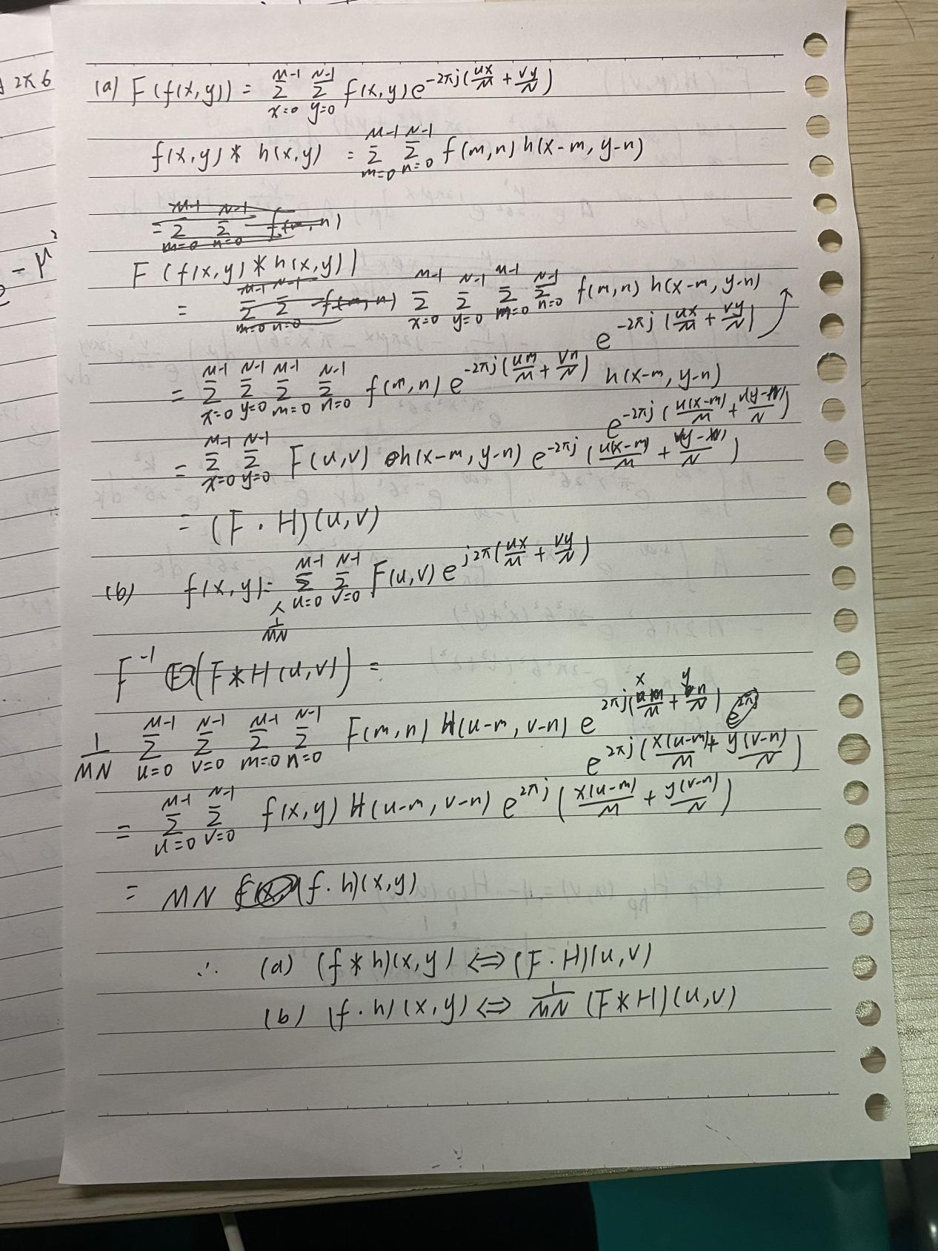

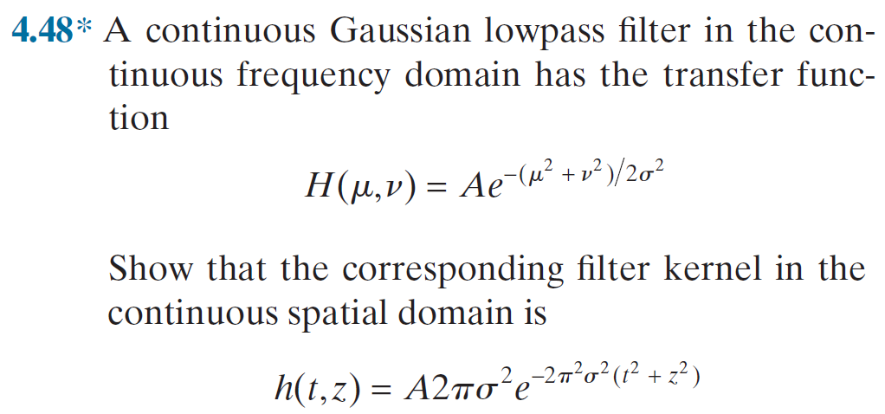

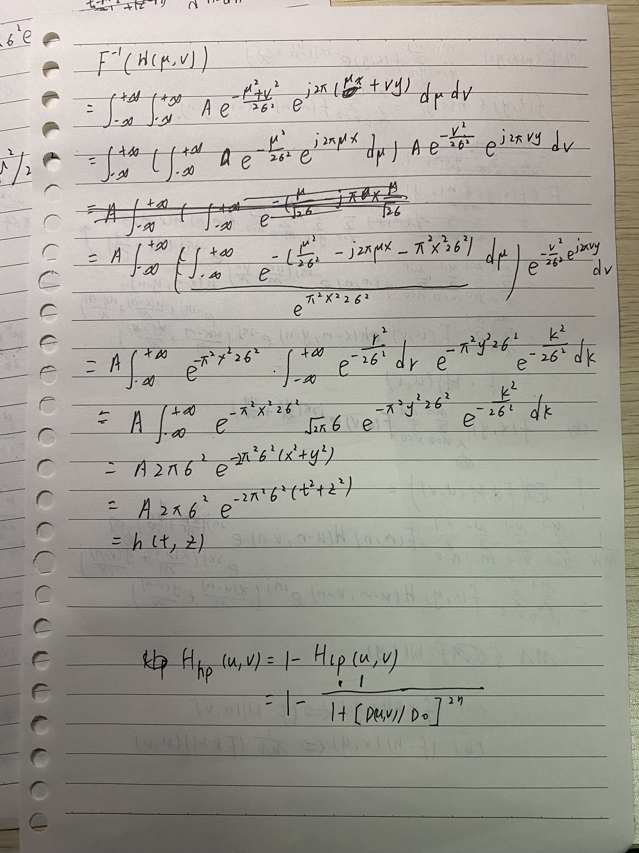

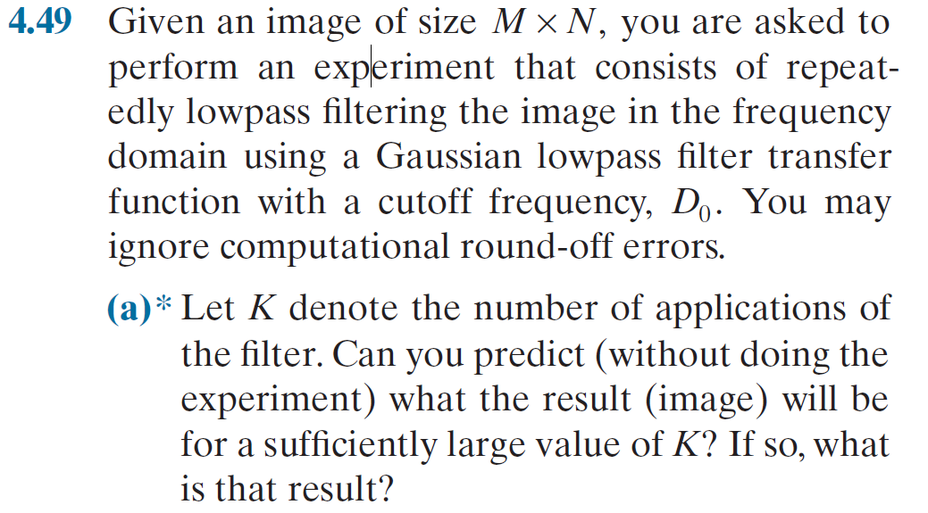

The whole process will show a notch filter features.

Because every time using Gaussian filter ,it will restrain every points in frequency domain except

F(M/2,N/2), it shows F(u,v)\*G(u,v),in every point ,and G(u,v)<1 ,when u!=M/2||v!=N/2

Through a K times Gaussian low pass filter ,F(u,v) in frequency domain will become

F’(u,v).

That F’(u,v)=F(u,v)\*r^K ,r<1 ,when u!=M/2||v!=N/2

r=1,when u==M/2&&v==N/2

when K is very large r^K=0,when r<1

r^K=1,when r=1.

So after K times application of Gaussian low pass filter ,it show a notch filter features

That in frequency domain ,only F(M/2,N/2) have value ,it is like an impulse.

Which means the information is all lost

The average value of the result image is the same as the original image.

But there is no any information left ,in a word every pixel is the same,is the average grey level of the original image.

