**6.4 \*** In an automated assembly application, three types of parts are to be color-coded to simplify detection. However, only a monochrome TV camera is available to acquire digital images. Propose a technique for using this camera to detect the three different colors.

Use different filters that can response to different colors.the filter produce high response when the color input is expected. If want to choose rgb,can use filters that produce high response when the color input is r or g or b.

**6.5** The R, G, and B component images of an RGB image have the horizontal intensity profiles shown in the following diagram. What color would a person see in the middle column of this image?

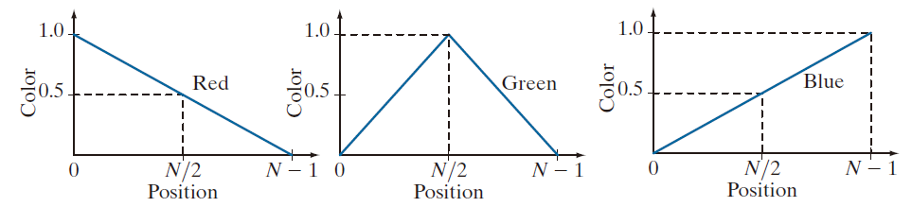

The color of the middle column of this image is

0.5*red+green+0.5*blue=midgrey+0.5*green.

If a person see in the middle column of this image ,the viewer like green with a impulse in intensity because the add of midgrey.

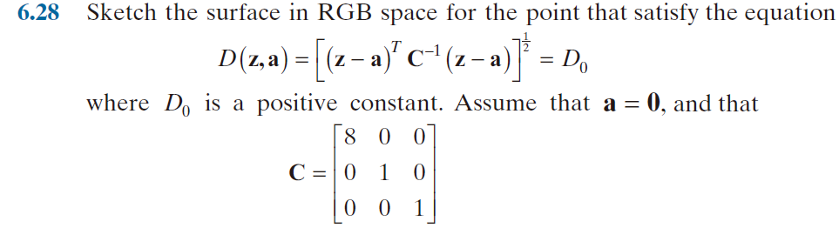

It means sqrt(r*r*8+g*g+b*b)

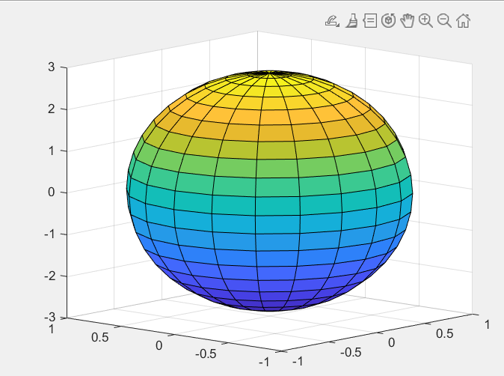

That z axis represent red ,and x , y represent green and blue;