Event Booking System

Laravel-Based Web Application Project

Submitted by:  
Wilson Manik / 001202400199  
  
Course: Server Side Internet Programming  
Date: May 2025

# 1. Database Tables Overview and ERD

This system consists of three primary tables: users, events, and bookings.

## users Table

|  |  |  |
| --- | --- | --- |
| Column | Type | Description |
| id | int | Primary Key |
| name | string | User's full name |
| email | string | Unique email address |
| password | string | Encrypted password |
| role | string | User role: admin or user |
| timestamps | timestamps | Created/updated timestamps |

## events Table

|  |  |  |
| --- | --- | --- |
| Column | Type | Description |
| id | int | Primary Key |
| title | string | Event title |
| description | text | Details of the event |
| location | string | Event location |
| date | date | Date of event |
| time | time | Time of event |
| capacity | int | Maximum allowed participants |
| timestamps | timestamps | Created/updated timestamps |

## bookings Table

|  |  |  |
| --- | --- | --- |
| Column | Type | Description |
| id | int | Primary Key |
| user_id | foreign key | References users.id |
| event_id | foreign key | References events.id |
| timestamps | timestamps | Created/updated timestamps |

# Entity Relationship Diagram

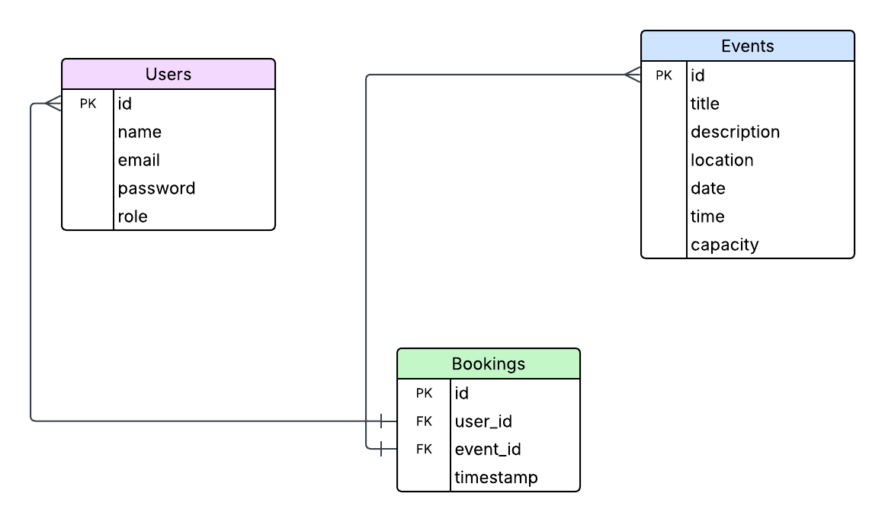

# 2. Application Flow Overview

The application uses role-based logic:  
- Guests can register and log in.  
- Users can view and book events, and manage their own bookings.  
- Admins can create and manage events, and view all bookings.  
  
Flow:  
Guest → Register/Login → Dashboard → View Events → Book Event → Confirm → My Bookings  
Admin → Login → Dashboard → Manage Events & Bookings

# 3. CRUD Operation Mapping

|  |  |  |  |  |
| --- | --- | --- | --- | --- |
| Entity | Create | Read | Update | Delete |
| Users | Register Form / Seeder | Auth System | Optional | Optional |
| Events | Admin: /events/create | /events (List) | /events/{id}/edit | Admin: /events/{id} |
| Bookings | /bookings/create | /bookings (List) | — | /bookings/{id} |

# 4. Important Views & Their Purpose

|  |  |
| --- | --- |
| View File | Description |
| home.blade.php | Landing page for guests |
| dashboard.blade.php | User/admin dashboard |
| events/index.blade.php | Admin's event list |
| events/create.blade.php | Form to create event |
| events/edit.blade.php | Edit existing event |
| bookings/index.blade.php | User or admin bookings list |
| bookings/create.blade.php | Event booking form with confirmation |
| auth/login.blade.php | User login page |
| auth/register.blade.php | User registration page |
| logout.blade.php | Logout success message |

# 5. Security Highlights

- Middleware: 'auth' and custom 'check.admin' protect routes  
- Re-authentication: Booking requires entering password again  
- Validation on all form inputs  
- Role-based redirection and access control

# 6. Technology Stack

|  |  |
| --- | --- |
| Layer | Technology |
| Backend | Laravel (PHP) |
| Frontend | Blade, Bootstrap 5 |
| Database | MySQL |
| Auth System | Laravel's built-in Auth |
| UI Enhancements | Flatpickr, Bootstrap Icons |