EduPredict AI: System Workflow & Data Flow Diagrams
This document outlines the step-by-step workflow of the EduPredict AI system and provides explanations for the Data Flow Diagrams (DFD) to help you explain the architecture to your supervisor.

1. System Workflow Overview
When an educator interacts with the EduPredict system, the data moves through a seamless pipeline from the frontend to the machine learning backend and into the database.
- Data Input: The Educator interacts with the Vue.js Frontend, either by filling out a form for a single student or uploading a .csv file for batch processing.
- API Routing: The frontend transmits the raw data via RESTful API requests to the FastAPI Backend (endpoints: /predict or /predict/batch).
- Data Preprocessing: The backend receives the data and immediately processes it using the saved scikit-learn artifacts (Scalers and Encoders) to ensure the data matches the format the model was trained on.
- Machine Learning Inference: The processed features are fed into the trained algorithm (best_model.pkl). The model outputs a categorical prediction: Excellent, Average, or At-Risk.
- Explainability Engine: Simultaneously, an intervention engine analyzes the raw input (e.g., Attendance < 60%) to generate human-readable explanations and intervention suggestions.
- Data Persistence: The original inputs and the model's prediction are saved to the SQLite Database (students.db) for historical tracking and future dashboard analytics.
- Result Delivery: The backend sends the prediction, probabilities, and explanations back to the frontend.
- Visualization: The Vue.js dashboard instantly updates, rendering the results visually via dynamic charts and statistical cards.

2. System Architecture Flowchart

3. Data Flow Diagrams (DFD)
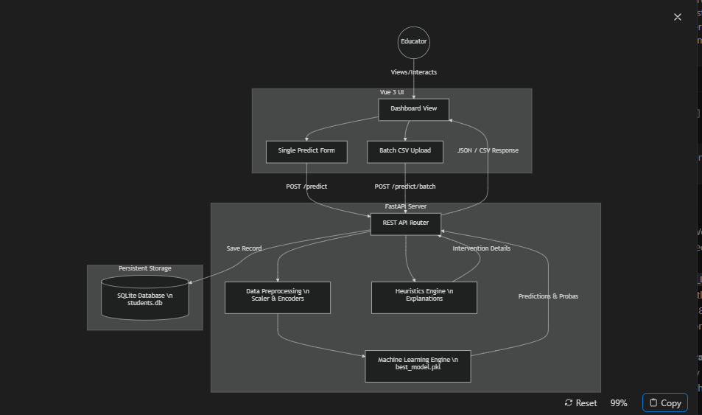

Level 0 DFD (Context Diagram)
The Context Diagram provides a high-level view of the entire system as a single process interacting with external entities.
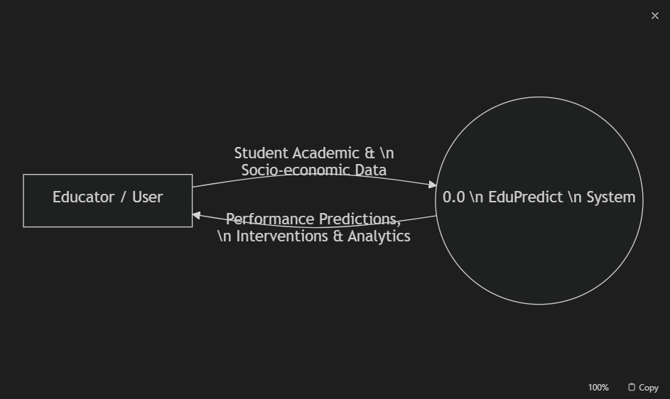
Level 1 DFD
The Level 1 DFD breaks down the main system into its primary sub-processes and data stores.
