NPU - Assignment Report
Problem 1: 4-bit Round Robin Arbiter

Design idea
When several requesters want one shared resource, a fixed-priority arbiter would let req0 win every time and starve the others. A round robin arbiter fixes this by rotating the priority. The design keeps a 2-bit register ptr that names the requester with the highest priority right now. Priority then runs cyclically: ptr, ptr+1, ptr+2, ptr+3 (mod 4).
Starting at ptr, the logic scans the four request bits in that cyclic order and raises the grant of the first active one. A found flag blocks every later bit, so grant is always one-hot (or all zero when req = 0000). A grant is therefore never given to a non-requester and never to two requesters at once. On the rising clock edge, if a grant was issued to requester i, ptr <= i+1 (mod 4). The requester just served becomes the lowest priority and the next one in the circle becomes the highest. If nobody requests, ptr holds. Reset (active-low, asynchronous) sets ptr = 0. After any grant the winner drops to last place, so a waiting requester can be overtaken by at most the 3 other requesters. Its wait is bounded by 3 grants.
Waveforms
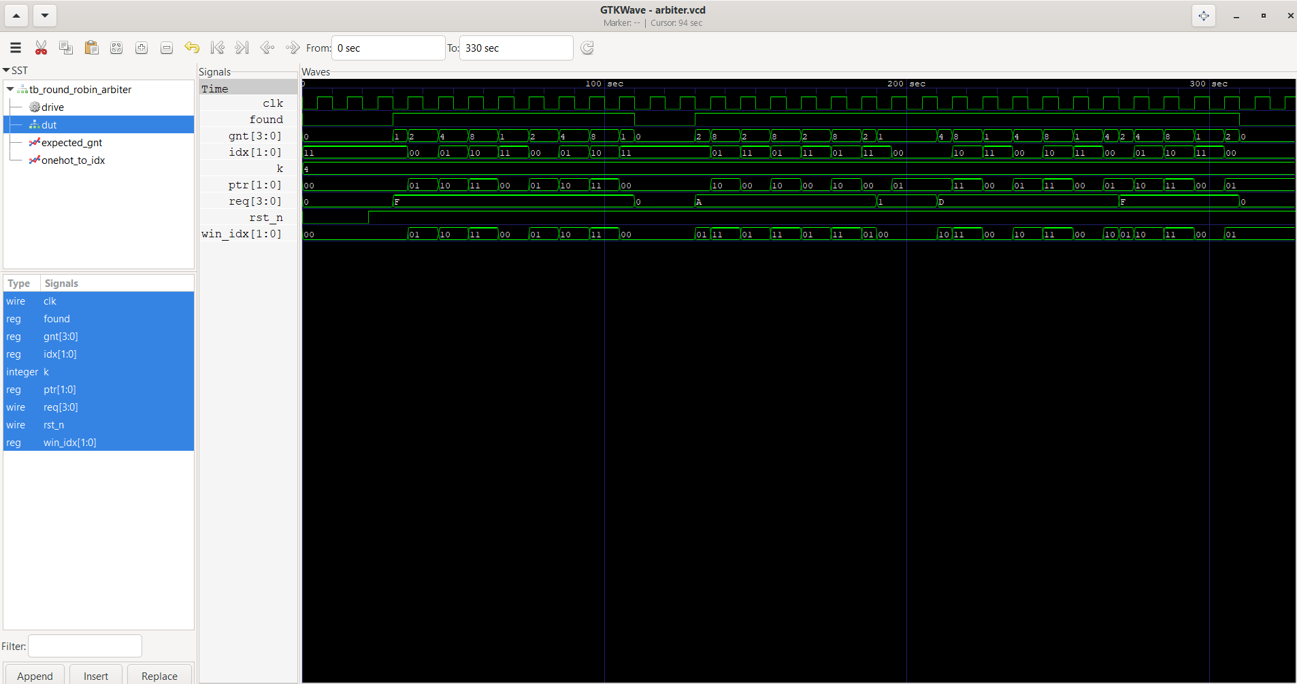

Phase 1 (cycles 1-8). All four request. ptr=0 so req0 wins and ptr becomes 1; then req1 wins (ptr 2), req2 wins (ptr 3), req3 wins (ptr 0), and the cycle repeats. Each requester gets exactly 2 of the 8 grants and only one grant bit is high in any cycle.
Phase 2 (9-10). req = 0000, so gnt = 0000 and ptr stays 0. The pointer only rotates after a successful grant.
Phase 3 (11-16). Only req1 and req3. With ptr=0 the scan 0-1-2-3 meets req1 first; ptr becomes 2, scan 2-3-0-1 meets req3 first; ptr becomes 0 again. They alternate 1,3,1,3 and neither starves.
Phase 4 (17-18). Only req0: it is served each time (ptr 0 then 1), so a lone requester is never blocked.
Phase 5 (19-24). req = 1101 (req1 silent). With ptr=1 the scan 1-2-3-0 skips the silent req1 and grants req2; ptr=3 grants req3; ptr=0 grants req0; the sequence 2,3,0 repeats, i.e. rotation among the active requesters only.
Phase 6 (25-30). All request again: ptr is 1 (left over from phase 5), so the order is 1,2,3,0. Fairness continues from wherever the pointer was; the idle cycles then hold ptr.
Priority update summary: next ptr = (index of granted requester + 1) mod 4, so the winner becomes the lowest-priority requester of the next round.

Problem 2 - Optimized Multiplier (n = 4)

Multiplier working
A plain 4x4 array multiplier needs many adders. The optimized version trades time for area: it uses a single 4-bit adder and reuses it for 4 clock cycles, one cycle per bit of the multiplier. This is the classic shift-and-add (sequential) algorithm.
M holds the multiplicand and never changes. Q holds the multiplier. A is the accumulator and starts at 0. C is the carry bit from the adder. The control sequencer counts the n cycles and decides, from the lowest bit of Q (q0), whether to add.
Each clock cycle: (1) look at q0. If q0=1 the MUX passes M to the adder, A+M is computed and written back to A with its carry in C. If q0=0 the MUX passes 0, so A is unchanged (no add). (2) Shift the combined register C-A-Q one place right: C moves into the MSB of A, the LSB of A moves into the MSB of Q, and the old q0 falls off. Q therefore consumes multiplier bits from the right while collecting the low half of the product on the left, so one 4-bit Q holds both.
After n=4 cycles the 8-bit product is {A,Q}: A is the upper half and Q the lower half.

Step-wise computation
Notation follows the handout: each cycle shows the state after the ADD (or no-add) and then after the SHIFT. C is the carry flip-flop.

(i) 1011 x 0111 (11 x 7 = 77)
M = 1011 (11), Q = 0111 (7)
Step | Operation | C | A | Q
init | load | 0 | 0000 | 0111
cycle 1 | Add (q0=1) | 0 | 1011 | 0111
 | Shift right | 0 | 0101 | 1011
cycle 2 | Add (q0=1) | 1 | 0000 | 1011
 | Shift right | 0 | 1000 | 0101
cycle 3 | Add (q0=1) | 1 | 0011 | 0101
 | Shift right | 0 | 1001 | 1010
cycle 4 | No add (q0=0) | 0 | 1001 | 1010
 | Shift right | 0 | 0100 | 1101
Final: A = 0100, Q = 1101 -> product = 01001101 = 77. Check: 11 x 7 = 77.
Multiplier 0111 read from the right gives q0 = 1,1,1,0. Cycles 1-3 add M (1011); cycle 4 only shifts. In cycle 2, 0101 + 1011 = 1 0000: the carry is shifted into A's MSB, giving 1000.

(ii) 0110 x 1001 (6 x 9 = 54)
M = 0110 (6), Q = 1001 (9)
Step | Operation | C | A | Q
init | load | 0 | 0000 | 1001
cycle 1 | Add (q0=1) | 0 | 0110 | 1001
 | Shift right | 0 | 0011 | 0100
cycle 2 | No add (q0=0) | 0 | 0011 | 0100
 | Shift right | 0 | 0001 | 1010
cycle 3 | No add (q0=0) | 0 | 0001 | 1010
 | Shift right | 0 | 0000 | 1101
cycle 4 | Add (q0=1) | 0 | 0110 | 1101
 | Shift right | 0 | 0011 | 0110
Final: A = 0011, Q = 0110 -> product = 00110110 = 54. Check: 6 x 9 = 54
Multiplier 1001 gives q0 = 1,0,0,1: add, no add, no add, add. In cycle 4 the accumulator is 0000, so 0000 + 0110 = 0110 with no carry; after the shift A = 0011 and Q = 0110, i.e. {A,Q} = 0011 0110 = 54.
Testbench plan and waveforms
The testbench applies a one-cycle start pulse, waits for done and compares the product with a*b. It first runs the two assignment examples (11x7 and 6x9) and the handout example (13x11) with a per-cycle register log, then an exhaustive regression of all 16 x 16 = 256 input pairs.
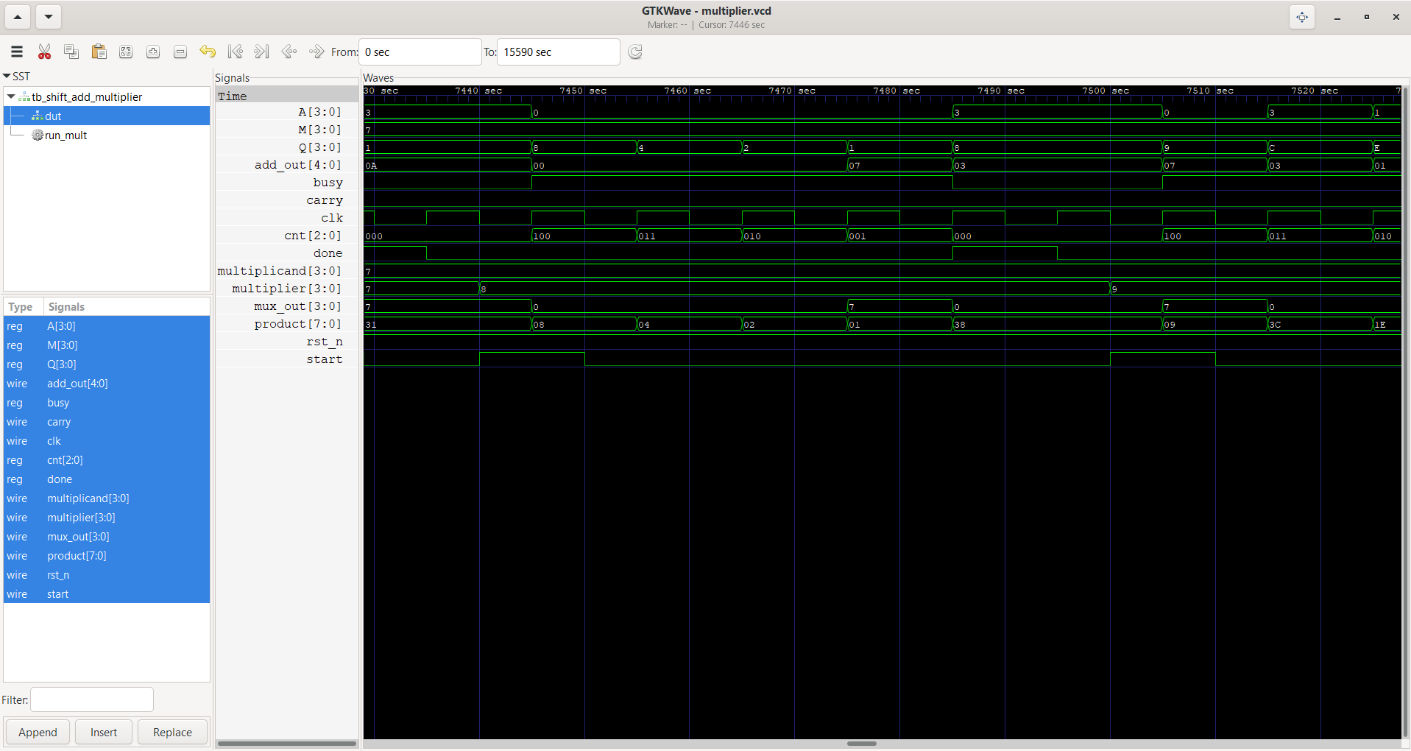

Justification that the waveforms are correct
The register values in the waveform at the start of each cycle equal the 'after shift' values of the previous row in the hand tables. For 11x7 the waveform shows A/Q = 0000/0111, 0101/1011, 1000/0101, 1001/1010 and finally 0100/1101 when done is high: 0100 1101 = 77. For 6x9 it shows 0000/1001, 0011/0100, 0001/1010, 0000/1101 and finally 0011/0110 = 54. The carry is high only where an add overflowed 4 bits (11x7: cycles 2 and 3; 6x9: never), and done pulses one clock after the fourth cycle with the product stable afterwards.
11 x 7
Slot | A | Q | q0 | carry | A,Q after edge
cycle 1 | 0000 | 0111 | 1 | 0 | 0101,1011
cycle 2 | 0101 | 1011 | 1 | 1 | 1000,0101
cycle 3 | 1000 | 0101 | 1 | 1 | 1001,1010
cycle 4 | 1001 | 1010 | 0 | 0 | 0100,1101
6 x 9
Slot | A | Q | q0 | carry | A,Q after edge
cycle 1 | 0000 | 1001 | 1 | 0 | 0011,0100
cycle 2 | 0011 | 0100 | 0 | 0 | 0001,1010
cycle 3 | 0001 | 1010 | 0 | 0 | 0000,1101
cycle 4 | 0000 | 1101 | 1 | 0 | 0011,0110

