XOOPS Documentation Series



**Repair Shop Module**

**Version 1.51**

**XOOPS 2.5.0**

© 2011 The XOOPS Project

[www.xoops.org](http://www.xoops.org)



# 



# REPAIR SHOP MODULE



# Auto Repair Service Management

This module was developed for use in an Auto Repair Service business.

It may, of course, be adapted to manage other businesses that include “after sales“ service.

It has been developed on XOOPS 2.4 and tested on XOOPS 2.5.

The goal was to develop a Web application for managing car repairs. It has two different areas: mechanical and bodywork, and can handle several workers in each area.

The module allows managing maintenance of the cars currently in the garage, follow up on current and completed repairs, and edit quotes and invoices.

## Detailed description

1. Admin area
   1. Customers
   2. Vehicles
   3. Suppliers
   4. Categories of spare parts
   5. Spare parts
   6. Package
   7. Brands
   8. Workers
   9. Documentation
   10. Trash
   11. Repair task
   12. Editions
   13. Preferences of the module
2. User area

# Administration

### New GUI Interface look

As explained by Mamba [here](http://xoops.org/modules/newbb/viewtopic.php?topic_id=73531&forum=75), Mage has created a new class for Module Administration GUI which provides a fresh and attractive admin interface, auto generated from data in the menu.php.

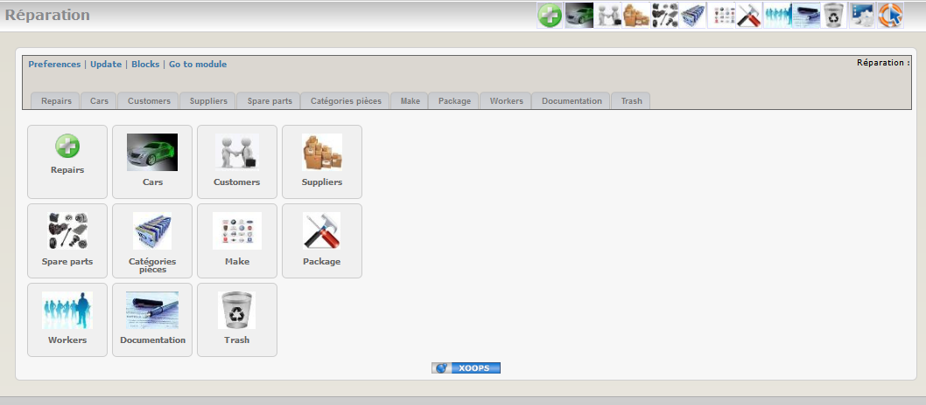

### Customers

You can save all customer information in the database. It’s of course useful for regular customers.

List of customer records :

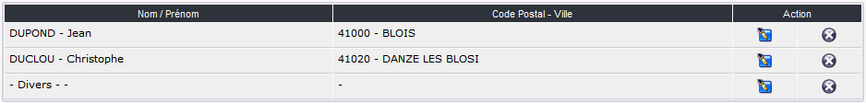

Form for adding a new customer:

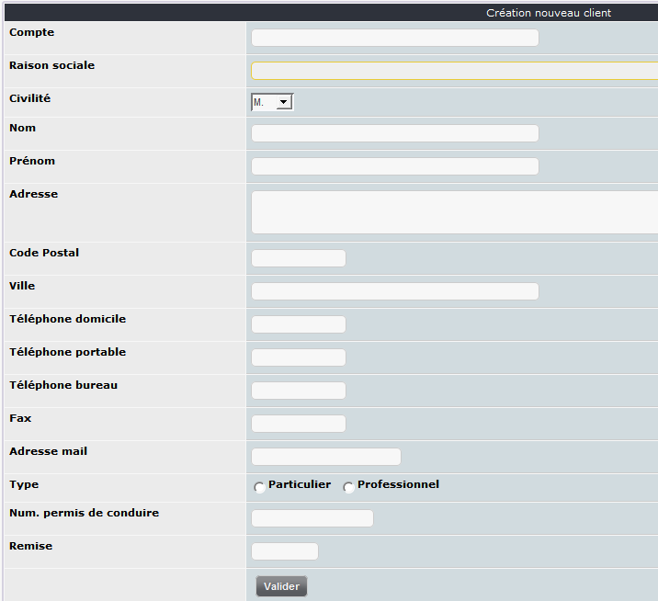

### Cars

This tab is dedicated to car maintenance management in the garage.

List of registered cars:



Form to add a new car:

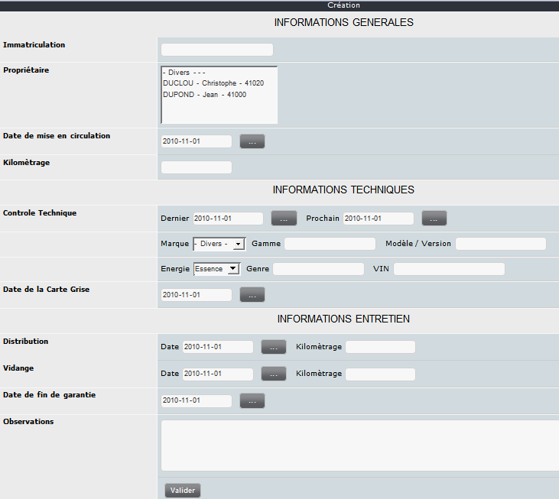

### Suppliers

Registered supplier list:



Form to add a new supplier:

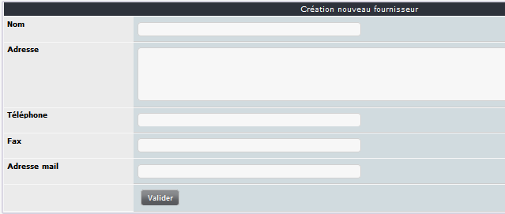

### Spare parts

As it’s possible to have many spare parts in the full list a small tab is available to show / hide the spare parts list.

Spare parts list:



Form to add a new spare part :

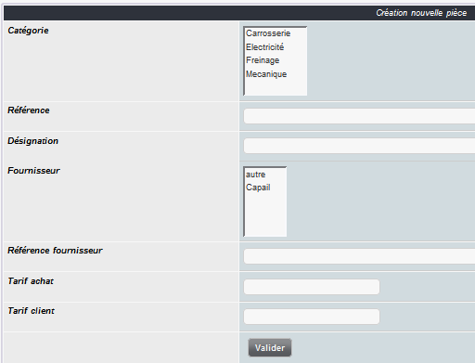

### Spare parts categories

Using categories allows sorting of the spare parts.

Category list:

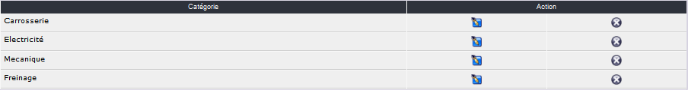

Form to add a new category:

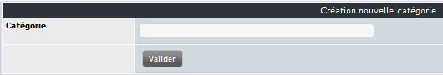

### Brands

Few brands are already included when you install the module. You can of course add other brands.

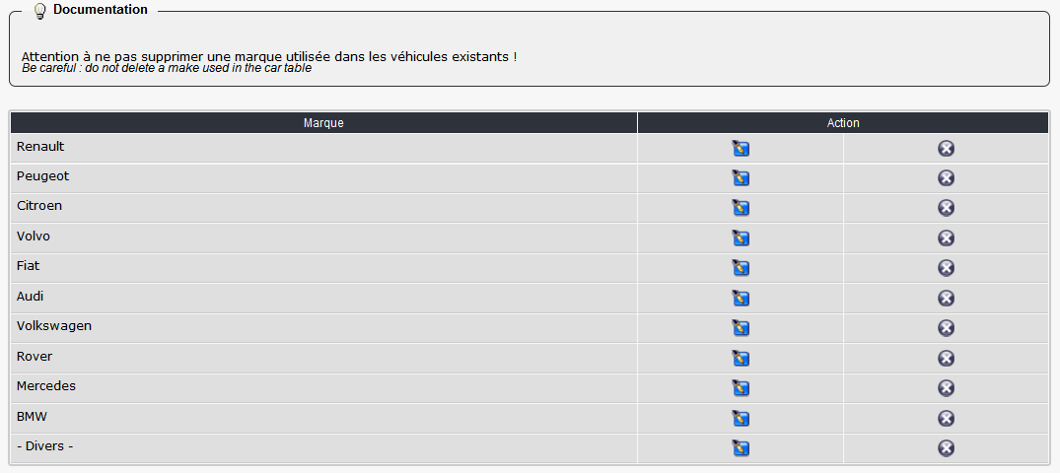

Form to add a new brand:

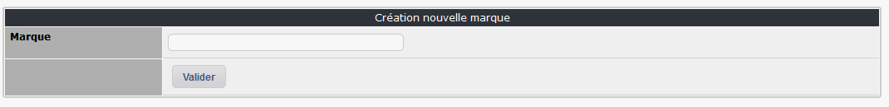

### Package

Package list:



Form to add a new package:

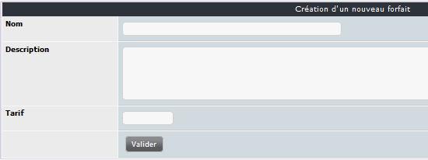

When you have submitted the first form a new one is shown which allows adding spare parts.

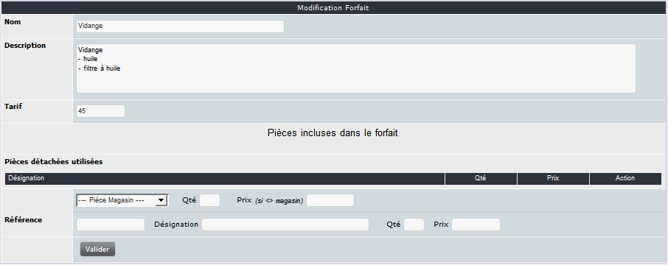

### Workers

List of available workers:

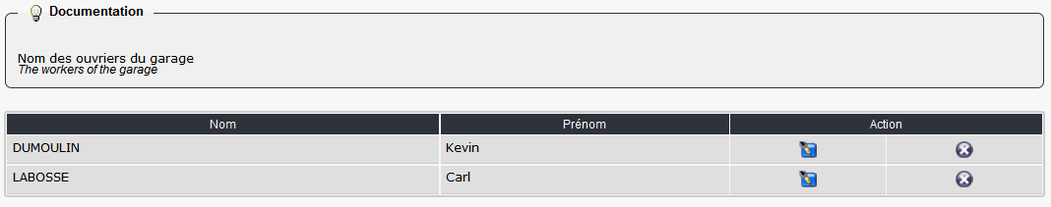

Form to add a new worker:

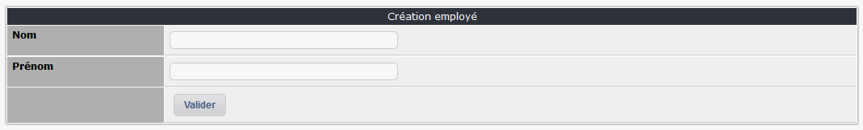

### Documentation

An integrated documentation system is available. It helps the administrator of the module by showing specific tips in each admin tabs.

You can of course update these tips by adding your own info. It can be useful when you use some tabs rarely and need a quick reminder about the functionality or if you delegate the admin of the module to a non-expert user.

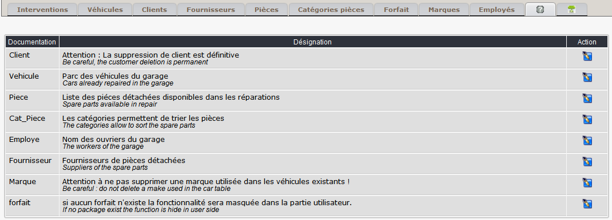

### Trash

A trash system is available to undelete a repair deleted by mistake ;-).

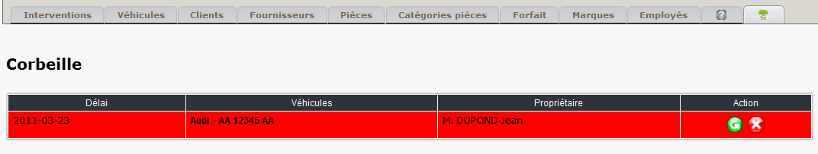

### Repair task

#### Logical process

You can add a new repair task both in admin area and in user side.

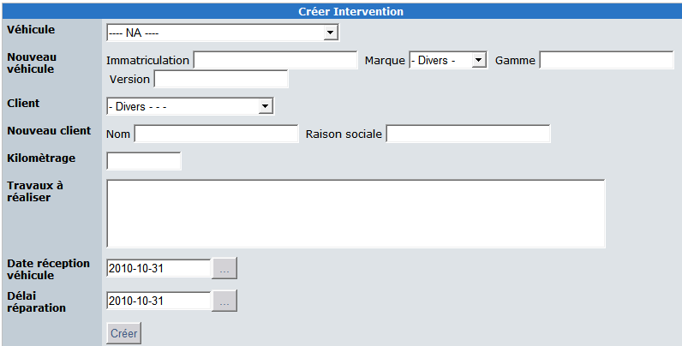

**Main data:**

The list of vehicles managed in the module is available in the first dropdown list.

You can, of course, add a new vehicle or a new customer directly in this form.

**Useful data:**

Kilometers/Miles, repair task to do are required to create a new repair task.

The arrival date and the due date are used to set priorities in the garage work.

Repair details are shown as follow in the user side:

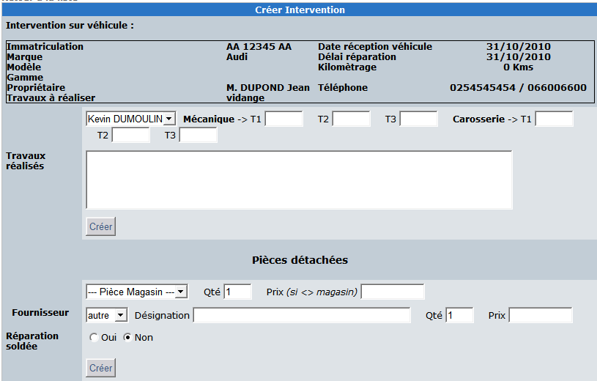

If at least one package is created by the admin a specific form is shown at the bottom of the screen:

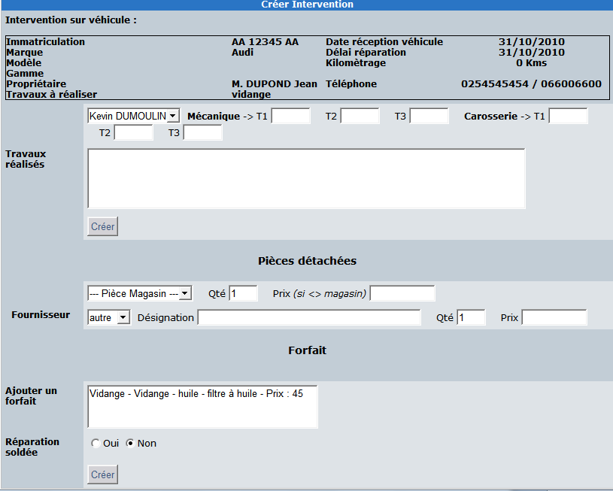

If an admin edit a repair task in the user side he can manage more data than a standard user.

He can add / delete some task :

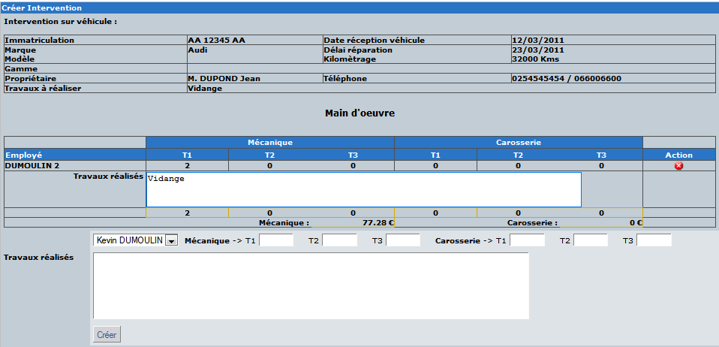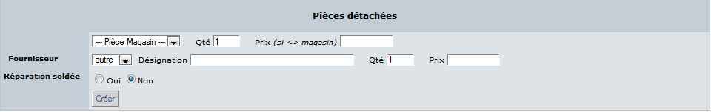

### Printing

The module can print quotation and invoices.

Some data as garage name can be managed in the preferences of the module.

**Quote**

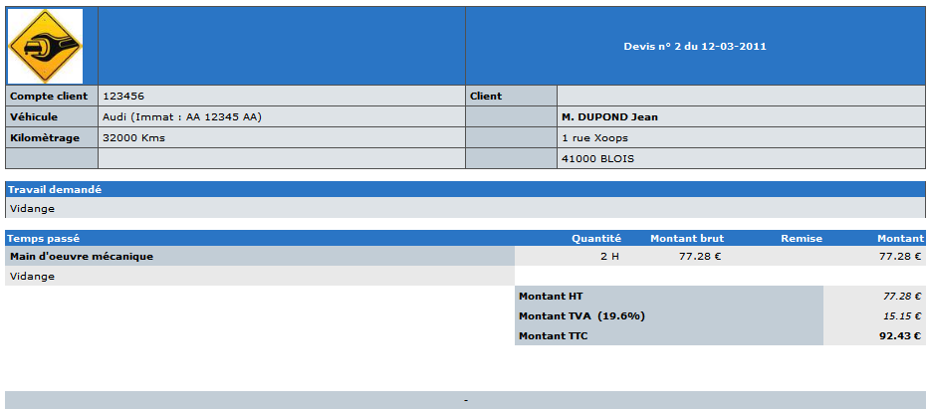

**Invoice**

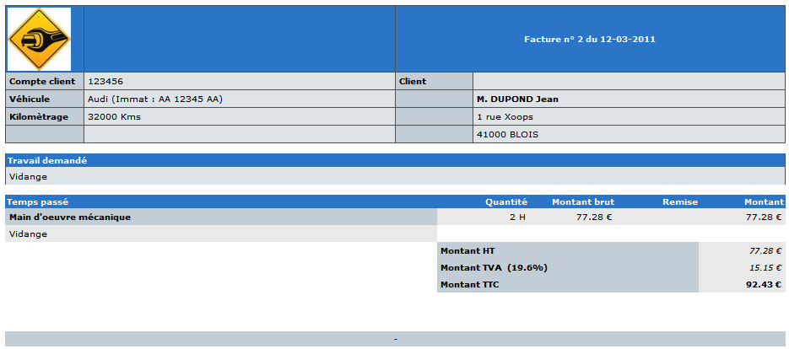

### Module preferences

You have many option to customize the module in the preferences.

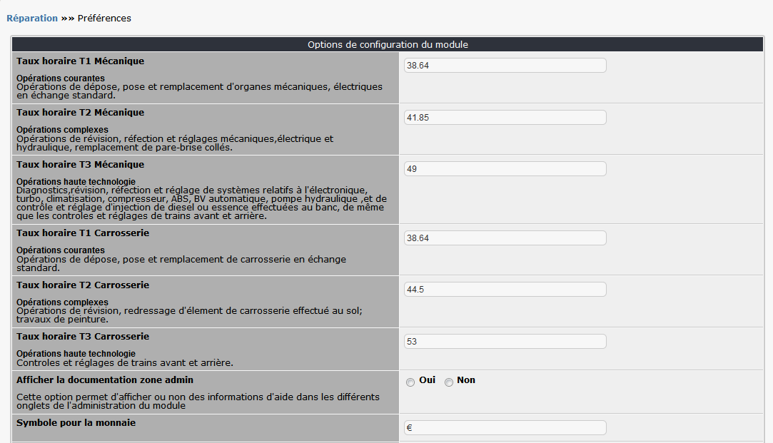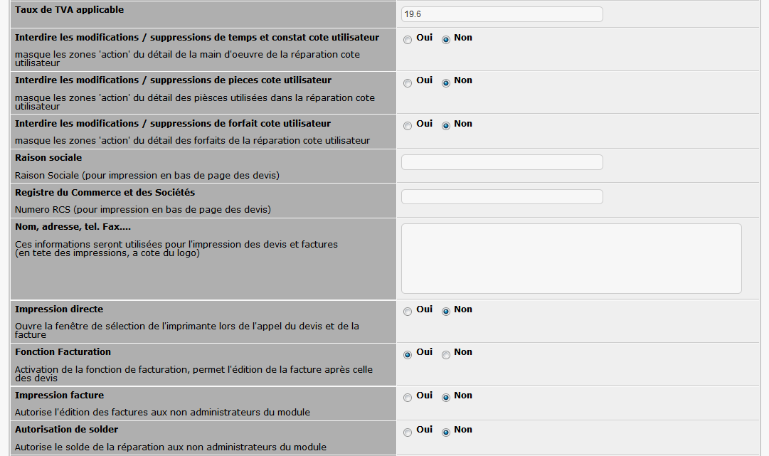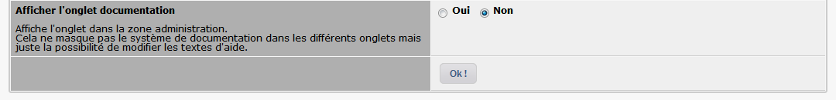

# User side

In the main menu you can choose repair task sorted by state.

3 states:

* **In progress**: the repair is created and not yet ended or not started. Of course it’s possible that you are just waiting the acceptation of the quote.
* **Ended**: the repair is terminated and the vehicle is given to the customer. The quote and the invoice have been printed.
* **Archived**: it’s necessary to store the history of the repair task so we keep the data in this area. I assume it’s a temporary solution and I’m working on this point for the next version of the module.

You can access to the repair in each state thru the main menu:

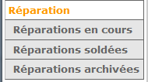

In the repair in progress it’s possible to create a new repair task, update a repair, print a quote or invoice.

If you have admin right you can access to the admin area with a clic on the key picture at the left top.

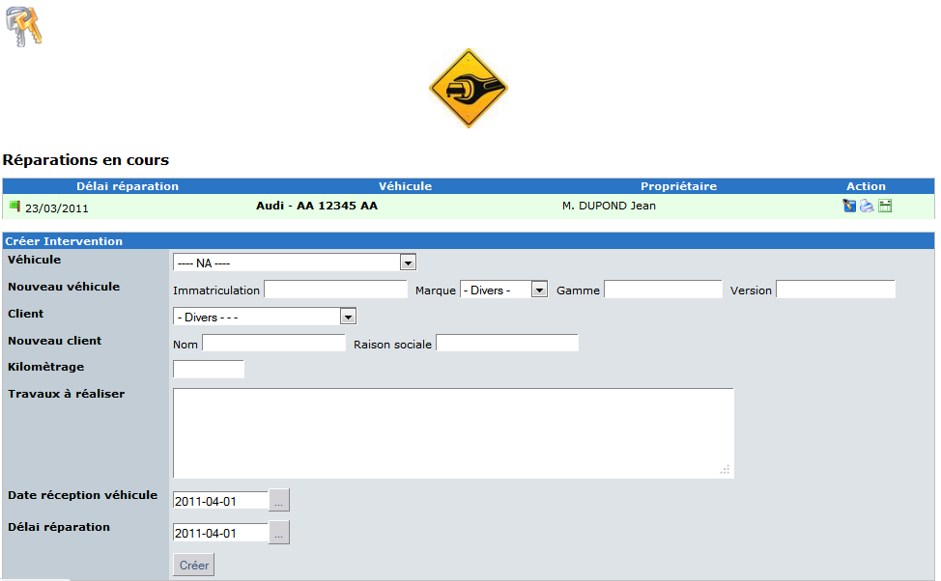

When all task are done for a repair you can « close » with the checkbox at the bottom of the modification form. (depending for the preferences. Always available for the admin and only for the user if allowed in the preferences module).

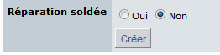

When the repair is closed you can archive it for keep it in history.

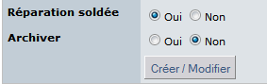

You can see repairs in each state area. A specific color prevent misunderstanding state.



Note: you always can print quote or invoice.



To improve the module, solve an issue, add a new feature or simply send me a comment, please send me an email at [masson.philippe@gmail.com](mailto:masson.philippe@gmail.com) or [philou@xoops.org](mailto:philou@xoops.org)