Inversion of Control

Dependency Injection

IoC container

context.xml to resource

ApplicationContext context = new ClassPathXmlApplicationContext("context.xml");

Robot robotT100 = (RobotT1000) context.getBean("robot");

@Component("legBean")

**public** **class** Leg

Aop

Aspect

Advice

Join Point

Pointcut

46 - Spring. Подключение CSS

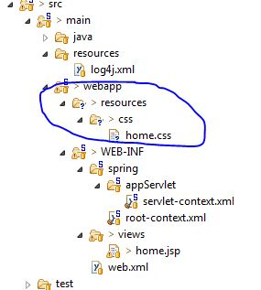

<head>

<link href=*"*<c:url value=*"/resources/css/home.css"* />*"* rel=*"stylesheet"*>

<title>Home</title>

</head>