Introduction

Purpose of this document
The State Electricity Board was finding it tough to deal with the billing process of their domestic consumers. Validating the consumer number, making a note of the respective units consumed, calculating the bill amount based on the units consumed, and other processes were done manually which was very time consuming. So, the Electricity Board decides to out source the billing process of their domestic consumers to Global Tek Software Company. Help the Global Tek to automate the above task.
The Electricity Board has the following business processes that must be automated.
- Parse data and generate a bill for all the customer
- Store the ElectricityBill of each customer

Project Overview
This project captures the various concepts, techniques and skills learn and helps to put them into practice using Java with JDBC. Admittedly, this would be at a scaled-down level since the purpose is to let the associate experience the various concepts learned in Java as an individual. The individual associate is expected to carry out the knock out challange and complete it within 4 hours.

Scope
The scope of the system is explained through its following modules
- Parse data and generate a bill for all the customer
- Store the ElectricityBill of each customer

Target Audience
Learner Level

Software Requirement
# | Item | Specification/Version
1. | Java | 8 and above
2. | MYSQL | 8.1

Functional Requirements

Functional Requirements
Req. # | Req. Name | Req. Description | Actors / Users | Comments
1 | Parse data and generate bill for all the customer | The units consumed and the other details of the customer are stored in a flat file. Retrieve the data from the file and generate a bill for each customer based on the units consumed | Admin | The admin of the electricity board is reponsible for parsing the data and generating the bill for all the customers
2 | Store the ElectricityBill of each customer | After generating the bill the electricity board will store the ElectricityBill of each customer in a database. | Admin | The admin of the electricity board is responsible for adding the ElectricityBill of each customer into the database

Use case Diagram
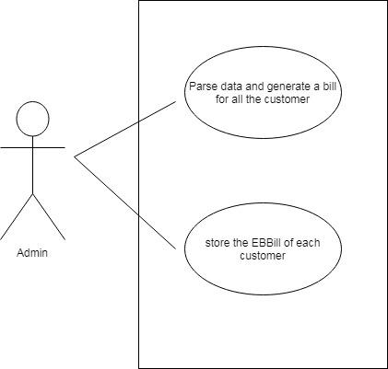

System Architecture Diagram
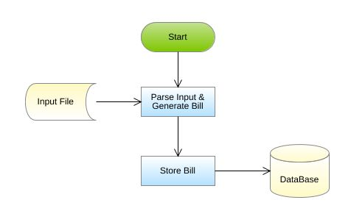

Design Specification

Data Design
Table Structure:
Table name: ElectricityBill
Column Name | Data type
consumer_number | varchar
name | varchar
address | varchar
units_consumed | Int
bill_amount | Float

Design Constraints:
- Use MYSQL database to store the data. The database name should be “EBBill” and table name should be ElectricityBill.
- The above table has been created already.
- The table names and the column names should be the same as specified in the table structure.
- Database connections should be configurable; it should not be hard coded. The database information is specified in the “db.properties” file.

Component Design for identified Use cases

3.2.1 Parse data and generate bill for all the customer
The units consumed and the other details of the customer are stored in a flat file. Retrieve the data from the file and generate bill for each customer based on the units consumed. The details of the customer are stored in a file named ElectricityBill.txt.
Sample File containing customer details. The file is comma delimited.
[ElectricityBillFormat: consumerNumber,Name,address,UnitsConsumed]
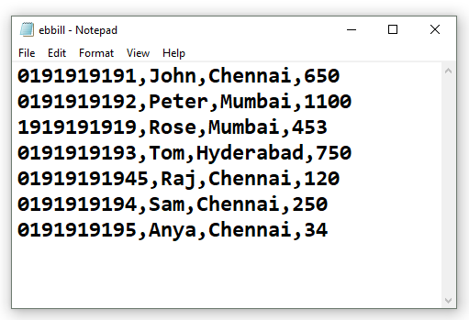
From the ElectricityBill.txt file, read the details , parse the data and construct an ElectricityBill object for each record in the file, then calculate the bill amount for each ElectricityBill based on theconditions given below:
Units Consumed | Rate per unit in rupees
<=100 | Free(0)
>100 and <=300 | 1.5
>300 and <=600 | 3.5
>600 and <=1000 | 5.5
>1000 | 7.5
For example: If the units Consumed is 650, then the first 100 units are free and for the next 200 units the charges are Rs. 1.50/unit, for next 300 units the charges are Rs. 3.50/unit and for the remaining 50 units the charges are Rs. 5.5 /unit. The total bill amounts to Rs. 1625(first 100 free then 200*1.50 + 300*3.50 + 50*5.5)
After calculating the bill amount store all the EBill object into a list.

Note: This functionality is about only reading the records from the file, parsing each record data, validating the consumerNumber, creation of ElectricityBill object and then storing the ElectricityBill Object into the list and return the list. This functionality does not deal with DB Connectivity.

Component Specification: ElectricityBill(model class)
Component Name | Type(Class) | Attributes | Methods | Responsibilities
Parse data and generate a bill for all the customers | ElectricityBill | String consumerNumber  String consumerName  String consumerAddress  int unitsConsumed  double billAmount | Include getters and setter method for all the attributes.
Parse data and generate a bill for all the customers | ElectricityBill |  | void calculateBillAmount() | This method should calculate and set the bill amount based on the units consumed.

ElectricityBoard(utility class)
Component Name | Type(Class) | Method | Responsibilities | Exception
Parse data and generate a bill for all the customers | ElectricityBoard | List<ElectricityBill>generateBill(String filePath) | This method takes the file path as argument and it should parse the data stored in the fileand it should validate the consumer number by invoking the validate() method, if valid,construct a ElectricityBill object for each record in the file, then calculate the bill amount by invoking the calculateBillAmount method of ElectricityBill class. After calculating the bill amount, each ElectricityBill should be added into the list and this method should return the list of ElectricityBill.
Parse data and generate a bill for all the customers | ElectricityBoard | booleanvalidate(String consumerNumber) | This method should validate the consumerNumber, if valid return true else this method should throw an user defined exception | Throw a user defined exception “InvalidConsumerNumberException” if the consumer number is invalid.
Note: The data file will contain both valid and invalid details. Valid ElectricityBill should be added to the list and for the invalid ones user defined exception should bethrown.

3.2.2 Store the ElectricityBill of each customer
After generating the bill ,the electricity board will store the ElectricityBill of each customer into the database.

Component Specification:ElectricityBill(model class)
Component Name | Type(Class) | Method | Responsibilities | Resources
Store the units consumed by each customer | ElectricityBoard | void addBill(List<ElectricityBill>billList) | This method should add all the ElectricityBill details into the ElectricityBill table.  Connect to the database by invoking the establishConnection() method of DBHandler class. | MYSQL database is used. Store the details into ElectricityBill table

DBHandler(DAO class)
Component Name | Type(Class) | Method | Responsibilities | Resources
Store the units consumed by each customer | DBHandler | Connection establishConnection() | This method should connect to the database by reading the database details from the db.properties file and it should return the connection object | MYSQL database is used. Store and retrieve the details into/from ElectricityBill table.  db.properties file is used to store the database configuration details.

