You are developing a small web application for managing a CD Library. The details of CDs(assume only movie CDs are available) are supposed to be stored in a database table. The application should allow the user to enter CD details when they are procured.
The details are as follows :
Table Name : CDDetails (This table has to be created manually in Oracle Db). The table name must be CDDetails. If the table name is anything other than what is mentioned here, you will lose 1 mark.
Column Name Column Type Size
CDId Varchar2 5
CDName Varchar2 20
Procure_date Date
Release Year Number 4
Price Number 10,2
The user interface must be as follows :
Insert View

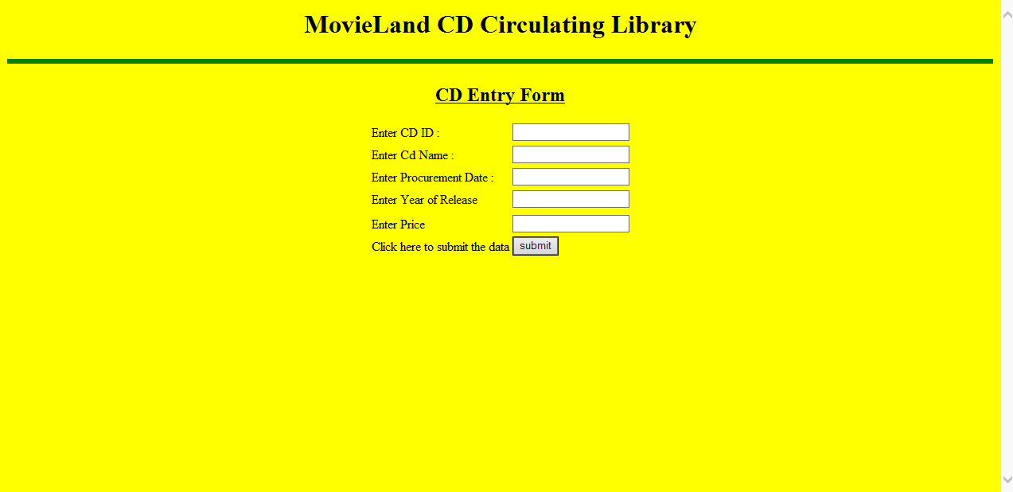
The user enters these details and these details need to be stored in the CDDetails table. Ensure that the user must enter Product Name. Do not allow him to keep the Product Name text box blank. Use either declarative or programmatic validation.
Create appropriate action class, DAO class and complete the application to insert these details in the CDDetails table. Ensure MVC is applied.
After successfully inserting the details, the application must return a message “Record inserted successfully. Do you want to insert one more record “ and two hyperlinks should be displayed in front of these message Yes / No
If the user clicks on yes, it should display the Product Entry Form once more. If the user clicks on No, then it should display an HTML page with the message “Thank you for using this application”.
Insert at least three rows to test your application.

The user interface to display the details must be as follows :
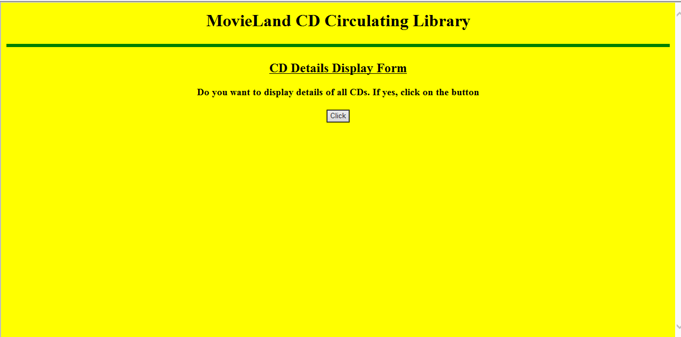

When the user clicks on the button, the CD details available in the table CDDetails must be displayed, as given below :
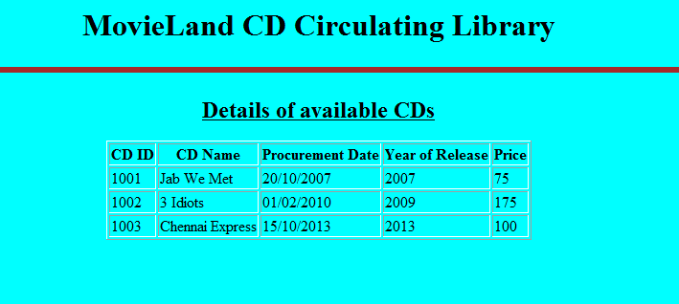
Create appropriate action class, DAO class and complete the application in every respect so that details available in CDDetails table are displayed appropriately in an HTML table. Ensure MVC is applied.

