## SQL HANDS ON

### SQL Basics with DML and DDL Statements

SCHEMA

## CAR

## Car rental system - Create Table

Refer to the given schema. Write a query to create the Owners table with the specified columns and constraints.

Note: Letters in bold represents the table name

NOTE: Maintain the same sequence of column order, as specified in the question description

## Car rental system - add new column

Refer to the given schema. Assume, CARS table has been already created. Write an appropriate query for the given requirement.

Requirement 1: Add a new column Car_Regno VARCHAR(10)  to the Cars table.  
  
Note: Letters in the bold represents the attribute name.

## Car rental system - Insert values

Refer to the given schema diagram. Insert the below records into Rentals Table. Assume the rentals table has been already created.

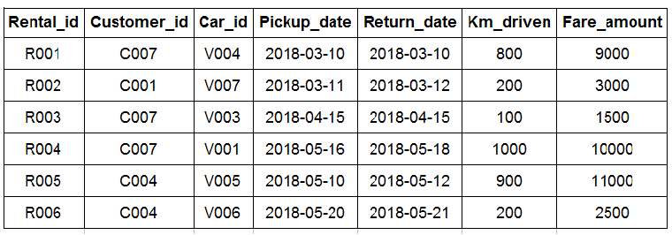

Note: Letters in bold represent the attributes.

NOTE: Maintain the same sequence of column order, as specified in the question description

## Car & owner details based on car type

Write a query to display car id, car name and owner id of all the cars whose car type is 'Hatchback' or 'SUV'.  Sort the result based on car id.

(Hint: Use  CARS tables to retrieve records. Data is case-sensitive. E.g: Car_type='Hatchback'. Use IN operator)

NOTE: Maintain the same sequence of column order, as specified in the question description

## Car details based on type and name

Write a query to display car id, car name and car type of Maruthi company 'Sedan' type cars.  Sort the result based on car id.

(HINT : Use Cars table to retrieve records.car name='Maruthi Swift'.car type='Sedan'.Data is case sensitive.)

NOTE: Maintain the same sequence of column order, as specified in the question description

## Customers having gmail id

Write a query to display customer id, customer name, address, and phone number of customers having Gmail id.  Sort the result based on customer id.

(HINT: Use Customers table to retrieve records. Email id='xxxxx@gmail.com'.Data is case sensitive.)

NOTE: Maintain the same sequence of column order, as specified in the question description

SCHEMA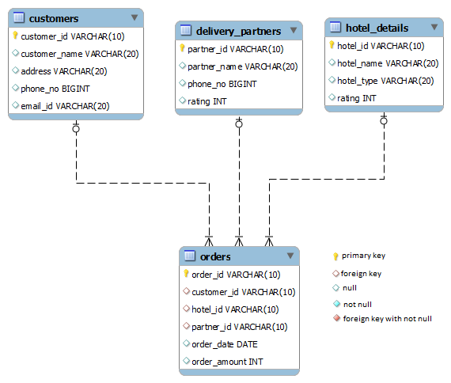

## Hunger eats - change datatype

Refer to the given schema. Assume that the 'Customers' table has been already created.  
Write a query to change the data type of the field customer_id in Customers table to int.  
  
Note: Letters in bold represents the attribute name

## Hunger eats - update table

Refer to the given schema diagram and sample records inserted into the Customers table

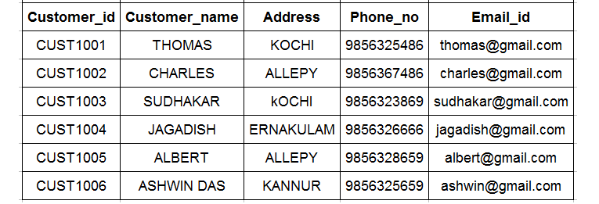

1. **Delivery Partner details based on rating**

Write a query to display partner id, partner name, phone number of delivery partners whose rating is between 3 to 5, sort the result based on partner id.

(Hint: Use Delivery_partners table to retrieve records.)

NOTE: Maintain the same sequence of column order, as specified in the question description

## Hunger eats - Change the field name

Write appropriate query/queries for the given requirement. Assume, Hotel_Details table has been already created.  
  
Requirement 1: Change the name of the existing field Rating to Hotel_Rating in the  Hotel_Details table.  
  
Note: Letters in the bold represents the attributes