Survey

Questions
- Who are the users in the requirement? Pharmacist, Cashier, Admin, Store Owner
- What are the real user needs?
  - Database application: web application
  - UX/UI design:
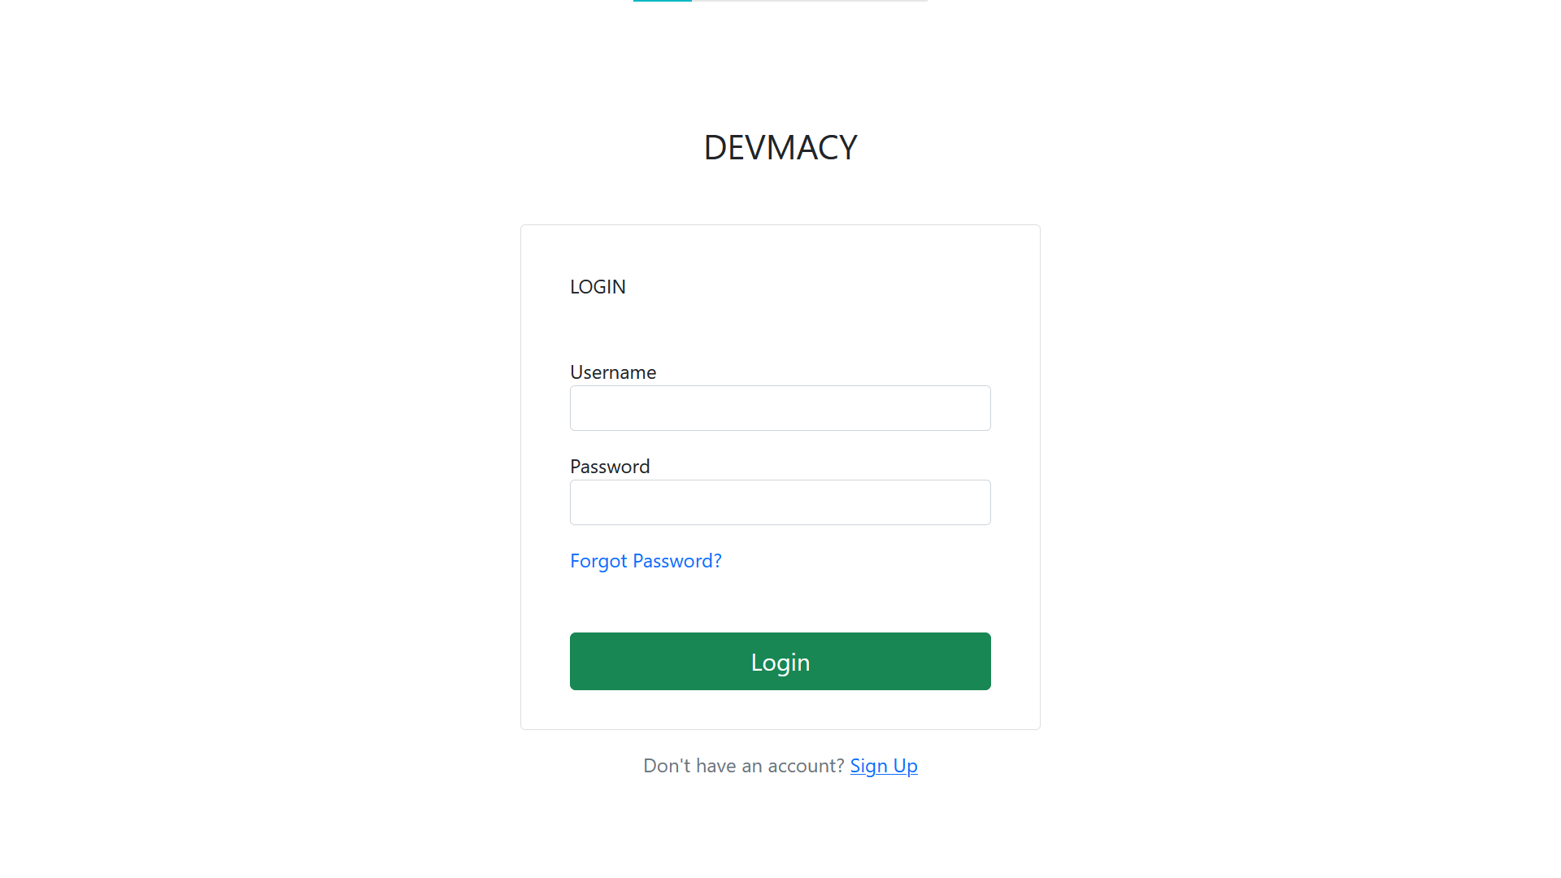
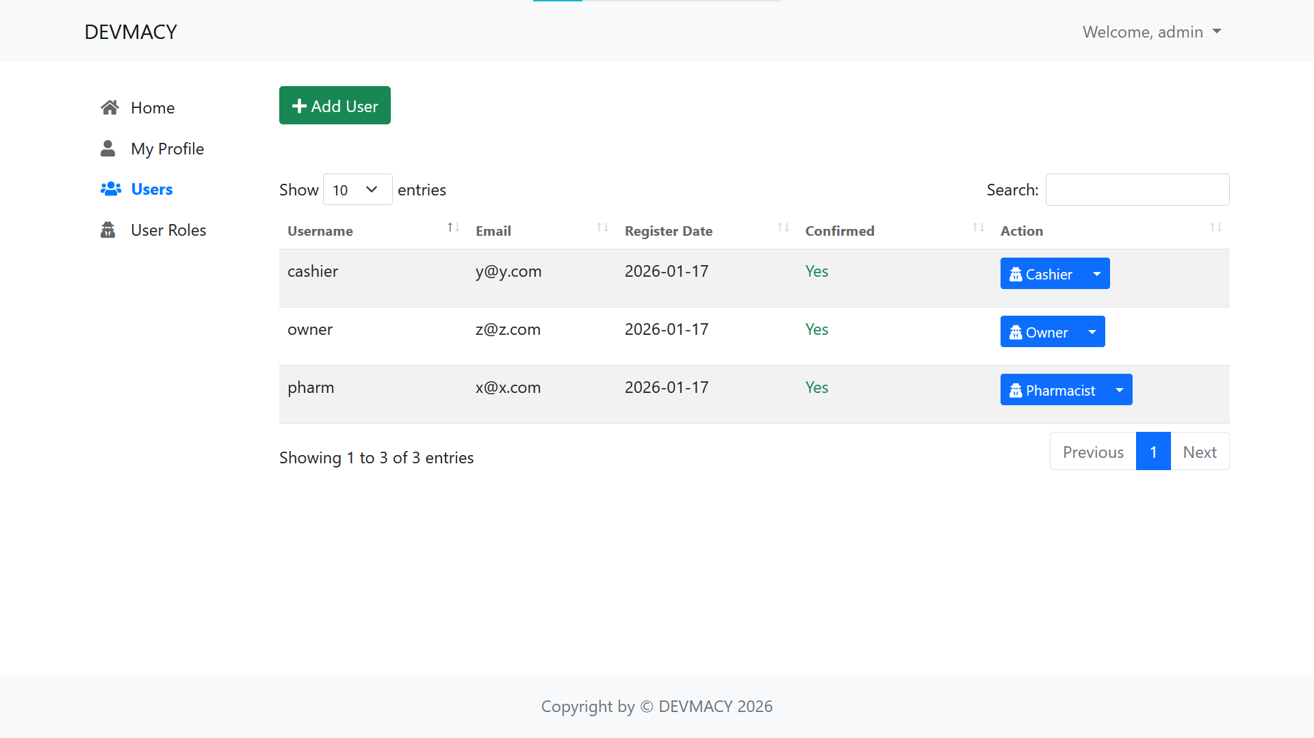

    - Dashboard
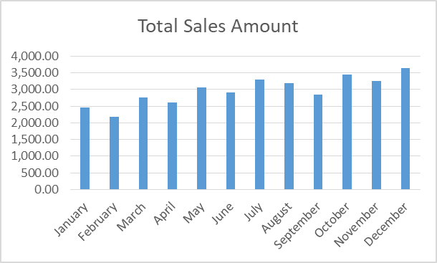
    - Forms:
      - Add product also adds stock card
      - Update product
      - Update stock card
      - Add/edit/delete supplier
  - Security: login system, role-based access
- Approximate budget of implementing project: 500 baht
- Time of project implementation: 11 weeks
- Business name: DEVMACY
- Business structure (department, products, …): Pharmacy store, sells medicine

User requirement
- Computerized system
- Records automatically
- Able to search who are the suppliers for a particular product
- Can update stock card
- Can view sales all the time
- Can query by symptom to find drug that remedies it
- Can query by product to find its variants
- System has role-based access to support many users
- Can visualize sales as graph or diagram in real-time
- Can show stock card summary all the time to show current merchandise
  - Report
- Can check for close to expiring products
  - Can check for expiring in the next specified days (e.g. next 15 days)

Scenarios
Customer enters store:
Customer tells symptom:  - Customer tells symptom  - Pharmacist asks for allergies  - Pharmacist tells price  - Customer pays for it | Customer tells drug name:  - Customer tells drug name  - Pharmacist informs customer about variants (sizes/other brands/pills or liquid)  - Customer confirms demands  - Pharmacist tells price  - Customer pays for it
*this store does not give out receipt (local)
After customer left:
- Pharmacist records what was sold in Daily Record Notebook
- Updates stock card
- If the store front runs out of a product, fetch from back-room
Daily:
At the end of the day, pharmacist will count the money in the drawer and check the day’s sales

Weekly:
Stocking up:
- Pharmacist will check inventory to see what products needs ordering.
- Consults the Supplier notebook to see supplier names.
- Search for the contact in Supplier Contact Notebook.
- Contacts supplier
- When goods arrive, keep receipts
- Updates stock card

Initial tables from notebooks
Daily Record Notebook:
Date | Product name | Number of units | Size of unit | Price per unit | Total
- Has calculation of total sales of each day
Supplier Contact Notebook:
Supplier name | Phone number | Contact name
Supplier Notebook:
Product name | Supplier name

Initial database schema
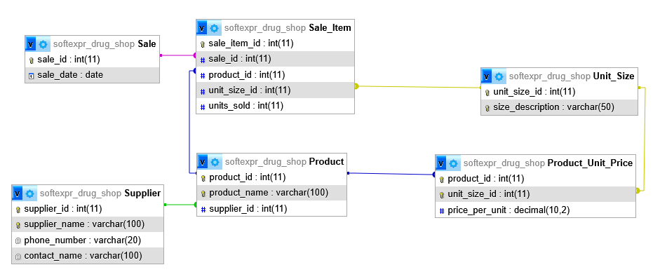
First Normal Form (1NF)
Rule of 1NF
- No repeating groups
- All attributes are atomic (single value per cell)
- Each table has a primary key
What changes here?
Your tables are already close to 1NF, but we must:
- Ensure each row represents one fact
- Add proper primary keys
- Remove calculated fields if possible (optional but recommended)
1NF Result
Daily_Record
| SaleID (PK) | Date | Product name | Unit size | Units sold | Price per unit | Total |
(Still has redundancy, but atomic ✔)
Supplier_Product
| Product name | Supplier name |
Supplier
| Supplier name | Phone number | Contact name |
What problems remain?
- Product name determines supplier
- Supplier name determines phone & contact
- Price depends on product + unit size
- Massive data repetition
Second Normal Form (2NF)
Rule of 2NF
- Must be in 1NF
- No partial dependency on a composite key
Key insight here
In Daily_Record, the real natural key is something like:
(Date, Product name, Unit size)
But:
- Product name → Supplier name
- (Product name, Unit size) → Price per unit
These are partial dependencies.
Fixes in 2NF
We separate data so that:
- Product data is not mixed with sales data
- Pricing depends only on product + unit size
2NF Resulting Tables
Sale
| SaleID (PK) | Date |
Sale_Item
| SaleItemID (PK) | SaleID (FK) | ProductID (FK) | UnitSizeID (FK) | Units sold |
Product
| ProductID (PK) | Product name | Supplier name |
Product_Unit_Price
| ProductID (FK) | UnitSizeID (FK) | Price per unit |
PK: (ProductID, UnitSizeID)
Supplier
| Supplier name (PK) | Phone number | Contact name |
What improved?
- Prices are no longer duplicated per sale
- Unit-size pricing is handled properly
- Still one issue…
Third Normal Form (3NF)
Rule of 3NF
- Must be in 2NF
- No transitive dependencies
(Non-key → Non-key)
Transitive dependencies found
- ProductID → Supplier name
- Supplier name → Phone number, Contact name
So:
ProductID → SupplierID → Phone number
That violates 3NF.
Fixes in 3NF
- Separate Supplier fully
- Reference suppliers by ID
- Remove derived fields (Total)
Final 3NF Design
Supplier
| SupplierID (PK) | Supplier name | Phone number | Contact name |
Product
| ProductID (PK) | Product name | SupplierID (FK) |
Unit_Size
| UnitSizeID (PK) | Size description |
(e.g., “10 pills”, “1 bottle”, “100 ml”)
Product_Unit_Price
| ProductID (FK) | UnitSizeID (FK) | Price per unit |
PK: (ProductID, UnitSizeID)
Sale
| SaleID (PK) | Date |
Sale_Item
| SaleItemID (PK) | SaleID (FK) | ProductID (FK) | UnitSizeID (FK) | Units sold |
Total is calculated when needed:
Units sold × Price per unit

Normalization summary
The pharmacy database initially contained sales, product, pricing, and supplier information with significant redundancy and dependency issues. Product and supplier details were repeatedly stored, prices varied by unit size, and derived values such as totals were saved, risking data inconsistency.
First Normal Form (1NF) was achieved by ensuring all attributes were atomic, removing repeating groups, and assigning primary keys. Each record represented a single sale item, but redundancy and dependency problems remained.
Second Normal Form (2NF) addressed partial dependencies by separating sales data from product and pricing data. Prices were stored based on product and unit size, and product details were removed from transaction records. This eliminated partial dependencies but not transitive ones.
Third Normal Form (3NF) removed transitive dependencies by separating supplier information into its own table and linking products to suppliers using foreign keys. Derived attributes, such as total price, were removed and calculated when needed.
The final 3NF design minimizes redundancy, prevents update anomalies, and ensures data integrity while supporting flexible unit-based pricing.
Parent Table | Child Table | Relationship Type | Primary Key (Parent) | Foreign Key (Child) | Notes
Supplier | Product | One-to-Many (1:M) | supplier_id | supplier_id | One supplier supplies many products
Product | Product_Unit_Price | One-to-Many (1:M) | product_id | product_id | Pricing varies by unit size
Unit_Size | Product_Unit_Price | One-to-Many (1:M) | unit_size_id | unit_size_id | Unit sizes reused across products
Sale | Sale_Item | One-to-Many (1:M) | sale_id | sale_id | One sale can contain many items
Product | Sale_Item | One-to-Many (1:M) | product_id | product_id | Product can appear in many sales
Unit_Size | Sale_Item | One-to-Many (1:M) | unit_size_id | unit_size_id | Unit size used in many sale items

Presentation 1
Scope, Fact finding, Business rules, Tools, Roles, Business structure, Data dictionary

Fact finding
What happens in the store
Customer enters store:
Customer tells symptom:  - Customer tells symptom  - Pharmacist asks for allergies  - Pharmacist tells price  - Customer pays for it | Customer tells drug name:  - Customer tells drug name  - Pharmacist informs customer about variants (sizes/other brands/pills or liquid)  - Customer confirms demands  - Pharmacist tells price  - Customer pays for it
*this store does not give out receipt (local)
After customer left:
- Pharmacist records what was sold in Daily Record Notebook
- Updates stock card
- If the store front runs out of a product, fetch from back-room
Daily:
At the end of the day, pharmacist will count the money in the drawer and check the day’s sales

Weekly:
Stocking up:
- Pharmacist will check inventory to see what products needs ordering.
- Consults the Supplier notebook to see supplier names.
- Search for the contact in Supplier Contact Notebook.
- Contacts supplier
- When goods arrive, keep receipts
- Updates stock card
Daily Record Notebook:
Date | Product name | Number of units | Size of unit | Price per unit | Total
- Has calculation of total sales of each day

Supplier Contact Notebook:
Supplier name | Phone number | Contact name

Supplier Notebook:Product name | Supplier name

Mapping Manual Notebooks → Database
Daily Record Notebook
Manual | Database
Date | Sale.sale_date
Product name | Product.product_name
Units | Sale_Item.units_sold
Size | Unit_Size.size_description
Price | Product_Unit_Price.price_per_unit
Total | Computed column
Your SQL already replicates this perfectly.
Supplier Contact Notebook
Manual | Database
Supplier name | Supplier.supplier_name
Phone | Supplier.phone_number
Contact name | Supplier.contact_name
Supplier Notebook
Manual | Database
Product name | Product
Supplier name | Supplier
Linked by foreign key.

Data dictionary
1️ TABLE: SupplierField Name | Data Type | Size | Null | Key | Description
Supplier_id | INT | — | NO | PK | Unique identifier for each supplier
supplier_name | VARCHAR | 100 | NO | UNIQUE | Official name of supplier
phone_number | VARCHAR | 20 | YES | — | Supplier contact number
contact_name | VARCHAR | 100 | YES | — | Primary contact person
Purpose: Stores supplier contact information.
2️ TABLE: ProductField Name | Data Type | Size | Null | Key | Description
product_id | INT | — | NO | PK | Unique identifier for product
product_name | VARCHAR | 100 | NO | UNIQUE | Name of the drug/product
supplier_id | INT | — | NO | FK | References Supplier(supplier_id)
Purpose: Stores drug/product master information.
Relationships:
- Many Products → One Supplier
3️ TABLE: Unit_SizeField Name | Data Type | Size | Null | Key | Description
unit_size_id | INT | — | NO | PK | Unique size identifier
size_description | VARCHAR | 50 | NO | UNIQUE | Description (e.g., 500mg tablet, 100ml syrup)
Purpose: Defines product variants/sizes.
4️ TABLE: Product_Unit_PriceField Name | Data Type | Size | Null | Key | Description
product_id | INT | — | NO | PK, FK | References Product
unit_size_id | INT | — | NO | PK, FK | References Unit_Size
price_per_unit | DECIMAL | (10,2) | NO | — | Selling price per unit
Primary Key: (product_id, unit_size_id)
Purpose: Stores price for each product variant.

5️ TABLE: SaleField Name | Data Type | Size | Null | Key | Description
sale_id | INT | — | NO | PK | Unique sale transaction ID
sale_date | DATE | — | NO | — | Date of transaction
Purpose: Stores sale transaction header.

6️ TABLE: Sale_ItemField Name | Data Type | Size | Null | Key | Description
sale_item_id | INT | — | NO | PK | Unique sale item ID
sale_id | INT | — | NO | FK | References Sale
product_id | INT | — | NO | FK | References Product
unit_size_id | INT | — | NO | FK | References Unit_Size
units_sold | INT | — | NO | — | Quantity sold (must be > 0)
Purpose: Stores individual products within a sale.

7️ TABLE: Stock (Recommended)Field Name | Data Type | Size | Null | Key | Description
stock_id | INT | — | NO | PK | Unique stock record
product_id | INT | — | NO | FK | References Product
unit_size_id | INT | — | NO | FK | References Unit_Size
quantity | INT | — | NO | — | Available stock quantity
expiry_date | DATE | — | NO | — | Expiry date of batch
last_updated | TIMESTAMP | — | NO | — | Last update timestamp
Purpose: Tracks inventory per batch (important for expiry monitoring).

8️ TABLE: Symptom (For Symptom Search)Field Name | Data Type | Size | Null | Key | Description
symptom_id | INT | — | NO | PK | Unique symptom identifier
symptom_name | VARCHAR | 100 | NO | UNIQUE | Name of symptom (e.g., Fever, Cough)

9️ TABLE: Product_SymptomField Name | Data Type | Size | Null | Key | Description
product_id | INT | — | NO | PK, FK | References Product
symptom_id | INT | — | NO | PK, FK | References Symptom
Primary Key: (product_id, symptom_id)
Purpose: Links products to treatable symptoms.

10 TABLE: RoleField Name | Data Type |  | Size |  | Null |  | Key |  | Description
role_id | INT |  | — |  | NO |  | PK |  | Unique role ID
role_name | VARCHAR |  | 50 |  | NO |  | UNIQUE |  | Role name (Admin, Owner, Pharmacist, Cashier)
1️1 TABLE: UserField Name |  | Data Type |  | Size |  | Null |  | Key |  | Description
user_id |  | INT |  | — |  | NO |  | PK |  | Unique user ID
username |  | VARCHAR |  | 50 |  | NO |  | UNIQUE |  | Login username
password_hash |  | VARCHAR |  | 255 |  | NO |  | — |  | Encrypted password
full_name |  | VARCHAR |  | 100 |  | NO |  | — |  | User's full name
role_id |  | INT |  | — |  | NO |  | FK |  | References Role
is_active |  | BOOLEAN |  | — |  | NO |  | — |  | Indicates if account is active
Purpose: Stores system users for login and access control.
KEY RELATIONSHIPS SUMMARY
- Supplier (1) → (M) Product
- Product (1) → (M) Product_Unit_Price
- Product (1) → (M) Stock
- Product (M) ↔ (M) Symptom
- Sale (1) → (M) Sale_Item
- User (M) → (1) Role
DERIVED / COMPUTED DATAName | Formula | Description
total_price | units_sold × price_per_unit | Total per sale item
daily_total | SUM(total_price) per date | Daily sales summary
monthly_total | SUM(total_price) per month | Monthly sales summary
SECURITY RULES IN DATA DICTIONARY
- Password must be stored as hashed value.
- Role_id controls authorization.
- Sale records cannot be deleted (audit integrity).
- Expired stock cannot be used in sale.
STOCK MONITORING FIELDS
For expiry checking:
- expiry_date
- quantity
- DATEDIFF(expiry_date, CURRENT_DATE)
Used for:
- Expired products
- Expiring within X days
This Data Dictionary Supports
✔ Inventory management
✔ Sales recording
✔ Supplier tracking
✔ Expiry monitoring
✔ Symptom-based drug search
✔ Role-based login
✔ Dashboard reporting
✔ Real-time stock summary

3NF SQL
1 Supplier
CREATE TABLE Supplier (
supplier_id INT PRIMARY KEY AUTO_INCREMENT,
supplier_name VARCHAR(100) NOT NULL UNIQUE,
phone_number VARCHAR(20),
contact_name VARCHAR(100)
);

2 Product
CREATE TABLE Product (
product_id INT PRIMARY KEY AUTO_INCREMENT,
product_name VARCHAR(100) NOT NULL UNIQUE,
supplier_id INT NOT NULL,
FOREIGN KEY (supplier_id) REFERENCES Supplier(supplier_id)
);

3 Unit Size
CREATE TABLE Unit_Size (
unit_size_id INT PRIMARY KEY AUTO_INCREMENT,
size_description VARCHAR(50) NOT NULL UNIQUE
);

4 Product Unit Price
CREATE TABLE Product_Unit_Price (
product_id INT NOT NULL,
unit_size_id INT NOT NULL,
price_per_unit DECIMAL(10,2) NOT NULL,
PRIMARY KEY (product_id, unit_size_id),
FOREIGN KEY (product_id) REFERENCES Product(product_id),
FOREIGN KEY (unit_size_id) REFERENCES Unit_Size(unit_size_id)
);

5 Sale
CREATE TABLE Sale (
sale_id INT PRIMARY KEY AUTO_INCREMENT,
sale_date DATE NOT NULL
);

6 Sale Item (stores price at time of sale)
CREATE TABLE Sale_Item (
sale_item_id INT PRIMARY KEY AUTO_INCREMENT,
sale_id INT NOT NULL,
product_id INT NOT NULL,
unit_size_id INT NOT NULL,
units_sold INT NOT NULL CHECK (units_sold > 0),
unit_price DECIMAL(10,2) NOT NULL,
FOREIGN KEY (sale_id) REFERENCES Sale(sale_id),
FOREIGN KEY (product_id) REFERENCES Product(product_id),
FOREIGN KEY (unit_size_id) REFERENCES Unit_Size(unit_size_id)
);

7 Stock (with expiry tracking)
CREATE TABLE Stock (
stock_id INT PRIMARY KEY AUTO_INCREMENT,
product_id INT NOT NULL,
unit_size_id INT NOT NULL,
quantity INT NOT NULL CHECK (quantity >= 0),
expiry_date DATE NOT NULL,
last_updated TIMESTAMP DEFAULT CURRENT_TIMESTAMP
ON UPDATE CURRENT_TIMESTAMP,
FOREIGN KEY (product_id) REFERENCES Product(product_id),
FOREIGN KEY (unit_size_id) REFERENCES Unit_Size(unit_size_id)
);

8 Symptom
CREATE TABLE Symptom (
symptom_id INT PRIMARY KEY AUTO_INCREMENT,
symptom_name VARCHAR(100) NOT NULL UNIQUE
);

9 Product_Symptom (Many-to-Many)
CREATE TABLE Product_Symptom (
product_id INT NOT NULL,
symptom_id INT NOT NULL,
PRIMARY KEY (product_id, symptom_id),
FOREIGN KEY (product_id) REFERENCES Product(product_id)
ON DELETE CASCADE,
FOREIGN KEY (symptom_id) REFERENCES Symptom(symptom_id)
ON DELETE CASCADE
);

10 Role
CREATE TABLE Role (
role_id INT PRIMARY KEY AUTO_INCREMENT,
role_name VARCHAR(50) NOT NULL UNIQUE
);

11 Users (renamed from User because USER is reserved)
CREATE TABLE Users (
user_id INT PRIMARY KEY AUTO_INCREMENT,
username VARCHAR(50) NOT NULL UNIQUE,
password_hash VARCHAR(255) NOT NULL,
full_name VARCHAR(100) NOT NULL,
role_id INT NOT NULL,
is_active BOOLEAN NOT NULL DEFAULT TRUE,
FOREIGN KEY (role_id) REFERENCES Role(role_id)
);

Visual schema
ROLE
-----
role_id (PK)
role_name
│
│ 1
│
▼
USER
-----
user_id (PK)
username
password_hash
full_name
role_id (FK)
│
│ 1
│
▼
SALE
-----
sale_id (PK)
sale_date
user_id (FK)
total_amount
│
│ 1
│
▼
SALE_ITEM
----------
sale_item_id (PK)
sale_id (FK)
stock_id (FK)
quantity_sold
price_at_sale
subtotal
▲
│ M
│
│
STOCK
-----
stock_id (PK)
product_id (FK)
unit_size_id (FK)
batch_number
quantity
expiry_date
received_date
▲
│
│ M
│
│
PRODUCT ───────────── SUPPLIER
-------- ----------
product_id (PK) supplier_id (PK)
product_name supplier_name
supplier_id (FK) phone_number
description contact_name
reorder_level
│
│ M
│
▼
PRODUCT_UNIT_PRICE
-------------------
product_id (PK, FK)
unit_size_id (PK, FK)
price_per_unit
▲
│
│
UNIT_SIZE
---------
unit_size_id (PK)
size_description

PRODUCT ────────< PRODUCT_SYMPTOM >─────── SYMPTOM

Crow's foot
[ROLE]
- role_id (PK)
- role_name
1
│
│
∞
[USER]
- user_id (PK)
- username
- password_hash
- full_name
- role_id (FK)
1
│
│
∞
[SALE]
- sale_id (PK)
- sale_date
- user_id (FK)
- total_amount
1
│
│
∞
[SALE_ITEM]
- sale_item_id (PK)
- sale_id (FK)
- stock_id (FK)
- quantity_sold
- price_at_sale
- subtotal
∞
│
│
1
[STOCK]
- stock_id (PK)
- product_id (FK)
- unit_size_id (FK)
- batch_number
- quantity
- expiry_date
- received_date
∞
│
│
1
[PRODUCT] -------------------- 1 ----------- ∞ [SUPPLIER]
- product_id (PK) - supplier_id (PK)
- product_name - supplier_name
- supplier_id (FK) - phone_number
- description - contact_name
- reorder_level

1
│
│
∞
[PRODUCT_UNIT_PRICE]
- product_id (PK, FK)
- unit_size_id (PK, FK)
- price_per_unit
∞
│
│
1
[UNIT_SIZE]
- unit_size_id (PK)
- size_description

M:N Relationship (Bridge Table)

[PRODUCT] 1 ────< [PRODUCT_SYMPTOM] >──── 1 [SYMPTOM]
(PK: product_id, symptom_id)

ER-diagram
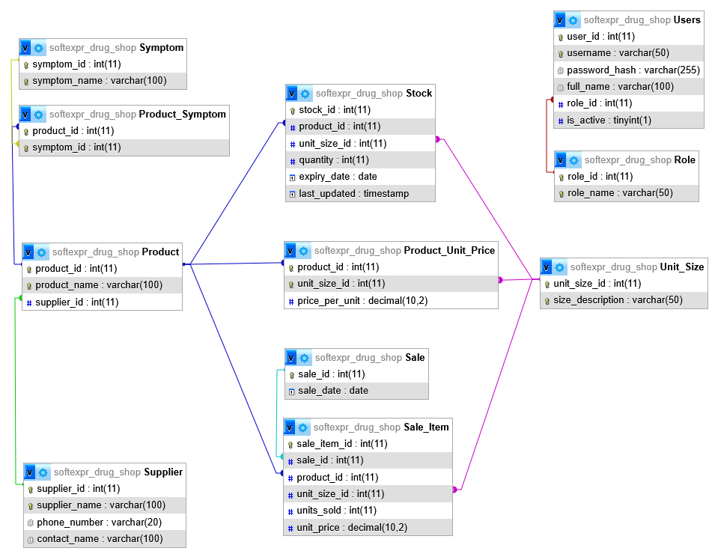

Relationship explaination
1️ Role → User (One-to-Many)
- One role can have many users.
- Example:
- Role: "Pharmacist"
- Users: John, Maria, Alex
This supports role-based access control.
2️ Supplier → Product (One-to-Many)
- One supplier supplies many products.
- One product belongs to one supplier.
Example:
- Supplier A supplies:
- Paracetamol
- Amoxicillin
- Cough Syrup
3️ Product → Unit_Size (Many-to-Many via Product_Unit_Price)
A product can have multiple sizes.
Example:
Paracetamol:
- 500mg tablet
- 250mg tablet
- 100ml syrup
Each size has its own price.
That is why we use:
Product_Unit_Price
(product_id, unit_size_id)
This ensures:
- No duplicate pricing
- Proper normalization
- Flexible variant management
4️ Product → Stock (One-to-Many)
One product can have multiple stock batches.
Example:
Paracetamol 500mg:
- Batch A – Exp: 2026-01-01 – Qty: 100
- Batch B – Exp: 2026-03-01 – Qty: 200
This is critical for pharmacy because:
- Each batch expires differently
- Must use FEFO (First Expire First Out)

5️ Sale → Sale_Item (One-to-Many)
One sale can contain multiple products.
Example:
Sale #101:
- 2 Paracetamol
- 1 Cough Syrup
Each is stored in Sale_Item.

6️ Sale_Item → Stock (Many-to-One)
Each sale item deducts from a specific stock batch.
This ensures:
- Proper expiry tracking
- Correct inventory deduction
- Batch accountability

7️ Product ↔ Symptom (Many-to-Many)
A product can treat multiple symptoms.
A symptom can have multiple drug options.
Example:
Symptom: Fever
Drugs:
- Paracetamol
- Ibuprofen
This supports:
✔ Search drug by symptom
✔ Suggest alternatives
WHY THIS DESIGN
This schema satisfies:
Normalization (3NF)
- No repeating groups
- No redundant data
- Proper foreign key usage
Real Pharmacy Requirements
- Batch tracking
- Expiry monitoring
- Supplier tracking
- Symptom lookup
- Variant pricing
- Multi-user tracking
Security
- Role-based system
- User-based sale tracking
- Password hashing

Data flow
DATA FLOW: WHAT HAPPENS DURING A SALE
Let’s simulate:
Customer wants Paracetamol 500mg.

Step 1: User logs in
User → verified from USER table.
Step 2: Search product
System checks:
Product
Product_Unit_Price
Stock (only non-expired stock)
Step 3: Create Sale
Insert into:
SALE
Step 4: Add Sale Item
Insert into:
SALE_ITEM
Using:
  - Stock_id
  - quantity_sold
  - price_at_sale
Step 5: Deduct Stock
Update:
STOCK.quantity = quantity - quantity_sold
Step 6: Update Sale Total
SALE.total_amount = SUM(subtotal)

Diagram 1
+------------------+
| Customer |
| Wants Paracetamol|
+---------+--------+
|
v
+------------------+
| Step 1: Login |
|------------------|
| Verify user from |
| USER table |
+---------+--------+
|
v
+---------------------------+
| Step 2: Search Product |
|---------------------------|
| Check PRODUCT |
| Check PRODUCT_UNIT_PRICE |
| Check STOCK (non-expired) |
+---------+-----------------+
|
v
+------------------+
| Step 3: Create |
| SALE |
|------------------|
| Insert into SALE |
+---------+--------+
|
v
+-----------------------------+
| Step 4: Add Sale Item |
|-----------------------------|
| Insert into SALE_ITEM |
| - stock_id |
| - quantity_sold |
| - price_at_sale |
+---------+-------------------+
|
v
+-----------------------------+
| Step 5: Deduct Stock |
|-----------------------------|
| Update STOCK.quantity = |
| quantity - quantity_sold |
+---------+-------------------+
|
v
+-----------------------------+
| Step 6: Update Sale Total |
|-----------------------------|
| SALE.total_amount = |
| SUM(subtotal) |
+-----------------------------+

Diagram 2
Customer
│
▼
USER (verification)
│
▼
PRODUCT → PRODUCT_UNIT_PRICE → STOCK
│
▼
SALE
│
▼
SALE_ITEM
│
▼
Update STOCK
│
▼
Update SALE.total_amount

Scope
Database application: web application
Security: login system, role-based access
UX/UI design:



  - Dashboard example:

  - Forms:
    - Add product also adds stock card
    - Update product
    - Update stock card
    - Add/edit/delete supplier

Technical demands:

- Computerized system
- Records automatically
- Able to search who are the suppliers for a particular product
- Can update stock card
- Can view sales all the time
- Can query by symptom to find drug that remedies it
- Can query by product to find its variants
- System has role-based access to support many users
- Can visualize sales as graph or diagram in real-time
- Can show stock card summary all the time to show current merchandise
  - Report
- Can check for close to expiring products
  - Can check for expiring in the next specified days (e.g. next 15 days)

System scope

Functional requirements
1️ Authentication & Security
- Login page
- Password hashing
- Role-based authorization
- Session management
- Logout
2️ Dashboard
- Monthly sales bar chart
- Daily total sales
- Low stock alerts
- Expiry alerts
- Real-time stock summary
3️ Inventory Management
- Add product (creates stock card)
- Update product
- Update stock quantity
- Search product
- Search by supplier
- View product variants
4️ Supplier Management
- Add supplier
- Edit supplier
- Delete supplier
- View supplier contact
- Query supplier by product
SQL for that:
SELECT s.supplier_name
FROM Product p
JOIN Supplier s ON p.supplier_id = s.supplier_id
WHERE p.product_name = 'Paracetamol';
5️ Sales Management
- Record sale
- Auto-calculate total
- View daily sales
- View monthly sales
- Filter by date
- Sales report
6 Expiry Monitoring
You currently do not store expiry date.
You NEED:
ALTER TABLE Product ADD expiry_date DATE;
ALTER TABLE Product ADD stock_quantity INT DEFAULT 0;
Or better: create a Stock table (recommended).
7 Symptom-Based Search (Requires New Table)
You need:
CREATE TABLE Symptom (
symptom_id INT PRIMARY KEY AUTO_INCREMENT,
symptom_name VARCHAR(100) UNIQUE
);
CREATE TABLE Product_Symptom (
product_id INT,
symptom_id INT,
PRIMARY KEY (product_id, symptom_id),
FOREIGN KEY (product_id) REFERENCES Product(product_id),
FOREIGN KEY (symptom_id) REFERENCES Symptom(symptom_id)
);
Then:
SELECT p.product_name
FROM Product p
JOIN Product_Symptom ps ON p.product_id = ps.product_id
JOIN Symptom s ON ps.symptom_id = s.symptom_id
WHERE s.symptom_name = 'Fever';

Non-functional requirements
- Web-based application
- Multi-user support
- Secure authentication
- Data consistency
- Real-time updates
- Fast search
- Backup & recovery
- Audit logs

Components
This is a Medium–Advanced Web Database System
It includes:
- Inventory
- POS
- Compliance
- Analytics
- Security
- Batch-level tracking
This is above a basic CRUD project.

Required reports
- Daily Sales Report
- Monthly Sales Report
- Supplier Report
- Low Stock Report
- Expiry Report (next X days)
- Product Sales Report

Dashboards
Schema supports:
- Monthly sales bar chart
- Daily sales summary
- Low stock alert
- Expiring within 15 days
- Supplier lookup by product
- Drug lookup by symptom
- Variant lookup by product

User Roles & Responsibilities
Admin (System Administrator)
Scope: System management only (not daily operations)
Responsibilities:
- Create / edit / delete users
- Assign roles
- Reset passwords
- Manage role permissions
- View system logs
Access Rights:
- Full system access
- Cannot alter sales records
- Cannot modify inventory unless also assigned pharmacist role

Shop Owner
Scope: Business monitoring & decision-making
Responsibilities:
- View real-time dashboard
- View monthly sales graphs
- View profit reports
- Monitor inventory levels
- Monitor expiring drugs
- View supplier performance
- Financial overview
Access Rights:
- Read-only access to:
- Sales
- Inventory
- Suppliers
- Cannot modify operational records

Pharmacist (Core Operational Role)
Scope: Full store operations
Responsibilities:
Sales Handling
- Search by:
- Symptom
- Drug name
- Suggest variants (sizes, forms, brands)
- Check allergies
- Inform price
- Record sale
Inventory Management
- Add new product
- Update stock card
- Receive supplier goods
- Monitor expiry
- Remove expired drugs
- Set reorder levels
Supplier Coordination
- Add/edit supplier
- View supplier contacts
- Order stock
- Record supplier deliveries
Compliance
- Ensure drug regulations followed
- Monitor controlled substances
- Ensure expired drugs not sold
Access Rights:
- Full CRUD on:
- Products
- Stock
- Suppliers
- Sales (create only)
- Cannot manage system users

Cashier
Scope: Billing & POS Only
Responsibilities:
- Record sales
- Search product
- Select variant
- Input units sold
- Accept payment
- Finalize sale
Access Rights:
- Create Sale
- View product list
- View price
- Cannot:
- Add product
- Update stock manually
- Delete suppliers
- See financial reports

Business rules
These define how the business operates logically and legally.
A. General Business Rules
- Every product must:
  - Have exactly one supplier
  - Have at least one unit size
  - Have a defined price per unit size
- Every sale:
  - Must contain at least one Sale_Item
  - Must be associated with a sale date
  - Must calculate total automatically
- Stock:
  - Stock must decrease automatically after each sale
  - Stock cannot go below zero
  - Expired products cannot be sold
- Suppliers:
  - A supplier may supply multiple products
  - A product must belong to exactly one supplier
- Role-Based Access:
  - Users must login
  - Users can only access features allowed by their role
- Expiry Monitoring:
  - System must detect:
  - Expired products
  - Products expiring within X days
B. Sales Rules
- Total price = units_sold × price_per_unit
- Sales are recorded immediately after payment
- Sales are immutable (cannot delete — only void with reason)
- Daily total is auto-calculated

C. Inventory Rules
- Adding product automatically creates stock record
- Updating stock must log:
  - Date
  - Quantity added
  - Reason (restock, correction)
- When stock reaches reorder threshold → alert pharmacist
- First-expire-first-out (FEFO) recommended

D. Compliance Rules (Pharmacy Specific)
- Pharmacist must verify allergies before completing symptom-based sale
- Certain drugs may require pharmacist-only access
- Expired drugs must not be available for sale
- All supplier transactions must be recorded

Business structure
A private business—shop owner owns it. Sole proprietorship.

Hierarchical Functional Structure:
Admin
- Manages users and roles
Shop Owner
- Monitors overall sales
Pharmacist
- Handles prescriptions
- Manages drugs
- Basic stock updates
- Inventory management
- Supplier coordination
- Handles licensing, supplier contracts, finances
- Oversees compliance with drug regulations
- Ensures regulatory compliance
Cashier
- Billing and POS operations

Admin (System Level)
↓
Shop Owner (Business Level)
↓
Pharmacist (Operational + Compliance)
↓
Cashier (Sales Execution)

Tools
Let’s discuss later

Evolution
Let’s clearly walk through how the design evolved from the handwritten notebooks → 1NF → 2NF → 3NF → your final schema.
Stage 0 — Original Manual Notebooks (Unnormalized)
You originally had three separate notebooks:
1️ Daily Record Notebook
- Date
- Product name
- Number of units
- Size of unit
- Price per unit
- Total
2️ Supplier Contact Notebook
- Supplier name
- Phone number
- Contact name
3️ Supplier Notebook
- Product name
- Supplier name
Problems in Original Structure
Data Redundancy
- Supplier name repeated for every product
- Phone/contact repeated many times
- Price per unit repeated every sale
Update Anomalies
If a supplier changes phone number:
- You must update every row manually.
Delete Anomalies
If you delete all sales of a product:
- You might accidentally lose supplier info.
Insert Anomalies
You cannot store a product until it has a sale.
Step 1 — First Normal Form (1NF)
1NF Rules:
- No repeating groups
- Atomic values (no multiple values per cell)
- Primary key exists
You turned the notebook into something like:
Daily_Record
| SaleID | Date | Product | UnitSize | Units | Price | Total |

✔ Values are atomic
✔ Table has a primary key
But…
Problems Still Present
- Product → Supplier (dependency)
- Supplier → Phone, Contact
- (Product, UnitSize) → Price
- Total is calculated (Units × Price)
Still heavy redundancy.
Step 2 — Second Normal Form (2NF)
2NF Rule:
- Must be in 1NF
- No partial dependency on composite key
The real natural key of sales was:
(Date, Product, UnitSize)

But:
- Product → Supplier
- (Product, UnitSize) → Price
These are partial dependencies, because:
They depend only on part of the key.
Fix in 2NF
We separate:
Sale
sale_id | date
Sale_Item
sale_item_id | sale_id | product_id | unit_size_id | units_sold
Product
product_id | product_name | supplier_name
Product_Unit_Price
product_id | unit_size_id | price
Supplier
supplier_name | phone | contact

Improvements
- Price no longer repeated in sales
- Sales no longer store supplier details
- Less duplication
But…
Step 3 — Third Normal Form (3NF)
3NF Rule:
- Must be in 2NF
- No transitive dependency
- Non-key attribute must depend only on the key
Transitive Dependency Problem
In 2NF design:
ProductID → SupplierName
SupplierName → Phone, Contact

Therefore:
ProductID → Phone

This is a transitive dependency.
That violates 3NF.
Final 3NF Fix
Separate Supplier fully and use IDs.
Your final schema:
Supplier
supplier_id (PK)
supplier_name (UNIQUE)
phone_number
contact_name

Product
product_id (PK)
product_name (UNIQUE)
supplier_id (FK)

Now:
- Product depends only on its key
- Supplier info depends only on supplier_id
- No transitive dependency
✔ 3NF satisfied
Additional Improvements You Added (Beyond Basic 3NF)
Your final schema actually goes beyond the textbook example.
You added:
Sale_Item stores unit_price
Why?
Because price may change over time.
If price changes in Product_Unit_Price,
old sales must not change.
So storing:
unit_price

in Sale_Item preserves historical accuracy.
This is good database design practice.
Stock with Expiry Tracking
Stock
| stock_id
| product_id
| unit_size_id
| quantity
| expiry_date

This is correct because:
- Quantity depends on product + unit size + expiry
- No transitive dependency
- Atomic values
Still in 3NF.
Product_Symptom (Many-to-Many)
Product_Symptom
| product_id
| symptom_id

Perfect associative table.
No redundancy.
Fully normalized.
Users and Role
Role → role_id → role_name
Users → role_id FK

Avoids repeating role names.
No transitive dependency.
Still 3NF.
Visual Summary of EvolutionStage | Main Problem | Fix
Notebook | Massive redundancy | Start structuring tables
1NF | Repeated supplier & price data | Add PKs, atomic columns
2NF | Partial dependencies | Separate Product & Pricing
3NF | Transitive dependency | Separate Supplier by ID
Final | Real-world accuracy | Store price at time of sale
Final Verdict
Yes — your schema is in Third Normal Form (3NF) because:
✔ Every table has a primary key
✔ No partial dependencies
✔ No transitive dependencies
✔ All non-key attributes depend only on the key

It is also:
- Clean
- Scalable
- Practical for real pharmacy/store systems
- Historically accurate for sales tracking

3NF check proof
A relation is in Third Normal Form (3NF) if:
- It is in 1NF
- It is in 2NF
- For every functional dependency:
X → Y

At least one of the following is true:
- X is a superkey, OR
- Y is a prime attribute (part of some candidate key)
In simpler words:
Every non-key attribute must depend on the key, the whole key, and nothing but the key.
1️ Supplier
Supplier(
supplier_id PK,
supplier_name UNIQUE,
phone_number,
contact_name
)

Step 1: 1NF
- Atomic attributes ✔
- Primary key exists ✔
→ 1NF satisfied
Step 2: 2NF
Primary key: supplier_id (single attribute)
No composite key → cannot have partial dependency ✔
→ 2NF satisfied
Step 3: 3NF
Functional dependencies:
supplier_id → supplier_name
supplier_id → phone_number
supplier_id → contact_name

Left side is the primary key (superkey).
No non-key → non-key dependency.
✔ Supplier is in 3NF
2️ Product
Product(
product_id PK,
product_name UNIQUE,
supplier_id FK
)

Step 1: 1NF
Atomic ✔
PK exists ✔
Step 2: 2NF
PK is single attribute → no partial dependency ✔
Step 3: 3NF
Dependencies:
product_id → product_name
product_id → supplier_id

No dependency like:
product_name → supplier_id

And no:
supplier_id → product_name

Everything depends only on product_id.
✔ Product is in 3NF
3️ Unit_Size
Unit_Size(
unit_size_id PK,
size_description UNIQUE
)

Dependencies:
unit_size_id → size_description

Single key → no partial dependency
No transitive dependency
✔ Unit_Size is in 3NF
4️ Product_Unit_Price
Product_Unit_Price(
product_id,
unit_size_id,
price_per_unit,
PK (product_id, unit_size_id)
)

Step 1: 1NF
Atomic ✔
Step 2: 2NF
Composite key:
(product_id, unit_size_id)

Dependency:
(product_id, unit_size_id) → price_per_unit

Check partial dependency:
Is there:
product_id → price_per_unit ❌
unit_size_id → price_per_unit ❌

No.
Price depends on BOTH parts.
✔ 2NF satisfied
Step 3: 3NF
No other attributes exist.
No non-key → non-key dependency.
✔ Product_Unit_Price is in 3NF
5️ Sale
Sale(
sale_id PK,
sale_date
)

Dependency:
sale_id → sale_date

Single key
No transitive dependency
✔ Sale is in 3NF
6️ Sale_Item
Sale_Item(
sale_item_id PK,
sale_id FK,
product_id FK,
unit_size_id FK,
units_sold,
unit_price
)

Step 1: 1NF
Atomic ✔
Step 2: 2NF
Single PK → no partial dependency ✔
Step 3: 3NF
Dependencies:
sale_item_id → sale_id
sale_item_id → product_id
sale_item_id → unit_size_id
sale_item_id → units_sold
sale_item_id → unit_price
Check for transitive dependency:
Is there:
product_id → unit_price ❌
sale_id → product_id ❌

No.
Important detail:
unit_price is intentionally stored for historical accuracy.
It does NOT depend on product_id inside this table.
Everything depends only on sale_item_id.
✔ Sale_Item is in 3NF
7️ Stock
Stock(
stock_id PK,
product_id FK,
unit_size_id FK,
quantity,
expiry_date,
last_updated
)

Dependencies:
stock_id → product_id
stock_id → unit_size_id
stock_id → quantity
stock_id → expiry_date
stock_id → last_updated

No composite key.
No attribute determines another non-key attribute.
✔ Stock is in 3NF
8️ Symptom
Symptom(
symptom_id PK,
symptom_name UNIQUE
)

Dependency:
symptom_id → symptom_name

✔ 3NF satisfied
9️ Product_Symptom (Junction Table)
Product_Symptom(
product_id,
symptom_id,
PK(product_id, symptom_id)
)

Only key attributes exist.
No non-key attributes.
✔ Automatically in 3NF (also BCNF)
10 Role
Role(
role_id PK,
role_name UNIQUE
)

Dependency:
role_id → role_name

✔ 3NF satisfied
1️1 Users
Users(
user_id PK,
username UNIQUE,
password_hash,
full_name,
role_id FK,
is_active
)

Dependencies:
user_id → username
user_id → password_hash
user_id → full_name
user_id → role_id
user_id → is_active

No:
role_id → username ❌

Role details are stored in Role table (correct separation).
✔ Users is in 3NF
Conclusion
Every table:
✔ Has atomic attributes (1NF)
✔ Has no partial dependency (2NF)
✔ Has no transitive dependency (3NF)
✔ Every non-key attribute depends only on the key
The database design is:
✔ Properly normalized
✔ Fully in 3NF
✔ Practically well-designed
✔ Suitable for real system implementation

Dependency diagram
SupplierID
→ SupplierName
→ PhoneNumber
→ ContactName

ProductID
→ ProductName
→ SupplierID

UnitSizeID
→ SizeDescription

(ProductID, UnitSizeID)
→ PricePerUnit

SaleID
→ SaleDate

SaleItemID
→ SaleID
→ ProductID
→ UnitSizeID
→ UnitsSold
→ UnitPrice

SymptomID
→ SymptomName

RoleID
→ RoleName

UserID
→ Username
→ PasswordHash
→ FullName
→ RoleID
→ IsActive

