Team 11
SOEN 6441
18-Oct-18

Architecture of Risk Project
According the instruction of the Project and the Grading list, our team implements the first phase of development, and generate the Build 1.
- Module structure in our implementation
As the following graph showed, these are our basic module and their function in our implementation.
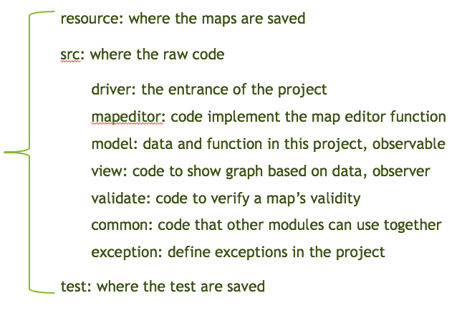
- Observer pattern in our implementation
In our implementation, we use three layer of observer pattern to update the interface in the real time:
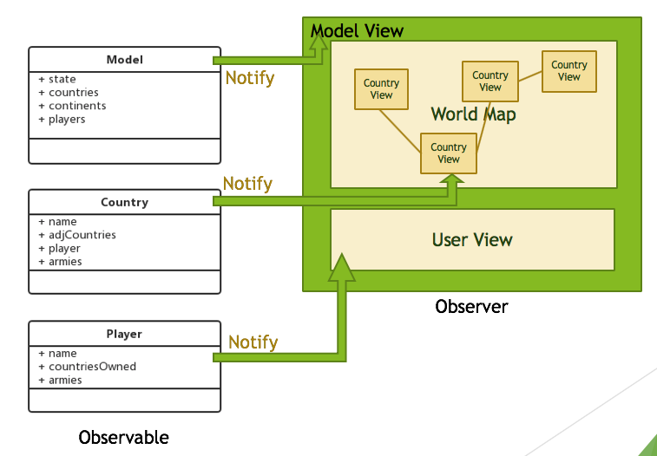
- Model ---- Model View: Model View change its pattern (interface, listen pattern) according observer the state of STATE in Model.
- Country ---- Country View: display correct country info according the Country notification.
- Player ---- Player View: display correct user info according the users notification.

- Project process and information exchange in our implementation
Based on our implementation, following is our flow chart. The main part of this project and how it runs is listed in the following figure.
