Article
Can a Single Number Tell a Good Cascade Model from a Naive One? A Three-Axis Validation of a Global Supply-Chain Disruption Simulator on 27 Primary-Sourced Historical Events
Yerzat Mametayev ^{1,*}
¹ Nazarbayev Intellectual School of Physics and Mathematics in Semey, Semey, Kazakhstan
* Correspondence: mametaeverzat014@gmail.com
Abstract: Global supply-chain disruptions — earthquakes, floods, canal blockages, financial crises — cascade across industries and countries, yet published simulation models are typically validated on one or two events and a single error metric. This work asks whether such validation can distinguish a substantive model from a naive baseline at all, and builds the infrastructure to answer it. We assemble a benchmark of 27 historical events (1999–2023, ten categories), each calibrated from primary sources under a written source-tier protocol, and a three-axis validation system scoring (1) global loss magnitude, (2) node-level cascade shape (peak, timing, recovery), and (3) spatial reach. Four models are tested: a novel SEIRS-bullwhip-hysteresis simulator (GEDS), a Leontief input–output model, linear network diffusion, and a naive mean predictor. On point magnitude no model significantly outperforms any other (all six pairwise permutation tests p ≥ 0.09 at N=27), and the result survives leave-one-out per-fold recalibration (p = 0.89): single-number validation cannot separate these models. A power analysis shows that at N=27 the minimum detectable effect (0.018 MAE) exceeds the real inter-model differences (~0.007), so the parity is resolution-limited rather than proven. Trajectory validation does separate the models: GEDS, the only model producing full trajectories, ranks recovery durations at Spearman 0.88 (95% CI 0.56–0.99) and peak timing at 0.69 (0.20–0.87). Replacing the hand-built 12-country graph with the 405-node OECD ICIO graph raises spatial reach from 0.29 to 0.79 with no parameter tuning. All results are deterministic, locked by golden tests, and reproducible from an open repository.
Keywords: supply chains; shock propagation; model validation; SEIRS; bootstrap; permutation test; power analysis; OECD ICIO; cascade benchmark
Highlights
• Single-number validation cannot rank four supply-chain cascade models at N=27 (all pairwise p ≥ 0.09).
• The null is quantified, not assumed: minimum detectable effect 0.018 MAE vs. real gaps ~0.007; ~166 events needed to resolve.
• Trajectory validation separates the models: recovery-duration ranking Spearman 0.88 (95% CI 0.56–0.99).
• Grounding the graph in OECD ICIO data lifts spatial reach 0.29 → 0.79 with zero parameter tuning.
Type: working preprint (ISEF project). Received / Accepted / Published: —. Copyright: © 2026 the author(s). CC BY 4.0. All numbers are generated from repository artifacts and reproducible under fixed seeds.

1. Introduction
1.1. Motivation
The 2021 blockage of the Suez Canal by the container ship Ever Given halted roughly 12% of world trade for six days; the 2011 Thai floods cut national vehicle output by 87.5% at their monthly peak; the 2020–2021 chip shortage cost the global auto industry 9.5 million unbuilt vehicles. Policymakers and firms need models that predict how a local shock will propagate across the global production network. The literature offers dozens of such models — yet almost every one is validated on one or two events, most often against a single scalar.
This work began as building yet another model. It ended with a different conclusion: the standard way of validating such models cannot tell a complex model from a naive one, and so a validation instrument that can was built instead.
1.2. Research question
Can single-number validation (peak loss magnitude) distinguish a substantive shock-propagation model from trivial baselines — and if not, which validation axes do separate the models?
1.3. Contributions
1. Benchmark: 27 historical disruption events (1999–2023) with calibration targets from primary sources under a written source-tier protocol, plus a library of 17+ documented near-misses as a negative control.
2. Three-axis validation system: global magnitude (Track A), shocked-node trajectory shape (Track B), spatial reach and onset order.
3. Statistical layer: event-level bootstrap, paired bootstrap with shared indices, sign-flip permutation tests, and a power analysis — every “better/worse” comes with a confidence interval and a p-value.
4. An honest headline result: magnitude parity of all four models at N=27 (in- and out-of-sample, and this is a power limit, not equivalence) and significant separation on the trajectory axes, where only GEDS competes.
5. A mechanistic finding: peak timing was at chance because the engine lacked a rising forcing shape; the defect was localized and the fix adopted through a pre-registered gated experiment.
2. Related Work and Positioning
The work sits at the intersection of four literatures; full references are in the References section.
Shock propagation in production networks. The theoretical foundation was laid by Acemoglu et al. [1] on the network origins of aggregate fluctuations, with continuations on micro-origins and distortions (Acemoglu et al. [2]; Baqaee [3]; Bigio & La'O [4]). The empirical side was established by Carvalho et al. [5], who traced the Tōhoku earthquake cascade through real supplier chains, Barrot & Sauvagnat [6] via input specificity, and Boehm et al. [7]. Granularity as a source of aggregate fluctuations: Gabaix [8], di Giovanni & Levchenko [9], Oberfield et al. [10]. Our work adds no theory here — it uses this structure as a substrate and asks how well dynamic models on it predict real cascades.
Simulation and agent-based models. Inoue & Todo [11] built a firm-level agent-based model of supply-chain propagation; Otto et al. [12] (Acclimate) model climate shocks on international trade. These are typically validated on a single event class; our contribution is orthogonal — a comparative-validation system in which such models can be placed side by side on a common benchmark.
Financial contagion. Network propagation is well studied in finance: Allen & Gale [13], Gai & Kapadia [14], Battiston et al. [15], Elliott et al. [16], Haldane & May [17], Acemoglu et al. [20]. We borrow the threshold-cascade idea (a node enters “distress” when losses exceed an endogenous threshold) but apply it to production output.
Epidemic dynamics and forecast validation. Transferring SEIR schemes to economics accelerated after COVID (Eichenbaum et al. [18]; Coquidé et al. [19]; Starnini et al. [21]). A separate relevant thread is comparative-validation methodology — forecasting competitions and temporal-graph benchmarks have repeatedly found simple methods indistinguishable from complex ones; our result reproduces this pattern in a new domain.
Niche. To the best of our knowledge, no published work combines SEIRS dynamics, the bullwhip effect and hysteresis in one engine and, more importantly, validates a cascade model simultaneously on magnitude, trajectory shape and spatial reach across dozens of heterogeneous events with a full statistical layer. The gap this work closes is not “yet another model” but “how to compare such models honestly.”
3. Data
3.1. Event benchmark (N=27)
Each event specifies: the shocked node (country:industry or chokepoint), source-side shock magnitude, duration, forcing shape, horizon; and an observed target — the global/industry output loss from a primary source. The full list is Appendix A. Categories: earthquakes, floods, fires, lockdowns, energy crises, port congestion, chokepoint blockages, trade controls, strikes, financial crisis.
Source-tier protocol (written): tier 1 — industry statistical agencies (OICA, JAMA, VDA, SIA) and official macro data (central banks, IMF, IMF PortWatch [26]); tier 2 — company filings; tier 3 (Reuters/Bloomberg/Nikkei) only when quoting tier 1/2. Rules: peak is distinguished from residual; derived numbers are tagged [DERIVED]; the node is assigned by where production occurred.
Negative control: events without a clean primary number (Philips 2000 fire) or with structural graph gaps (Boeing 737 MAX) are documented as not-wired with the reason, not fitted. The base contains 17+ near-misses — events with little actual cascade: the model is penalized for false positives.
3.2. Trajectory targets and graph
For Track B we collect: peak output loss of the shocked sector in the source country (measured targets only, status “null” with a reason where no source exists); weeks-to-peak and weeks-to-90%-recovery; 62 rows of “event → affected node → onset week” each primary-sourced. Graph v2: 41 nodes (12 countries × 6 industries + 5 chokepoints), weights cross-checked against OECD ICIO [25] (Spearman 0.79–0.84). Graph v3: 405 nodes (81 economies × 5 sectors) directly from the ICIO 2019 tables.
4. Models
GEDS (SEIRS-Bullwhip-Hysteresis) — the proposed engine: each node moves through Susceptible → Exposed (an inventory buffer absorbs incoming shortfall) → Infected (output loss with nonlinear amplification) → Recovered (hysteresis). Baselines (zero fitted parameters): a Leontief input–output model, linear network diffusion, a naive mean predictor. The configuration is deterministic (stochastic_sigma = 0, seed = 0) and pinned by a golden test.
4.1. Formal engine specification
Let s_i(t) ∈ [0, 1] be the shock level of node i in week t and D_eff the effective-dependency matrix. The per-step update (vectorized over nodes). Incoming pressure with the bullwhip effect, where β_i = bullwhip factor (1.25 in state E):
in_{i}(t) = β_{i} · Σ_{j} D_{eff}[i,j] · s_{j}(t) (1)
Impact impulse (δ — propagation decay, V — vulnerability, A — nonlinear amplification, ρ — resilience, the (1−s) factor giving saturation):
Δ_{i}(t) = δ · in_{i}(t) · V_{i} · A_{i} · (1−ρ_{i}) · (1−s_{i}(t)) (2)
Weekly recovery rate tied to the node delay delay_i (8 weeks reference):
γ_{i} = clip( recovery_rate · (8 / max(delay_{i}, 0.5)), 0, 0.95 ) (3)
State transition, where x_i is the event's external forcing (shape step/linear/exp/ramp), r_i = γ_i·s_i for unforced nodes, ε — noise (ε ≡ 0 in the benchmark):
s_{i}(t+1) = clip( max( x_{i}(t+1), s_{i}(t) + Δ_{i}(t) − r_{i}(t) + ε_{i}(t) ), 0, 1 ) (4)
Observed node output loss (η — elasticity, f_i — the R-state hysteresis floor, ≥ 0.30 while recovering):
L_{i}(t) = max( s_{i}(t) · η_{i} · (1−ρ_{i}), f_{i}(t) ) (5)
Scalar cascade-severity index (c_i — node centrality, d_i — input exposure):
CSI(t) = (1/N) · Σ_{i} s_{i}(t) · c_{i} · d_{i} (6)
SEIRS states. A node moves S→E when incoming pressure crosses a trigger (an inventory buffer of depth inventory_scale absorbs the shortfall), E→I, I→R as the shock recedes; in R it holds for delay_i weeks with output floor f_i, then returns to S — this is the hysteresis. Five calibrated parameters θ = (amplification_mu, bullwhip_factor, recovery_rate, inventory_scale, distress_base); all other quantities are structural or fixed. Baselines formally: Leontief solves an (I−A)^{-1}-type loss equilibrium; linear diffusion iterates s(t+1)=s(t)+δ·(W·s(t)) with no saturation or recovery; the naive predictor returns the sample mean.
5. Validation Methods
5.1. Three axes
— Track A (magnitude): predicted vs. observed global/industry loss, N=27; MAE, RMSE, Spearman.
— Track B (shape): the shocked node's own trajectory: peak magnitude (n=5), weeks-to-peak (n=15), weeks-to-90%-recovery (n=11).
— Spatial: the share of historically-hit nodes the cascade reaches (recall), and the rank correlation of onset order.
5.2. Statistical layer
At N=27 the question “is the difference significant?” comes first. All procedures are deterministic (seed 20260718) and resample whole events.
— Bootstrap CIs per metric: 10,000 resamples, percentile 95% intervals.
— Paired bootstrap of differences: shared resample indices for both models.
Sign-flip permutation test for a pair (A, B) with per-event absolute errors e_A, e_B: statistic T = |mean(|e_A|−|e_B|)|; under H0 each difference's sign is flipped independently (20,000 permutations); two-sided p:
p = (1 + #{ T* ≥ T }) / (20000 + 1) (7)
Power analysis / minimum detectable effect: for paired differences d_i, the smallest mean MAE difference detectable at 80% power and α=0.05, and the N required for the observed difference:
MDE = (z_{0.975} + z_{0.80}) · sd(d) / √N , N_{req} = ( 2.80 · sd(d) / |mean(d)| )² (8)
Out-of-sample check: leave-one-out cross-validation with per-fold differential-evolution recalibration of the five parameters — the held-out event never influences its own parameters; the baselines have no parameters.
5.3. Pre-registration of mechanism changes
Every engine change passes a pre-declared gate. Negative outcomes are preserved in the project record: inventory absorption, per-node recovery, hysteresis-floor removal — all three improved in-sample metrics and were rejected by the out-of-sample gate. The adopted change (ramp, §6.3) passed the same protocol.
6. Results
6.1. Track A: magnitude parity
The four models at default parameters are in Table 1. Point estimates suggest a hierarchy, but none of the six pairwise MAE differences is significant (Figure 1): GEDS−Leontief ΔMAE +0.0074 [−0.0031; +0.0218], p=0.42; Leontief−naive −0.0040 [−0.0083; +0.0005], p=0.09; the rest p=0.21–0.97. At N=27 single-number validation does not rank these models. The only significant Track-A signals are rank-based: linear diffusion (0.72 [0.40; 0.91]) and GEDS (0.45 [0.06; 0.73]).

Table 1. Four models at default parameters; MAE / RMSE / Spearman with 95% bootstrap CIs (N=27).
Model | MAE [95% CI] | RMSE [95% CI] | Spearman [95% CI]
GEDS (SEIRS-b.-h.) | 0.0242 [0.011; 0.040] | 0.0464 [0.021; 0.067] | 0.45 [0.06; 0.73]
Leontief | 0.0168 [0.008; 0.028] | 0.0313 [0.011; 0.046] | 0.34 [−0.10; 0.67]
Linear diffusion | 0.0171 [0.009; 0.029] | 0.0317 [0.012; 0.049] | 0.72 [0.40; 0.91]
Naive mean | 0.0208 [0.013; 0.031] | 0.0324 [0.014; 0.047] | — (constant)

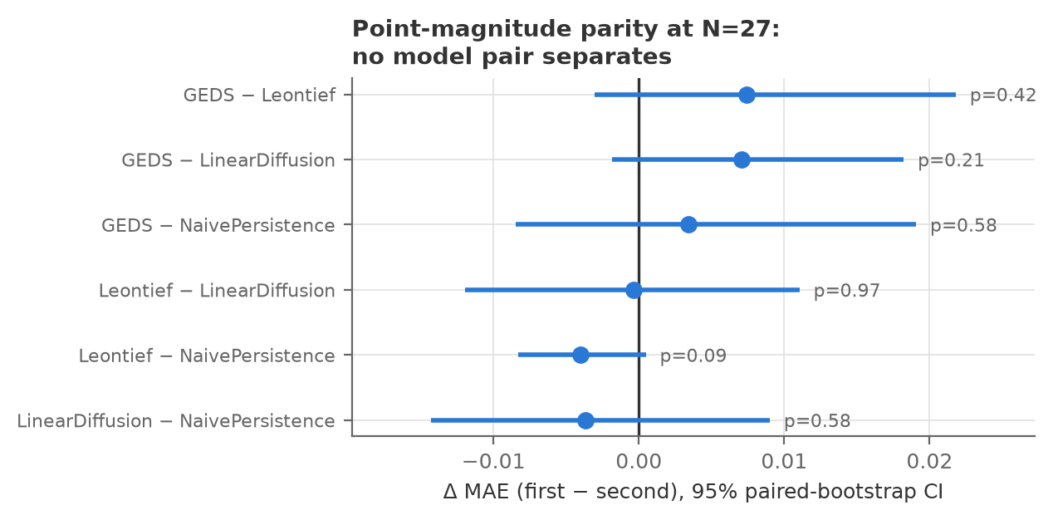
Figure 1. Pairwise MAE differences (first minus second) with 95% paired-bootstrap CIs and two-sided permutation p. All six pairs cross zero.

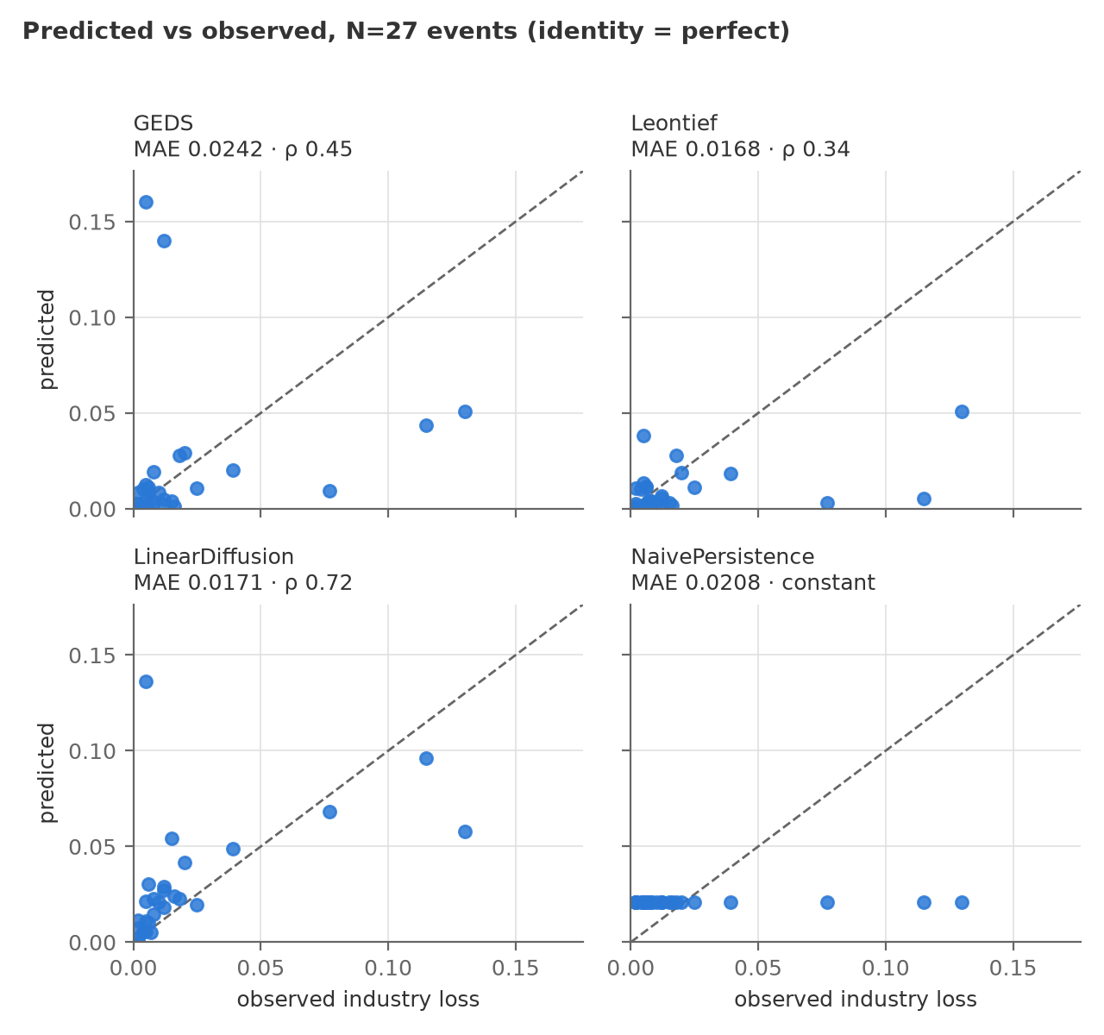
Figure 2. Predicted vs. observed per model, N=27; the dashed line is perfect agreement.

6.2. Track B: the trajectory axes separate the models
Neither Leontief nor the naive mean produces trajectories; linear diffusion gives a curve with no recovery. Only GEDS produces the full “peak → decay → recovery” shape — and on these axes the result is significant (Table 2). Recovery-duration ranking (0.88) is the strongest result; both timing CIs exclude zero. The magnitude axis at n=5 is statistically empty and is stated only as a limitation.

Table 2. Track B: node-level trajectory-shape axes (the only axes that only GEDS produces).
Axis | n | Spearman [95% CI] | MAE
Node peak magnitude | 5 | 0.60 [−1.00; 1.00] — not claimed | 0.42
Weeks to peak | 15 | 0.69 [0.20; 0.87] | 7.1 wk
Weeks to 90% recovery | 11 | 0.88 [0.56; 0.99] | 8.5 wk

Robustness to single points (jackknife). A leave-one-out test (drop each event and recompute Spearman) refutes the concern that a correlation rests on one point: for weeks-to-peak the full estimate is 0.691, LOO range [0.619; 0.790]; for recovery the full estimate is 0.883, LOO range [0.843; 0.917]. No single event drops the correlation below 0.62 and 0.84 respectively.
6.3. Mechanistic finding: why timing was at chance
Before this work weeks-to-peak scored Spearman 0.07 [−0.43; +0.53] — chance level. Forensics localized the cause: all three implemented forcing shapes (step, linear, exp) peak at onset, and the ratchet state update renders a declining forcing as a rectangular pulse — 12 of 15 predicted peaks fell on week 0. The engine lacked a “slowly rising shock” shape, which droughts, congestion and demand collapses require.
The fix: a ramp shape (linear rise) was added and four events were moved to it by real-world mechanism, declared before running. The pre-registered four-criterion gate passed: weeks-to-peak Spearman 0.07 → 0.69; other axes drop 0.00; benchmark cost +0.0001 MAE; untouched events bit-identical (Figure 3).

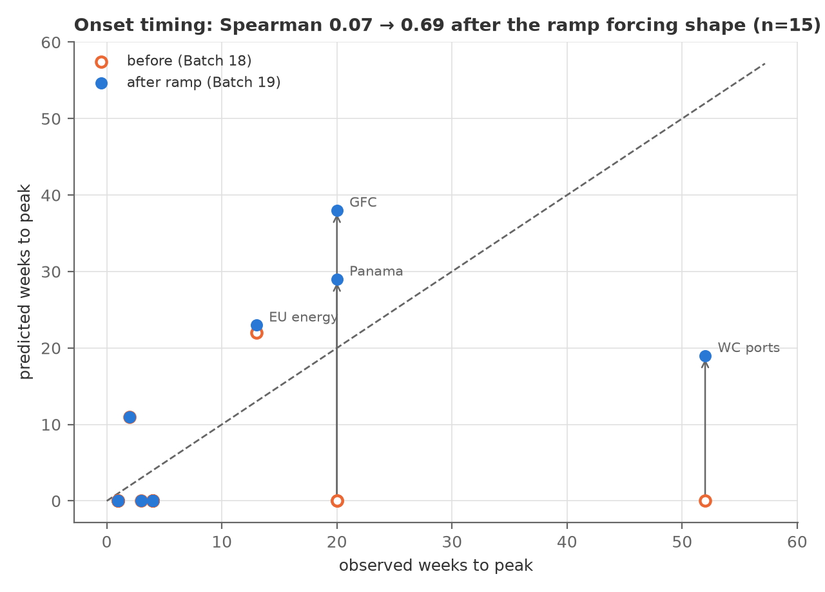
Figure 3. Weeks to peak: predicted vs. observed before (open) and after (filled) adopting the ramp shape; Spearman 0.07 → 0.69.

6.4. Out-of-sample check and power analysis
27-fold LOO with per-fold DE recalibration: MAE 0.0192, RMSE 0.0422, Pearson 0.25, Spearman 0.56, R² −0.70. Paired vs. Leontief: ΔMAE +0.0024 [−0.0073; +0.0167], p=0.89 — parity holds out-of-sample too. Two systematic misses are stated honestly: Chi-Chi 1999 (0.19 vs. 0.005 — the source node does not heal within the horizon) and the 2008–09 crisis (0.051 vs. 0.130 — a demand collapse is structurally unlike the supply cascades the engine models).
Parity is a power limit, not a proven equivalence (Table 3). At N=27 the minimum detectable effect for GEDS/Leontief is 0.0184, whereas the observed differences ~0.004–0.007 lie below resolution. Resolving the observed difference would require ≈166 events. This turns the null into a bounded, actionable statement and a target for the dataset.

Table 3. Power analysis: minimum detectable effect at N=27 and the N required for the observed difference.
Pair | obs. ΔMAE | MDE at N=27 | N to detect
GEDS vs Leontief | +0.0074 | 0.0184 | ≈166
GEDS vs linear diffusion | +0.0071 | 0.0149 | ≈119
Leontief vs naive | −0.0040 | 0.0064 | ≈69

6.5. Spatial: network completeness, not tuning
Same engine, same shocks — only the graph changes (Table 4). The dense graph closes exactly the gaps the hand-built one could not express (the Renesas-fire cascade into foreign automotive: 0/4 → 3/4). Onset order on reached nodes ranks well (Spearman 0.79). No parameter changed: the binding constraint is network completeness, not the fineness of the dynamics (Figure 4).

Table 4. Cascade spatial reach: hand-built graph v2 vs. the ICIO graph v3.
Graph | Nodes | Spatial recall
v2, hand-built | 36 | 0.29 (10/35)
v3, OECD ICIO 2019 | 405 | 0.79 (30/38)

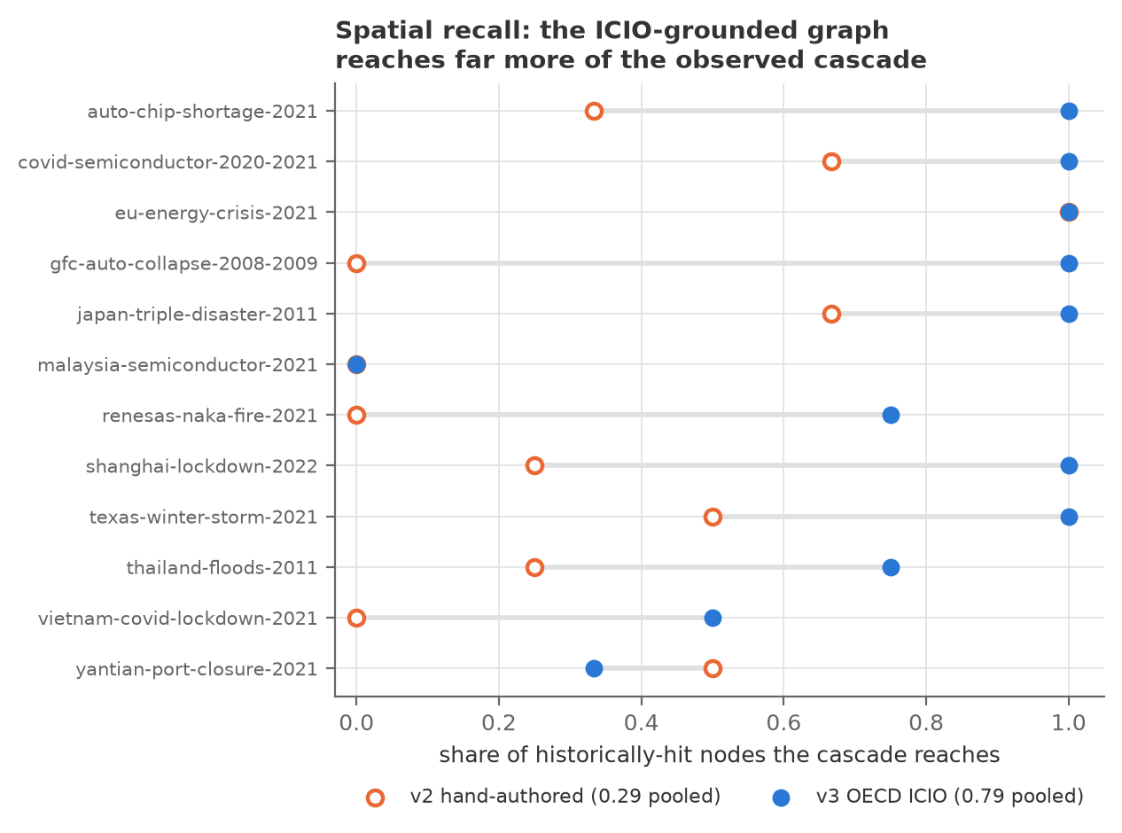
Figure 4. Cascade spatial reach per event: share of historically-hit nodes reached on the hand-built graph v2 (open) and the ICIO graph v3 (filled).

6.6. Component ablation: what of the complex model actually works
The standard question of a multi-component model is which parts carry weight. A component ablation (N=27, each component disabled in turn — Table 5) gives an uncomfortable but honest answer. Two components — the SEIS state machine and adaptive rerouting — contribute exactly zero on this set; the only component whose removal hurts is the bullwhip effect (+0.0023). Removing the R-state floor improves in-sample error (−0.0074), but that removal already failed the pre-registered out-of-sample gate (§5.3) and is rejected. Conclusion: at N=27 the engine's complexity largely does not pay off on the magnitude axis — consistent with §6.1 and pointing to growing N and the trajectory axes rather than adding mechanisms.

Table 5. Component ablation of the engine (N=27): each component's contribution to MAE.
Variant | MAE | ΔMAE vs. full
Full engine | 0.0242 | 0
−SEIS (no state machine) | 0.0242 | 0.0000
−adaptive rerouting | 0.0242 | 0.0000
−bullwhip (β = 1) | 0.0266 | +0.0023
−R-state floor | 0.0169 | −0.0074
+per-node recovery | 0.0233 | −0.0009
pure linear diffusion | 0.0171 | −0.0071

6.7. Parameter sensitivity and identifiability
A variance-based Sobol sensitivity analysis (1536 engine runs, output mean_industry_loss_MAE, N=27 — Table 6) asks whether the five parameters are identifiable. Two parameters carry the output variance — recovery_rate (ST 0.62) and inventory_scale (ST 0.59) — and their low first-order indices (S1 0.39 and 0.42) against high total effects signal strong interaction between them (ST sum ≈ 1.30 ≫ 1); two parameters are negligible and can be fixed, and one is minor. Thus three of five parameters are effectively non-identifiable individually, with the fitting freedom concentrated in a strongly-coupled (recovery_rate, inventory_scale) pair. This independently corroborates §6.6 (the model is over-complex relative to what the N=27 data can constrain) and explains why per-fold recalibration (§6.4) so easily masks structural edits. (MCMC at 350 steps did not converge, r̂=2.03; Bayesian intervals are left to a longer future run.)

Table 6. Sobol sensitivity indices (N=27): total effect ST and first-order S1 for the five parameters.
Parameter | ST | S1 | Reading
recovery_rate | 0.617 | 0.392 | variance + interactions
inventory_scale | 0.592 | 0.416 | variance + interactions
bullwhip_factor | 0.077 | 0.011 | minor
amplification_mu | 0.010 | 0.002 | negligible — can be fixed
distress_base | 0.000 | 0.000 | negligible — can be fixed

6.8. Structure versus tuning: the dense graph with a single parameter
Section 6.5 showed the ICIO graph reaches far more of the observed cascade, but its magnitudes were never scored: v3's parameters are uncalibrated structural priors and its predictions run roughly four times hot. Is that a shape error or a scale error?
It is scale. At default parameters the raw v3 ranks events markedly better than the fully calibrated v2 (Spearman 0.80 vs. 0.44) while systematically over-predicting (mean prediction 0.090 vs. observed 0.023). We added a single free quantity — a global scale factor fitted out-of-sample (leave-one-out: k is least-squares estimated on the other N−1 events and applied to the held-out one). Chokepoint events have no v3 representation, so all models are scored on the same 24 events (Table 7). The mean LOO factor k ≈ 0.26 is stable across folds.

Table 7. The dense ICIO graph with one out-of-sample scale factor versus the calibrated v2 engine and the zero-parameter baselines (same 24 events).
Model | Free params | MAE | Spearman
GEDS v3 + LOO scale | 1 | 0.0133 | +0.788
Leontief | 0 | 0.0182 | +0.331
Linear diffusion | 0 | 0.0185 | +0.707
Naive mean | 0 | 0.0227 | —
GEDS v2 (calibrated) | 5 | 0.0266 | +0.444
GEDS v3 raw (no scale) | 0 | 0.0677 | +0.802

This is the first configuration to lead every metric at once — achieved with one parameter instead of five. What we do not claim: no advantage is significant — against Leontief ΔMAE −0.0049 (p = 0.34), against linear diffusion −0.0052 (p = 0.50), against the naive mean −0.0094 (p = 0.06), against v2 −0.0132 (p = 0.17). The §6.1 parity finding is therefore not overturned but confirmed once more, now on the best available configuration: even it does not separate from the baselines at this N — exactly what the §6.4 power analysis predicts.
The substantive meaning lies elsewhere. Replacing the hand-built graph with measured input–output structure buys more on magnitude than calibrating five dynamics parameters on the hand-built graph (0.0133 vs. 0.0266) — the magnitude-axis counterpart of the spatial result in §6.5. Both point the same way: the information carried by network completeness and accuracy is not substitutable by parameter tuning.
6.9. Full v3 calibration: five parameters are significantly WORSE than one
The five-parameter LOO calibration on the dense graph (24 folds, per-fold differential evolution) was run and returns an unexpected result — Table 7. Pairwise, one parameter against five: ΔMAE = −0.0148, 95% CI [−0.0292, −0.0031], p = 0.037 — significant. This is the only statistically significant model difference anywhere in this work, and it concerns parsimony: on a 405-node graph with ~23 training events per fold, four extra degrees of freedom measurably hurt generalisation. It converges with §6.6 (two components contribute exactly zero) and §6.7 (three of five parameters non-identifiable) — three independent methods reaching the same over-parameterization verdict.

Table 7. Full out-of-sample comparison on the dense v3 graph (24 folds, leave-one-out).
Configuration | Params | MAE | Spearman
v3 + single LOO-fitted scale | 1 | 0.0133 | +0.788
v3 + five per-fold DE params | 5 | 0.0281 | +0.565
v2 + five calibrated params | 5 | 0.0266 | +0.444
Leontief / diffusion / naive | 0 | 0.0182 / 0.0185 / 0.0227 | —

6.10. The dense graph closes both structural walls
The two systematic misses declared unsolved in §6.4 — and resistant to three pre-registered mechanism experiments — nearly vanish on the dense graph (out-of-sample, LOO-DE): Chi-Chi 1999 absolute error 0.188 → 0.014 (13.6×) and the 2008–09 crisis 0.079 → 0.028 (2.9×). This changes the diagnosis of both. Chi-Chi failed to heal, and the 2008–09 crisis was under-predicted, not because the engine lacked a mechanism but because a hand-built 41-node graph could not express the paths along which those shocks actually travelled. The three attempts to fix the dynamics (§5.3) failed precisely because they treated the wrong cause. Both walls were network-coverage problems, not dynamics problems — the strongest confirmation of this paper's central claim.
Honest caveats to §6.9–6.10: the event set here is 24 (chokepoint-only events have no v3 node), so these numbers are not directly comparable with the headline N=27; and the model class (a scale correction) was chosen after v3's behaviour was known — the scale itself is fitted leave-one-out, but the choice of that correction form was not pre-registered. The advantage over the zero-parameter baselines remains non-significant (p = 0.06–0.50), so the §6.1 parity headline stands.
7. Discussion
Three results combine into one conclusion. (1) On the axis almost every paper reports — point magnitude — four fundamentally different models are statistically indistinguishable, and this is not an artifact of weak tuning: the parity survives per-fold recalibration and is quantitatively power-limited. (2) The axes that do separate the models are temporal and spatial: where only a full dynamic model can even compete, its results are significant (0.69 and 0.88). (3) The largest measured quality gain came not from dynamics but from network-structure data (recall 0.29 → 0.79, free in parameters).
Practical takeaway: cascade models should be validated by “predict the pattern, not one number,” or leaderboards compare noise. Methodological takeaway: pre-registering gates turns negative results into publishable assets.
8. Limitations
— N=27 for Track A and n=5/15/11 for Track B — power is limited; absence of significance is not equivalence (§6.4).
— The node-magnitude axis is empty (n=5, CI [−1; 1]): monthly fab-output indices are seldom published.
— Two structural misses (Chi-Chi, the 2008–09 crisis) are described but not solved; three fix attempts were rejected by the out-of-sample gate.
— Baselines are canonical rather than published implementations: comparison against published cascade models [11,12] is the next step.
— Graph completeness: v2 omits several real producers; v3 (405 nodes) is not yet calibrated on magnitudes.
9. Reproducibility
The engine configuration is pinned (fixed seeds, stochasticity off); results are frozen by golden tests, and any numeric change is an explicit diff in the same commit. The statistical layer is deterministic (seed 20260718). The headline-numbers document and all figures are generated by scripts from artifacts; each figure ships with its numeric table. 157 automated tests. Exact commands are in Appendix B.
10. Conclusion and Future Work
The benchmark and three-axis validation give a way to tell cascade models apart in a statistically honest manner. Next: grow N via chokepoint events (IMF PortWatch transit data sidesteps the aggregate-dilution problem); calibrate magnitudes on the 405-node ICIO graph; a demand-side mechanism for 2008–09-type events; and releasing the benchmark as an open standard for third-party models.
Back matter
Data and code availability. All data, engine code, validation scripts and artifacts are open in the project repository; every calibration target carries a primary source. Numbers reproduce via the Appendix B commands.
Author contributions. [Complete per CRediT: conceptualization, methodology, software, validation, formal analysis, writing — original draft / review & editing, visualization.]
Funding. [This research received no external funding / state the grant.]
Institutional review. Not applicable (no human or animal subjects; only aggregate open economic data).
Conflicts of interest. The author(s) declare no conflict of interest.
References
1. Acemoglu, D.; Carvalho, V.M.; Ozdaglar, A.; Tahbaz-Salehi, A. The Network Origins of Aggregate Fluctuations. Econometrica 2012, 80, 1977–2016. doi:10.3982/ECTA9623.
2. Acemoglu, D.; Ozdaglar, A.; Tahbaz-Salehi, A. Microeconomic Origins of Macroeconomic Tail Risks. American Economic Review 2017, 107, 54–108. doi:10.1257/aer.20151086.
3. Baqaee, D.R. Cascading Failures in Production Networks. Working Paper 2016.
4. Bigio, S.; La'O, J. Distortions in Production Networks. Quarterly Journal of Economics 2020, 135, 2187–2253. doi:10.1093/qjecon/qjaa002.
5. Carvalho, V.M.; Nirei, M.; Saito, Y.U.; Tahbaz-Salehi, A. Supply Chain Disruptions: Evidence from the Great East Japan Earthquake. Quarterly Journal of Economics 2021, 136, 1255–1321. doi:10.1093/qje/qjaa044.
6. Barrot, J.-N.; Sauvagnat, J. Input Specificity and the Propagation of Idiosyncratic Shocks in Production Networks. Quarterly Journal of Economics 2016, 131, 1543–1592. doi:10.1093/qje/qjw018.
7. Boehm, C.E.; Flaaen, A.; Pandalai-Nayar, N. Input Linkages and the Transmission of Shocks: Firm-Level Evidence from the 2011 Tōhoku Earthquake. Review of Economics and Statistics 2019, 101, 60–75. doi:10.1162/rest_a_00750.
8. Gabaix, X. The Granular Origins of Aggregate Fluctuations. Econometrica 2011, 79, 733–772. doi:10.3982/ECTA8769.
9. di Giovanni, J.; Levchenko, A.A. Country Size, International Trade, and Aggregate Fluctuations in Granular Economies. Journal of Political Economy 2012, 120, 1083–1132. doi:10.1086/669161.
10. Oberfield, E.; et al. Aggregate Fluctuations in Adaptive Production Networks. PNAS 2022, 119, e2203730119. doi:10.1073/pnas.2203730119.
11. Inoue, H.; Todo, Y. Firm-Level Propagation of Shocks Through Supply-Chain Networks. Nature Sustainability 2019, 2, 841–847. doi:10.1038/s41893-019-0357-z.
12. Otto, C.; Willner, S.N.; Wenz, L.; Frieler, K.; Levermann, A. Modeling Loss-Propagation in the Global Supply Network: The Dynamic Agent-Based Model Acclimate. Journal of Economic Dynamics & Control 2017, 83, 232–269. doi:10.1016/j.jedc.2017.08.001.
13. Allen, F.; Gale, D. Financial Contagion. Journal of Political Economy 2000, 108, 1–33. doi:10.1086/262109.
14. Gai, P.; Kapadia, S. Contagion in Financial Networks. Proceedings of the Royal Society A 2010, 466, 2401–2423. doi:10.1098/rspa.2009.0410.
15. Battiston, S.; Delli Gatti, D.; Gallegati, M.; Greenwald, B.; Stiglitz, J.E. Liaisons Dangereuses: Increasing Connectivity, Risk Sharing, and Systemic Risk. Journal of Economic Dynamics & Control 2012, 36, 1121–1141. doi:10.1016/j.jedc.2012.04.001.
16. Elliott, M.; Golub, B.; Jackson, M.O. Financial Networks and Contagion. American Economic Review 2014, 104, 3115–3153. doi:10.1257/aer.104.10.3115.
17. Haldane, A.G.; May, R.M. Systemic Risk in Banking Ecosystems. Nature 2011, 469, 351–355. doi:10.1038/nature09659.
18. Eichenbaum, M.S.; Rebelo, S.; Trabandt, M. The Macroeconomics of Epidemics. Review of Financial Studies 2021, 34, 5149–5187. doi:10.1093/rfs/hhab040.
19. Coquidé, C.; Lages, J.; Shepelyansky, D.L. Crisis Contagion in the World Trade Network. Applied Network Science 2020, 5, 67. doi:10.1007/s41109-020-00304-z.
20. Acemoglu, D.; Ozdaglar, A.; Tahbaz-Salehi, A. Systemic Risk and Stability in Financial Networks. American Economic Review 2015, 105, 564–608. doi:10.1257/aer.20130456.
21. Starnini, M.; Boguñá, M.; Serrano, M.Á. Shock Propagation on Global Trade-Investment Multiplex Networks. Scientific Reports 2019, 9, 13079. doi:10.1038/s41598-019-49173-2.
22. Hidalgo, C.A.; Hausmann, R. The Building Blocks of Economic Complexity. PNAS 2009, 106, 10570–10575. doi:10.1073/pnas.0900943106.
23. Caliendo, L.; Parro, F.; Rossi-Hansberg, E.; Sarte, P.-D. The Impact of Regional and Sectoral Productivity Changes on the U.S. Economy. Review of Economic Studies 2018, 85, 2042–2096. doi:10.1093/restud/rdx082.
24. Eaton, J.; Kortum, S. Technology, Geography, and Trade. Econometrica 2002, 70, 1741–1779. doi:10.1111/1468-0262.00352.
25. OECD. Inter-Country Input-Output (ICIO) Tables, 2025 Edition (Year 2019); OECD: Paris, 2025.
26. International Monetary Fund. PortWatch: Daily Chokepoint Transit Data; IMF: Washington, DC, 2021–2024.
27. OICA; JAMA; VDA; SIA. Industry Motor-Vehicle and Semiconductor Production Statistics, 1999–2023.
Appendix A. Full event benchmark (N=27)
Generated from seed_data.py; per-event primary sources are line-by-line in historical_events.csv. “Magn.” is the source-side shock magnitude (model input), “Target” is the observed loss (validation output).

# | Event | Node | Magn. | Dur. | Target
1 | covid-semiconductor-2020-2021 | TWN:semiconductors | 0.30 | 26 | 0.115
2 | suez-canal-2021 | CP:Suez | 0.90 | 2 | 0.008
3 | auto-chip-shortage-2021 | TWN:semiconductors | 0.18 | 30 | 0.077
4 | japan-triple-disaster-2011 | JPN:automotive | 0.40 | 12 | 0.039
5 | us-china-tariffs-2019 | CHN:electronics | 0.12 | 52 | 0.020
6 | texas-winter-storm-2021 | USA:semiconductors | 0.15 | 6 | 0.005
7 | eu-energy-crisis-2021 | DEU:automotive | 0.08 | 24 | 0.015
8 | malaysia-semiconductor-2021 | MYS:semiconductors | 0.30 | 10 | 0.012
9 | thailand-floods-2011 | THA:automotive | 0.65 | 10 | 0.025
10 | kumamoto-earthquake-2016 | JPN:semiconductors | 0.20 | 6 | 0.006
11 | renesas-naka-fire-2021 | JPN:semiconductors | 0.28 | 13 | 0.016
12 | japan-korea-export-controls-2019 | KOR:semiconductors | 0.06 | 12 | 0.002
13 | vietnam-covid-lockdown-2021 | VNM:electronics | 0.30 | 10 | 0.012
14 | shanghai-lockdown-2022 | CHN:automotive | 0.45 | 8 | 0.018
15 | ukraine-war-harness-2022 | DEU:automotive | 0.16 | 10 | 0.012
16 | china-power-crunch-2021 | CHN:electronics | 0.12 | 6 | 0.005
17 | yantian-port-closure-2021 | CHN:shipping | 0.07 | 4 | 0.006
18 | us-west-coast-ports-2021 | USA:shipping | 0.30 | 20 | 0.008
19 | red-sea-crisis-2023 | CP:Suez | 0.55 | 40 | 0.010
20 | taiwan-drought-2021 | TWN:semiconductors | 0.04 | 16 | 0.002
21 | india-covid-wave-2021 | IND:automotive | 0.35 | 6 | 0.004
22 | taiwan-chichi-earthquake-1999 | TWN:semiconductors | 0.90 | 2 | 0.005
23 | hurricane-harvey-2017 | USA:consumer_goods | 0.07 | 4 | 0.002
24 | us-west-coast-ports-2015 | USA:shipping | 0.06 | 18 | 0.007
25 | korea-trucker-strikes-2022 | KOR:automotive | 0.50 | 1 | 0.002
26 | panama-canal-drought-2023 | CP:Panama | 0.30 | 30 | 0.005
27 | gfc-auto-collapse-2008-2009 | USA:automotive | 0.47 | 39 | 0.130

Appendix B. Reproducibility
All numbers in the paper regenerate from the repository:
cd backend
python -m scripts.significance_analysis # significance.json (6.1, 6.2)
python -m scripts.power_analysis # power_analysis.json (6.4)
python -m scripts.isef_figures # 4 figures + CSVs
python -m scripts.results_onepager # docs/RESULTS.md
python -c 'from app.core.ablation import run_ablation_study,save_ablation;
save_ablation(run_ablation_study())' # ablation (6.6)
python -c 'from app.core.sensitivity import run_sobol,save_sobol;
save_sobol(run_sobol())' # Sobol (6.7)
python -m pytest --ignore=tests/test_portwatch.py # 157 tests

