Proposal: Deployment of the Log Pull Analyzer Tool for QA Team
1. Executive Summary
I have developed an internal tool called the Log Pull Analyzer, designed to significantly improve the efficiency, accuracy, and consistency of analyzing broadband gateway log pulls.
This tool automates several manual steps that engineers currently perform, reducing analysis time from 30–45 minutes per log pull to under 2 minutes.
To enable the team to use this tool daily, I am requesting permission to deploy it on an internal Windows PC so it can be accessed through a secure internal URL.
2. Problem Statement
Today, our QA engineers manually analyze log pulls from broadband gateways. This process is:
❌ Time-consuming
Engineers must:
- Extract archives manually
- Search through multiple log files
- Identify key events
- Detect anomalies
- Summarize findings
This often takes 30–45 minutes per device, depending on log size.
❌ Error-prone
Manual scanning leads to:
- Missed events
- Inconsistent interpretations
- Delayed debugging
❌ Not scalable
As we test more devices and firmware builds, manual log analysis becomes a bottleneck.
3. The Solution: Log Pull Analyzer
I built a Streamlit-based web application that automates the entire log analysis workflow.
Key Capabilities
- Upload ZIP/7Z/TGZ/TAR log pulls
- Auto-extract and parse logs
- Detect anomalies using rule-based and keyword-based scanning
- Color-coded severity classification
- Interactive charts (Plotly)
- Dark mode
- Tabs for Logs, Anomalies, Summary, and Report
- Exportable PDF/HTML reports
- Clean, modern UI
- Runs on any browser — no installation needed for team members
4. Benefits to the Team
⏱ 1. Saves Time
Reduces log analysis time from 45 minutes → under 2 minutes.
🎯 2. Improves Accuracy
Automated detection ensures:
- No missed events
- Consistent interpretation
- Faster root-cause identification
📊 3. Better Visibility
Interactive charts help engineers:
- Visualize error spikes
- Track event timelines
- Compare builds
📄 4. Professional Reports
Engineers can export:
- PDF reports
- HTML reports
These can be attached to Jira tickets or shared with development teams.
🌐 5. Accessible to Everyone
Once deployed on an internal PC:
- No installation needed
- Accessible via browser
- Works on Windows, Mac, Linux
🔒 6. Secure
Runs entirely inside our internal network.
5. Deployment Plan (Simple & Safe)
The tool will be hosted on an internal Windows PC using:
- Python
- Streamlit
- NSSM (to run as a Windows service)
- Internal firewall rules
Team members will access it via:
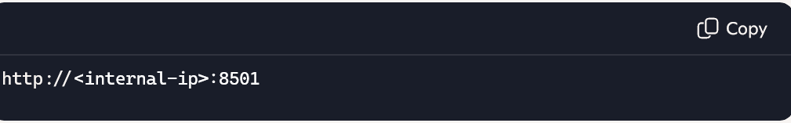
No external exposure.
No cloud dependency.
No security risk.
6. Sample UI Screenshots (Text Mockups)
Dashboard Home
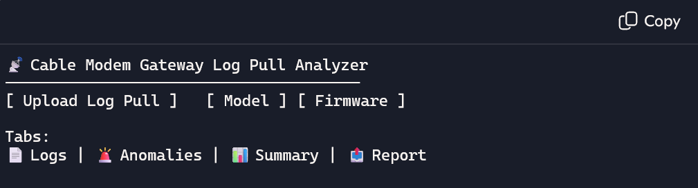
Anomalies (Color-coded)
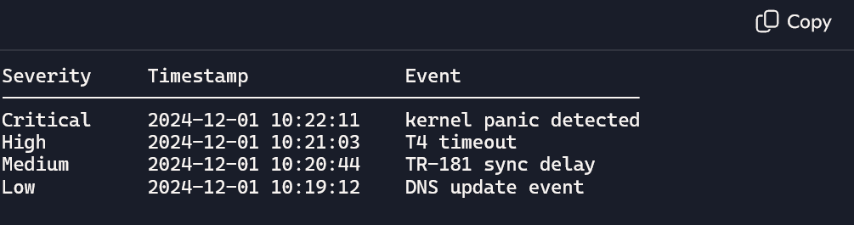
Interactive Charts
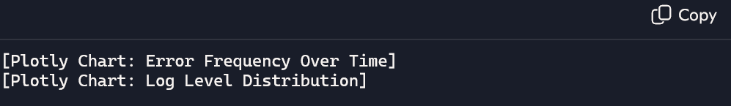
Export Report
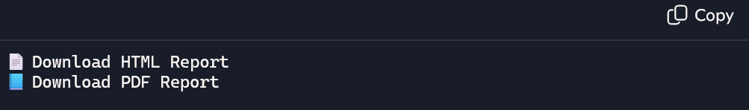
7. Request for Approval
To enable the QA team to use this tool daily, I request approval to:
✔ Host the Log Pull Analyzer on an internal Windows PC
✔ Open port 8501 on the internal firewall
✔ Run the tool as a Windows service for 24/7 availability
This setup is lightweight, secure, and requires minimal maintenance.
8. Expected Impact
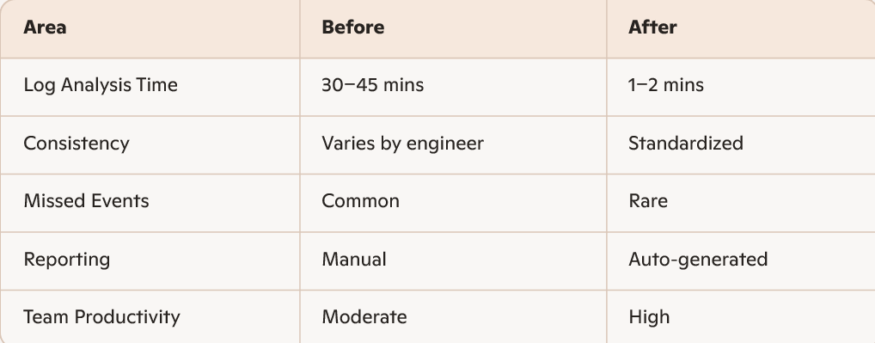
9. Conclusion
The Log Pull Analyzer directly supports our goals of:
- Faster validation cycles
- Higher QA efficiency
- Better firmware quality
- Reduced manual workload
With your approval, we can deploy this tool internally and immediately improve our daily workflow.

