LogiScope
Logistics Performance Analysis and Visualization
Project overview: name, description and image suggestions

1. Project Name
Chosen name: LogiScope: Logistics Performance Analysis and Visualization
Alternative names: FreightInsight, Shipment Analytics Dashboard, LogiViz

2. Short Description
A Python-based exploratory data analysis and visualization project on a simulated logistics dataset of 1,500 shipments. It identifies cost drivers, delivery delays and operational bottlenecks across hubs, carriers and transport modes.

3. Full Description
LogiScope simulates a year of shipment data (2025) covering five origin hubs, four carriers and four transport modes, with variables such as distance, weight, volume, planned and actual delivery time, and cost. Using pandas, NumPy, matplotlib and seaborn, the project runs a full exploratory analysis (central tendency, distributions, correlations and regression) and produces eight visualizations: a histogram, box plots, a correlation heatmap, a scatter plot, a trend chart, a carrier ranking, a bottleneck heatmap and a regression plot.
The findings show that delays concentrate in one carrier, two hubs and the October-December peak season, while air freight drives most of the cost. The project ends with prioritized recommendations for improving on-time performance and reducing cost.

4. Tech Stack and Keywords
Item | Details
Tech stack | Python, pandas, NumPy, matplotlib, seaborn
Keywords | logistics, supply chain analytics, EDA, data visualization, delivery performance, cost analysis
Deliverables | Word report, logistics_analysis.py, logistics_data.csv

5. Image Suggestions
Use charts you already have
- Hero or thumbnail: the hub-by-month bottleneck heatmap (fig7_heat.png). It is the most striking and tells the main story at a glance.
- Second choice: the monthly volume vs delay chart (fig5_trend.png), which shows the October-December spike.
- Gallery row: fig2_box.png, fig4_scatter.png and fig6_carrier.png together show the range of chart types.
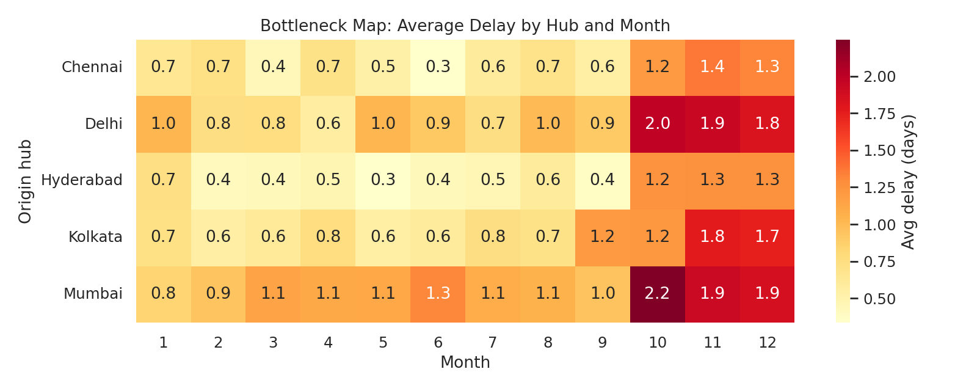
Suggested hero image: bottleneck heatmap (delay by hub and month)
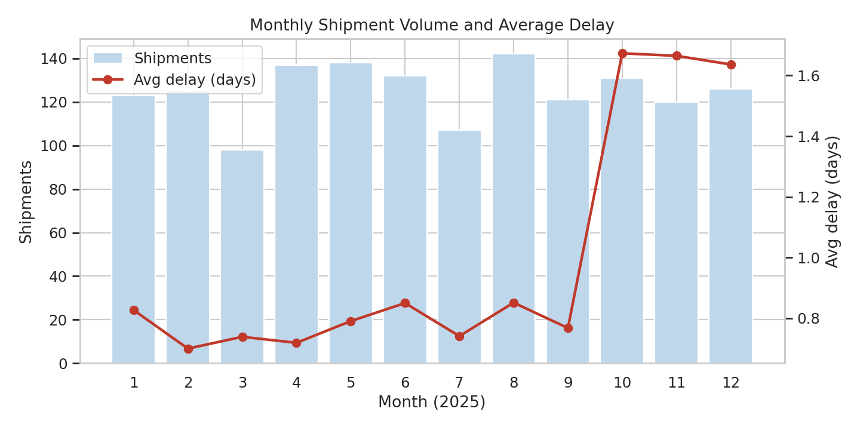
Second choice: monthly shipment volume and average delay
Cover or banner ideas
- A 2x2 collage of four charts (heatmap, scatter, box plot, bar chart) with the project name over it.
- A dark banner with the title and a faint India route map, with glowing lines connecting the hub cities (Hyderabad, Mumbai, Delhi, Chennai, Kolkata).
- A flat illustration of a truck, cargo plane, train and ship in a row, with a small rising bar chart behind them.
Stock photo search terms
- warehouse logistics aerial view
- cargo containers port sunset
- supply chain network abstract
Free sources such as Unsplash or Pexels work well; credit the photographer if the licence asks for it.
Practical tips
- Keep a consistent palette: dark blue (#1F4E79) with red and orange accents matches the report.
- Keep text on images short (project name plus a one-line tagline) so it stays readable as a thumbnail.

