WEEK 4 TASK
Optimization in Logistics Systems
Predicting shipment delay with machine learning and using the predictions to optimize carrier allocation and proactive intervention
Project: LogiScope (continuation of the Week 3 analysis; same 1,500-shipment dataset)
Tools: Python 3, pandas, NumPy, scikit-learn, SciPy (linear programming), matplotlib, seaborn
Deliverables: this report, logistics_model.py, logistics_data.csv

Contents

1. Executive Summary
Week 3 showed where delivery performance fails. This report goes one step further: it builds a model that predicts how many days late each shipment will be at the moment it is dispatched, and then uses those predictions to decide what to change. The work has three parts: a predictive model, a validation of that model, and two optimization methods that turn predictions into decisions.
Headline results
- Prediction problem: forecast delay_days (actual minus planned delivery time) for each shipment from information known at dispatch. Five models were compared with 5-fold cross-validation on 1200 training shipments and evaluated on 300 held-out shipments.
- Model performance: the tuned Gradient Boosting model reached an RMSE of 0.631 days, MAE of 0.472 days and R-squared of 0.469 on unseen data, against an RMSE of 0.866 for a naive "predict the average" baseline (a 27% error reduction). Plain linear regression performed equally well (RMSE 0.627), which is explained in Section 8.
- What drives delay: carrier is the strongest predictor by a wide margin, followed by origin hub and the time of year. Distance, weight and transport mode add almost nothing once those are known.
- Optimization A, carrier allocation (linear programming): moving about 300 shipments away from Carrier C, within a +25% capacity limit on the other carriers, lowers the predicted average delay from 1.00 to 0.82 days (17.4%) and cuts predicted late shipments (more than one day) from 621 to 442.
- Optimization B, risk-based intervention: flagging only shipments with a high predicted delay is the economic way to intervene. Blanket intervention loses money under the stated assumptions, while a threshold policy breaks even or gains, depending on how cheap and effective the intervention is (Section 11).
Important caveat. The dataset is simulated and the cost figures (delay penalty, intervention cost and effectiveness) are stated assumptions. The numbers show how the method works and how large effects could be; they are not claims about a real company.

2. Problem Definition

2.1 The business problem
A logistics operator promises a delivery time when a shipment is booked. When the shipment arrives later than promised, the operator pays in customer penalties, re-planning effort and lost goodwill. In the Week 3 analysis, 41% of shipments arrived more than one day late, and the lateness was concentrated in particular carriers, hubs and months. The operator cannot fix this with averages: it needs to know which individual shipments are at risk, and which levers reduce that risk most.

2.2 Prediction target
The model predicts delay_days = actual delivery days minus planned delivery days, in days, as a continuous (regression) target. Delay was chosen over raw delivery time for two reasons:
- Delay is the quantity that actually costs money. A 6-day sea shipment arriving in 6 days is a success; a 2-day air shipment arriving in 4 days is not.
- Raw delivery time is mostly explained by distance and mode, which the operator already knows when it sets the plan. Delay isolates the part that is uncertain and actionable.

2.3 Prediction moment and leakage control
The model is meant to run at dispatch, so it may only use information available then. The columns actual_days, on_time and cost_per_kg are excluded because they are only known after delivery (or are derived from the target). The promised planned_days is known at booking, so it is allowed. Excluding post-delivery columns is the single most important step for avoiding data leakage, which would make the model look far better than it would behave in practice.

3. Dataset and Features
The model uses the simulated LogiScope dataset from Week 3: 1,500 shipments dispatched across calendar year 2025 from five hubs, with four carriers and four transport modes. In the simulation, delay is driven by carrier quality, hub congestion and a peak-season effect (October-December), reduced slightly for Express shipments, plus random noise. The model is not told this; it has to discover it from the data.
Table 1. Model inputs and target
Variable | Type | Role | Known at dispatch?
distance_km | Numeric | Feature | Yes
weight_kg | Numeric | Feature | Yes
volume_m3 | Numeric | Feature | Yes
planned_days | Numeric | Feature | Yes (promised time)
month | Numeric | Feature | Yes
is_peak | Binary | Feature (1 if Oct-Dec) | Yes
origin_hub | Categorical (5) | Feature | Yes
transport_mode | Categorical (4) | Feature | Yes
carrier | Categorical (4) | Feature | Yes
priority | Categorical (2) | Feature | Yes
delay_days | Numeric | TARGET | No (outcome)

3.1 Data preparation
- Categorical features are one-hot encoded; numeric features are standardized (zero mean, unit variance). Standardization matters for linear and ridge models and is harmless for tree models.
- The data is split 80/20 into 1200 training and 300 test shipments with a fixed random seed. The test set is never used for model selection or tuning.
- All preprocessing is placed inside a scikit-learn Pipeline, so that scaling and encoding statistics are learned from the training folds only. This prevents information from the validation folds leaking into training during cross-validation.
Code excerpt 1. Preparation, split and preprocessing pipeline
df["is_peak"] = df.month.isin([10, 11, 12]).astype(int)

TARGET = "delay_days"
num_feats = ["distance_km", "weight_kg", "volume_m3", "planned_days", "month", "is_peak"]
cat_feats = ["origin_hub", "transport_mode", "carrier", "priority"]
X, y = df[num_feats + cat_feats], df[TARGET]

X_train, X_test, y_train, y_test = train_test_split(X, y, test_size=0.2, random_state=42)

prep = ColumnTransformer([
("num", StandardScaler(), num_feats),
("cat", OneHotEncoder(handle_unknown="ignore"), cat_feats),
])
make = lambda model: Pipeline([("prep", prep), ("model", model)])

4. Model Selection
Five candidate models were chosen to span the range from simple and interpretable to flexible and powerful, plus a naive baseline. A model is only useful if it beats the baseline, and the comparison shows whether extra complexity is worth it.
Table 2. Candidate models and rationale
Model | Why it was included | Main weakness
Mean baseline | Predicts the training average for every shipment. Sets the minimum bar. | Ignores all information
Linear Regression | Fast, transparent, coefficients readable by managers; strong when effects are additive. | Cannot capture interactions or non-linearity
Ridge Regression | Linear model with L2 regularization to stabilize coefficients with correlated inputs (weight and volume are correlated at 0.95). | Same linearity limit
Decision Tree (depth 6) | Captures non-linear rules and interactions; easy to visualize. | High variance; overfits easily
Random Forest | Averages many trees to reduce variance; handles mixed features without scaling. | Less interpretable; can overfit noise
Gradient Boosting | Builds trees sequentially, each correcting the previous errors; often the best tabular model. | Needs tuning; slower to train

Code excerpt 2. Candidate models
models = {
"Linear Regression": LinearRegression(),
"Ridge Regression": Ridge(alpha=1.0),
"Decision Tree": DecisionTreeRegressor(max_depth=6, random_state=42),
"Random Forest": RandomForestRegressor(n_estimators=200,
random_state=42),
"Gradient Boosting": GradientBoostingRegressor(random_state=42),
}

5. Evaluation Metrics and Validation Strategy

5.1 Metrics
- MAE (mean absolute error): the average size of the error in days. Easy to explain to operations staff ("the forecast is off by about half a day on average").
- RMSE (root mean squared error): also in days, but squaring penalizes large misses more heavily. This matters in logistics because a few very late shipments cause most of the damage. RMSE is the main selection metric.
- R-squared: the share of variance in delay that the model explains (0 = no better than the average, 1 = perfect). Useful for judging how much is predictable.

5.2 Cross-validation
Models were compared with 5-fold cross-validation on the training data: the training set is split into five parts, each part is used once for validation while the other four train the model, and the five scores are averaged. This gives a far more stable estimate than a single split and also gives a standard deviation, which shows whether differences between models are real or just noise. The 300-shipment test set was kept untouched until the very end.
Code excerpt 3. Cross-validated comparison
kf = KFold(n_splits=5, shuffle=True, random_state=42)
for name, m in models.items():
pipe = make(m)
rmse = -cross_val_score(pipe, X_train, y_train, cv=kf,
scoring="neg_root_mean_squared_error")
r2 = cross_val_score(pipe, X_train, y_train, cv=kf, scoring="r2")
print(name, rmse.mean().round(3), "+/-", rmse.std().round(3),
r2.mean().round(3))

Table 3. 5-fold cross-validation results (training data)
Model | CV RMSE (days) | Std dev | CV R-squared
Mean baseline | 0.838 | - | 0.000
Linear Regression | 0.610 | 0.025 | 0.467
Ridge Regression | 0.610 | 0.025 | 0.467
Decision Tree | 0.710 | 0.025 | 0.280
Random Forest | 0.656 | 0.023 | 0.384
Gradient Boosting | 0.634 | 0.031 | 0.424

Every model beats the baseline (RMSE 0.838). Linear and Ridge regression lead (RMSE 0.610, R-squared 0.467), followed by default Gradient Boosting (0.634). Random Forest and the Decision Tree are worse, a sign that they are fitting noise. Linear and Ridge are identical to three decimals because the data has few features and plenty of rows, so regularization has nothing to fix.

6. Hyperparameter Tuning
Gradient Boosting has several settings that control how closely it fits the training data. A grid search with the same 5-fold cross-validation tried all 54 combinations of the settings below and kept the one with the lowest CV RMSE.
Code excerpt 4. Grid search
gb_grid = {"model__n_estimators": [100, 200, 300],
"model__max_depth": [2, 3, 4],
"model__learning_rate": [0.03, 0.05, 0.1],
"model__subsample": [0.8, 1.0]}

gs = GridSearchCV(make(GradientBoostingRegressor(random_state=42)), gb_grid,
cv=kf, scoring="neg_root_mean_squared_error", n_jobs=-1)
gs.fit(X_train, y_train)
best = gs.best_estimator_

Result. The best combination was n_estimators = 200, max_depth = 2, learning_rate = 0.03 and subsample = 0.8, with a CV RMSE of 0.616 (an improvement from 0.634 for the default settings). The winning model is shallow and learns slowly, which is the model telling us that the signal in this data is simple and the rest is noise: deeper, faster models only memorize noise (Figure 1).
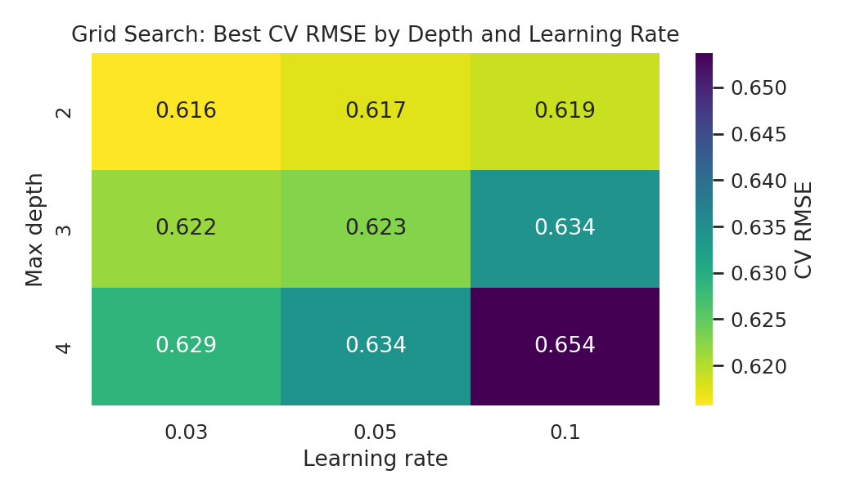
Figure 1. Grid search results: lower CV RMSE is better. Shallow, slow-learning models win.
Note on the search range. The best values for depth and learning rate sit at the lowest edge of the grid, so an even shallower or slower model might do slightly better. The gains between neighbouring cells are tiny (0.616 versus 0.617), so extending the grid would not change the conclusions.

7. Final Model Evaluation
Each model was refit on the full training set and scored once on the held-out test shipments. The test set only gives an honest estimate if it is used exactly once, so no choices were made after seeing these results.
Table 4. Test-set performance (300 unseen shipments)
Model | MAE (days) | RMSE (days) | R-squared
Mean baseline | 0.681 | 0.866 | 0.000
Linear Regression | 0.467 | 0.627 | 0.476
Decision Tree | 0.491 | 0.655 | 0.428
Random Forest | 0.503 | 0.671 | 0.400
Gradient Boosting (tuned) | 0.472 | 0.631 | 0.469

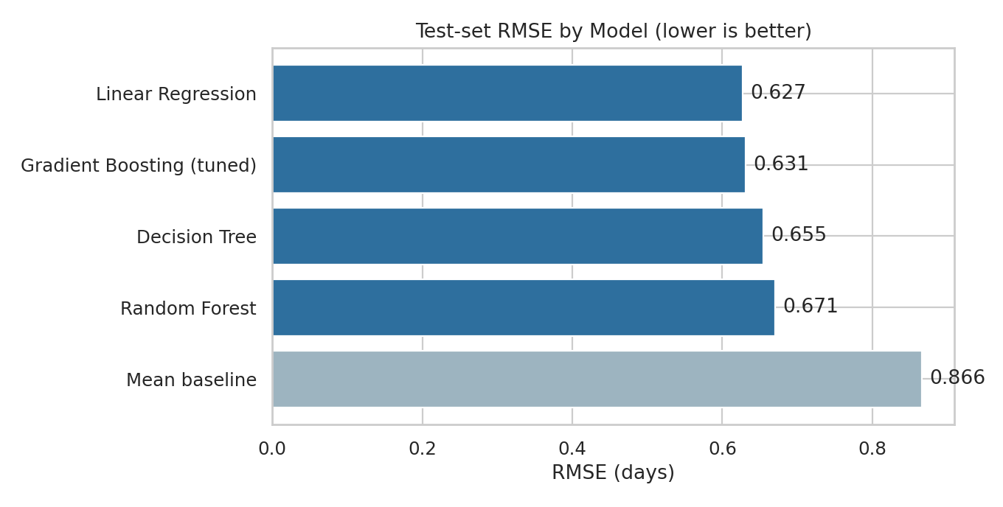
Figure 2. Test-set RMSE by model. All real models clearly beat the baseline.
Reading the results. The tuned Gradient Boosting model explains 47% of the variance in delay and is typically off by 0.47 days (MAE). Linear regression is marginally better (RMSE 0.627 versus 0.631), but that gap of 0.004 days is far smaller than the cross-validation standard deviation of about 0.025, so the two are statistically indistinguishable. Random Forest and the Decision Tree are the weakest of the four.
The remaining unexplained 53% of variance is not a failure of the model. In this dataset, a large part of each delay is random (weather, breakdowns, handling errors in real life), and no model can predict randomness. In the simulation the random component has a standard deviation of about 0.6 days, and the best models reach an RMSE of 0.63, which means they are close to the best achievable accuracy. A real dataset would have a different noise level, which is why a baseline comparison is always needed.

8. Model Diagnostics and Insights

8.1 Predictions and residuals
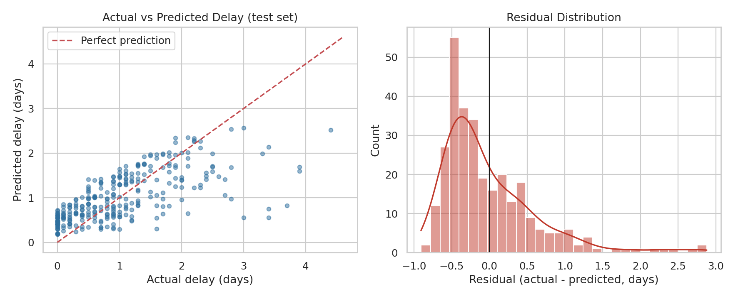
Figure 3. Left: actual versus predicted delay on the test set. Right: distribution of residuals.
- Unbiased on average: the mean residual is -0.011 days, essentially zero, with a standard deviation of 0.63 days.
- Under-predicts the worst delays: the residual histogram has a long right tail, and in the scatter plot the points at the far right (actual delays of 3-4 days) lie well below the red diagonal. The model regresses towards the mean and cannot foresee the rare extreme delays. For planning, this means predictions are best used to rank shipments by risk, and a safety margin should be added when promising delivery windows.

8.2 What drives delay
Permutation importance measures how much the test error rises when one feature's values are randomly shuffled. A large increase means the model relies heavily on that feature.
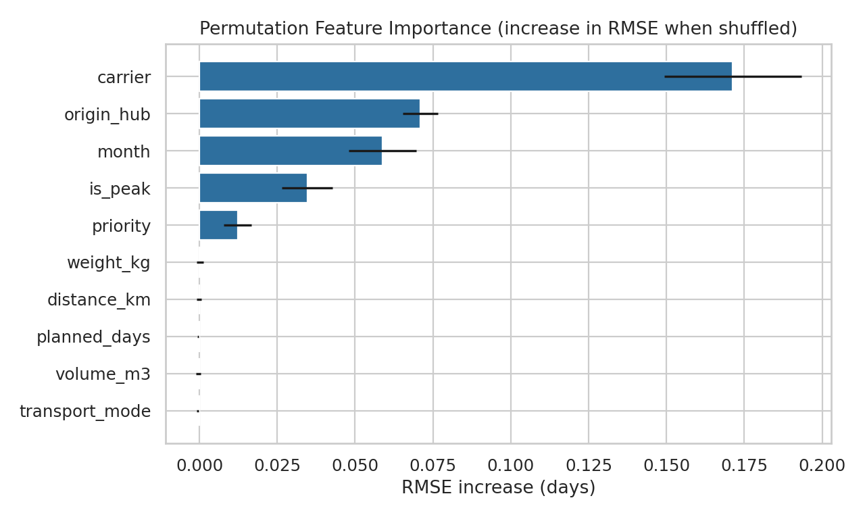
Figure 4. Permutation feature importance for the tuned model.
Table 5. Feature importance (increase in RMSE when shuffled)
Feature | RMSE increase (days) | Interpretation
carrier | 0.171 | Dominant driver; the choice of carrier matters most
origin_hub | 0.071 | Hub congestion (Mumbai and Delhi) is the second driver
month | 0.059 | Seasonal pattern; shares information with is_peak
is_peak | 0.035 | Oct-Dec effect
priority | 0.012 | Express handling helps a little
weight, distance, volume, planned_days, transport_mode | about 0.000 | No predictive value for delay once the above are known

This confirms the Week 3 findings from a different angle: delay is a process problem (who carries it, where it starts, when) and not a physical one (how heavy, how far, which mode). That distinction is what makes optimization possible, because carriers, hubs and capacity are things management controls. Note that month and is_peak both describe the season and so share their importance; the combined seasonal effect is larger than either bar alone.

9. From Prediction to Optimization
A forecast only creates value when it changes a decision. The model supports two decisions that operations managers actually make:
- Where should each shipment go? Assigning shipments to carriers to minimize expected delay cost, subject to carrier capacity (a resource allocation problem).
- Which shipments deserve extra attention? Choosing which at-risk shipments to expedite or monitor, so that intervention effort is spent where it pays back (a cost minimization problem).
Both methods use the same trained model. To keep them honest, the cost figures below are explicit assumptions, listed in each section, that a real operator would replace with its own contract and penalty data.

10. Optimization A: Carrier Allocation (Linear Programming)

10.1 Method
For each of the 1,500 shipments, the tuned model was used to predict the delay it would experience with each of the four carriers (by changing only the carrier input and keeping everything else fixed). Multiplying by an assumed penalty of $25 per day of delay gives a cost for every shipment-carrier pair. The allocation is then found by solving a linear program:
- Decision variable: x(i, j) between 0 and 1, the share of shipment i assigned to carrier j.
- Objective: minimize the sum over i and j of cost(i, j) x x(i, j), the total expected delay penalty.
- Constraint 1: each shipment is fully assigned (the shares over j sum to 1).
- Constraint 2: each carrier's total volume must not exceed its current volume plus 25% (a realistic limit for how fast a carrier can scale up).
The problem has 6,000 variables and was solved in a fraction of a second with SciPy's HiGHS solver, which reported an optimal solution. Because this is a transportation-type problem, the optimal solution assigns every shipment wholly to one carrier, with no fractional shares in the result.
Code excerpt 5. Linear programming formulation
carriers = sorted(df.carrier.unique())
pred_matrix = np.column_stack(
[final.predict(df[FEATS].assign(carrier=c)) for c in carriers])
cost_matrix = pred_matrix * PENALTY # shipments x carriers; $25/day
n, k = cost_matrix.shape
cap = np.ceil(current_counts * 1.25) # +25% capacity per carrier

A_eq = np.zeros((n, n * k)) # each shipment assigned once
for i in range(n): A_eq[i, i*k:(i+1)*k] = 1
A_ub = np.zeros((k, n * k)) # carrier capacity limits
for j in range(k): A_ub[j, j::k] = 1

res = linprog(cost_matrix.flatten(), A_ub=A_ub, b_ub=cap,
A_eq=A_eq, b_eq=np.ones(n), bounds=(0, 1), method="highs")

10.2 Results
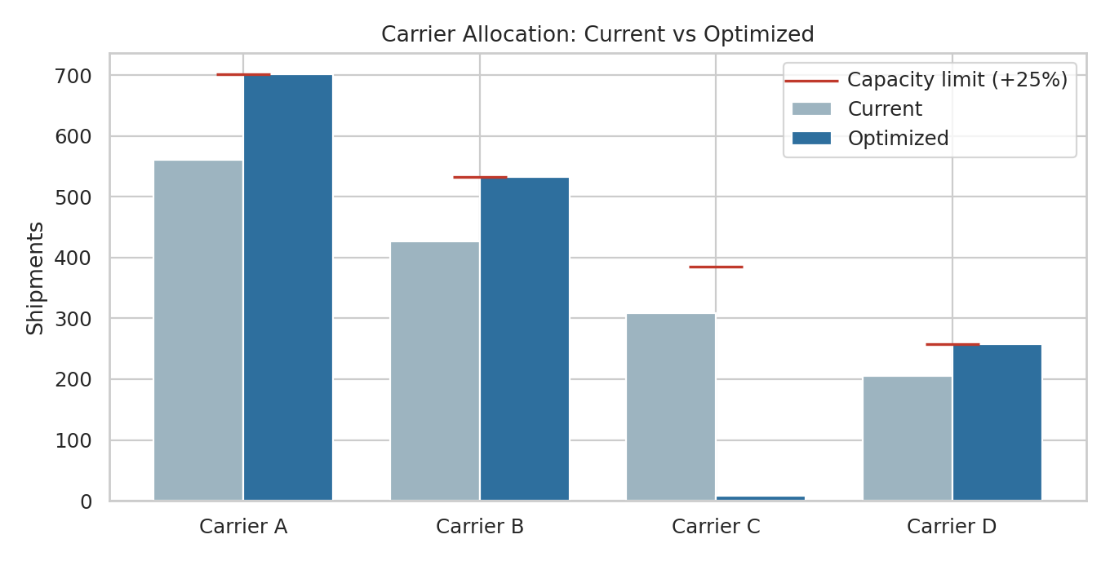
Figure 5. Shipments per carrier before and after optimization, with the capacity limits.
Table 6. Allocation results
Carrier | Current shipments | Optimized | Change | Capacity limit
Carrier A | 561 | 702 | +141 | 702
Carrier B | 426 | 533 | +107 | 533
Carrier C | 308 | 8 | -300 | 385
Carrier D | 205 | 257 | +52 | 257

Table 7. Predicted impact
Measure | Current | Optimized | Change
Average predicted delay (days) | 0.998 | 0.824 | -0.174
Shipments predicted > 1 day late | 621 | 442 | -179 (29%)
Total delay penalty at $25/day | $37,421 | $30,917 | -$6,505 (17.4%)

The optimizer essentially empties Carrier C (from 308 to 8 shipments) and pushes Carriers A, B and D to their capacity ceilings (+141, +107 and +52 shipments). Carrier A is the best performer, so it is filled first, then B and D. The saving of $6,505 per year (17.4% of the delay penalty) comes entirely from better matching of volume to carrier quality, with no new resources.

10.3 Assumptions and cautions
- The model assumes that a carrier performs equally well on its extra volume. In reality a carrier running at its capacity ceiling may slow down, so the capacity limit is the key parameter to test.
- The simulated data contains no price differences between carriers, so the objective counts delay cost only. With real rates, the carrier's price per shipment should be added to cost(i, j) so the optimizer trades service against price.
- Removing almost all volume from one carrier is an extreme result. A practical roll-out should be gradual (for example, shift 25% of Carrier C's volume first), keep a minimum share with each carrier for resilience, and re-measure before shifting more.
- The delay penalty of $25 per day is an assumption. Savings scale linearly with it, but the allocation itself, which depends only on the ranking of carriers, does not change.

11. Optimization B: Risk-Based Proactive Intervention

11.1 Method
Some shipments can be rescued with extra effort, for example by assigning priority handling at the hub, rerouting, or proactively informing the customer. Doing this for every shipment is expensive, so the question is where to draw the line. The model's predicted delay is used as a risk score: shipments whose predicted delay exceeds a threshold are flagged for intervention.
To evaluate the policy fairly, predictions for each shipment came from 5-fold out-of-sample prediction (each shipment was predicted by a model that never saw it). The following assumptions were used:
- Each intervention costs $15 and reduces that shipment's delay by 30%.
- A day of delay costs $25 (same as in Section 10).
- A shipment counts as "late" for precision and recall when its true delay is more than one day.
Code excerpt 6. Threshold search
oof = cross_val_predict(make(GradientBoostingRegressor(**best_params)), X, y, cv=kf)

for thr in np.arange(0.4, 3.01, 0.1):
flag = oof > thr
benefit = (y[flag] * REDUCTION * PENALTY).sum() # delay-days avoided x $/day
cost = flag.sum() * INTERV_COST
late = y > 1.0
precision = (late & flag).sum() / flag.sum()
recall = (late & flag).sum() / late.sum()
net = benefit - cost

11.2 Results
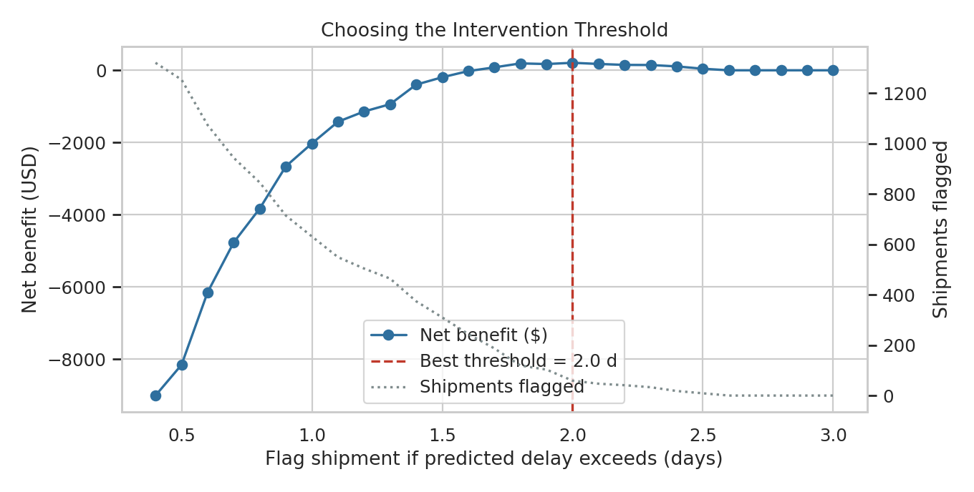
Figure 6. Net benefit of the intervention policy as the flagging threshold changes.
Table 8. Effect of the threshold (intervention cost $15, effectiveness 30%)
Flag if predicted delay > | Shipments flagged | Precision | Recall | Net benefit
0.4 days | 1320 | 46% | 97% | -$9,005
0.7 days | 943 | 58% | 88% | -$4,766
1.0 days | 631 | 73% | 75% | -$2,025
1.3 days | 464 | 84% | 63% | -$939
1.6 days | 244 | 98% | 39% | -$22
1.9 days | 103 | 100% | 17% | $173
2.2 days | 41 | 100% | 7% | $149
2.5 days | 9 | 100% | 2% | $43

At a $15 intervention cost and 30% effectiveness, intervening on every shipment loses $11,252. The best threshold is 2.0 days: it flags only 59 shipments (precision 100%, so every flagged shipment really was late) and yields a small net gain of $208. The reason is simple arithmetic: an intervention pays back only when predicted delay x 0.3 x $25 exceeds the $15 cost, which means the predicted delay must exceed 2.0 days. The model helps by finding exactly those few shipments.
The flagged shipments are concentrated where Week 3 predicted: 100% fall in the October-December peak and 83.1% originate in Mumbai or Delhi. This also shows the strength of combining the two methods: allocation reduces the number of high-risk shipments, and the intervention policy handles those that remain.

11.3 Sensitivity to the assumptions
Because intervention costs and effectiveness are assumed, the policy was re-optimized under six different combinations. The table shows that the economics are very sensitive to these two numbers.
Table 9. Best achievable net benefit under different assumptions
Intervention cost | Effectiveness | Best threshold | Shipments flagged | Net benefit
$5 | 30% | 0.7 days | 943 | $4,664
$5 | 50% | 0.5 days | 1253 | $11,474
$10 | 30% | 1.4 days | 374 | $1,473
$10 | 50% | 0.8 days | 845 | $6,300
$15 | 30% | 2.0 days | 59 | $208
$15 | 50% | 1.2 days | 504 | $3,139

The lesson for management is that two things decide whether proactive intervention pays: how cheap the intervention is and how well it works. A cheap, effective measure (for example $5 and 50%) justifies flagging most shipments and gains about $11,500; an expensive, weak one should be reserved for the few highest-risk cases. The right threshold falls out of the model automatically once the real cost and effectiveness are known, and should be measured in a pilot before it is relied on.

12. Additional Optimization Strategies from Model Insights
The two quantified methods above are complemented by strategies that follow directly from the model's findings but need business data beyond this simulation to size:
- Hub capacity at Mumbai and Delhi. Hub is the second-strongest driver. Adding dock capacity or shifts at these hubs, cross-docking, or routing some volume through lower-delay hubs (Hyderabad, Chennai) attacks the bottleneck at its source. The model can be rerun with a hub's congestion effect reduced to estimate the gain.
- Seasonal capacity planning. Delay jumps in October-December even though volume is flat, so the problem is capacity, not demand. Pre-booking carrier capacity and staffing for Q4, and earlier order cut-off times, would address this. The month and is_peak features give a ready-made early-warning signal for when the model's predicted delay starts to climb.
- Route planning and mode choice. Mode and distance have no effect on delay, so switching a shipment from air to road or rail does not worsen reliability in this data. Combined with the cost finding from Week 3 (air is 63% of spend), non-urgent air shipments are the best candidates for a cost-reducing mode switch. The delay model can be paired with a cost model to choose mode shipment by shipment.
- Realistic delivery promises. Adding a risk-based buffer to the promised date for shipments with high predicted delay (for example, when using Carrier C in Q4) turns late deliveries into on-time ones without changing operations, and improves customer satisfaction.

13. Recommendations
Table 10. Prioritized recommendations
# | Action | Basis in this report | Expected effect
1 | Shift volume from Carrier C to Carriers A, B and D in stages, using the allocation model with real carrier prices and capacities | Sections 8, 10 | Up to 17.4% lower delay penalty and about 29% fewer predicted late shipments
2 | Run the delay model at dispatch and flag high-risk shipments; pilot an intervention to measure its true cost and effectiveness, then set the threshold from Table 9 | Sections 7, 11 | Intervention spend limited to shipments where it pays back
3 | Increase capacity at Mumbai and Delhi hubs, especially in Q4 | Sections 8, 12 | Reduces the second-largest delay driver
4 | Plan and pre-book Q4 capacity; add a risk buffer to Q4 delivery promises | Sections 8, 12 | Offsets the seasonal doubling of delay
5 | Move non-urgent air shipments to ground modes | Section 12 | Lowers cost with no measurable effect on delay
6 | Retrain the model monthly and track MAE and RMSE on new shipments; alert when error rises | Section 14 | Keeps predictions reliable as conditions change

14. Limitations and Future Work
- Simulated data: the strength of the carrier, hub and season effects was built into the simulation. A real dataset would be noisier and would need cleaning, but the workflow transfers directly.
- Moderate predictive power (R-squared about 0.47): the model ranks risk well but cannot predict individual delays precisely, and it under-predicts extreme delays.
- Random split: shipments were split at random. For a deployed forecast, a time-based split (train on earlier months, test on later months) is a stricter test and should be used with real data.
- Counterfactual predictions: the allocation model predicts what would happen if a shipment moved to another carrier based on the patterns in the data. This is only valid if carriers perform the same way on new volume, which should be verified with a pilot.
- Assumed costs: delay penalty, intervention cost and effectiveness are placeholders and should be replaced with contract data.
- Future work: add weather, congestion and driver data as features; try a time-series model for weekly shipment volume; extend the linear program with carrier prices, minimum-share rules and lane-level capacity; and monitor for model drift.

15. Conclusion
This report built and validated a model that predicts shipment delay at dispatch with an RMSE of about 0.63 days and R-squared of 0.47 on unseen data, using careful controls against leakage, cross-validation and hyperparameter tuning. The model showed that delay is driven by carrier, hub and season, not by distance, weight or mode. Those insights were then turned into two concrete optimization methods: a linear program that reallocates volume across carriers (17.4% lower predicted delay cost) and a risk-threshold policy that targets intervention only where it pays back. Together with the capacity and planning recommendations, they give an operator a practical route from "why are we late?" to "what do we do on Monday?". The accompanying script reproduces every number and chart in this report.

Appendix A. Reproducing the Work
Required libraries: pandas, numpy, scikit-learn, scipy, matplotlib, seaborn. Place logistics_data.csv in the working directory and create an empty folder named charts4, then run:
pip install pandas numpy scikit-learn scipy matplotlib seaborn
mkdir charts4
python logistics_model.py

The script prints "done" and writes the charts to charts4/ and all numbers used in this report to stats4.json. All random operations use a fixed seed (42), so results are reproducible.
Code excerpt 7. Final test-set evaluation
def evaluate(name, pipe):
pipe.fit(X_train, y_train)
p = pipe.predict(X_test)
return {"model": name,
"mae": mean_absolute_error(y_test, p),
"rmse": np.sqrt(mean_squared_error(y_test, p)),
"r2": r2_score(y_test, p)}, p

result, pred = evaluate("Gradient Boosting (tuned)", best) # test set used once

