WEEK 3 TASK
Advanced Data Analysis and Visualization in Logistics
Exploratory analysis, visualization and operational insights on a simulated shipment dataset (1,500 shipments, calendar year 2025)
Tools: Python 3, pandas, NumPy, matplotlib, seaborn
Deliverables: this report, logistics_analysis.py, logistics_data.csv

Contents

1. Executive Summary
This report analyses a hypothetical logistics network of five origin hubs, four carriers and four transport modes. A dataset of 1,500 shipments was simulated, explored statistically and visualized with eight charts, each chosen for a specific analytical question. The analysis is aimed at three decisions an operations manager would face: where service is failing, what drives cost, and where the bottlenecks sit.
Headline findings
- Service level: only 58.9% of shipments arrived within one day of plan, with an average delay of 1.0 days.
- Carrier C is the largest single problem: it handles 20.5% of shipments but produces about 40% of all late deliveries (20% on-time versus 62-75% for the other carriers).
- Mumbai and Delhi are the hub bottlenecks: together they originate 53% of shipments and 67% of late ones; Mumbai's on-time rate is 42% against 74% at Hyderabad.
- Peak season (Oct-Dec) doubles delay (1.66 vs 0.78 days) even though shipment counts stay flat, which points to a capacity or handling constraint, not a demand surge.
- Cost is driven by mode, weight and priority: air carries 16% of shipments but 63% of total spend, and Express costs about 54% more per shipment than Standard.
Important caveat. The data is simulated. The patterns described below reflect the assumptions built into the simulation (Section 3), not a real company. The goal is to demonstrate the analytical workflow; the same code can be pointed at real shipment records.

2. Objectives and Approach
The task asks for a complete analytical workflow: define a dataset, explore it, visualize it, interpret the results and document everything. The approach followed five steps.
- Simulate a realistic logistics dataset and document its structure and assumptions.
- Run exploratory data analysis (EDA): central tendency, spread, distributions and correlations.
- Build multiple visualizations, justifying the chart type chosen for each question.
- Interpret the results in terms of operational efficiency, cost drivers and bottlenecks.
- Turn the findings into specific, prioritized recommendations.

3. Data Simulation

3.1 Dataset structure
The dataset contains 1,500 shipment records, one row per shipment, with 0 missing values. Fixing a random seed (42) makes the simulation fully reproducible.
Table 1. Variables in the simulated dataset
Variable | Type | Description
shipment_id | Identifier | Unique shipment code (SH00001 ...)
ship_date | Date | Dispatch date, uniformly spread over 2025
origin_hub | Categorical | Hyderabad, Mumbai, Delhi, Chennai, Kolkata
transport_mode | Categorical | Road (55%), Rail (20%), Air (15%), Sea (10%)
carrier | Categorical | Carrier A, B, C, D
priority | Categorical | Standard (75%) or Express (25%)
distance_km | Numeric | Route distance, range depends on mode
weight_kg | Numeric | Shipment weight, log-normal (right-skewed)
volume_m3 | Numeric | Shipment volume, derived from weight and density
planned_days | Numeric | Promised transit time from distance and mode speed
actual_days | Numeric | Planned time plus simulated delay
cost_usd | Numeric | Transport cost from weight, distance, mode rate, priority and season
delay_days | Derived | actual_days - planned_days
on_time | Derived | True when delay_days is at most 1.0
cost_per_kg | Derived | cost_usd / weight_kg

3.2 Simulation assumptions
Realistic data needs structure, so the simulation encodes a few cause-and-effect relationships that the analysis should later be able to recover:
- Delay depends on carrier quality (Carrier C worst), hub congestion (Mumbai and Delhi highest) and a peak-season effect in October-December. Express shipments are slightly faster.
- Cost scales with weight x distance x a per-mode rate, with Air far more expensive than Road, Rail or Sea, plus a 35% Express premium and a 12% peak-season surcharge.
- Weight is log-normally distributed, so most shipments are light and a few are very heavy, as in real freight data.
Code excerpt 1. Data simulation (abridged)
np.random.seed(42)
N = 1500
dates = pd.to_datetime("2025-01-01") + pd.to_timedelta(np.random.randint(0, 365, N), unit="D")
hubs = np.random.choice(["Hyderabad","Mumbai","Delhi","Chennai","Kolkata"], N, p=[.22,.28,.25,.15,.10])
modes = np.random.choice(["Road","Rail","Air","Sea"], N, p=[.55,.20,.15,.10])
weight = np.random.lognormal(mean=6.0, sigma=0.8, size=N).clip(20, 5000)

# delay drivers: carrier + hub congestion + peak season - express benefit + noise
delay = (carrier_effect + hub_effect + 0.9*peak - 0.3*(priority=="Express")
+ np.random.gamma(1.5, 0.5, N) - 1.0).clip(min=0)
actual_days = np.round(planned_days + delay, 1)

# cost: (weight/100) * (distance/100) * mode_rate, with noise, express and peak multipliers
cost = cost * np.random.normal(1.0, 0.08, N) + 25
cost = cost * np.where(priority=="Express", 1.35, 1.0) * (1 + 0.12*peak)

4. Exploratory Data Analysis

4.1 Data preview and quality checks
A first look at the data confirms that the structure is as intended: no missing values, sensible ranges and consistent data types.
Table 2. First five records (selected columns)
ID | Hub | Mode | Carrier | Dist (km) | Wt (kg) | Plan (d) | Actual (d) | Cost ($)
SH00001 | Mumbai | Rail | Carrier A | 966 | 256 | 2 | 2.8 | 39
SH00002 | Kolkata | Rail | Carrier A | 1329 | 347 | 3 | 3.5 | 77
SH00003 | Hyderabad | Rail | Carrier A | 900 | 83 | 2 | 2.0 | 39
SH00004 | Hyderabad | Road | Carrier B | 861 | 807 | 2 | 3.3 | 95
SH00005 | Hyderabad | Road | Carrier B | 1604 | 181 | 2 | 2.8 | 52

Code excerpt 2. Basic inspection and summary statistics
df.info() # types and missing values
df.isna().sum().sum() # -> 0 missing values
desc = df[num].describe().T
desc["median"] = df[num].median()
desc["skew"] = df[num].skew()

4.2 Central tendency and spread
Table 3. Descriptive statistics
Variable | Mean | Median | Std dev | Min | Max | Skew
distance_km | 1252.54 | 1233.05 | 682.25 | 52.80 | 2984.10 | 0.26
weight_kg | 561.82 | 398.15 | 534.30 | 26.40 | 5000.00 | 3.13
volume_m3 | 3.19 | 2.17 | 3.16 | 0.18 | 36.40 | 3.25
planned_days | 2.11 | 2.00 | 1.25 | 1.00 | 7.00 | 1.54
actual_days | 3.11 | 2.90 | 1.51 | 1.00 | 9.30 | 0.96
delay_days | 1.00 | 0.90 | 0.84 | 0.00 | 4.70 | 0.93
cost_usd | 177.02 | 68.59 | 372.26 | 25.81 | 4885.34 | 6.31
cost_per_kg | 0.37 | 0.19 | 0.49 | 0.01 | 2.87 | 2.51

Three observations stand out from the summary table:
- Mean exceeds median for every right-skewed variable. Cost averages $177 but the median is only $69 (skew 6.3), because a small number of heavy air shipments cost thousands of dollars. Weight shows the same pattern (mean 562 kg, median 398 kg). For reporting, the median is the better "typical shipment" measure.
- Delivery time is moderately skewed. Actual delivery averages 3.1 days against a planned 2.1, an average slippage of 1.0 day. The delay standard deviation (0.84 days) is large relative to its mean, so reliability, not just average speed, is an issue.
- Distance is roughly symmetric (mean 1253 km, median 1233 km), which reflects the range assumptions in the simulation.

4.3 Correlation analysis
Pearson correlations were computed for the six main numeric variables (visualized as a heatmap in Figure 3). The most informative coefficients are:
Table 4. Selected correlations
Pair | r | Reading
weight_kg and volume_m3 | 0.95 | Near-redundant: volume is derived from weight
delay_days and actual_days | 0.56 | Delays are a major part of total delivery time
distance_km and actual_days | 0.43 | Longer routes take longer, as expected
weight_kg and cost_usd | 0.35 | Heavier shipments cost more
distance_km and cost_usd | 0.32 | Longer routes cost more, but the link is moderate
actual_days and cost_usd | -0.21 | Negative: the fast mode (air) is the expensive one
distance_km and delay_days | 0.00 | No relationship: delay is not caused by distance

Two points deserve emphasis. First, the near-zero correlation between distance and delay means that delays come from the process (carriers, hubs, season), not from route length, so they can be fixed operationally. Second, the negative cost-time correlation is a good example of why correlation needs context: it does not mean that slower shipping costs more, it reflects the mode mix. A simple regression of cost on weight x distance explains 32% of cost variance (R-squared = 0.318); the remainder is mostly the mode rate, which is why mode shows up so strongly in the later charts.
Code excerpt 3. Correlations and regression
corr = df[["distance_km","weight_kg","volume_m3",
"actual_days","delay_days","cost_usd"]].corr()

x = (df.distance_km * df.weight_kg) / 1e5
slope, intercept = np.polyfit(x, df.cost_usd, 1)
r2 = np.corrcoef(x, df.cost_usd)[0, 1] ** 2

4.4 Group-level performance
Aggregating by mode, carrier, hub, season and priority gives the numbers behind the charts in Section 5.
Table 5. Performance by transport mode
Mode | Shipments | Avg days | Avg cost ($) | Cost/kg ($) | On-time %
Air | 241 | 1.96 | 692.8 | 1.35 | 61
Rail | 309 | 3.82 | 75.1 | 0.19 | 58
Road | 806 | 2.65 | 81.7 | 0.19 | 58
Sea | 144 | 6.10 | 66.0 | 0.17 | 62

Table 6. Performance by carrier
Carrier | Shipments | Avg delay (d) | On-time % | Avg cost ($)
Carrier A | 561 | 0.68 | 75 | 188.2
Carrier B | 426 | 0.95 | 62 | 179.3
Carrier C | 308 | 1.70 | 20 | 138.5
Carrier D | 205 | 0.92 | 66 | 199.6

Table 7. Performance by origin hub
Hub | Shipments | Avg delay (d) | On-time %
Chennai | 232 | 0.76 | 69
Delhi | 384 | 1.09 | 55
Hyderabad | 337 | 0.70 | 74
Kolkata | 137 | 0.93 | 66
Mumbai | 410 | 1.32 | 42

Table 8. Season and priority comparison
Segment | Avg delay (d) | On-time % | Avg cost ($)
Off-peak | 0.78 | 70 | 175.8
Peak (Oct-Dec) | 1.66 | 25 | 180.6
Priority: Express | 0.78 | 71 | 241.1
Priority: Standard | 1.07 | 55 | 157.0

5. Visualizations and Interpretation
Each visualization below answers one specific question. For every chart, the chart type is justified, the key code is shown and the result is interpreted.

5.1 Distribution of delivery time (histogram with KDE)
Why this chart: a histogram shows the shape of a single continuous variable. A kernel density curve is overlaid to smooth the shape, and mean and median lines are added because the gap between them signals skew. Averages alone hide the long tail of late deliveries that customers actually notice.
sns.histplot(df.actual_days, bins=30, kde=True, color="#2E6F9E", ax=ax)
ax.axvline(df.actual_days.mean(), color="#C0392B", ls="--", label="Mean")
ax.axvline(df.actual_days.median(), color="#27AE60", ls=":", label="Median")

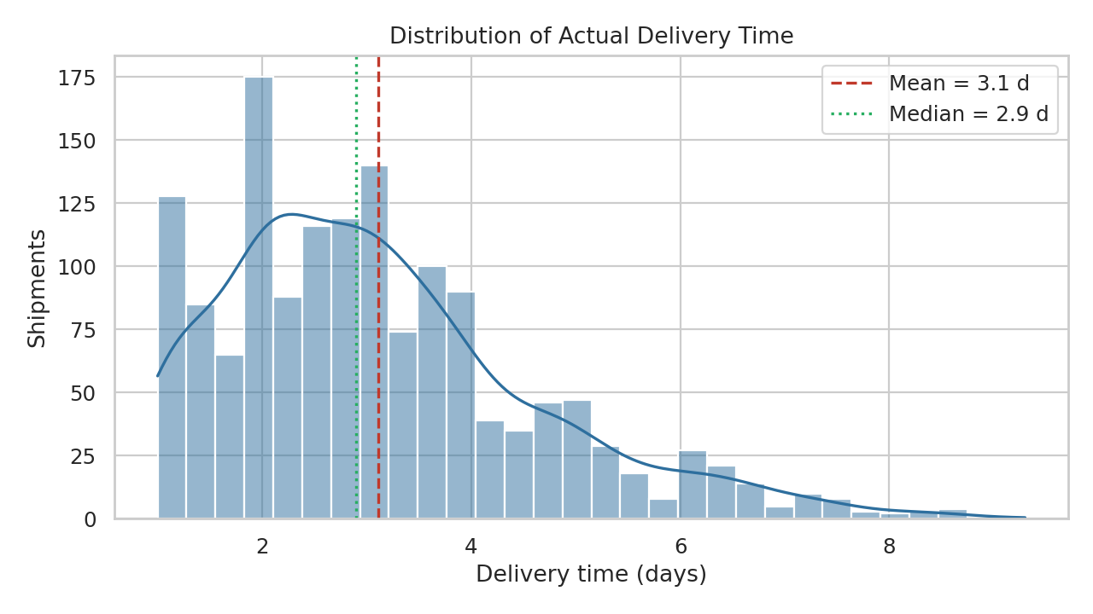
Figure 1. Distribution of actual delivery time with mean and median.
Interpretation: the distribution is right-skewed with a long tail extending past eight days. The mean (3.1 days) sits above the median (2.9 days), so a minority of very slow shipments pulls the average up. The secondary bump around three to four days likely reflects the slower modes (rail and sea), which have longer typical durations. This chart shows that managing the tail matters more than improving the average.

5.2 Delivery time and cost per kg by mode (box plots)
Why this chart: box plots compare a numeric variable across categories while showing median, spread and outliers in one view. Placing two panels side by side puts speed and cost in the same frame, which is the core trade-off in mode selection. Cost per kg uses a log scale because air is several times more expensive than the other modes.
fig, axes = plt.subplots(1, 2, figsize=(11, 4.5))
sns.boxplot(data=df, x="transport_mode", y="actual_days", order=order, ax=axes[0])
sns.boxplot(data=df, x="transport_mode", y="cost_per_kg", order=order, ax=axes[1])
axes[1].set_yscale("log")

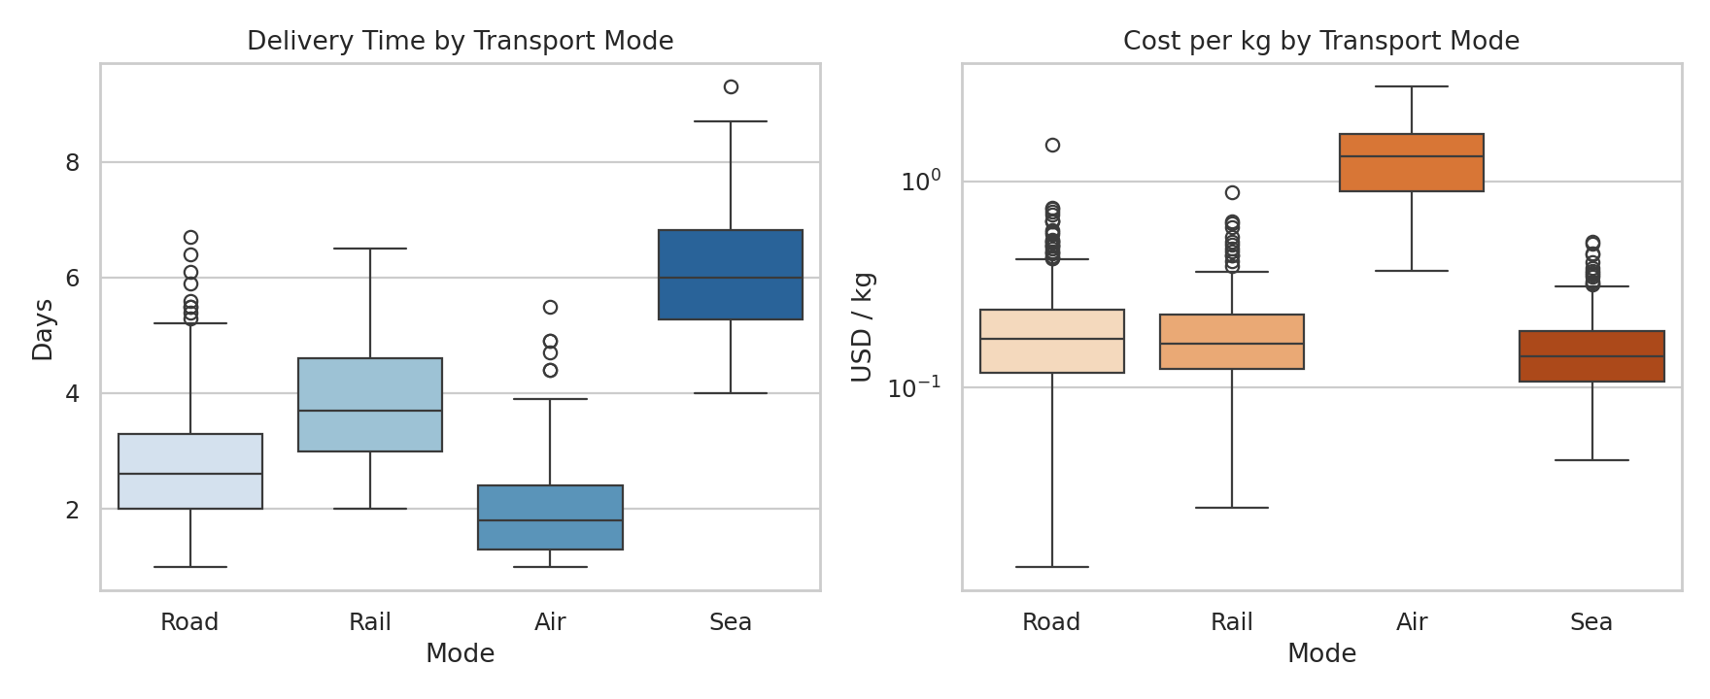
Figure 2. Delivery time (left) and cost per kg (right) by transport mode.
Interpretation: air is the fastest mode (1.96 days on average) but costs about $1.35 per kg, roughly seven times the $0.17-0.19 per kg of road, rail and sea. Sea is slowest (6.1 days) and cheapest. Road and rail have nearly identical cost per kg, but road is about 1.2 days faster on average. Air therefore buys speed at a steep premium, and the question for management is whether every air shipment truly needs that speed.

5.3 Correlation heatmap
Why this chart: a heatmap summarizes all pairwise relationships among the numeric variables in one image. A diverging colour scale centred on zero separates positive from negative relationships at a glance, and annotation keeps the exact values readable.
sns.heatmap(corr, annot=True, fmt=".2f", cmap="RdBu_r", vmin=-1, vmax=1, square=True)

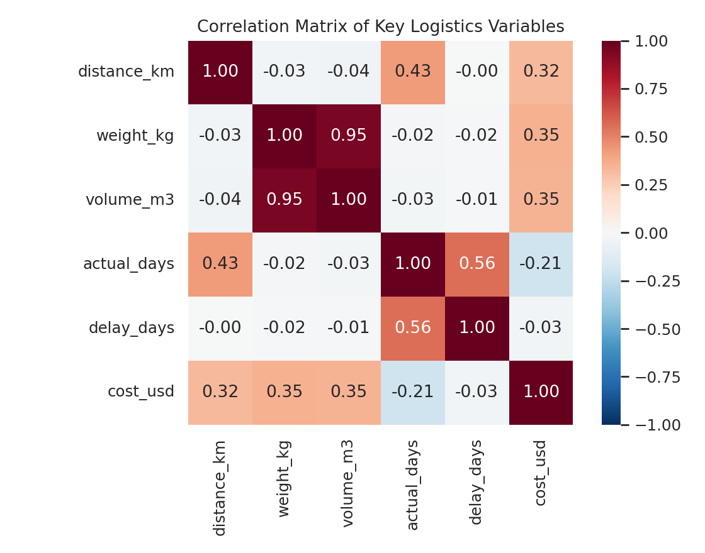
Figure 3. Correlation matrix of key logistics variables.
Interpretation: the heatmap makes three things clear: weight and volume are almost the same signal (r = 0.95), so only one is needed in a cost model; distance drives delivery time (r = 0.43) but not delay (r = 0.00); and cost correlates only moderately with distance and weight individually (about 0.3-0.35), which signals that mode and priority matter too.

5.4 Cost versus distance (scatter plot with encodings)
Why this chart: a scatter plot is the standard tool for a relationship between two continuous variables. Colour encodes transport mode and marker size encodes weight, so one plot shows four variables. A log scale on cost handles the wide range and makes the separate mode bands visible.
sns.scatterplot(data=df, x="distance_km", y="cost_usd", hue="transport_mode",
size="weight_kg", sizes=(10, 150), alpha=0.6, hue_order=order)
ax.set_yscale("log")

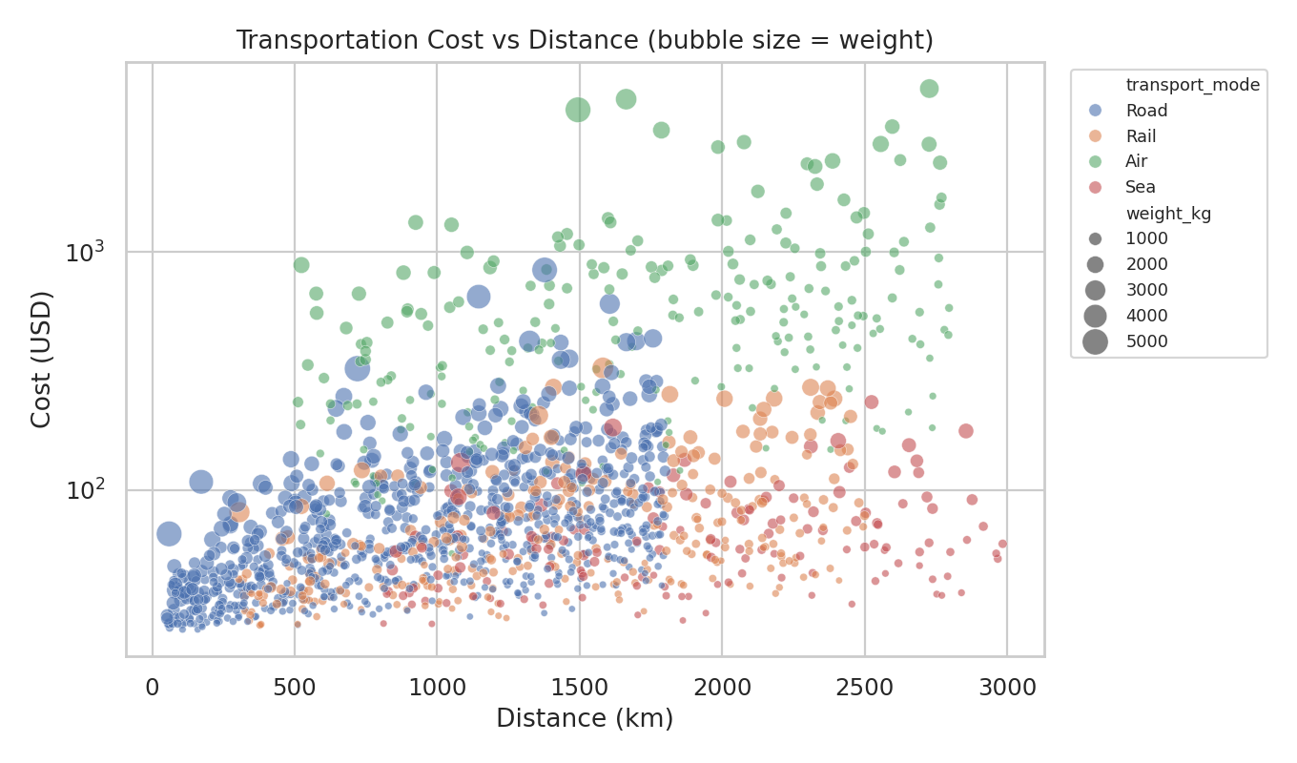
Figure 4. Transportation cost versus distance, coloured by mode and sized by weight.
Interpretation: cost rises with distance, but the points separate into clear bands by mode: air sits well above the others at any distance, while sea, rail and road overlap at the bottom. Larger markers (heavier shipments) sit higher within each band. This confirms that cost is multiplicative in weight, distance and mode, and that distance alone is a poor predictor of cost.

5.5 Monthly trend (combined bar and line chart)
Why this chart: a time-ordered chart reveals seasonality. Bars show monthly shipment volume while a line on a secondary axis shows average delay. Putting them together allows the key operational question to be answered directly: do delays follow volume?
monthly = df.groupby("month").agg(shipments=("shipment_id","count"),
avg_delay=("delay_days","mean")).reset_index()
ax1.bar(monthly.month, monthly.shipments)
ax2 = ax1.twinx(); ax2.plot(monthly.month, monthly.avg_delay, marker="o")

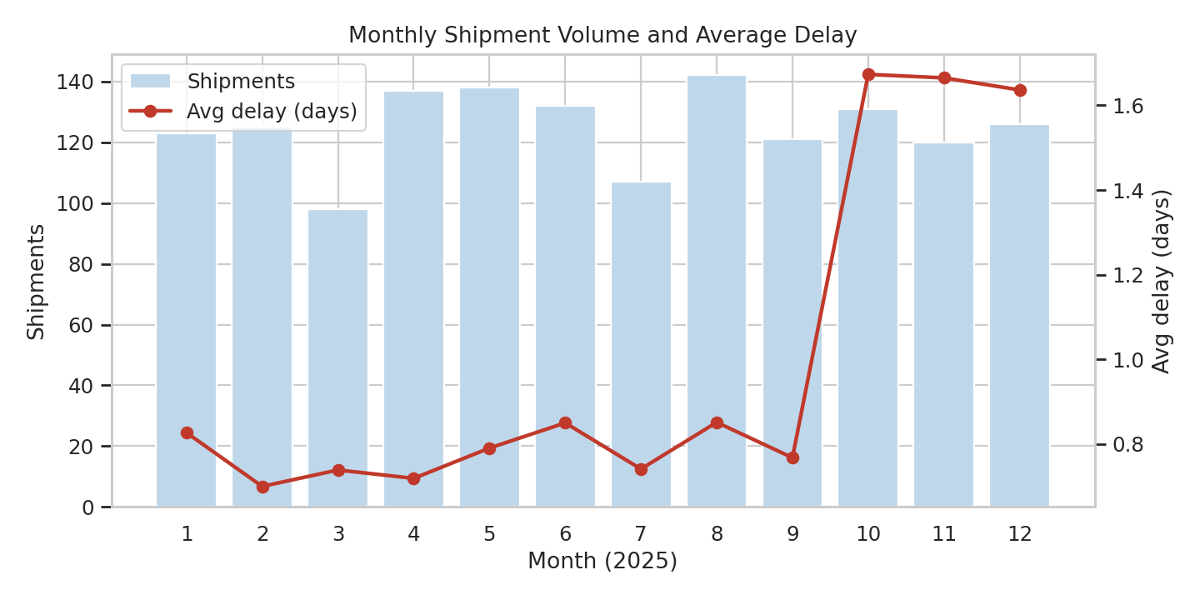
Figure 5. Monthly shipment volume and average delay.
Interpretation: average delay is steady at roughly 0.7-0.85 days from January to September, then jumps to about 1.65 days in October, November and December. Shipment volume does not change in those months (98-142 per month throughout the year). Delay is therefore not caused by more shipments; it points to reduced capacity or slower handling in the festive season. This distinction matters because adding capacity and reducing demand require different responses.

5.6 On-time rate by carrier (horizontal bar chart)
Why this chart: a sorted bar chart is the clearest way to rank categories on a single metric. Horizontal bars suit text labels, and a reference line at the network average makes under- and over-performers obvious.
ct = carr_tbl.reset_index().sort_values("on_time")
ax.barh(ct.carrier, ct.on_time)
ax.axvline(df.on_time.mean()*100, color="grey", ls="--", label="Network average")

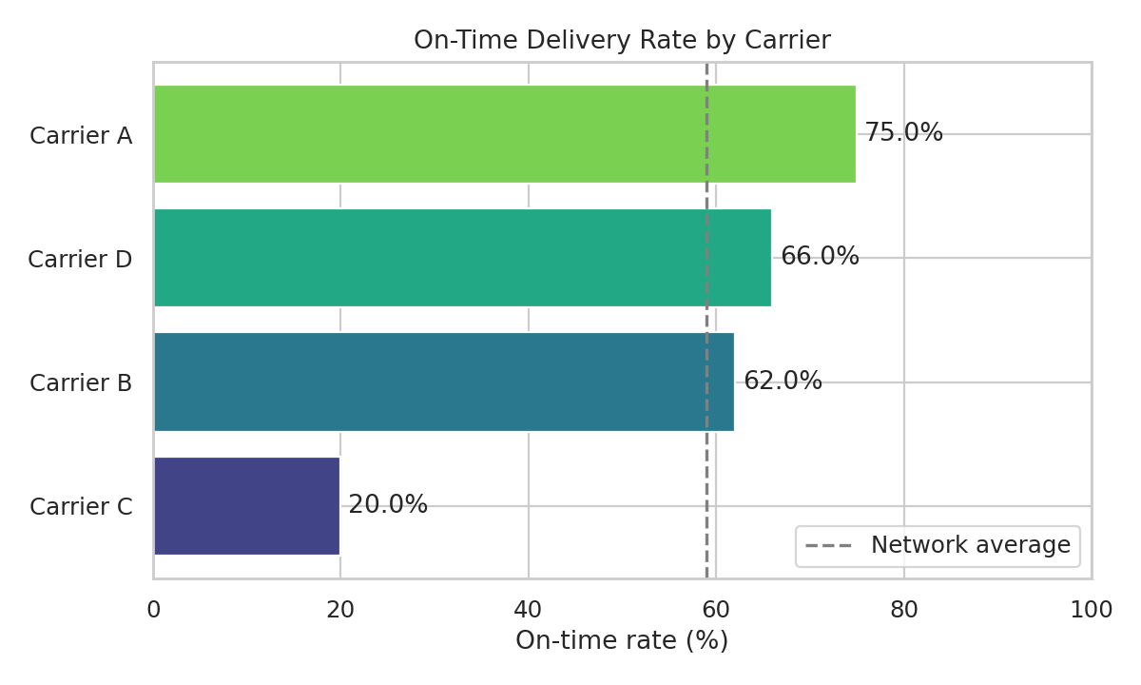
Figure 6. On-time delivery rate by carrier.
Interpretation: Carrier A leads at 75% on-time, followed by Carrier D (66%) and Carrier B (62%). Carrier C is a clear outlier at 20%, far below the 59% network average. Since Carrier C handles 20.5% of shipments but accounts for about 40% of late deliveries, it is the single highest-leverage target for improvement.

5.7 Bottleneck map: delay by hub and month (heatmap)
Why this chart: bottlenecks are location-and-time problems, so a two-dimensional grid is the right structure. A sequential yellow-to-red scale makes hot spots stand out immediately, which would be hard to see in a table of 60 numbers.
pv = df.pivot_table(index="origin_hub", columns="month",
values="delay_days", aggfunc="mean")
sns.heatmap(pv, annot=True, fmt=".1f", cmap="YlOrRd")

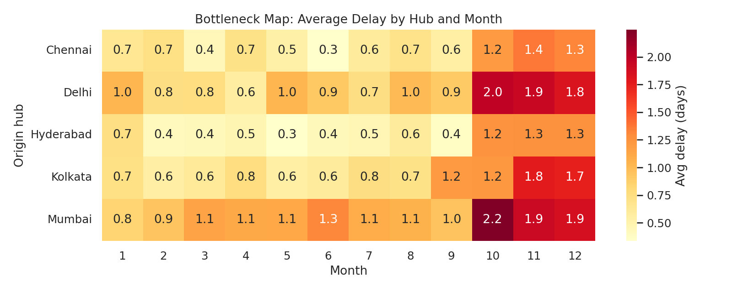
Figure 7. Average delay (days) by origin hub and month.
Interpretation: the darkest cells are Mumbai and Delhi in October-December, with Mumbai in October the worst at 2.25 days of average delay. Hyderabad stays the lightest row all year. The pattern is additive: the peak-season effect raises every hub, but hubs that are already congested are pushed to the worst levels. Mumbai and Delhi account for 67% of all late shipments, so hub-level interventions there will have the largest impact.

5.8 Economies of scale: cost per kg versus weight (regression plot)
Why this chart: a regression plot on log-log axes shows how unit cost changes with shipment size and fits a trend line. Log scales are appropriate because both variables are heavily right-skewed and the relationship is closer to a power law than a straight line.
sns.regplot(data=df, x="weight_kg", y="cost_per_kg", logx=True,
scatter_kws={"alpha":0.3,"s":14}, line_kws={"color":"#C0392B"}, ax=ax)
ax.set(xscale="log", yscale="log")

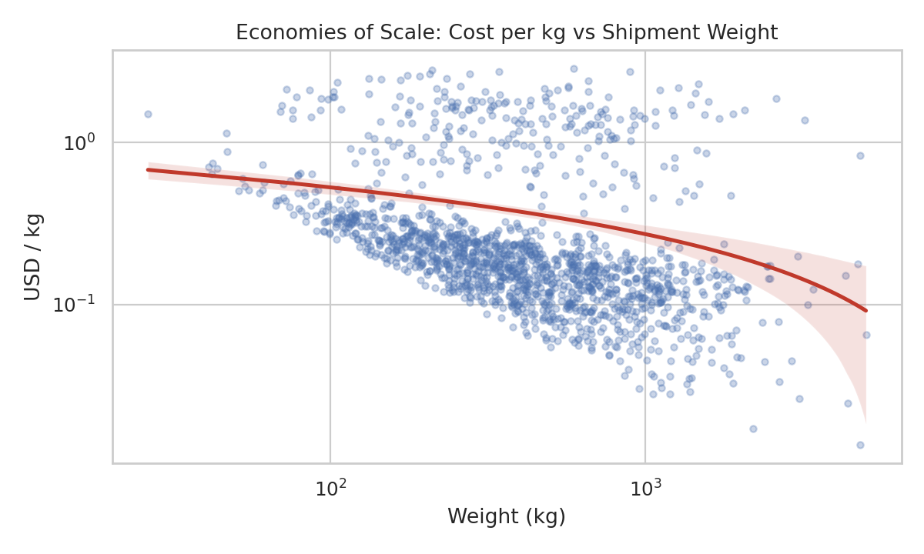
Figure 8. Cost per kg versus shipment weight (log-log axes).
Interpretation: unit cost falls as shipments get heavier (log-log correlation = -0.4). A fixed handling charge is spread over more kilograms, so small shipments are disproportionately expensive per kg. The wide vertical scatter at each weight is the mode effect: the upper cloud is air freight and the lower band is road, rail and sea. This supports consolidating small shipments where service levels allow.

6. Analytical Insights

6.1 Operational efficiency
- Reliability, not average speed, is the main weakness: 41% of shipments (616 of 1,500) missed plan by more than a day, and the delivery-time distribution has a long right tail.
- Delays are process-driven. Distance has zero correlation with delay, while carrier, hub and season each have large, measurable effects.
- Express service works but only modestly: it cuts average delay from 1.07 to 0.78 days and lifts on-time performance from 55% to 71%, at a 54% higher cost per shipment.

6.2 Cost drivers
- Mode is the dominant driver: air is 16% of shipments but 63% of total spend, at roughly seven times the cost per kg of ground modes.
- Weight and distance matter, but jointly (cost scales with their product). Their combined linear fit explains about 32% of cost variance; the rest is mostly mode.
- Priority and season add premiums: Express costs about $0.50 per kg versus $0.34 for Standard, and the simulated peak surcharge adds 12%.
- Small shipments are expensive per kg (negative log-log relationship), so consolidation is a lever.

6.3 Bottlenecks
- Carrier bottleneck: Carrier C (20% on-time, 1.70 days average delay) generates about 40% of all late shipments.
- Hub bottleneck: Mumbai (42% on-time) and Delhi (55%) generate 67% of late shipments from 53% of volume. Mumbai in October is the worst single point in the network.
- Seasonal bottleneck: Q4 delay is double the rest of the year despite flat volume, indicating a capacity or processing limit rather than a demand surge.

7. Recommendations
Table 9. Prioritized recommendations
# | Recommendation | Evidence | Expected effect
1 | Put Carrier C on a performance improvement plan, with penalties tied to on-time rate; shift volume to Carriers A and D if targets are missed | Figure 6; Table 6 | Largest single reduction in late shipments (C causes about 40%)
2 | Add dock capacity, extra shifts or cross-docking at Mumbai and Delhi; consider rerouting some Mumbai volume through Hyderabad or Chennai | Figure 7; Table 7 | Targets 67% of late shipments
3 | Plan Q4 capacity in advance: pre-book carrier capacity and staff for Oct-Dec; set earlier cut-off times | Figure 5; Table 8 | Cuts the seasonal doubling of delay
4 | Audit air shipments and move non-urgent ones to road or rail | Figures 2 and 4; Table 5 | Air is 63% of spend, so even a modest shift saves substantially
5 | Consolidate small shipments and batch low-priority loads | Figure 8 | Lowers unit cost through scale
6 | Set a dashboard with on-time rate by carrier and hub plus a delay-percentile (P90) metric, not just the mean | Figures 1, 6, 7 | Makes tail risk and bottlenecks visible early

8. How the Visualizations Help Interpret Logistics Performance
The eight charts form a deliberate sequence, from describing the data to diagnosing causes:
Question | Chart type | Metric it clarifies
What does delivery performance look like? | Histogram with KDE (Fig. 1) | Delivery time, tail risk, skew
Which mode is best for speed and cost? | Box plots (Fig. 2) | Transit time, cost per kg, outliers
Which variables move together? | Correlation heatmap (Fig. 3) | Cost, delay and distance drivers
What drives transportation cost? | Scatter plot (Fig. 4) | Cost versus distance, weight and mode
Is there seasonality? | Bar and line combo (Fig. 5) | Volume versus delay over time
Who performs best and worst? | Sorted bar chart (Fig. 6) | On-time rate by carrier
Where and when are the bottlenecks? | Heatmap (Fig. 7) | Delay by hub and month
Do larger shipments cost less per unit? | Regression plot (Fig. 8) | Unit cost and economies of scale

Visualization is necessary because summary statistics alone would have hidden several of these findings. A single network-wide on-time rate of 59% looks tolerable, but the carrier and hub charts reveal that performance is highly uneven: some carriers and hubs are doing well, while a few are failing badly. The monthly chart reveals that delay rises while volume is flat, which an average cannot show. The mode box plots reveal the cost-speed trade-off at a glance. In short, the charts convert a table of 1,500 rows into decisions about where to act.

9. Limitations
- The data is simulated, and the relationships found were partly built in by design. Real data would be noisier and would need data-cleaning steps (missing values, duplicates, inconsistent units) that were not required here.
- Correlation does not imply causation. For example, Carrier C's lower average cost per shipment may reflect its route and mode mix and should not be read as a pricing advantage without controlling for those.
- The on-time definition (delay of at most 1 day) is a modelling choice. A stricter or looser threshold changes the percentages but not the ranking of carriers or hubs.
- Costs are in US dollars for simplicity; a real analysis would use local currency and include fuel and surcharge detail.

10. Conclusion
This task demonstrated an end-to-end analytical workflow on logistics data: simulation, EDA, visualization, interpretation and recommendations. The analysis showed that the network's weaknesses are concentrated rather than diffuse: one carrier, two hubs and one season account for most of the late deliveries, while one transport mode accounts for most of the cost. Focusing improvement effort on those few areas, and monitoring them with the dashboards suggested above, is likely to deliver far more than network-wide changes. The accompanying Python script (logistics_analysis.py) reproduces every number and chart in this report and can be applied to real shipment data with minimal changes.

Appendix A. Reproducing the Analysis
Required libraries: pandas, numpy, matplotlib, seaborn. The full script is provided as logistics_analysis.py and writes the dataset to logistics_data.csv and charts to the charts/ folder. Core plotting setup used throughout:
import numpy as np
import pandas as pd
import matplotlib.pyplot as plt
import seaborn as sns

sns.set_theme(style="whitegrid", context="notebook")

# group-level KPI tables used in Section 4.4
df.groupby("carrier").agg(shipments=("shipment_id", "count"),
avg_delay=("delay_days", "mean"),
on_time=("on_time", "mean"),
avg_cost=("cost_usd", "mean"))

