**1 INRODUCTION**

  1.1 OVERVIEW

**ToDo List App** is a kind of app that generally used to maintain our day-to-day tasks or list everything that we have to do, with the most important tasks at the top of the list, and the least important tasks at the bottom. It is helpful in planning our daily schedules. We can add more tasks at any time and delete a task that is completed

1.2 PURPOSE

They list everything that you have to do, with the most important tasks at the top of the list, and the least important tasks at the bottom. By keeping such a list, you make sure that your tasks are written down all in one place so you don't forget anything important.

Increases productivity

At work and at home, having a to-do list may help you prioritize your work and personal tasks. This allows you to organize and complete the most crucial tasks first. To-do lists can be used to improve time management because all of your tasks are laid out clearly in advance.

**2 LITERATURE SURVEY**

2.1 Existing Problem

People encounter problems every day, whether they do so at work or in their daily, personal lives. Given this, once you're equipped with the right problem-solving approaches, problems transform from stressful setbacks into opportunities to learn and improve. That's why becoming practiced in several problem-solving approaches is essential, no matter what position you hold or what industry you work in.

2.2 Proposed Solution

To-do list methods are strategies to help you optimize your list and personalize it to your preferences. Understanding the different methods when creating a to-do list for your projects can help you get work done and accomplish more each day. In this article, we outline five ways you can create your to-do lists that will expedite your work process and track the progress you've made.

**3 THEORITICAL ANALYSIS**

3.1 Block Diagram

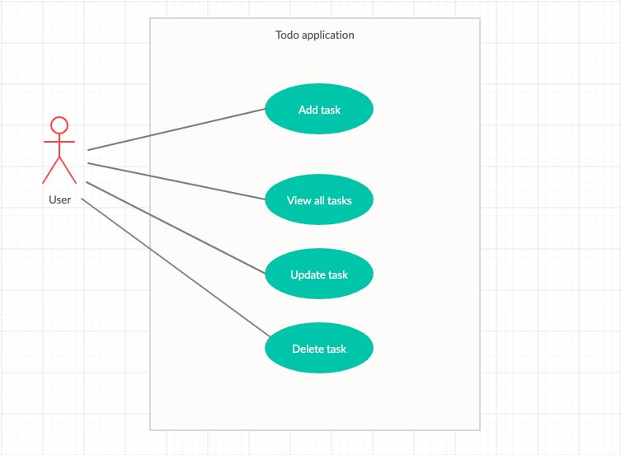

3.2 Hardware/software designing

**Hardware Requirements**

We strongly recommend a computer fewer than 5 years old.

* Processor: Minimum 1 GHz; Recommended 2GHz or more
* Ethernet connection (LAN) OR a wireless adapter (Wi-Fi)
* Hard Drive: Minimum 32 GB; Recommended 64 GB or more
* Memory (RAM): Minimum 1 GB; Recommended 4 GB or above
* Sound card w/speakers
* Some classes require a camera and microphone

Google Chrome on macOS, Windows, and Linux

Firefox on macOS, Windows, and Linux

Opera on macOS, Windows, and Linux

Safari on macOS and Windows

Microsoft Edge on Windows

**4 RESULT**

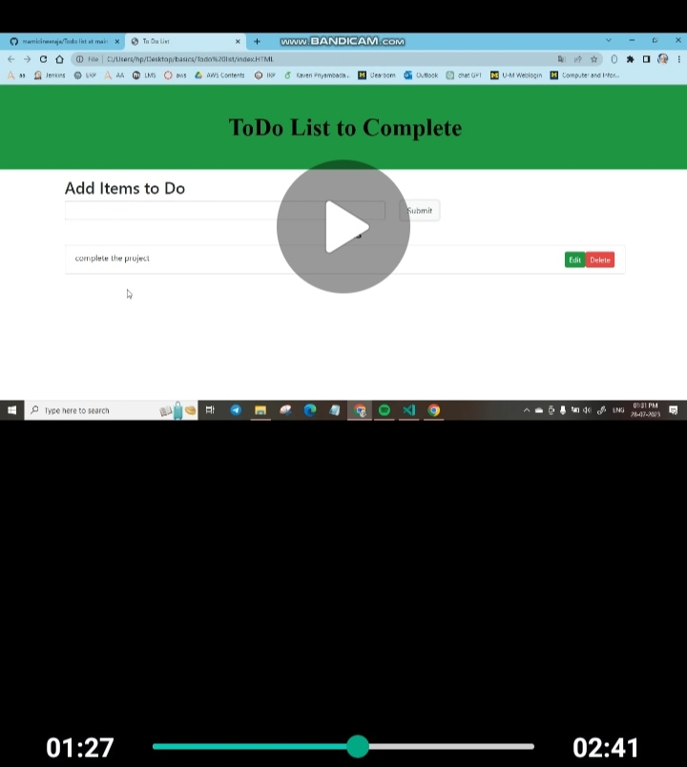

**5 ADVANTAGES & DISADVANTAGES**

ADVATAGES OF TODO APP

Having a to-do list makes it easier to organize everything that you want to accomplish in the day so that you can start fresh the next. Physically crossing items off a list can also increase motivation. Being unmotivated can make you less likely to complete items on your to-do list

DISADVANTAGES OF TODO APP

Incomplete items on your to-do list might induce stress and disrupt your sleep if you feel really bad about not completing them. A high amount of tasks on your to-do list might also make you feel overwhelmed and incompetent

**6 APPLICATIONS**

In this version of the ToDo list, the user will be getting four options:

* Create (add) a new task or adding a new ToDo in the ToDo List App.
* See all the tasks or View all the ToDos that were added to the app.
* Delete any ToDo from the list of ToDos.
* Exit from the app.

**7 CONCLUSION**

App ***todo-list-app*** performs very efficient comparing to competitor. There is a space for further developments with regards of keeping app small and quick. It would be optimal to use dedicated CSS and continuing using vanilla JavaScript.

To-do-app can be developed as a sole application as well as a very efficient module to be combined in a larger project. One of the key challenges is to chose appropriate storage solution, that will allow to maintain its biggest advantages:

* simplicity
* speed
* low recourses demand

**8 FUTURE SCOPE**

We’re addicted to compile never-ending to-do lists and it feels so good to check off items as we progress with our work. But we hardly manage to clear our list by the end of the workday.

It’s only natural that we want to keep stock of what we’re supposed to do, but only a few will keep stock of stuff that won’t get done. That leads us to the not-to-do list, which is as much important as the to-do list itself.

THIS IS OUR PROJET FORMAT

Me and my team member done the project

Team leader: M.Neeraja

Team Members are:S.Durga Bhaskar Rao ,G.Giddroni,P.Naga venkata sudher,A.Ganeshmanikanta