**fGelML: Gel Markup Language (Version 1.1) Specification**

Status of This Memo

This memo provides information to the Proteomics community about the modelling of the experimental procedures of gel electrophoresis in a proteomics pipeline, prior to protein identification, for example by mass spectrometry. It includes the acquisition of an image of a gel but does not contain any information derived from image analysis. This document is a recommendation for a standard released by the Proteomics Standards Initiative. Distribution is unlimited.

*Version*: Version 1.1 draft document, June 2010.

# Abstract

The Human Proteome Organisation (HUPO) Proteomics Standards Initiative (PSI) defines community standards for data representation in proteomics to facilitate data comparison, exchange and verification. The Protein Separation (PSI-PS) Working Group is developing standards for describing the processing and separations of proteins in samples using gel electrophoresis, within a proteomics experiment. This document defines models that can be used to describe the process of gel electrophoresis, which can be used to separate, and in some instances to quantify, proteins within a proteomics workflow. This is important, as the quality and interpretation of protein identifications are affected by the experimental processes to which a sample is subjected.

Contents

Abstract 1

1. Introduction 5

2. Concepts and Terminology 6

3. Relationship to Other Specifications 6

3.1 Important concepts from FuGE 6

3.2 Changes from GelML version 1.0 7

3.3 The PSI Sample Processing and Separations Controlled Vocabulary (sepCV) 7

3.4 Validation of controlled vocabulary terms 8

4. Model Overview 8

4.1 Schema overview 9

4.2 Model of a gel 9

4.3 One-dimensional gel electrophoresis 13

4.4 Two dimensional gel electrophoresis 15

4.5 Other Gel Electrophoresis 17

4.6 Sample loading 18

4.7 Electrophoresis 19

4.8 Detection 21

4.9 Image acquisition 21

4.10 The excision of locations on gels 25

4.11 SubstanceMixtureProtocol and SubstanceAction 28

5. Model in XML Schema 29

5.1 Element <GelML> 29

5.2 Element <Provider> 30

5.3 Element <cvList> 30

5.4 Element <GelMLMaterialCollection> 30

5.5 Element <GelMLDataCollection> 31

5.6 Element <GelMLProtocolCollection> 31

5.7 Element <Gel1DExperiment> 32

5.8 Element <Gel2DExperiment> 33

5.9 Element <OtherGelExperiment> 34

5.10 Element <AuditCollection> 35

5.11 Element <Organization> 36

5.12 Element <parent> 36

5.13 Element <Person> 36

5.14 Element <affiliations> 37

5.15 Element <ReferenceableCollection> 37

5.16 Element <Database> 38

5.17 Element <BibliographicReference> 38

5.18 Element <cv> 39

5.19 Element <GenericMaterial> 39

5.20 Element <components> 40

5.21 Element <Image> 40

5.22 Element <GenericEquipment> 41

5.23 Element <AtomicValue> 41

5.24 Element <BooleanValue> 42

5.25 Element <ComplexValue> 42

5.26 Element <Range> 42

5.27 Element <make> 43

5.28 Element <model> 43

5.29 Element <equipmentParts> 43

5.30 Element <GenericSoftware> 44

5.31 Element <GenericProtocol> 44

5.32 Element <SampleLoadingProtocol> 45

5.33 Element <Gel2DProtocol> 45

5.34 Element <Gel1DProtocol> 46

5.35 Element <OtherGelProtocol> 47

5.36 Element <ElectrophoresisProtocol> 47

5.37 Element <SubstanceMixtureProtocol> 48

5.38 Element <SubstanceAction> 49

5.39 Element <DetectionProtocol> 50

5.40 Element <ImageAcquisitionProtocol> 50

5.41 Element <electrophoresisType> 51

5.42 Element <ContactRole> 51

5.43 Element <GelManufactureApplication> 52

5.44 Element <Gel1DApplication> 52

5.45 Element <ImageAcquisitionApplication> 53

5.46 Element <ExcisionApplication> 54

5.47 Element <Gel2DApplication> 54

5.48 Element <OtherGelApplication> 55

5.49 Element <externalFormatDocumentation> 55

5.50 Element <fileFormat> 56

5.51 Element <channel> 56

5.52 Element <resolution> 56

5.53 Element <protocolText> 57

5.54 Element <loadingBuffer> 57

5.55 Element <GenericParameter> 57

5.56 Element <parameterType> 58

5.57 Element <sampleLoadingEquipment> 58

5.58 Element <SampleLoadingAction> 58

5.59 Element <FirstDimensionAction> 59

5.60 Element <SecondDimensionAction> 59

5.61 Element <InterDimensionAction> 60

5.62 Element <DetectionAction> 61

5.63 Element <ElectrophoresisAction> 61

5.64 Element <DimensionAction> 62

5.65 Element <AddBufferAction> 62

5.66 Element <electrophoresisEquipment> 63

5.67 Element <TemporalSubstanceAction> 63

5.68 Element <mixtureType> 64

5.69 Element <DetectionAgent> 64

5.70 Element <detectionEquipment> 65

5.71 Element <equipment> 65

5.72 Element <software> 65

5.73 Element <Steps> 65

5.74 Element <AutoCalibration> 66

5.75 Element <cvParam> 66

5.76 Element <userParam> 67

5.77 Element <productGel> 67

5.78 Element <GenericMaterialMeasurement> 67

5.79 Element <inputGel> 68

5.80 Element <output> 68

5.81 Element <ChildProtocolApplications> 68

5.82 Element <inputImageLocations> 69

5.83 Element <ExcisedSample> 70

5.84 Element <inputGelLocations> 70

5.85 Element <inputFirstDimension> 70

5.86 Element <inputSecondDimension> 71

5.87 Element <inputGels> 71

5.88 Element <cvParam> 71

5.89 Element <dimension> 72

5.90 Element <Concentration> 72

5.91 Element <Mass> 72

5.92 Element <substanceCharacteristics> 73

5.93 Element <substanceType> 73

5.94 Element <AbsoluteVolume> 73

5.95 Element <RelativeVolume> 74

5.96 Element <VolumeFunction> 75

5.97 Element <Duration> 75

5.98 Element <TimePoint> 76

5.99 Element <GenericAction> 76

5.100 Element <ParameterPair> 77

5.101 Element <sourceParameter> 77

5.102 Element <targetParameter> 77

5.103 Element <actionTerm> 78

5.104 Element <Gel> 78

5.105 Element <Gel2D> 79

5.106 Element <Gel1D> 80

5.107 Element <OtherGel> 81

5.108 Element <SampleLoadingApplication> 81

5.109 Element <ElectrophoresisApplication> 82

5.110 Element <DirectDetection> 83

5.111 Element <IndirectDetection> 83

5.112 Element <LocationSet> 84

5.113 Element <ContactRole> 84

5.114 Element <gelType> 85

5.115 Element <GelLane> 85

5.116 Element <componentGels> 85

5.117 Element <percentAcrylamide> 86

5.118 Element <AcrylamideToCrossLinker> 86

5.119 Element <otherGelConstituents> 86

5.120 Element <model> 87

5.121 Element <Dimensions> 87

5.122 Element <gelLaneReference> 88

5.123 Element <MolWeightRange> 88

5.124 Element <OtherGelRange> 88

5.125 Element <PHRange> 88

5.126 Element <InputSample> 89

5.127 Element <TransferMedium> 89

5.128 Element <DetectionMedium> 90

5.129 Element <GelLocation> 90

5.130 Element <locationEvidence> 91

5.131 Element <setType> 91

5.132 Element <role> 91

5.133 Element <crossLinkerType> 92

5.134 Element <x> 92

5.135 Element <y> 93

5.136 Element <z> 93

5.137 Element <Range> 93

5.138 Element <rangeType> 94

5.139 Element <separationType> 94

5.140 Element <LocationMeasure> 95

5.141 Element <BoundaryChain> 95

5.142 Element <BoundaryPointSet> 96

5.143 Element <Circle> 96

5.144 Element <Rectangle> 96

5.145 Element <mappedLocation> 97

5.146 Element <dataType> 97

5.147 Element <lowerLimit> 97

5.148 Element <upperLimit> 97

5.149 Element <rangeDescriptors> 98

5.150 Element <evidence> 98

5.151 Element <Point> 98

5.152 Element <PropertyValue> 98

6. Conclusions 99

7. Contributors 99

8. Intellectual Property Statement 100

Copyright Notice 100

# Introduction

Proteomics deploys a wide range of experimental techniques to identify proteins from samples in different conditions. The result of a proteomics experiment can typically be summarized as a relationship between a sample and the collection of proteins identified therein. The identifications may in turn be associated with some confidence measure from the software that ultimately produced them, or some measure of quantity derived from the experimental technique employed. However, differences at any point in a proteomics workflow may affect which proteins are identified and any associated measures of quantity. For example, the stain or label applied to a gel affects the estimates of protein quantity produced. As such, interpreting and comparing the results of experiments requires substantial detail about the experimental methodology used for gel electrophoresis.

This document addresses the systematic description of gel electrophoresis, with a view to supporting the following tasks:

1. *The discovery of relevant results,* so that, for example, data sets in a database that use a particular technique or combination of techniques can be identified and studied by experimentalists during experiment design or data analysis.
2. *The sharing of best practice*, whereby, for example, approaches that have been successful at identifying low abundance proteins can be captured alongside the results produced.
3. *The evaluation of results*, whereby, for example, the total number of protein isoforms detected on a gel or the specific proteins found to be in a sample (or not) can be assessed in the light of the experimental process undertaken.
4. *The sharing of data sets,* so that, for example, public repositories can import or export data, or multi-site projects can share results to support integrated analysis.

The objective is not to capture information in sufficient detail to allow the automatic re-running of a protocol; to do so would involve modelling many fine-grained machine parameters, giving rise to large models that evolve rapidly. As such, the primary focus of the model is to support long-term archiving and sharing, rather than day-to-day laboratory management, although the model is extensible to support context-specific details.

The description of gel electrophoresis requires that models describe: (i) the methods used to perform electrophoresis, detection of proteins, and image acquisition of gel matrices; and (ii) the way in which these relate to other techniques to form a proteomics workflow. Most of this document is concerned with the former – the identification of the key features of different techniques that are required to support the tasks T1 to T4 above. The latter is supported by developing in the context of the Functional Genomics Experimental Object Model (FuGE), which defines model components of relevance to a wide range of experimental techniques, which are extended in this document to reflect the specific requirements of gel electrophoresis in proteomics.

This document presents a specification, not a tutorial. As such, the presentation of technical details is deliberately direct. The role of the text is to describe the model and justify design decisions made. The document does not discuss how the models should be used in practice, consider tool support for data capture or storage, or provide comprehensive examples of the models in use. It is anticipated that tutorial material will be developed when the specification is stable.

The remainder of this document is structured as follows. Section 2 introduces concepts and terminology that are used later in the document. Section 3 describes how the specification presented in Section 4 relates to other specifications, both those that it extends and those that it is intended to complement. The models for the different experimental techniques are presented in overview in Section 4; with the formal XML Schema documentation in Section 5. Sections 6, 7 and 8 present Conclusions, Contributors and the Intellectual Property statement respectively.

# Concepts and Terminology

This document assumes familiarity with XML Schema ([www.w3.org/XML/Schema](http://www.w3.org/XML/Schema)). The key words “MUST,” “MUST NOT,” “REQUIRED,” “SHALL,” “SHALL NOT,” “SHOULD,” “SHOULD NOT,” “RECOMMENDED,” “MAY,” and “OPTIONAL” are to be interpreted as described in RFC-2119 [RFC2119].

# Relationship to Other Specifications

The specification described in this document is not being developed in isolation; indeed, it is designed to be complementary to, and thus used in conjunction with, several existing and emerging models. Related specifications include the following:

1. *FuGE* (<http://fuge.sourceforge.net>). FuGE is a data model in UML, and an associated XML rendering, that represents various high-level concepts that are characteristic of functional genomics, such as investigations and protocols. FuGE has been developed by representatives of several standards bodies, with a view to making the representation of functional genomic data sets more consistent, and as such more easily shared and compared. The FuGE specifications are available from [Jones 07].
2. *sepCV* (<http://obo.sourceforge.net/cgi-bin/detail.cgi?sep>). At various defined positions within GelML, terms must be provided from a controlled vocabulary or ontology. sepCV is a controlled vocabulary designed specifically by PSI and the Metabolomics Standards Initiative to provide a lexicon for protein separation techniques. sepCV will support the annotation of GelML with an agreed standard terminology.
3. *mzML* (http://www.psidev.info/index.php?q=node/257). mzML is the PSI standard for capturing peak lists resulting from mass spectrometry in proteomics. As such, mzML is complementary to the specification presented in this document. It is anticipated that GelML will be used alongside mzML for proteome data sharing and archiving for cases where gels have been used in conjunction with mass spectrometry. This document does not assume familiarity with mzML.
4. *spML* (<http://www.psidev.info/index.php?q=node/90>). *spML* (sample processing Markup Language) is the proposed PSI standard for describing general protein separation and sample processing other than gel electrophoresis. GelML is being developed separately from spML because there is a well defined community associated with gel electrophoresis. As both GelML and spML build on FuGE and use FuGE to describe the relationships between steps in a proteomics workflow, they will be designed to be straightforward to use together where appropriate. This document does not assume familiarity with spML.
5. *MIAPE GE* (<http://www.psidev.info/index.php?q=node/91>) The “Minimum Information About a Proteomics Experiment: Gel Electrophoresis” document defines the reporting requirements for gel-based experiments. It is expected that GelML will be used to capture the requirements specified in MIAPE GE.

## Important concepts from FuGE

GelML v1.1 makes use of several components from FuGE to allow the format to be more easily integrated with other FuGE-based formats. However, FuGE is a large, flexible specification that can cover a variety of concepts not required for GelML. As such, it was decided to remove a number of elements from the FuGE XSD to make the format as simple as possible to implement. The components of the FuGE model used by GelML are described briefly here. Furthermore, some minor changes have been made to FuGE, such that it uses the same conventions as mzML and mzIdentML, since close compatibility with other PSI formats was deemed a high priority. In this context, the altered FuGE schema has been renamed “FuGE-light”.

In the GelML schema the following elements from FuGE have been extended or used without extension:

* *<Identifiable>* - Elements in GelML that are referenced elsewhere in the file are subclasses of FuGE <Identifiable>, which gives the element a mandatory attribute to store a unique identifier, and an optional attribute to store a human readable name. A change is made to FuGE in that the attribute has been changed from “identifier” to “id” to match mzML.
* *<Protocol>* – Instances of <Protocol> represent a description of, for example, standard operating procedures or data processing instructions. In GelML, extensions have been created to model analyses and the associated sets of parameters used in a data analysis routine (for peptide and protein identification).
* *<ProtocolApplication>* represents the running of a <Protocol>, mapping the input and output data sets, and thus allowing different processes to be tied together through a chain of inputs and outputs.
* *<Material>* from FuGE represents materials or samples and is extended in GelML to capture descriptions of the starting sample(s) that has been analysed. Controlled vocabulary or ontology terms can be attached to represent the properties of the sample.
* *Controlled vocabulary terms* - An alteration has been made in the FuGE schema, to use the mzML mechanism for referencing controlled vocabulary terms, rather than the more complex ontology term specification in the standard FuGE schema.

## Changes from GelML version 1.0

GelML version 1.0 was developed in the Unified Modeling Language (UML), which was subsequently mapped automatically to an XML Schema (XSD) using pre-defined mapping rules. The development approach has subsequently altered to work directly with the GelML XSD and the FuGElight XSD, following the approach used by other PSI workgroups. The content of the most of the models within GelML v1.1 remain largely unchanged from GelML v1.0, although the model contains less flexibility, since FuGElight does not have the top-level hierarchy element Describable, which is present in FuGE to give all elements extensibility with the NameValueType element and ontology terms, and provides audit trails and security settings. These features are no longer available within GelML v 1.1.

## The PSI Sample Processing and Separations Controlled Vocabulary (sepCV)

The sepCV controlled vocabulary is intended to provide terms for annotation of GelML and other formats developed by the PSI-SP group. Some terms describe attributes that must be coupled with a numerical value attribute in the <cvParam> element (e.g. sep:00197 “sample volume”) and a unit for that value.

<cvParam cvRef="sepCV" accession="sep:00197" name="sample volume" value="20" unitCvRef="UO" unitAccession="UO:0000098" unitName="milliliter"/>

The terms that require a value are denoted by having a “datatype” key-value pair in the CV itself. Terms that need to be qualified with units are denoted by have a “has_units” key in the CV itself:

relationship: has_units UO:0000098 ! milliliter

relationship: has_units UO:0000101 ! microliter

The details of which terms are allowed or required in a given schema section is reported in the mapping file (Section 3.4).

As recommended by the PSI CV guidelines, sepCV should be dynamically maintained via the [psidev-gps-dev@lists.sourceforge.net](mailto:psidev-gps-dev@lists.sourceforge.net) mailing list that allows any user to request new terms in agreement with the community involved. Once a consensus is reached among the community the new terms are added within few days. If there is no obvious consensus, the CV coordinators committee should vote and make a decision. A new sepCV OBO file should then be released by updating the file on the CVS server without changing the name of the file (this would alter the propagation of the file to the OBO website and to other ontology services that rely on file stable URI). For this reason an internal version number with two decimals (x.y.z) should be increased:

* x should be increased when a first level term is renamed, added, deleted or rearranged in the structure. Such rearrangement will be rare and is very likely to have repercussion on the mapping.
* y should be increased when any other term except the first level one is altered.
* z should be increased when there is no term addition or deletion but just editing on the definitions or other minor changes.

The following ontologies or controlled vocabularies specified below may also be suitable or required in certain instances:

* Unit Ontology (<http://www.obofoundry.org/cgi-bin/detail.cgi?id=unit>)
* ChEBI (<http://www.ebi.ac.uk/chebi/>)
* OBI (Ontology of Biological Investigations - <http://obi.sourceforge.net/>)
* PSI Protein modifications workgroup - <http://psidev.sourceforge.net/mod/data/PSI-MOD.obo>
* Unimod modifications database - <http://www.unimod.org/obo/unimod.obo>

## Validation of controlled vocabulary terms

The correct usage of controlled vocabulary terms within mzIdentML is governed by the use of a mapping file which defines each XML location (XPath) where a cvParam instance can be used, and the allowed terms from sepCV, or other, controlled vocabularies. The mapping file is read and interpreted by validation software, checking that the data annotation is consistent. The mapping file needs to be checked and updated when the structure of CV is changed, and in some instances when new terms are added to the CV. The draft specifications for the mapping file can be found here: <http://www.psidev.info/files/validator/PSI-Mapping.doc>. XML paths are associated with CV terms along with a requirement level (MAY, SHOULD or MUST) defining what should be reported by validation software if one of the mapped terms is not provided in an instance document. Example validation software based on the mapping file has been implemented as part of OpenMS: [www.psidev.info/validator](http://www.psidev.info/validator), which has been used to perform syntactic and semantic validation of the example files listed in Section 5.4.

# Model Overview

The model covers both one and two dimensional gel electrophoresis (including difference gel electrophoresis), which are commonly performed in proteomics pipelines. The model also attempts to anticipate non-standard gel electrophoresis techniques. The model is intended to be at a level of detail that supports tasks T1 to T4 in Section 1.

This section gives a general overview of selected features from GelML and Section 5 provides the XML Schema specifications in full.

## Schema overview



Figure 1 Diagrammatic representation of the GelML XML Schema.

The contents of the GelML XML Schema are summarised in Figure 1. A typical experiment is represented within one of Gel2DExperiment, Gel1DExperiment or OtherGelExperiment, as applicable. These elements contain several extensions of the FuGE ProtocolApplication type, representing the running of particular protocols, for sample loading, electrophoresis, protein detection, image acquisition and sample excision. These extensions of ProtocolApplication contain a reference to protocol details stored within the GelMLProtocolCollection. Other elements within the file contain additional metadata, such as references to controlled vocabularies used (cvList), contact details (AuditCollection) and external databases or bibliographic sources (ReferenceableCollection).

## Model of a gel

The Gel element (Section 5.104 and Figure 2) represents the gel material on which separation takes place. For 1D (one-dimensional) gel electrophoresis one instance of Gel is REQUIRED (Section 4.2) and for 2D (two-dimensional) gel electrophoresis, two instances of Gel are REQUIRED (Section 4.3). The GelType association to cvParam SHOULD be used in the context of Gel to give information about the type of Gel[1]. Gel has an association to Dimensions to capture the physical dimensions of the gel[2]. The association to Measurement called PercentAcrylamide captures the percentage of acrylamide in the gel; Measurement has subelements AtomicValue which SHOULD be used for single values, RangeValue which SHOULD be used for ranges of acrylamide in the gel (with which a cvParam MAY be used to supply the type of range e.g. “linear distribution”) and ComplexValue which MAY be used for more complex specifications (if suitable ontology entries exist to describe the distribution of acrylamide). The ratio of acrylamide to the crosslinker SHOULD be captured by AcrylamideToCrossLinker except in rare cases where monomers other than acrylamide has been used or if a gradient gel has been used in which there is no simple ratio of acrylamide to crosslinker. For these cases the gel components SHOULD be specified as OtherGelConstituents. The model number or name of the gel SHOULD be captured by the association to ParamGroup (with which a user-defined term MAY be provided if no suitable terms can be sourced from a controlled vocabulary) and the batchNumber MAY be captured by the attribute on Gel.

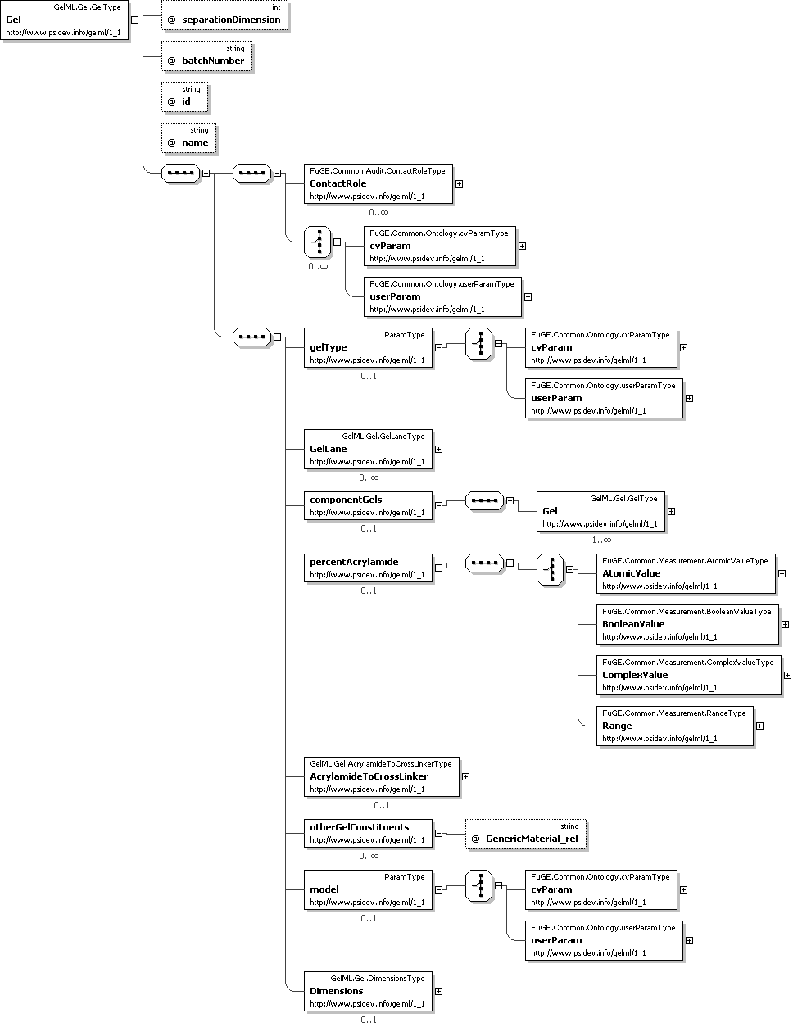

Figure 2 The model of a Gel within GelML

The Gel class has an association to GelLanes to describe the lanes present on the gel. GelLane has an attribute laneNumber, which stores an integer value to identify the lane with respect to the parent gel. Any additional substances in the gel not described elsewhere can be recorded using the OtherGelConstituents association to MeasuredMaterial.

The self-association on Gel, ComponentGels, SHOULD be used for describing stacking gels, for example where a parent Gel comprises more than one ComponentGels that have different values for PercentAcrylamide. If the ComponentGels association is used, the parent Gel SHOULD NOT supply a value for AdditionalSubstances, PercentAcrylamide or AcrylamideCrossLinker; these values SHOULD be supplied in the instances of Gel referenced as ComponentGels. Other values should be supplied where applicable, for example it MAY be applicable to supply Dimensions for both parent and child Gel instances.

The abstract class ElectrophoresedGel and its subclasses Gel1D, Gel2D and OtherGel represent the Gel material(s) following protein separation and detection as described in Sections 4.2, 4.3 and 4.4. ElectrophoresedGel has an association to the abstract class SeparationRange for the physicochemical separation range of the gel. Subclasses of SeparationRange are PHRange (for separations by isoelectric point), MolWeightRange (for molecular weight separations) and OtherGelRange (for any other kind of separation). For example, to represent a 2-D gel where an IPG strip is used in the first dimension and separation by molecular weight in the second dimension, a Gel2D object SHOULD have an association to both PHRange and MolWeightRange (if known). SeparationRange has an association to FuGE:Measurement and thus inherits the mechanism for giving various types of value (such as an atomic value or a range). The dimension attribute on SeparationRange MUST be used to represent the dimension that the range refers to. RangeValue (subclass of Measurement) SHOULD be used in conjunction with SeparationRange.

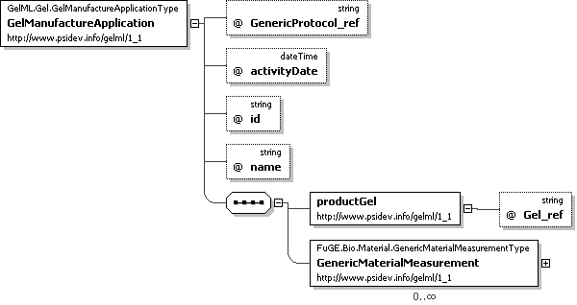

Figure 3 The model of gel manufacture in GelML.

GelManufactureApplication SHOULD be used to capture the application of a procedure that produced or manufactured a Gel, if the Gel has not been purchased pre-cast (Figure 3). The inputs to GelManufactureApplication are measured quantities of materials, captured using FuGE GenericMaterialMeasurement and GenericMaterial elements. GelManufactureApplication references GenericProtocol, which SHOULD be used to capture the procedure of gel production. Any of the features of GenericProtocol MAY be used. If a gel is purchased pre-cast the FuGE ContactRole[3] and Contact elements SHOULD be used to capture the manufacturer of the Gel (Figure 2).

## One-dimensional gel electrophoresis

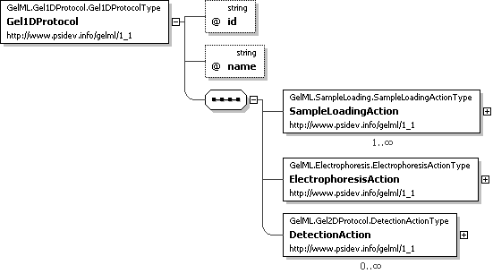

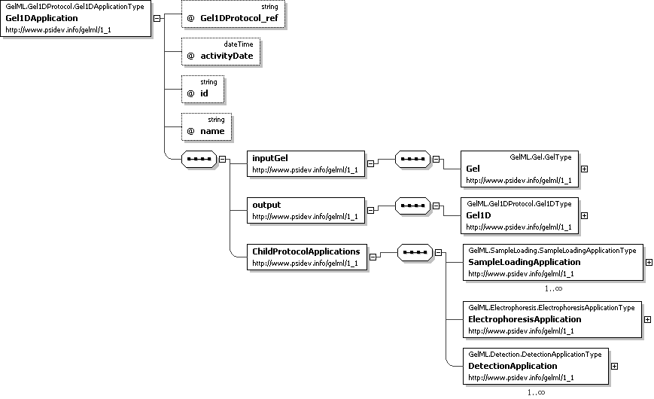

Figure 4 Gel1DProtocol and Gel1DApplication models.

The Gel1DProtocol element represents a protocol for one-dimensional gel electrophoresis (Figure 4). Gel1DProtocol has associations to three defined steps within that protocol: SampleLoadingAction, ElectrophoresisAction and DetectionAction. Subelements of Action can be given an order within their parent Protocol, using the actionOrdinal attribute, and provide a method for referencing child protocols that occur within the parent Protocol. SampleLoadingAction has an attribute laneNumber that MAY be used to provide an integer corresponding to the lane of a gel that this procedure refers to, for example if different protocols are used to load samples onto different lanes. If the laneNumber is not provided, only one SampleLoadingAction SHOULD be used and it is assumed that this references the SampleLoadingProtocol used to load samples onto every lane. There is an association from SampleLoadingAction to the element SampleLoadingProtocol (a subelement of FuGE Protocol). SampleLoadingProtocol stores the method used to load the sample onto the gel as described in Section 4.5. ElectrophoresisAction has an association to ElectrophoresisProtocol that captures the method used to perform electrophoresis on the gel as described in Section 4.6. DetectionAction has an association to DetectionProtocol, as described in Section 4.7, to represent the method of protein detection (such as staining). The dimension attributes on SampleLoadingAction and DetectionAction MUST NOT be used within a Gel1DProtocol.

Gel1DApplication represents the application of the Gel1DProtocol described above (Figure 4). Gel1DApplication has an association to Gel to describe the physical gel material on which electrophoresis has taken place. The output of a Gel1DApplication is modelled by an association to Gel1D, which represents the gel after sample loading, electrophoresis and detection. Gel1D is a subelement of the abstract element ElectrophoresedGel which can be referenced by elements that model processes that occur after the Gel1DApplication, as described in Sections 4.8 and 4.9.

Gel1DApplication references ones or more SampleLoadingApplication elements, one ElectrophoresisApplication and zero or more DetectionApplication elements, following the structure of the Gel1DProtocol. If only one SampleLoadingAction has been provided in the Gel1DProtocol, instances of SampleLoadingApplication MUST be created for each gel lane. For example, if 10 lanes have been loaded, 10 instances of SampleLoadingApplication will exist.

## Two dimensional gel electrophoresis

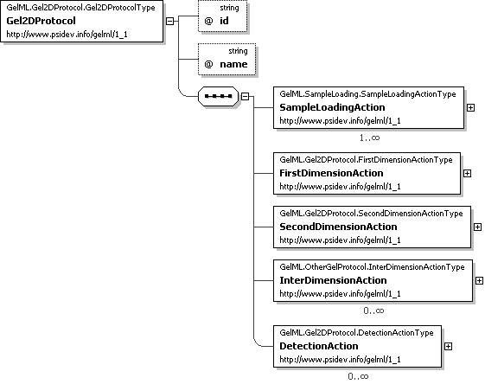

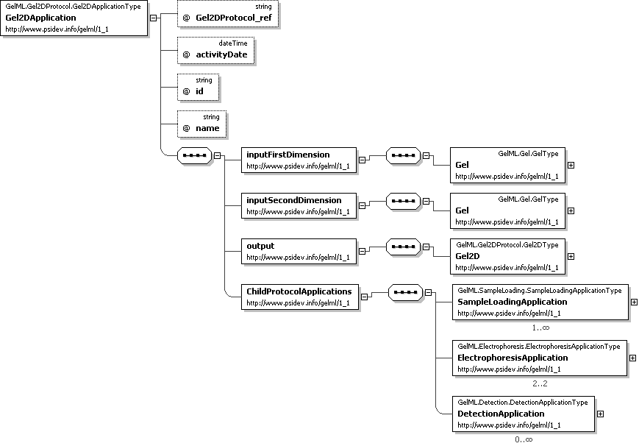

Figure 5 Gel2DProtocol and Gel2DApplication model.

Figure 5 displays the model of two-dimensional gel electrophoresis, including difference gel electrophoresis. Gel2DProtocol models the method employed, with associations to SampleLoadingAction, FirstDimensionAction, SecondDimensionAction, InterDimensionAction and DetectionAction to describe steps within the Gel2DProtocol. SampleLoadingAction references SampleLoadingProtocol and allows a specification of the dimension and gel lane (laneNumber), if applicable, that the referenced SampleLoadingProtocol refers to. FirstDimensionAction and SecondDimensionAction reference the ElectrophoresisProtocol element to describe the method of electrophoresis used in the two dimensions. The InterDimensionAction element references the abstract Protocol element which MAY be used to describe procedures that occurs between the first and second dimension separations (including equilibration), for example using the non-abstract subclass GenericProtocol. DetectionAction references the DetectionProtocol used on the gel. The dimension attribute on DetectionAction SHOULD only be used in rare cases where a detection procedure has taken place on both a first and second dimension gel.

Gel2DApplication describes the running of the Gel2DProtocol. Gel2DApplication has two associations to Gel in order to model the two gels used in the separation. Gel2DApplication also has an association to Gel2D, representing the substrate following the combination of the two gels and the proteins separated by the two stages of electrophoresis.

Gel2DApplication inherits an association to ActionApplication that can be used to reference child ProtocolApplication objects. Gel2DApplication MUST reference one or more SampleLoadingApplication objects, two ElectrophoresisApplication objects, zero or more GenericProtocolApplication objects (if GenericProtocol objects have been used with InterDimensionAction), and zero or more DetectionApplication objects matching the structure of the referenced Gel2DProtocol.

## Other Gel Electrophoresis

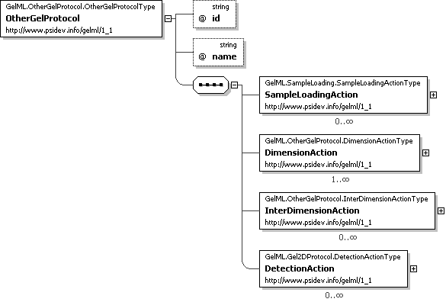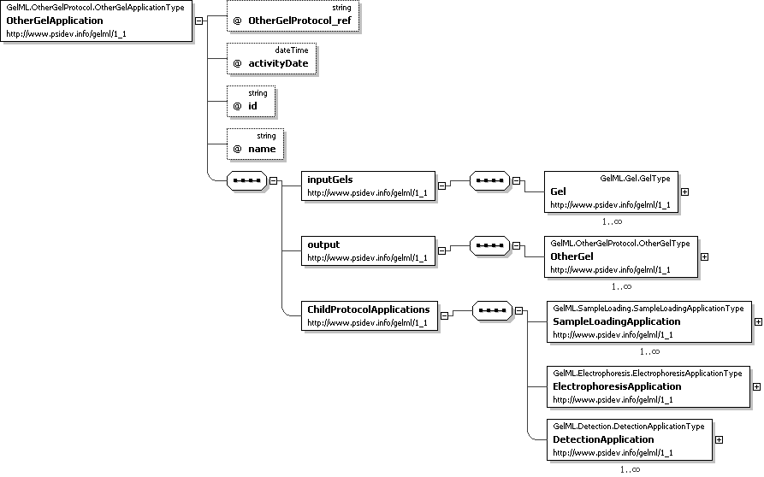

Figure 6 A model for types of gel electrophoresis other than standard 1D or 2D electrophoresis.

Figure 6displays a model that allows gel electrophoresis experiments other than “standard” 1D or 2D gel electrophoresis to be captured in GelML. OtherGelProtocol SHOULD be associated with SampleLoadingAction, DimensionAction, InterDimensionAction and DetectionAction. Each subclass of Action SHOULD be given a value for the dimension attribute which captures the dimension Gel that the protocol refers to. InterDimensionAction captures procedures that occur between the electrophoresis on each dimension (see Section 5.35). The preDimension attribute captures the number of the dimension that occurs after the referenced protocol. For example, if three dimensions of separation are performed, a protocol that occurs between the second and third dimension SHOULD be referenced by an InterDimensionAction with preDimension = 3. OtherGelApplication captures an application of the OtherGelProtocol. The InputGels association captures the one or more Gel substrates that are used. The OutputGels association captures the output of the procedure as one or more instances of OtherGel (a subclass of ElectrophoresedGel).

OtherGelApplication MUST reference SampleLoadingApplication, ElectrophoresisApplication, DetectionApplication, and GenericProtocolApplication objects matching the structure of the referenced OtherGelProtocol.

## Sample loading

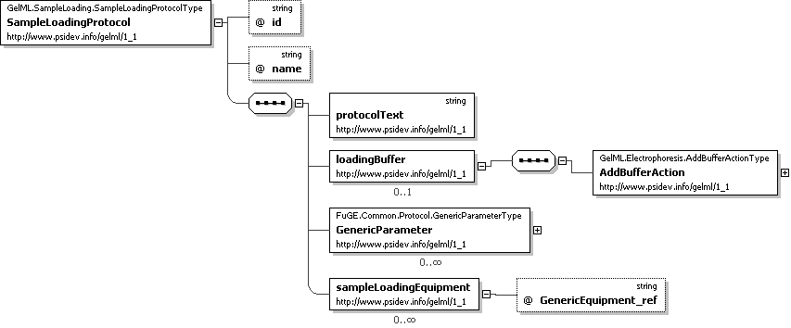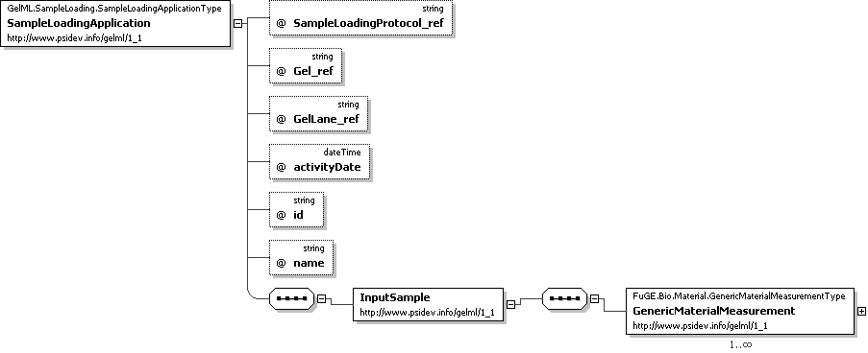

Figure 7 Models for describing the loading samples onto gels.

Figure 7 shows the model for loading a sample onto a gel. At least one instance of SampleLoadingApplication is REQUIRED for a 1D gel experiment, referencing the protein sample loaded via the association InputSample. The quantity of sample loaded SHOULD be specified using the association on GenericMaterialMeasurement (not shown) to Measurement. The Gel onto which the sample is loaded MUST be the same Gel that is referenced from Gel1DApplication (Figure 4). If the sample has been loaded onto a particular GelLane, the association LoadedGelLane SHOULD also used to reference the GelLane onto which the sample has been loaded. The GelLane MUST be a lane belonging to the Gel referenced from Gel1DApplication. One instance of SampleLoadingApplication is REQUIRED per GelLane that is loaded.

In a 2D gel experiment, one or more instances of SampleLoadingApplication are REQUIRED. If a protein sample has been loaded onto the first dimension gel, SampleLoadingApplication MUST reference the first dimension Gel that is associated with Gel2DApplication as InputFirstDimension. The protein sample loaded is referenced via InputSample and is captured using GenericMaterial for example. If a DIGE experiment has been performed, in which multiple samples are loaded onto the same gel, each labelled with a particular Cy dye, the characteristics association on GenericMaterial SHOULD be used to reference the relevant fluorescent label using a term from a controlled vocabulary. If multiple samples have been loaded onto a standard (non-DIGE) gel, this SHOULD be captured using the same mechanism.

SampleLoadingApplication MAY also be used to capture the loading of protein samples onto gel lanes on a second dimension Gel, such as molecular weight markers. If SampleLoadingApplication is used in this way, the second dimension Gel referenced as LoadedGel MUST be the instance referenced by Gel2DApplication as InputSecondDimension.

SampleLoadingApplication references SampleLoadingProtocol, which describes the method used to load the sample. It is REQUIRED that at least one SampleLoadingProtocol is specified within a Gel1DProtocol, and at least one is specified within a Gel2DProtocol (Figure 4 and Figure 5). The text of a SampleLoadingProtocol SHOULD be provided in the protocolText attribute. GenericEquipment MAY be used to describe any equipment used in sample loading and GenericParameter MAY be used for any protocol parameters as appropriate. The loading buffer SHOULD be specified by the association to AddBufferAction.

## Electrophoresis

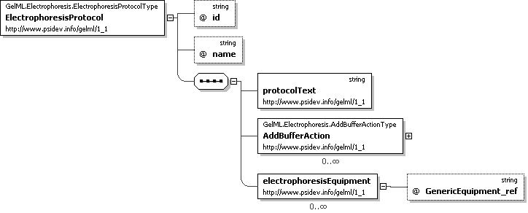

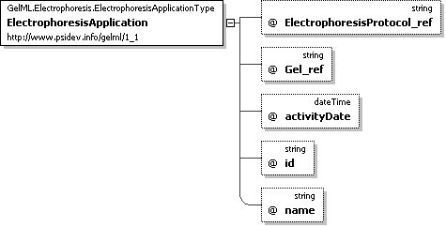

Figure 8 The model for electrophoresis.

Figure 8 displays the model for an electrophoresis protocol. The main protocol description is captured within protocolText. The equipment used for electrophoresis such as tanks or power-packs MAY be captured using GenericEquipment. The buffers used in electrophoresis, such as the cathode buffer or anode buffer, SHOULD be specified by the association to AddBufferAction. The type of buffer SHOULD be specified using the MixtureType association on SubstanceMixtureProtocol. The constituents of buffers or solutions used during electrophoresis SHOULD be defined by SubstanceMixtureProtocol, as described in Section 4.10.

An application of ElectrophoresisProtocol is captured by ElectrophoresisApplication. An instance of ElectrophoresisApplication MUST reference the Gel on which electrophoresis takes place. The Gel MUST be one of the Gel instances referenced from the parent Gel2DApplication, OtherGelApplication, or Gel1DApplication. Two ElectrophoresisApplications are REQUIRED for each Gel2DApplication, as described in Section 4.3.

## Detection



Figure 9 The model of protein detection, either by a direct or an indirect method.

The model for detection of proteins separated on gels is shown in Figure 9. The process is modelled by a DetectionProtocol and the associated application elements DirectDetection and IndirectDetection. The DetectionProtocol references the DetectionAgent, specified using a cvParam. Any buffers or solutions used in the DetectionProtocol MAY be defined by an instance of SubstanceMixtureProtocol referenced by AddBufferAction. The overall description of the protocol SHOULD be captured as plain text in the protocolText attribute. Any instruments used with the DetectionProtocol MAY be captured by GenericEquipment.

A DirectDetection procedure consists of applying a detection agent to a gel as specified in the DetectionProtocol. An IndirectDetection procedure captures processes such as Western blots and autoradiography. If the proteins on a gel are transferred to another substrate, such as an immobilizing membrane, this MUST be captured by TransferMedium, referenced from IndirectDetection. If the gel is subjected to autoradiography, the photographic film (or other medium) MUST be captured by an instance of DetectionMedium.

## Image acquisition

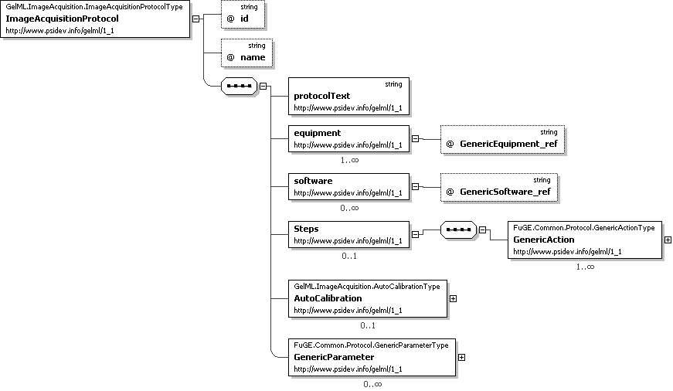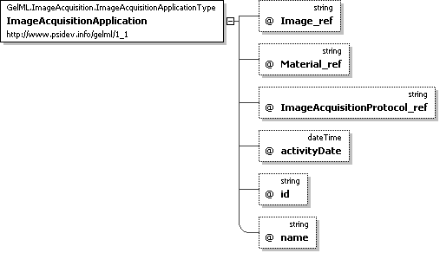

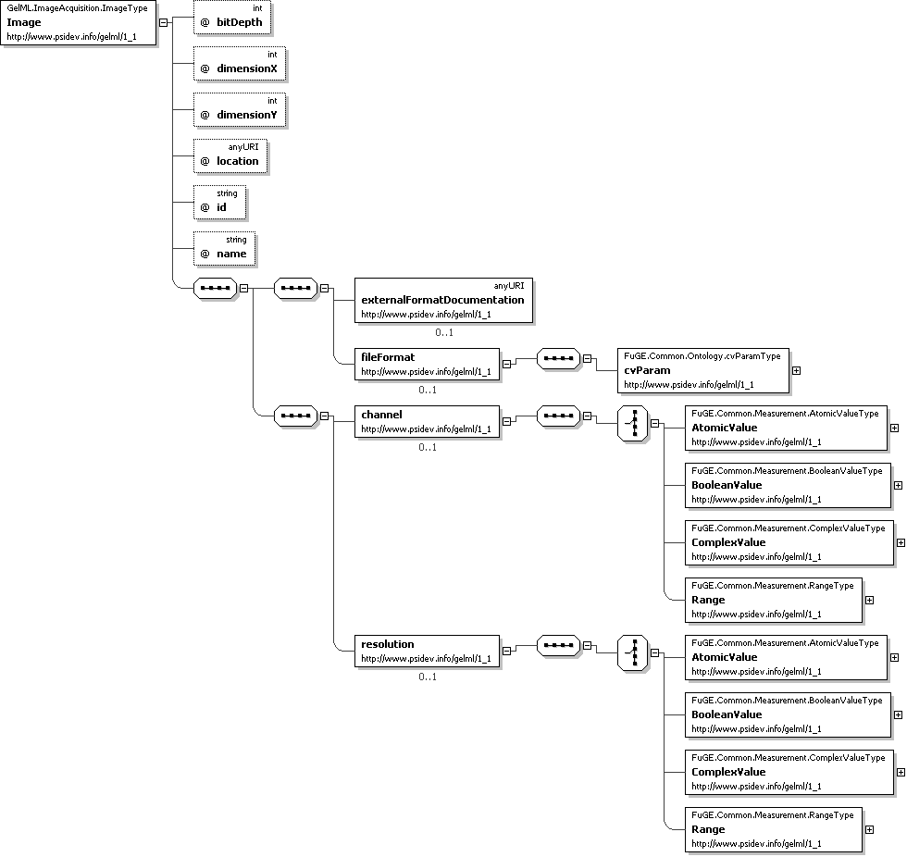

Figure 10 The model for image acquisition and gel images.

The model for image acquisition, such as scanning or photographing, in GelML is displayed in Figure 10. ImageAcquisitionApplication has an association to ImageAcquisitionProtocol for capturing the details of how the image acquisition was performed. The image acquisition equipment and software SHOULD be captured using GenericSoftware and GenericEquipment. There are an association from ImageAcquisitionProtocol to GenericAction that SHOULD be used for reporting the protocol or calibration Steps performed. Any parameters that are deemed to have affected the resulting image SHOULD be captured using GenericParameter (using terms that will be developed as part of the associated controlled vocabulary). The text of the ImageAcquisitionProtocol SHOULD be captured in the protocolText attribute.

The input to ImageAcquisitionApplication is an instance of Material, allowing any subclass of FuGE Material to be referenced. During a 1D gel electrophoresis experiment, if the gel is scanned after electrophoresis, ImageAcquisitionApplication MUST reference the instance of Gel1D that is output from Gel1DApplication. During a 2D gel electrophoresis experiment, if the gel is scanned after electrophoresis, ImageAcquisitionApplication MUST reference the instance of Gel2D that is output from Gel2DApplication. If a DetectionMedium or TransferMedium has been scanned, the referenced object SHOULD be an object referenced by IndirectDirection.

The output of ImageAcquisitionApplication is a single Image, hence if multiple images have been produced, this MUST be represented by multiple instances of ImageAcquisitionApplication. Image has an association to Measurement for capturing the Channel[4] or wavelength at which the image was created. Image has attributes for capturing the bit-depth and the x and y dimensions in pixels. There is an association to Measurement elements to capture the image resolution with which an appropriate unit MUST be given. Image has an attribute for capturing the location of the file. The location of the Image SHOULD be provided. The file format SHOULD be specified using the association to cvParam. An image of a 1D gel or 2D gel MUST be in the standard orientation as defined in MIAPE GE[5]. A URI MAY also be given describing the image format (ExternalFormatDocumentation), for example if the image is not in a standard file format, such as a validation schema or formal specification document.

## The excision of locations on gels

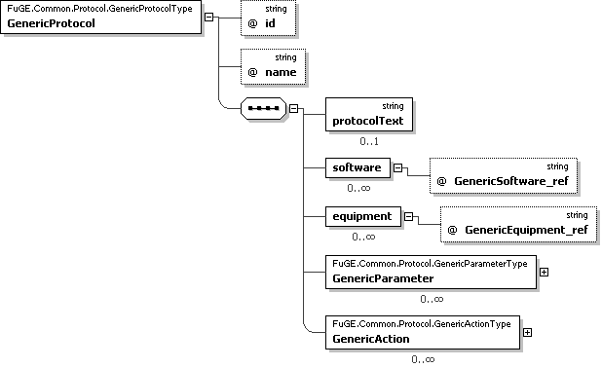

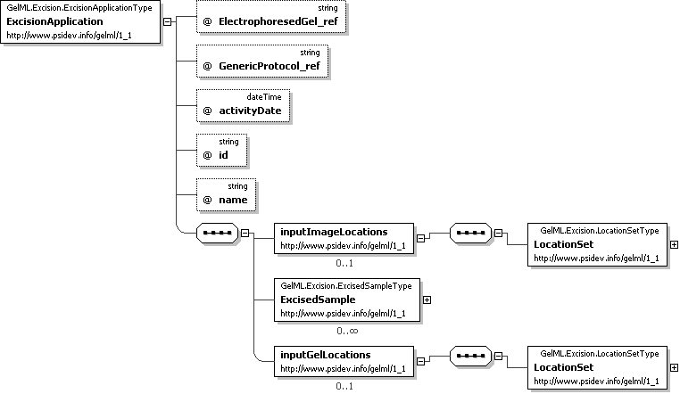

Figure 11 The model for excising specified locations on gels.

Figure 11 captures information about how locations, such as spots or bands, have been excised from electrophoresed gels. The input to ExcisionApplication is modelled by a reference to ElectrophoresedGel for which values of one of Gel1D, Gel2D and OtherGel MUST be given. ExcisionApplication referencesGenericProtocol, which captures the details of the procedure and any parameters required as controlled vocabulary terms. The software and equipment used, such as a robotic spot picker, MAY be captured using GenericSoftware and GenericEquipment. ExcisionProtocol has two associations to the LocationSet class that captures the locations on the physical gels (GelLocation) that have been excised. The two associations may be required because one LocationSet SHOULD correspond with locations on the original digitised image, the other MAY be used to specify the locations on the physical gel as determined by a robotic spot picker at run-time. GelLocation has a self-association to allow the mapping of locations from one set to another, for instance if a robot has determined that locations on a physical gel correspond with others on the original digitised image. LocationSet has an association to FuGE ExternalData for capturing a file containing information about image analysis carried out on a gel image. There is also an association from LocationSet to Image to capture the source image on which the LocationSet is based.

The output of ExcisionLocation is a set of ExcisedSamples (subclass of FuGE Material) which, for example, could be referenced as the input to another technique, such as in preparation for mass spectrometry. Each ExcisedSample has an association to GelLocation to specify the position from which it was excised.

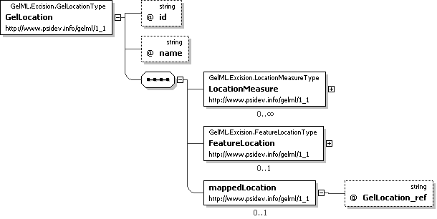

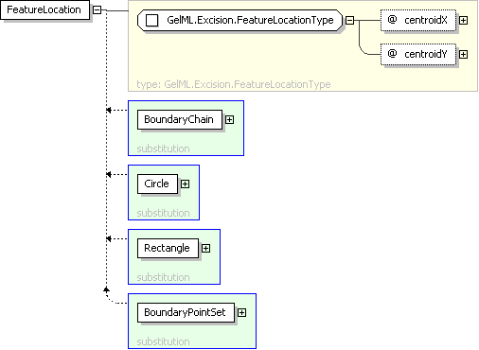

Figure 12 The model of feature locations of gels.

A GelLocation has an association to LocationMeasure for capturing properties of a location such as predicted charge or molecular weight values, using terms from a controlled vocabulary (Figure 12). The location on a gel MUST be specified using either FeatureLocation (for simple X/Y coordinates with no information about area, for example if spots are manually excised) or one of its subclasses: Rectangle, Circle, BoundaryPointSet and BoundaryChain unless gel locations have been excised but the coordinates are not known i.e. image analysis was not performed. In this case, for each ExcisedSample, a GelLocation SHOULD be reported but a FeatureLocation SHOULD NOT be reported. Rectangle captures rectangular locations, with the x/y coordinates corresponding to the upper left corner of the feature. The Circle class has the attribute pixelRadius for the feature radius. It is expected that multiple instances of BoundaryPointSet can be used to define an irregularly shaped location, giving X/Y coordinates (Point) of all the points surrounding a location. BoundaryChain is an alternative method for specifying the outline of a location on an image. The X/Y coordinates specify the starting point and then a chain SHOULD be described consisting of directional steps. Each step is encoded using the following convention:

0 = East; 1 = NE; 2 = North; 3 = NW; 4 = West; 5 = SW; 6 = South; 7 = SE (Figure 13).

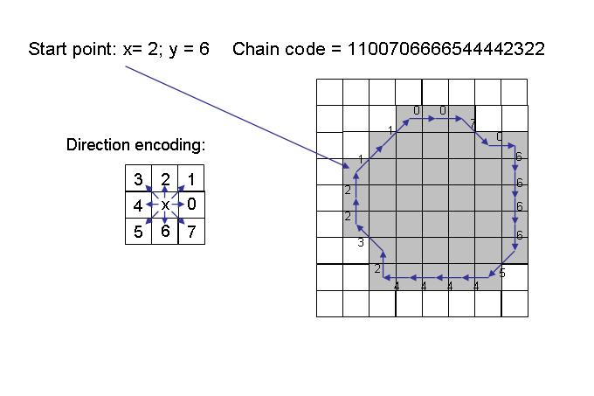

Figure 13 An example of the encoding of a BoundaryChain chainCode.

## SubstanceMixtureProtocol and SubstanceAction

There are various places in GelML where buffers or solutions must be described (Figure 14). SubstanceMixtureProtocol can describe a set of substances, each modelled by SubstanceAction, for instance to describe the creation of a buffer or solution. If the time points at which the substance is used or added within the parent protocol must be captured, an instance of TemporalSubstanceAction SHOULD be used. The type of substance and its characteristics MAY be captured using CV terms. Alternatively, the type of substance MAY be described using the attribute substanceName. The process performed with a substance MAY be captured in the actionText attribute. This allows SubstanceAction to be used in the context of other Protocol objects, such as DetectionProtocol (Section 4.7). The volume, concentration and mass of the substance and the time points MAY be captured.

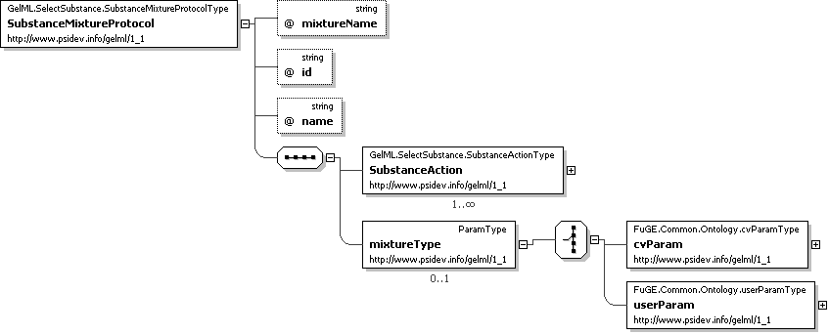

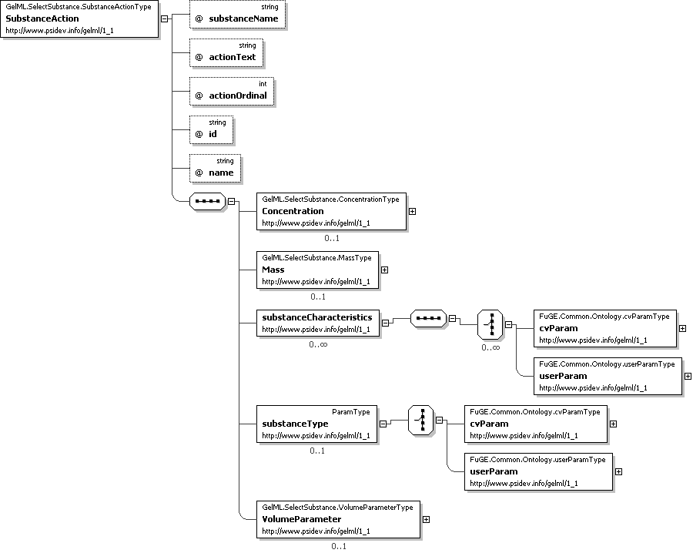

Figure 14 The SubstanceMixtureProtocol model allows mixtures of substances, solutions, buffers and so on to be defined, along with recipes for how they were produced.

# Model in XML Schema

The following section contains the formal documentation for the GelML XML Schema, detailing each element, sub-elements, attributes, cardinalities and possible values for CV terms where applicable.

## Element <GelML>

|  |  |
| --- | --- |
| **Definition:** | The root of the GelML document. |
| **Type:** | GelML.GelMLRoot.GelMLType |
| **Attributes:** | |  |  |  |  | | --- | --- | --- | --- | | **Attribute Name** | **Data Type** | **Use** | **Definition** | | id | xsd:string | required | An identifier is an unambiguous string that is unique within the scope (i.e. a document, a set of related documents, or a repository) of its use. | | name | xsd:string | optional | The potentially ambiguous common identifier, such as a human-readable name for the instance. | |
| **Subelements:** | |  |  |  |  | | --- | --- | --- | --- | | **Subelement Name** | **minOccurs** | **maxOccurs** | **Definition** | | Provider | 0 | 1 | The provider of the document in terms of the Contact and the software the produced the document instance. | | cvList | 1 | 1 | The list of CVs used within the file | | GelMLMaterialCollection | 0 | 1 | Collection class for accessing all GenericMaterial instances used in GelML. | | GelMLDataCollection | 0 | 1 | Collection class for accessing all ExternalData instances in GelML. | | GelMLProtocolCollection | 0 | 1 | Collection class for accessing all Software, Protocol and Equipment instances. | | Gel1DExperiment | 0 | unbounded | Abstract superclass representing the groups of ProtocolApplications that should be represented in a valid GelML document. | | Gel2DExperiment | 0 | unbounded | Abstract superclass representing the groups of ProtocolApplications that should be represented in a valid GelML document. | | OtherGelExperiment | 0 | unbounded | Abstract superclass representing the groups of ProtocolApplications that should be represented in a valid GelML document. | | AuditCollection | 0 | 1 | The collection of Contact records. | | ReferenceableCollection | 0 | 1 | The collection of objects that allow external references. | |
| **Example Context:** | <GelML xmlns:xsi="http://www.w3.org/2001/XMLSchema-instance"  xsi:schemaLocation="http://www.psidev.info/gelml/1_1candidate ../Schema/GelML-v1_1candidate.xsd"  xmlns="http://www.psidev.info/gelml/1_1candidate"  id="ex006:GelML:001" name="DIGE example from http://www5.amershambiosciences.com/">  ...  </GelML> |

## Element <Provider>

|  |  |
| --- | --- |
| **Definition:** | The provider of the document in terms of the Contact and the software the produced the document instance. |
| **Attributes:** | |  |  |  |  | | --- | --- | --- | --- | | **Attribute Name** | **Data Type** | **Use** | **Definition** | | Software_ref | xsd:string | optional | The Software that produced the document instance. | | id | xsd:string | required | An identifier is an unambiguous string that is unique within the scope (i.e. a document, a set of related documents, or a repository) of its use. | | name | xsd:string | optional | The potentially ambiguous common identifier, such as a human-readable name for the instance. | |
| **Subelements:** | |  |  |  |  | | --- | --- | --- | --- | | **Subelement Name** | **minOccurs** | **maxOccurs** | **Definition** | | ContactRole | 0 | 1 | The Contact that provided the document instance. | |
| **Example Context:** | <Provider id="newid:Provider1">  <ContactRole Contact_ref="newid:Person115">  <role>  <cvParam accession="sep:00035" cvRef="SEP" name="principle investigator"/>  </role>  </ContactRole>  </Provider> |

## Element <cvList>

|  |  |
| --- | --- |
| **Definition:** | The list of CVs used within the file |
| **Attributes:** | none |
| **Subelements:** | |  |  |  |  | | --- | --- | --- | --- | | **Subelement Name** | **minOccurs** | **maxOccurs** | **Definition** | | cv | 1 | unbounded | A source controlled vocabulary from which cvParams will be obtained. | |
| **Example Context:** | <cvList>  <cv URI="https://psidev.svn.sourceforge.net/svnroot/psidev/psi/sepcv/trunk/sep.obo"  fullName="sepCV" id="SEP" version="1.0"/>  <cv URI="http://obo.cvs.sourceforge.net/*checkout*/obo/obo/ontology/phenotype/unit.obo"  fullName="Unit Ontology" id="UO"/>  </cvList> |

## Element <GelMLMaterialCollection>

|  |  |
| --- | --- |
| **Definition:** | Collection class for accessing all GenericMaterial instances used in GelML. |
| **Type:** | GelML.GelMLRoot.GelMLMaterialCollectionType |
| **Attributes:** | none |
| **Subelements:** | |  |  |  |  | | --- | --- | --- | --- | | **Subelement Name** | **minOccurs** | **maxOccurs** | **Definition** | | GenericMaterial | 0 | unbounded | A subclass of the abstract Material class, which should be used in conjunction with controlled vocabulary terms to describe Materials of any types used in an investigation. | |
| **Example Context:** | <GelMLMaterialCollection>  <GenericMaterial id="736" name="33 ugx3=99 ug, Cy2, Cy3, Cy5">  <cvParam accession="sep:00196" cvRef="SEP" name="sample description"  value="Sample preparation: Protein extraction buffer composition: 30 mM Tris-HCl pH 8.5; 8 M Urea; 2 M Thiourea; 4% CHAPS. Volume of buffer used: 300 ul Homogenization procedure used (mechanical, sonication...): sonication (8x30 sec pulses, on ice) What precautions were taken to avoid proteolysis (if any)?: Lysis Buffer with 8 M Urea; 2 M Thiourea; 4% CHAPS. Method used for purification and/or concentration of the sample: TCA-acetone precipitation Final volume of sample (microliters): 300 Quantitation method used: RC DC Protein Assay BIO RAD Protein concentration (mg/mL): 471 Total protein amount (micrograms): 141300"  />  </GenericMaterial>  ...  </GelMLMaterialCollection> |

## Element <GelMLDataCollection>

|  |  |
| --- | --- |
| **Definition:** | Collection class for accessing all ExternalData instances in GelML. |
| **Type:** | GelML.GelMLRoot.GelMLDataCollectionType |
| **Attributes:** | none |
| **Subelements:** | |  |  |  |  | | --- | --- | --- | --- | | **Subelement Name** | **minOccurs** | **maxOccurs** | **Definition** | | Image | 0 | unbounded | A single entry from an ontology or a controlled vocabulary | |
| **Example Context:** | <GelMLDataCollection>  <Image location="uri.to.image" id="ex001:Image1" name="[optional image name]" bitDepth="16" dimensionX="3215" dimensionY="3530">  <channel>  <AtomicValue>  <PropertyValue value="450" unitName="hertz" unitAccession="UO:0000106" unitCvRef="UO"/>  </AtomicValue>  </channel>  ...  </GelMLDataCollection> |

## Element <GelMLProtocolCollection>

|  |  |
| --- | --- |
| **Definition:** | Collection class for accessing all Software, Protocol and Equipment instances. |
| **Type:** | GelML.GelMLRoot.GelMLProtocolCollectionType |
| **Attributes:** | none |
| **Subelements:** | |  |  |  |  | | --- | --- | --- | --- | | **Subelement Name** | **minOccurs** | **maxOccurs** | **Definition** | | GenericEquipment | 0 | unbounded | A subclass of the abstract Equipment class for capturing the description of Equipment used. | | GenericSoftware | 0 | unbounded | A subclass of the abstract Software class for capturing the description of Software used. | | GenericProtocol | 0 | unbounded | GenericProtocol should be used with GenericAction, GenericParameter or protocolText to describe protocols in a data format for cases where no explicit extension of Protocol has been developed. </xsd:documentation> | | SampleLoadingProtocol | 0 | unbounded | A Protocol defining how samples are loaded onto a Gel or GelLanes. | | Gel2DProtocol | 0 | unbounded | A protocol describing the procedure of 2D gel electrophoresis. | | Gel1DProtocol | 0 | unbounded | A protocol describing the procedure of 1D gel electrophoresis. | | OtherGelProtocol | 0 | unbounded | A protocol for capturing experiments that cannot be represented by Gel1DProtocol or Gel2DProtocol. | | ElectrophoresisProtocol | 0 | unbounded | A protocol for capturing the details of electrophoresis. The running conditions applied to the gel should be given in terms of voltages versus time/kilovolt hours, (or appropriate measurements) and temperature. The voltage mode profile (eg. step and hold, or gradient) should be given as ontology terms on ElectricalParameter. | | SubstanceMixtureProtocol | 0 | unbounded | A Protocol representing the creation of a mixture of substances, for example to be used for specifying the components of buffers, solutions etc. If the actionText attribute of SubtanceAction is not used, the SubstanceMixtureProtocol represents only the components of the mixture and not the processes applied to them. | | DetectionProtocol | 0 | unbounded | The process by which proteins are to be detected on a gel, either by a direct process e.g. staining or by an indirect process e.g. Western blot. The type of protocol should be specified using the types association inherited from Protocol | | ImageAcquisitionProtocol | 0 | unbounded | A protocol describing image acquisition. | |
| **Example Context:** | <GelMLProtocolCollection>  <GenericEquipment name="Ettan DALT II Separation Unit and Power Supply/Control Unit "  id="ex002:GenericEquipment0"/>  <GenericEquipment  name="Gels and reagents contained in 14 L Sealfresh food storage boxes, approx. dimensions 290 x 290 x 160 mm (Stewart). Universal shaker SM-30, with to-and-fro motion (Edmund Buhler)."  id="ex002:GenericEquipment1"/>  <GenericEquipment  ...  </GelMLProtocolCollection> |

## Element <Gel1DExperiment>

|  |  |
| --- | --- |
| **Definition:** | Gel1DExperiment captures the ProtocolApplications that should be reported for 1D gel electrophoresis in a GelML file. |
| **Type:** | GelML.GelMLRoot.Gel1DExperimentType |
| **Attributes:** | |  |  |  |  | | --- | --- | --- | --- | | **Attribute Name** | **Data Type** | **Use** | **Definition** | | date | xsd:date | optional | The date the experiment was initiated on. | | id | xsd:string | required | An identifier is an unambiguous string that is unique within the scope (i.e. a document, a set of related documents, or a repository) of its use. | | name | xsd:string | optional | The potentially ambiguous common identifier, such as a human-readable name for the instance. | |
| **Subelements:** | |  |  |  |  | | --- | --- | --- | --- | | **Subelement Name** | **minOccurs** | **maxOccurs** | **Definition** | | electrophoresisType | 0 | 1 | The experiment type definition, such as "2D-DIGE", "one-dimensional gel electrophoresis", "two-dimensional gel electrophoresis" etc. | | ContactRole | 0 | 1 | The primary contact for this GelExperiment | | GelManufactureApplication | 0 | unbounded | The application of a protocol that defines how a gel was produced. | | Gel1DApplication | 1 | 1 | The application of a Gel1DProtocol. Gel1DApplication should reference (via ActionApplication) SampleLoadingApplication, ElectrophoresisApplication and DetectionApplication matching the structure of the referenced Gel1DProtocol. | | ImageAcquisitionApplication | 0 | unbounded | An application of a protocol (GenericProtocol) describing the scanning of a material to produce an Image. In this context it is expected that the Material would be an ElectrophoresedGel, TransferMedium or DetectionMedium. | | ExcisionApplication | 0 | unbounded | The Application of a protocol that describes the excision of locations on gels. | |
| **Example Context:** | <Gel1DExperiment id="ex001:Gel1DExperiment0">  <electrophoresisType>  <cvParam cvRef="sepCV" accession="sep:00150" name="one dimensional gel electrophoresis"/>  </electrophoresisType>  <ContactRole Contact_ref="ex001:Person0">  <role>  <cvParam cvRef="sepCV" accession="sep:00035" name="principle investigator"/>  ...  </Gel1DExperiment> |

## Element <Gel2DExperiment>

|  |  |
| --- | --- |
| **Definition:** | Gel2DExperiment captures the ProtocolApplications that should be reported for 2D gel electrophoresis in a GelML file. |
| **Type:** | GelML.GelMLRoot.Gel2DExperimentType |
| **Attributes:** | |  |  |  |  | | --- | --- | --- | --- | | **Attribute Name** | **Data Type** | **Use** | **Definition** | | date | xsd:date | optional | The date the experiment was initiated on. | | id | xsd:string | required | An identifier is an unambiguous string that is unique within the scope (i.e. a document, a set of related documents, or a repository) of its use. | | name | xsd:string | optional | The potentially ambiguous common identifier, such as a human-readable name for the instance. | |
| **Subelements:** | |  |  |  |  | | --- | --- | --- | --- | | **Subelement Name** | **minOccurs** | **maxOccurs** | **Definition** | | electrophoresisType | 0 | 1 | The experiment type definition, such as "2D-DIGE", "one-dimensional gel electrophoresis", "two-dimensional gel electrophoresis" etc. | | ContactRole | 0 | 1 | The primary contact for this GelExperiment | | GelManufactureApplication | 0 | unbounded | The application of a protocol that defines how a gel was produced. | | Gel2DApplication | 1 | 1 | Gel2DApplication is the application of a Gel2DProtocol. An instance of Gel2DApplication should reference SampleLoadingApplication, ElectrophoresisApplication, DetectionApplications and GenericProtocolApplication as its sub-steps, as defined by the referenced Gel2DProtocol. | | ImageAcquisitionApplication | 0 | unbounded | An application of a protocol (GenericProtocol) describing the scanning of a material to produce an Image. In this context it is expected that the Material would be an ElectrophoresedGel, TransferMedium or DetectionMedium. | | ExcisionApplication | 0 | unbounded | The Application of a protocol that describes the excision of locations on gels. | |
| **Example Context:** | <Gel2DExperiment id="">  <Gel2DApplication Gel2DProtocol_ref="ex06:Gel2DProtocol1" id="ex06:Gel2DApp1">  <inputFirstDimension>  <Gel id="ex001:Gel1" name="[e.g. IPG strip name]" batchNumber="[batchNumber]">  <gelType>  <cvParam cvRef="sepCV" accession="sep:00130" name="immobilized pH gradient gel" />  </gelType>  ...  </Gel2DExperiment> |

## Element <OtherGelExperiment>

|  |  |
| --- | --- |
| **Definition:** | OtherGelExperiment captures the ProtocolApplications that should be reported for a type of gel electrophoresis other than 1D or 2D in a GelML file. |
| **Type:** | GelML.GelMLRoot.OtherGelExperimentType |
| **Attributes:** | |  |  |  |  | | --- | --- | --- | --- | | **Attribute Name** | **Data Type** | **Use** | **Definition** | | date | xsd:date | optional | The date the experiment was initiated on. | | id | xsd:string | required | An identifier is an unambiguous string that is unique within the scope (i.e. a document, a set of related documents, or a repository) of its use. | | name | xsd:string | optional | The potentially ambiguous common identifier, such as a human-readable name for the instance. | |
| **Subelements:** | |  |  |  |  | | --- | --- | --- | --- | | **Subelement Name** | **minOccurs** | **maxOccurs** | **Definition** | | electrophoresisType | 0 | 1 | The experiment type definition, such as "2D-DIGE", "one-dimensional gel electrophoresis", "two-dimensional gel electrophoresis" etc. | | ContactRole | 0 | 1 | The primary contact for this GelExperiment | | GelManufactureApplication | 0 | unbounded | The application of a protocol that defines how a gel was produced. | | OtherGelApplication | 1 | 1 | OtherGelApplication is the application of an OtherGelProtocol. An instance of OtherApplication should reference (via ActionApplication) SampleLoadingApplication, ElectrophoresisApplication, DetectionApplication and GenericProtocolApplication as its sub-steps, as defined by the referenced OtherGelProtocol. | | ImageAcquisitionApplication | 0 | unbounded | An application of a protocol (GenericProtocol) describing the scanning of a material to produce an Image. In this context it is expected that the Material would be an ElectrophoresedGel, TransferMedium or DetectionMedium. | | ExcisionApplication | 0 | unbounded | The Application of a protocol that describes the excision of locations on gels. | |
| **Example Context:** | <OtherGelDExperiment id="">  <OtherGelApplication Gel2DProtocol_ref="ex06:Gel2DProtocol1" id="ex06:Gel2DApp1">  <inputFirstDimension>  <Gel id="ex001:Gel1" name="[e.g. IPG strip name]" batchNumber="[batchNumber]">  <gelType>  <cvParam cvRef="sepCV" accession="sep:00130" name="immobilized pH gradient gel" />  </gelType>  ...  </ OtherGelDExperiment > |

## Element <AuditCollection>

|  |  |
| --- | --- |
| **Definition:** | The collection of Contact records. |
| **Attributes:** | none |
| **Subelements:** | |  |  |  |  | | --- | --- | --- | --- | | **Subelement Name** | **minOccurs** | **maxOccurs** | **Definition** | | Organization | 0 | unbounded | Organizations are entities like companies, universities, government agencies for which the attributes are self describing. | | Person | 0 | unbounded | A person for which the attributes are self describing. | |
| **Example Context:** | <AuditCollection>  <Organization name="Amersham Biosciences" id="ex002:Organization0"/>  <Person id="ex002:Person0" lastName="Brown" firstName="Alistair">  <affiliations Organization_ref="ex002:Organization1"/>  </Person>  <Organization id="ex002:Organization1"  address="School of Medical Sciences, University of Aberdeen, Aberdeen, AB25 2ZD, UK"/>  ...  </AuditCollection> |

## Element <Organization>

|  |  |
| --- | --- |
| **Definition:** | Organizations are entities like companies, universities, government agencies for which the attributes are self describing. |
| **Type** | FuGE.Common.Audit.OrganizationType |
| **Attributes:** | |  |  |  |  | | --- | --- | --- | --- | | **Attribute Name** | **Data Type** | **Use** | **Definition** | | address | xsd:string | optional | The address of the Contact. | | email | xsd:string | optional | The email address of the Contact. | | fax | xsd:string | optional | The fax number of the Contact. | | id | xsd:string | required | An identifier is an unambiguous string that is unique within the scope (i.e. a document, a set of related documents, or a repository) of its use. | | name | xsd:string | optional | The potentially ambiguous common identifier, such as a human-readable name for the instance. | | phone | xsd:string | optional | The telephone number of the Contact including the suitable area codes. | | tollFreePhone | xsd:string | optional | A toll free phone number for the Contact, including suitable area codes. | |
| **Subelements:** | |  |  |  |  | | --- | --- | --- | --- | | **Subelement Name** | **minOccurs** | **maxOccurs** | **Definition** | | parent | 0 | 1 | The containing organization (the university or business which a lab belongs to, etc.) | |
| **Example Context:** | <Organization name="Amersham Biosciences" id="ex002:Organization0"/> |

## Element <parent>

|  |  |
| --- | --- |
| **Definition:** | The containing organization (the university or business which a lab belongs to, etc.) |
| **Attributes:** | |  |  |  |  | | --- | --- | --- | --- | | **Attribute Name** | **Data Type** | **Use** | **Definition** | | Organization_ref | xsd:string | required | Organizations are entities like companies, universities, government agencies for which the attributes are self describing. | |
| **Subelements:** | none |
| **Example Context:** | <parent Organization_ref="RUB"/> |

## Element <Person>

|  |  |
| --- | --- |
| **Definition:** | A person for which the attributes are self describing. |
| **Type** | FuGE.Common.Audit.PersonType |
| **Attributes:** | |  |  |  |  | | --- | --- | --- | --- | | **Attribute Name** | **Data Type** | **Use** | **Definition** | | address | xsd:string | optional | The address of the Contact. | | email | xsd:string | optional | The email address of the Contact. | | fax | xsd:string | optional | The fax number of the Contact. | | firstName | xsd:string | optional | The Person's first name. | | id | xsd:string | required | An identifier is an unambiguous string that is unique within the scope (i.e. a document, a set of related documents, or a repository) of its use. | | lastName | xsd:string | optional | The Person's last/family name. | | midInitials | xsd:string | optional | The Person's middle initial. | | name | xsd:string | optional | The potentially ambiguous common identifier, such as a human-readable name for the instance. | | phone | xsd:string | optional | The telephone number of the Contact including the suitable area codes. | | tollFreePhone | xsd:string | optional | A toll free phone number for the Contact, including suitable area codes. | |
| **Subelements:** | |  |  |  |  | | --- | --- | --- | --- | | **Subelement Name** | **minOccurs** | **maxOccurs** | **Definition** | | affiliations | 0 | unbounded | The organization a person belongs to. | |
| **Example Context:** | <Person id="MPCMEYER" name="Prof. Dr. Helmut E. Meyer" address="Universitaetsstr. 150, D-44795 Bochum, Germany" email="helmut.e.meyer@rub.de">  <affiliations Organization_ref="MPCINSTITUTE"/>  </Person> |

## Element <affiliations>

|  |  |
| --- | --- |
| **Definition:** | The organization a person belongs to. |
| **Attributes:** | |  |  |  |  | | --- | --- | --- | --- | | **Attribute Name** | **Data Type** | **Use** | **Definition** | | Organization_ref | xsd:string | required | Organizations are entities like companies, universities, government agencies for which the attributes are self describing. | |
| **Subelements:** | none |
| **Example Context:** | <Person id="MPCMEYER" name="Prof. Dr. Helmut E. Meyer" address="Universitaetsstr. 150, D-44795 Bochum, Germany" email="helmut.e.meyer@rub.de">  <affiliations Organization_ref="MPCINSTITUTE"/>  </Person> |

## Element <ReferenceableCollection>

|  |  |
| --- | --- |
| **Definition:** | The collection of objects that allow external references. |
| **Type:** | FuGE.Collection.ReferenceableCollectionType |
| **Attributes:** | none |
| **Subelements:** | |  |  |  |  | | --- | --- | --- | --- | | **Subelement Name** | **minOccurs** | **maxOccurs** | **Definition** | | BibliographicReference | 0 | unbounded | Reference to the complete set of BibliographicReference objects in the FuGE document. | | Database | 0 | unbounded | Reference to the complete set of Database objects in the FuGE document. | |
| **Example Context:** | <ReferenceableCollection>  <BibliographicReference  id="ex003:BibliographicReference0"  authors="J. Inagawa, J. Hirano, and S. Hattori"  volume="12" title="CyDye DIGE Fluor minimal dyes for tracking membrane protein abundance from epilepsy-induced rats : A clinical proteomic study"/>  ...  </ReferenceableCollection> |

## Element <Database>

|  |  |
| --- | --- |
| **Definition:** | An address to a repository. |
| **Type:** | FuGE.Common.IdentifiableType |
| **Attributes:** | |  |  |  |  | | --- | --- | --- | --- | | **Attribute Name** | **Data Type** | **Use** | **Definition** | | version | xsd:string | required | The version of the Database. | | URI | xsd:anyURI | optional | The location of the Database. | |
| **Subelements:** | |  |  |  |  | | --- | --- | --- | --- | | **Subelement Name** | **minOccurs** | **maxOccurs** | **Definition** | | ContactRole | 0 | unbounded | Contact details for the Material. The association to ContactRole could specify, for example, the creator or provider of the Material. | |
| **Example Context:** | <ReferenceableCollection>  <Database version=”v1.2” URI=”http://www.ebi.ac.uk/ontology-lookup/”/>  ...  </ReferenceableCollection> |

## Element <BibliographicReference>

|  |  |
| --- | --- |
| **Definition:** | Represents bibliographic references, including the most common attributes. Note that because a BibliographicReference is Identifiable, a DatabaseEntry can also be specified. |
| **Type:** | FuGE.Common.References.BibliographicReferenceType |
| **Attributes:** | |  |  |  |  | | --- | --- | --- | --- | | **Attribute Name** | **Data Type** | **Use** | **Definition** | | id | xsd:string | required | Reference to the complete set of BibliographicReference objects in the FuGE document. | | name | xsd:string | optional | Reference to the complete set of Database objects in the FuGE document. | | authors | xsd:string | optional | The names of the authors of the reference. | | publication | xsd:string | optional | The name of the journal, book etc. | | publisher | xsd:string | optional | The publisher of the publication. | | editor | xsd:string | optional | The editor(s) of the reference. | | year | xsd:int | optional | The year of publication. | | volume | xsd:string | optional | The volume name or number. | | issue | xsd:string | optional | The issue name or number. | | pages | xsd:string | optional | The page numbers. | | title | xsd:string | optional | The title of the BibliographicReference. | |
| **Subelements:** | none |
| **Example Context:** | <ReferenceableCollection>  <BibliographicReference  id="ex003:BibliographicReference0"  authors="J. Inagawa, J. Hirano, and S. Hattori"  volume="12" title="CyDye DIGE Fluor minimal dyes for tracking membrane protein abundance from epilepsy-induced rats : A clinical proteomic study"/>  ...  </ReferenceableCollection> |

## Element <cv>

|  |  |
| --- | --- |
| **Definition:** | A source controlled vocabulary from which cvParams will be obtained. |
| **Type:** | FuGE.Common.Ontology.cvType |
| **Attributes:** | |  |  |  |  | | --- | --- | --- | --- | | **Attribute Name** | **Data Type** | **Use** | **Definition** | | id | xsd:string | required | An identifier is an unambiguous string that is unique within the scope (i.e. a document, a set of related documents, or a repository) of its use. | | fullName | xsd:string | required | The full name of the CV. | | version | xsd:string | optional | The version of the CV. | | URI | Xsd:anyURI | required | The URI of the source CV. | |
| **Subelements:** | none |
| **Example Context:** | <cv URI="https://psidev.svn.sourceforge.net/svnroot/psidev/psi/sepcv/trunk/sep.obo"  fullName="sepCV" id="SEP" version="1.0"/>  <cv URI="http://obo.cvs.sourceforge.net/*checkout*/obo/obo/ontology/phenotype/unit.obo"  fullName="Unit Ontology" id="UO"/> |

## Element <GenericMaterial>

|  |  |
| --- | --- |
| **Definition:** | A subclass of the abstract Material class, which should be used in conjunction with controlled vocabulary terms to describe Materials of any types used in an investigation. |
| **Type:** | FuGE.Bio.Material.GenericMaterialType |
| **Attributes:** | |  |  |  |  | | --- | --- | --- | --- | | **Attribute Name** | **Data Type** | **Use** | **Definition** | | id | xsd:string | required | An identifier is an unambiguous string that is unique within the scope (i.e. a document, a set of related documents, or a repository) of its use. | | name | xsd:string | optional | The potentially ambiguous common identifier, such as a human-readable name for the instance. | |
| **Subelements:** | |  |  |  |  | | --- | --- | --- | --- | | **Subelement Name** | **minOccurs** | **maxOccurs** | **Definition** | | components | 0 | unbounded | Association from a GenericMaterial to other GenericMaterials that are sub-components (such as wells within an array plate). If a subcomponent undergoes a ProtocolApplication, then the containing GenericMaterial must also be an input to the ProtocolApplication and be output as a new GenericMaterial or version of the GenericMaterial. | | ContactRole | 0 | unbounded | Contact details for the Material. The association to ContactRole could specify, for example, the creator or provider of the Material. | | cvParam | 0 | unbounded | A single entry from an ontology or a controlled vocabulary | | userParam | 0 | unbounded | A single user-defined parameter. | |
| **Example Context:** | <GenericMaterial id="736" name="33 ugx3=99 ug, Cy2, Cy3, Cy5">  <cvParam accession="sep:00196" cvRef="SEP" name="sample description"  value="Sample preparation: Protein extraction buffer composition: 30 mM Tris-HCl pH 8.5; 8 M Urea; 2 M Thiourea; 4% CHAPS. Volume of buffer used: 300 ul Homogenization procedure used (mechanical, sonication...): sonication (8x30 sec pulses, on ice) What precautions were taken to avoid proteolysis (if any)?: Lysis Buffer with 8 M Urea; 2 M Thiourea; 4% CHAPS. Method used for purification and/or concentration of the sample: TCA-acetone precipitation Final volume of sample (microliters): 300 Quantitation method used: RC DC Protein Assay BIO RAD Protein concentration (mg/mL): 471 Total protein amount (micrograms): 141300"  />  </GenericMaterial> |
| **cvParam Mapping Rules:** | Path /GelML/GelMLMaterialCollection/GenericMaterial  MAY supply a *child* term of sep:00104 (chemical substance) with ??? cardinality  e.g.: sep:00114 (Coomassie blue)  e.g.: sep:00183 (Cy2)  e.g.: sep:00184 (Cy3)  e.g.: sep:00185 (Cy5)  e.g.: sep:00190 (bisacrylamide)  SHOULD supply term sep:00196 (sample description) with ??? cardinality  MAY supply term sep:00197 (sample volume) with ??? cardinality |

## Element <components>

|  |  |
| --- | --- |
| **Definition:** | Association from a GenericMaterial to other GenericMaterials that are sub-components (such as wells within an array plate). If a subcomponent undergoes a ProtocolApplication, then the containing GenericMaterial must also be an input to the ProtocolApplication and be output as a new GenericMaterial or version of the GenericMaterial. |
| **Attributes:** | |  |  |  |  | | --- | --- | --- | --- | | **Attribute Name** | **Data Type** | **Use** | **Definition** | | GenericMaterial_ref | xsd:string | required |  | |
| **Subelements:** | none |
| **Example Context:** | <GenericMaterial id="736" name="33 ugx3=99 ug, Cy2, Cy3, Cy5">  <components GenericMaterial_ref="ex001:GenericMaterial2"/>  </GenericMaterial> |

## Element <Image>

|  |  |
| --- | --- |
| **Definition:** | A reference to an image file stored in an external location. |
| **Type:** | GelML.ImageAcquisition.ImageType |
| **Attributes:** | |  |  |  |  | | --- | --- | --- | --- | | **Attribute Name** | **Data Type** | **Use** | **Definition** | | bitDepth | xsd:int | optional | The image bit-depth e.g. 8 bit, 16 bit. | | dimensionX | xsd:int | optional | The x-axis dimension of the image in pixels. | | dimensionY | xsd:int | optional | The y-axis dimension of the image in pixels. | | id | xsd:string | required | An identifier is an unambiguous string that is unique within the scope (i.e. a document, a set of related documents, or a repository) of its use. | | location | xsd:anyURI | required | The location of the data file. | | name | xsd:string | optional | The potentially ambiguous common identifier, such as a human-readable name for the instance. | |
| **Subelements:** | |  |  |  |  | | --- | --- | --- | --- | | **Subelement Name** | **minOccurs** | **maxOccurs** | **Definition** | | externalFormatDocumentation | 0 | 1 | A URI to access documentation and tools to interpret the external format of the ExternalData instance. For example, XML Schema or static libraries (APIs) to access binary formats. | | fileFormat | 0 | 1 | The format of the ExternalData file, for example "tiff" for image files. | | channel | 0 | 1 | The channel or wavelength at which the image was scanned. | | resolution | 0 | 1 | The value of the resolution of the Image. | |
| **Example Context:** | <Image bitDepth="8" dimensionX="819" dimensionY="612" id="1430" location="http://estrellapolar.cnb.csic.es/proteored/MIAPE/Ficheros/355/Gel1600PMT~(2).jpg"  name="Gel1">  <channel>  <AtomicValue>  <PropertyValue unitAccession="UO:0000106" unitCvRef="UO" unitName="hertz"  value="TO_DO"/>  ...  </Image> |

## Element <GenericEquipment>

|  |  |
| --- | --- |
| **Definition:** | A subclass of the abstract Equipment class for capturing the description of Equipment used. |
| **Type:** | FuGE.Common.Protocol.GenericEquipmentType |
| **Attributes:** | |  |  |  |  | | --- | --- | --- | --- | | **Attribute Name** | **Data Type** | **Use** | **Definition** | | id | xsd:string | required | An identifier is an unambiguous string that is unique within the scope (i.e. a document, a set of related documents, or a repository) of its use. | | name | xsd:string | optional | The potentially ambiguous common identifier, such as a human-readable name for the instance. | |
| **Subelements:** | |  |  |  |  | | --- | --- | --- | --- | | **Subelement Name** | **minOccurs** | **maxOccurs** | **Definition** | | make | 0 | 1 | The equipment make, usually the organization that makes the equipment.. | | model | 0 | 1 | The Equipment model. | | software | 0 | unbounded | Associates GenericEquipment with GenericSoftware to indicate that instances of software are run on piece(s) of Equipment. | | GenericParameter | 0 | Unbounded | The parameters for this piece of GenericEquipment. | | equipmentParts | 0 | unbounded | An association between a parent GenericEquipment and its parts. If a GenericProtocol utilises GenericEquipment and its parts, both the parent and child GenericEquipment instances should be referenced. | |
| **Example Context:** | <GenericEquipment  name="Gels and reagents contained in 14 L Sealfresh food storage boxes, approx. dimensions 290 x 290 x 160 mm (Stewart). Universal shaker SM-30, with to-and-fro motion (Edmund Buhler)."  id="ex002:GenericEquipment1"/>  <GenericEquipment  name="PowerLook 1120 Professional Scanner with UTA-1100 Transparency Adapter"  ...  </GenericEquipment> |

## Element <AtomicValue>

|  |  |
| --- | --- |
| **Definition:** | An atomic value i.e. one that has a single value. |
| **Type:** | FuGE.Common.Measurement.AtomicValueType |
| **Attributes:** | none |
| **Subelements:** | |  |  |  |  | | --- | --- | --- | --- | | **Subelement Name** | **minOccurs** | **maxOccurs** | **Definition** | | dataType | 0 | 1 | The data type of the Parameter such as Boolean, integer, String. | | PropertyValue | 0 | 1 | A single value and unit combination. | |
| **Example Context:** | <AtomicValue>  <PropertyValue value="45" unitCvRef="UO" unitAccession="UO:0000101" unitName="microliter"/>  </AtomicValue> |

## Element <BooleanValue>

|  |  |
| --- | --- |
| **Definition:** | A Boolean value. |
| **Type:** | FuGE.Common.Measurement.BooleanValueType |
| **Attributes:** | |  |  |  |  | | --- | --- | --- | --- | | **Attribute Name** | **Data Type** | **Use** | **Definition** | | value | xsd:boolean | required | A Boolean default value for the parameter. | |
| **Subelements:** | |  |  |  |  | | --- | --- | --- | --- | | **Subelement Name** | **minOccurs** | **maxOccurs** | **Definition** | | dataType | 0 | 1 | The data type of the Parameter such as Boolean, integer, String. | | PropertyValue | 0 | 1 | A single value and unit combination. | |
| **Example Context:** | <BooleanValue value="true"/> |

## Element <ComplexValue>

|  |  |
| --- | --- |
| **Definition:** | A complex default value for the Parameter, such as a term from a controlled list or a function. |
| **Type:** | FuGE.Common.Measurement.BooleanValueType |
| **Attributes:** | none |
| **Subelements:** | |  |  |  |  | | --- | --- | --- | --- | | **Subelement Name** | **minOccurs** | **maxOccurs** | **Definition** | | dataType | 0 | 1 | The data type of the Parameter such as Boolean, integer, String. | | PropertyValue | 0 | 1 | A single value and unit combination. | | cvParam | 0 | 1 | A single entry from an ontology or a controlled vocabulary. | | userParam | 0 | 1 | A single user-defined parameter | |
| **Example Context:** | <ComplexValue>  <PropertyValue value="45" unitCvRef="UO" unitAccession="UO:0000101" unitName="microliter"/>  </ComplexValue> |

## Element <Range>

|  |  |
| --- | --- |
| **Definition:** | A range value. |
| **Type:** | FuGE.Common.Measurement.RangeType |
| **Attributes:** | none |
| **Subelements:** | |  |  |  |  | | --- | --- | --- | --- | | **Subelement Name** | **minOccurs** | **maxOccurs** | **Definition** | | dataType | 0 | 1 | The data type of the Parameter such as Boolean, integer, String. | | PropertyValue | 0 | 1 | A single value and unit combination. | | lowerLimit | 1 | 1 | The lower limit of a range value. | | upperLimit | 1 | 1 | The lower limit of a range value. | | rangeDescriptors | 0 | unbounded | Ontology terms can be used the define the semantics of the lower and upper limit in the range, for example the inclusivity of the values or what the values correspond to in the annotated object. | |
| **Example Context:** | <PHRange dimension="1">  <Range>  <lowerLimit>  <PropertyValue unitAccession="UO:0000196" unitCvRef="UO" unitName="pH" value="3"/> |

## Element <make>

|  |  |
| --- | --- |
| **Definition:** | The equipment make, usually the organization that makes the equipment.. |
| **Type:** | ParamType |
| **Attributes:** | none |
| **Subelements:** | |  |  |  |  | | --- | --- | --- | --- | | **Subelement Name** | **minOccurs** | **maxOccurs** | **Definition** | | cvParam | 1 | 1 | A single entry from an ontology or a controlled vocabulary. | | userParam | 1 | 1 | A single user-defined parameter. | |
| **Example Context:** | <make>  <userParam name=”make” value=”equipment_maker”>  </make> |

## Element <model>

|  |  |
| --- | --- |
| **Definition:** | The Equipment model. |
| **Type:** | ParamType |
| **Attributes:** | none |
| **Subelements:** | |  |  |  |  | | --- | --- | --- | --- | | **Subelement Name** | **minOccurs** | **maxOccurs** | **Definition** | | cvParam | 1 | 1 | A single entry from an ontology or a controlled vocabulary. | | userParam | 1 | 1 | A single user-defined parameter. | |
| **Example Context:** | <model>  <userParam name=”model” value=”modelName”>  </model> |

## Element <equipmentParts>

|  |  |
| --- | --- |
| **Definition:** | An association between a parent GenericEquipment and its parts. If a GenericProtocol utilises GenericEquipment and its parts, both the parent and child GenericEquipment instances should be referenced. |
| **Attributes:** | |  |  |  |  | | --- | --- | --- | --- | | **Attribute Name** | **Data Type** | **Use** | **Definition** | | GenericEquipment_ref | xsd:string | required |  | |
| **Subelements:** | none |
| **Example Context:** | <equipmentParts GenericEquipment_ref="ex001:GenericEquipment2"/> |

## Element <GenericSoftware>

|  |  |
| --- | --- |
| **Definition:** | A subclass of the abstract Software class for capturing the description of Software used |
| **Type:** | FuGE.Common.Protocol.GenericSoftwareType |
| **Attributes:** | |  |  |  |  | | --- | --- | --- | --- | | **Attribute Name** | **Data Type** | **Use** | **Definition** | | id | xsd:string | required | An identifier is an unambiguous string that is unique within the scope (i.e. a document, a set of related documents, or a repository) of its use. | | name | xsd:string | optional | The potentially ambiguous common identifier, such as a human-readable name for the instance. | | version | Xsd:string | optional | The version of Software used. | |
| **Subelements:** | |  |  |  |  | | --- | --- | --- | --- | | **Subelement Name** | **minOccurs** | **maxOccurs** | **Definition** | | equipment | 0 | unbounded | Associates GenericEquipment with GenericSoftware to indicate that instances of software are run on piece(s) of Equipment. | | GenericParameter | 0 | unbounded | The parameters for this piece of GenericSoftware. | | contactRole | 0 | 1 | The primary contact for this GelExperiment | |
| **Example Context:** | <GenericSoftware name="MagicScan" id="ex002:GenericSoftware0" version="4.6"/> |

## Element <GenericProtocol>

|  |  |
| --- | --- |
| **Definition:** | GenericProtocol should be used with GenericAction, GenericParameter or protocolText to describe protocols in a data format for cases where no explicit extension of Protocol has been developed. |
| **Attributes:** | |  |  |  |  | | --- | --- | --- | --- | | **Attribute Name** | **Data Type** | **Use** | **Definition** | | id | xsd:string | required | An identifier is an unambiguous string that is unique within the scope (i.e. a document, a set of related documents, or a repository) of its use. | | name | xsd:string | optional | The potentially ambiguous common identifier, such as a human-readable name for the instance. | |
| **Subelements:** | |  |  |  |  | | --- | --- | --- | --- | | **Subelement Name** | **minOccurs** | **maxOccurs** | **Definition** | | protocolText | 0 | 1 | The text that applies to the entire Protocol. | | software | 0 | unbounded | A reference to the GenericSoftware used with this GenericProtocol. | | equipment | 0 | unbounded | A reference to the GenericProtocol used with this GenericEquipment. | | GenericParameter | 0 | unbounded | The parameters defined for the GenericProtocol. | | GenericAction | 0 | unbounded | The actions performed within a GenericProtocol. | |
| **Example Context:** | <GenericProtocol name="Equilibration, reduction & alkylation"  id="ex002:GenericProtocol2">  <GenericAction id="ex002:GenericAction6" actionOrdinal="1"  actionText="First equilibration with DTT (10 mg/mL): 25 min"/>  <GenericAction id="ex002:GenericAction7"  actionText="Equilibration buffer: urea (6 M), Tris pH 8.8 (50 mM), glycerol (30%), SDS (2%), bromophenol blue (0.00125%)"/>  <GenericAction id="ex002:GenericAction8" actionOrdinal="2"  ...  </GenericProtocol> |

## Element <SampleLoadingProtocol>

|  |  |
| --- | --- |
| **Definition:** | A Protocol defining how samples are loaded onto a Gel or GelLanes. |
| **Type:** | GelML.SampleLoading.SampleLoadingProtocolType |
| **Attributes:** | |  |  |  |  | | --- | --- | --- | --- | | **Attribute Name** | **Data Type** | **Use** | **Definition** | | id | xsd:string | required | An identifier is an unambiguous string that is unique within the scope (i.e. a document, a set of related documents, or a repository) of its use. | | name | xsd:string | optional | The potentially ambiguous common identifier, such as a human-readable name for the instance. | |
| **Subelements:** | |  |  |  |  | | --- | --- | --- | --- | | **Subelement Name** | **minOccurs** | **maxOccurs** | **Definition** | | protocolText | 1 | 1 | The details of the Protocol as free text. | | loadingBuffer | 0 | 1 | The loading buffer of the sample. | | GenericParameter | 0 | unbounded | - | | sampleLoadingEquipment | 0 | unbounded | Any equipment used in the SampleLoadingProtocol. | |
| **Example Context:** | <SampleLoadingProtocol id="ex01:SampleLoadProtocol1">  <protocolText>[Protocol text in here]</protocolText>  <loadingBuffer>  <AddBufferAction SubstanceMixtureProtocol_ref="ex001:SubMixProtocol1" id="ex001:AddBufferAction1"/>  </loadingBuffer>  </SampleLoadingProtocol> |

## Element <Gel2DProtocol>

|  |  |
| --- | --- |
| **Definition:** | A protocol describing the procedure of 2D gel electrophoresis. |
| **Type:** | GelML.Gel2DProtocol.Gel2DProtocolType |
| **Attributes:** | |  |  |  |  | | --- | --- | --- | --- | | **Attribute Name** | **Data Type** | **Use** | **Definition** | | id | xsd:string | required | An identifier is an unambiguous string that is unique within the scope (i.e. a document, a set of related documents, or a repository) of its use. | | name | xsd:string | optional | The potentially ambiguous common identifier, such as a human-readable name for the instance. | |
| **Subelements:** | |  |  |  |  | | --- | --- | --- | --- | | **Subelement Name** | **minOccurs** | **maxOccurs** | **Definition** | | SampleLoadingAction | 1 | unbounded | An action to represent the order of the referenced SampleLoadingProtocol, with respect to other Actions performed within this parent protocol. | | FirstDimensionAction | 1 | 1 | An action to represent the order of the referenced ElectrophoresisProtocol, with respect to other Actions performed within this parent protocol. | | SecondDimensionAction | 1 | 1 | An action to represent the order of the referenced ElectrophoresisProtocol, with respect to other Actions performed within this parent protocol. | | InterDimensionAction | 0 | unbounded | The Action represent a reference to a Protocol for the stages that occur between electrophoresis over particular dimensions and an ordering of the reference with respect to other Actions performed within the parent Protocol. | | DetectionAction | 0 | unbounded | An action to represent the order of the referenced DetectionProtocol, with respect to other Actions performed within this parent protocol. | |
| **Example Context:** | <Gel2DProtocol name="Protocol for 2D prep gel" id="ex003:Gel2DProtocol1">  <SampleLoadingAction id="ex003:SampleLoadingAction1" actionOrdinal="1"  dimension="1" SampleLoadingProtocol_ref="ex003:SampleLoadingProtocol1"/>  <FirstDimensionAction id="ex003:FirstDimensionAction1" actionOrdinal="2"  ElectrophoresisProtocol_ref="ex003:ElectrophoresisProtocol0"/>  <SecondDimensionAction id="ex003:SecondDimensionAction1" actionOrdinal="2"  ElectrophoresisProtocol_ref="ex003:ElectrophoresisProtocol1"/>  ...  </Gel2DProtocol> |

## Element <Gel1DProtocol>

|  |  |
| --- | --- |
| **Definition:** | A protocol describing the procedure of 1D gel electrophoresis. |
| **Type:** | GelML.Gel1DProtocol.Gel1DProtocolType |
| **Attributes:** | |  |  |  |  | | --- | --- | --- | --- | | **Attribute Name** | **Data Type** | **Use** | **Definition** | | id | xsd:string | required | An identifier is an unambiguous string that is unique within the scope (i.e. a document, a set of related documents, or a repository) of its use. | | name | xsd:string | optional | The potentially ambiguous common identifier, such as a human-readable name for the instance. | |
| **Subelements:** | |  |  |  |  | | --- | --- | --- | --- | | **Subelement Name** | **minOccurs** | **maxOccurs** | **Definition** | | SampleLoadingAction | 1 | unbounded | An action to represent the order of the referenced SampleLoadingProtocol, with respect to other Actions performed within this parent protocol. | | ElectrophoresisAction | 1 | 1 | A reference to the ElectrophoreisProtocol performed within the parent protocol. | | DetectionAction | 0 | unbounded | An action to represent the order of the referenced DetectionProtocol, with respect to other Actions performed within this parent protocol. | |
| **Example Context:** | <Gel1DProtocol id="ex001:Gel1DProtocol0">  <SampleLoadingAction id="ex001:SampleLoadingAction0" actionOrdinal="1"  laneNumber="1" SampleLoadingProtocol_ref="ex001:SampleLoadingProtocol0"/>  <SampleLoadingAction id="ex001:SampleLoadingAction1" actionOrdinal="2"  laneNumber="2" SampleLoadingProtocol_ref="ex001:SampleLoadingProtocol0"/>  <ElectrophoresisAction id="ex001:ElectrophoresisAction0"  ElectrophoresisProtocol_ref="ex001:ElectrophoresisProtocol0"/>  ...  </Gel1DProtocol> |

## Element <OtherGelProtocol>

|  |  |
| --- | --- |
| **Definition:** | A protocol for capturing experiments that cannot be represented by Gel1DProtocol or Gel2DProtocol. |
| **Type:** | GelML.OtherGelProtocol.OtherGelProtocolType |
| **Attributes:** | |  |  |  |  | | --- | --- | --- | --- | | **Attribute Name** | **Data Type** | **Use** | **Definition** | | id | xsd:string | required | An identifier is an unambiguous string that is unique within the scope (i.e. a document, a set of related documents, or a repository) of its use. | | name | xsd:string | optional | The potentially ambiguous common identifier, such as a human-readable name for the instance. | |
| **Subelements:** | |  |  |  |  | | --- | --- | --- | --- | | **Subelement Name** | **minOccurs** | **maxOccurs** | **Definition** | | SampleLoadingAction | 0 | unbounded | An action to represent the order of the referenced SampleLoadingProtocol, with respect to other Actions performed within this parent protocol. | | DimensionAction | 1 | unbounded | An action to represent the order of the referenced ElectrophoresisProtocol, with respect to other Actions performed within this parent protocol. | | InterDimensionAction | 0 | unbounded | The Action represent a reference to a Protocol for the stages that occur between electrophoresis over particular dimensions and an ordering of the reference with respect to other Actions performed within the parent Protocol. | | DetectionAction | 0 | unbounded | An action to represent the order of the referenced DetectionProtocol, with respect to other Actions performed within this parent protocol. | |
| **Example Context:** |  |

## Element <ElectrophoresisProtocol>

|  |  |
| --- | --- |
| **Definition:** | A protocol for capturing the details of electrophoresis. The running conditions applied to the gel should be given in terms of voltages versus time/kilovolt hours, (or appropriate measurements) and temperature. The voltage mode profile (eg. step and hold, or gradient) should be given as ontology terms on ElectricalParameter. |
| **Type:** | GelML.Electrophoresis.ElectrophoresisProtocolType |
| **Attributes:** | |  |  |  |  | | --- | --- | --- | --- | | **Attribute Name** | **Data Type** | **Use** | **Definition** | | id | xsd:string | required | An identifier is an unambiguous string that is unique within the scope (i.e. a document, a set of related documents, or a repository) of its use. | | name | xsd:string | optional | The potentially ambiguous common identifier, such as a human-readable name for the instance. | |
| **Subelements:** | |  |  |  |  | | --- | --- | --- | --- | | **Subelement Name** | **minOccurs** | **maxOccurs** | **Definition** | | protocolText | 1 | 1 | The details of the Protocol as free text. | | AddBufferAction | 0 | unbounded | An action to represent the use of buffers in the Protocol by reference to a SubstanceMixtureProtocol that represents the buffer and optionally the method of producing the buffer. | | electrophoresisEquipment | 0 | unbounded | Any equipment used during electrophoresis, such as gel tanks or power packs. | |
| **Example Context:** | <ElectrophoresisProtocol name="Electrophoresis protocol (enter optional other name here)" id="ex001:ElectrophoresisProtocol0">  <protocolText>  0.1 amperes, 20 minutes  0.25 amperes, 30 minutes  </protocolText>  <AddBufferAction id="ex001:AddBufferAction0"  SubstanceMixtureProtocol_ref="ex001:SubstanceMixtureProtocol0"/>  ...  </ElectrophoresisProtocol> |

## Element <SubstanceMixtureProtocol>

|  |  |
| --- | --- |
| **Definition:** | A Protocol representing the creation of a mixture of substances, for example to be used for specifying the components of buffers, solutions etc. If the actionText attribute of SubtanceAction is not used, the SubstanceMixtureProtocol represents only the components of the mixture and not the processes applied to them. |
| **Type:** | GelML.SelectSubstance.SubstanceMixtureProtocolType |
| **Attributes:** | |  |  |  |  | | --- | --- | --- | --- | | **Attribute Name** | **Data Type** | **Use** | **Definition** | | id | xsd:string | required | An identifier is an unambiguous string that is unique within the scope (i.e. a document, a set of related documents, or a repository) of its use. | | mixtureName | xsd:string | optional | The name of the mixture represented by this protocol. | | name | xsd:string | optional | The potentially ambiguous common identifier, such as a human-readable name for the instance. | |
| **Subelements:** | |  |  |  |  | | --- | --- | --- | --- | | **Subelement Name** | **minOccurs** | **maxOccurs** | **Definition** | | SubstanceAction | 1 | unbounded | An action representing the use of a substance within a protocol. The substance can be named by free text or using the substanceType association. The attribute actionText can be used to specify how the substance has been used within the protocol. | | mixtureType | 0 | 1 | The type of mixture e.g. buffer, solution, protein complex etc. | |
| **Example Context:** | <SubstanceMixtureProtocol id="ex001:SubMixProtocol1" name="[Loading buffer name]">  <SubstanceAction id="ex001:SubstanceAction1" substanceName="[constituent 1]">  <AbsoluteVolume id="ex001:AbVol1">  <AtomicValue>  <PropertyValue value="45" unitCvRef="UO" unitAccession="UO:0000101" unitName="microliter"/>  </AtomicValue>    ...  </SubstanceMixtureProtocol> |

## Element <SubstanceAction>

|  |  |
| --- | --- |
| **Definition:** | A Protocol representing the creation of a mixture of substances, for example to be used for specifying the components of buffers, solutions etc. If the actionText attribute of SubtanceAction is not used, the SubstanceMixtureProtocol represents only the components of the mixture and not the processes applied to them. |
| **Type:** | GelML.SelectSubstance.SubstanceActionType |
| **Attributes:** | |  |  |  |  | | --- | --- | --- | --- | | **Attribute Name** | **Data Type** | **Use** | **Definition** | | id | xsd:string | required | An identifier is an unambiguous string that is unique within the scope (i.e. a document, a set of related documents, or a repository) of its use. | | substanceName | xsd:string | optional | The name of the substance given as free text. | | actionText | xsd:string | optional | A specification of the use of the substance within the parent protocol. | | Name | xsd:string | optional | The potentially ambiguous common identifier, such as a human-readable name for the instance. | | actionOrdinal | xsd:int | optional | The order by which this Action should occur with respect to the Parent protocol. Note that two Actions with the same actionOrdinal are performed in parallel or the order is not important. | |
| **Subelements:** | |  |  |  |  | | --- | --- | --- | --- | | **Subelement Name** | **minOccurs** | **maxOccurs** | **Definition** | | Concentration | 0 | 1 | The Concentration of a substance. | | Mass | 0 | 1 | The mass of a substance. | | substanceCharacteristics | 0 | unbounded | The characteristics of the substance. | | substanceType | 0 | 1 | The type of substance, if the substance name has not been given as free text in the SubstanceAction. | | RelativeVolume | 0 | 1 | The volume of a substance relative to the medium in which it is in. | | AbsoluteVolume | 0 | 1 | An absolute volume parameter. | | VolumeFunction | 0 | 1 | VolumeFunction represents a specification of a volume that changes, for example, over time. The value provided for a VolumeFunction should use the ComplexValue specification to represent the function. | |
| **Example Context:** | <SubstanceMixtureProtocol id="ex001:SubMixProtocol1" name="[Loading buffer name]">  <SubstanceAction id="ex001:SubstanceAction1" substanceName="[constituent 1]">  <AbsoluteVolume id="ex001:AbVol1">  <AtomicValue>  <PropertyValue value="45" unitCvRef="UO" unitAccession="UO:0000101" unitName="microliter"/>  </AtomicValue>    ...  </SubstanceMixtureProtocol> |

## Element <DetectionProtocol>

|  |  |
| --- | --- |
| **Definition:** | The process by which proteins are to be detected on a gel, either by a direct process e.g. staining or by an indirect process e.g. Western blot. The type of protocol should be specified using the types association inherited from Protocol |
| **Type:** | GelML.Detection.DetectionProtocolType |
| **Attributes:** | |  |  |  |  | | --- | --- | --- | --- | | **Attribute Name** | **Data Type** | **Use** | **Definition** | | id | xsd:string | required | An identifier is an unambiguous string that is unique within the scope (i.e. a document, a set of related documents, or a repository) of its use. | | name | xsd:string | optional | The potentially ambiguous common identifier, such as a human-readable name for the instance. | |
| **Subelements:** | |  |  |  |  | | --- | --- | --- | --- | | **Subelement Name** | **minOccurs** | **maxOccurs** | **Definition** | | protocolText | 1 | 1 | The details of the Protocol as free text. | | DetectionAgent | 1 | unbounded | - | | detectionEquipment | 0 | unbounded | Any equipment used in the DetectionProtocol. | | AddBufferAction | 0 | unbounded | An action to represent the use of buffers in the Protocol by reference to a SubstanceMixtureProtocol that represents the buffer and optionally the method of producing the buffer. | |
| **Example Context:** | <DetectionProtocol name="Colloidal Coomassie Blue staining"  id="ex002:DetectionProtocol0">  <protocolText>Fixing: 2-3 hours with continuous shaking at ambient temperature, followed by 3 x 30-60 min washes in ultrapure water. Fixative: methanol (30%), phosphoric acid (2%)    Equilibrate with continuous shaking (80 cycles/min) for 1 h then add Coomassie blue directly to solution and continue shaking for 4 days.  </protocolText>  <DetectionAgent>  ...  </DetectionProtocol> |

## Element <ImageAcquisitionProtocol>

|  |  |
| --- | --- |
| **Definition:** | A protocol describing image acquisition. |
| **Type:** | GelML.ImageAcquisition.ImageAcquisitionProtocolType |
| **Attributes:** | |  |  |  |  | | --- | --- | --- | --- | | **Attribute Name** | **Data Type** | **Use** | **Definition** | | id | xsd:string | required | An identifier is an unambiguous string that is unique within the scope (i.e. a document, a set of related documents, or a repository) of its use. | | name | xsd:string | optional | The potentially ambiguous common identifier, such as a human-readable name for the instance. | |
| **Subelements:** | |  |  |  |  | | --- | --- | --- | --- | | **Subelement Name** | **minOccurs** | **maxOccurs** | **Definition** | | protocolText | 1 | 1 | The details of the Protocol as free text. | | equipment | 1 | unbounded | The Equipment used for image acquisition. | | software | 0 | unbounded | The software used for image acquisition. | | Steps | 0 | 1 | Descriptions of calibration performed during image acquisition. | | AutoCalibration | 0 | 1 | A parameter to represent whether auto-calibration was performed. This should use BooleanValue (subclass of Measurement). | | GenericParameter | 0 | unbounded | - | |
| **Example Context:** | <ImageAcquisitionProtocol id="ex001:ImageAcqProtocol0">  <protocolText>Gels were scanned with the Li-Cor Odyssey</protocolText>  <equipment GenericEquipment_ref="ex001:GenericEquipment1"/>  <software GenericSoftware_ref="ex001:GenericSoftware0"/>  <AutoCalibration id="ex001:AutoCalib1">  <BooleanValue value="true"/>  </AutoCalibration>  ...  </ImageAcquisitionProtocol> |

## Element <electrophoresisType>

|  |  |
| --- | --- |
| **Definition:** | The experiment type definition, such as "2D-DIGE", "one-dimensional gel electrophoresis", "two-dimensional gel electrophoresis" etc. |
| **Attributes:** | none |
| **Subelements:** | |  |  |  |  | | --- | --- | --- | --- | | **Subelement Name** | **minOccurs** | **maxOccurs** | **Definition** | | cvParam | 1 | 1 | A single entry from an ontology or a controlled vocabulary | |
| **Example Context:** | <electrophoresisType>  <cvParam cvRef="sepCV" accession="sep:00155" name="two dimensional gel electrophoresis"/>  </electrophoresisType> |
| **cvParam Mapping Rules:** | Path /GelML/Gel1DExperiment/electrophoresisType  MUST supply term sep:00150 (one dimensional gel electrophoresis) or any of its children with ??? cardinality  e.g.: sep:00171 (agarose gel electrophoresis)  e.g.: sep:00173 (sodium dodecyl sulfate polyacrylamide gel electrophoresis)  Path /GelML/Gel2DExperiment/electrophoresisType  MUST supply term sep:00155 (two dimensional gel electrophoresis) or any of its children with ??? cardinality  e.g.: sep:00180 (difference gel electrophoresis) |

## Element <ContactRole>

|  |  |
| --- | --- |
| **Definition:** | The primary contact for this GelExperiment |
| **Attributes:** | |  |  |  |  | | --- | --- | --- | --- | | **Attribute Name** | **Data Type** | **Use** | **Definition** | | Contact_ref | xsd:string | required | When a ContactRole is used, it specifies which Contact the role is associated with. | |
| **Subelements:** | |  |  |  |  | | --- | --- | --- | --- | | **Subelement Name** | **minOccurs** | **maxOccurs** | **Definition** | | role | 1 | 1 | The roles (lab equipment sales, contractor, etc.) the Contact fills. | |
| **Example Context:** | <ContactRole Contact_ref="ex002:Organization0">  <role>  <cvParam cvRef="sepCV" accession="sep:00189" name="manufacturer"/>  </role>  </ContactRole> |

## Element <GelManufactureApplication>

|  |  |
| --- | --- |
| **Definition:** | The application of a protocol that defines how a gel was produced. |
| **Type:** | GelML.Gel.GelManufactureApplicationType |
| **Attributes:** | |  |  |  |  | | --- | --- | --- | --- | | **Attribute Name** | **Data Type** | **Use** | **Definition** | | GenericProtocol_ref | xsd:string | required | The protocol applied in the GelManufactureApplication. | | activityDate | xsd:dateTime | optional | When the protocol was applied. | | id | xsd:string | required | An identifier is an unambiguous string that is unique within the scope (i.e. a document, a set of related documents, or a repository) of its use. | | name | xsd:string | optional | The potentially ambiguous common identifier, such as a human-readable name for the instance. | |
| **Subelements:** | |  |  |  |  | | --- | --- | --- | --- | | **Subelement Name** | **minOccurs** | **maxOccurs** | **Definition** | | productGel | 1 | 1 | The gel produced by the GelManufactureApplication. | | GenericMaterialMeasurement | 0 | unbounded | A subclass of MaterialMeasurement to be used without being extended in conjunction with GenericProtocolApplication and GenericMaterial to model measured sources of materials. | |
| **Example Context:** |  |

## Element <Gel1DApplication>

|  |  |
| --- | --- |
| **Definition:** | The application of a Gel1DProtocol. Gel1DApplication should reference (via ActionApplication) SampleLoadingApplication, ElectrophoresisApplication and DetectionApplication matching the structure of the referenced Gel1DProtocol. |
| **Type:** | GelML.Gel1DProtocol.Gel1DApplicationType |
| **Attributes:** | |  |  |  |  | | --- | --- | --- | --- | | **Attribute Name** | **Data Type** | **Use** | **Definition** | | Gel1DProtocol_ref | xsd:string | required | The protocol used in this Gel1DProtocolApplication. | | activityDate | xsd:dateTime | optional | When the protocol was applied. | | id | xsd:string | required | An identifier is an unambiguous string that is unique within the scope (i.e. a document, a set of related documents, or a repository) of its use. | | name | xsd:string | optional | The potentially ambiguous common identifier, such as a human-readable name for the instance. | |
| **Subelements:** | |  |  |  |  | | --- | --- | --- | --- | | **Subelement Name** | **minOccurs** | **maxOccurs** | **Definition** | | inputGel | 1 | 1 | The gel material on which this Gel1DProtocol acts. | | output | 1 | 1 | - | | ChildProtocolApplications | 1 | 1 | - | |
| **Example Context:** | <Gel1DApplication id="ex001:Gel1DApplication0"  Gel1DProtocol_ref="ex001:Gel1DProtocol0">  <inputGel>  <Gel name="Slab gel" id="ex001:Gel0">  <GelLane id="GelLane1" laneNumber="1"/>  <GelLane id="GelLane2" laneNumber="2"/>  <GelLane id="GelLane3" laneNumber="3"/>  ...  </Gel1DApplication> |

## Element <ImageAcquisitionApplication>

|  |  |
| --- | --- |
| **Definition:** | An application of a protocol (GenericProtocol) describing the scanning of a material to produce an Image. In this context it is expected that the Material would be an ElectrophoresedGel, TransferMedium or DetectionMedium. |
| **Type:** | GelML.ImageAcquisition.ImageAcquisitionApplicationType |
| **Attributes:** | |  |  |  |  | | --- | --- | --- | --- | | **Attribute Name** | **Data Type** | **Use** | **Definition** | | ImageAcquisitionProtocol_ref | xsd:string | required | The protocol describing this image acquisition procedure, such as scanning or photography. | | Image_ref | xsd:string | required | The Image produced from ImageAcquisitionApplication. | | Material_ref | xsd:string | required | In a 1D Gel experiment, if the gel is scanned after electrophoresis, this should reference the Gel1D produced by Gel1DApplication. In a 2D Gel experiment, if the gel is scanned after electrophoresis, this should reference the Gel2D produced by Gel2DApplication. If an image is aquired of a TransferMedium or DetectionMedium, this should reference an instance that is referenced by IndirectDetection as OutputTransferMedium or OutputDetectionMedium. | | activityDate | xsd:dateTime | optional | When the protocol was applied. | | id | xsd:string | required | An identifier is an unambiguous string that is unique within the scope (i.e. a document, a set of related documents, or a repository) of its use. | | name | xsd:string | optional | The potentially ambiguous common identifier, such as a human-readable name for the instance. | |
| **Subelements:** | none |
| **Example Context:** | <ImageAcquisitionApplication id="ex002:ImageAcquisitionApplication0"  Image_ref="ex002:Image0" ImageAcquisitionProtocol_ref="ex002:ImagingProtocol1" Material_ref="ex002:Gel2D0"/>    <ExcisionApplication ElectrophoresedGel_ref="ex002:Gel2D0" GenericProtocol_ref="ExcisionProtocol1" id="ExcisionApplication1">  <ExcisedSample GelLocation_ref="GL1" id="ExcisedSample1"/>  <ExcisedSample GelLocation_ref="GL2" id="ExcisedSample2"/>  <ExcisedSample GelLocation_ref="GL3" id="ExcisedSample3"/>  ...  </ImageAcquisitionApplication> |

## Element <ExcisionApplication>

|  |  |
| --- | --- |
| **Definition:** | The Application of a protocol that describes the excision of locations on gels. |
| **Type:** | GelML.Excision.ExcisionApplicationType |
| **Attributes:** | |  |  |  |  | | --- | --- | --- | --- | | **Attribute Name** | **Data Type** | **Use** | **Definition** | | ElectrophoresedGel_ref | xsd:string | required | The ElectrophoresedGel from which locations are excised. | | GenericProtocol_ref | xsd:string | required | The Protocol applied for excision. Note that equipment and software used should be provided using the associations from GenericProtocol to GenericEquipment and GenericSoftware. | | activityDate | xsd:dateTime | optional | When the protocol was applied. | | id | xsd:string | required | An identifier is an unambiguous string that is unique within the scope (i.e. a document, a set of related documents, or a repository) of its use. | | name | xsd:string | optional | The potentially ambiguous common identifier, such as a human-readable name for the instance. | |
| **Subelements:** | |  |  |  |  | | --- | --- | --- | --- | | **Subelement Name** | **minOccurs** | **maxOccurs** | **Definition** | | inputImageLocations | 0 | 1 | The set of locations on an image of a gel. | | ExcisedSample | 0 | unbounded | A sample excised from a gel. These materials can be referenced by formats modelling other techniques, such as mass spectrometry. | | inputGelLocations | 0 | 1 | The set of locations on a gel as determined by, for instance, a robotic spot picker at runtime. | |
| **Example Context:** | <ExcisionApplication id="ex003:ExcisionApplication0"  ElectrophoresedGel_ref="ex003:Gel2D1" GenericProtocol_ref="ex003:GenericProtocol2">  <inputImageLocations>  <LocationSet id="ex003:LocationSet1" Image_ref="ex003:Image3">  <GelLocation name="example gel location (no genuine locations are known)"  id="ex003:GelLocation0">  <Circle centroidY="1" centroidX="1" pixelRadius="1"/>  ...  </ExcisionApplication> |

## Element <Gel2DApplication>

|  |  |
| --- | --- |
| **Definition:** | Gel2DApplication is the application of a Gel2DProtocol. An instance of Gel2DApplication should reference SampleLoadingApplication, ElectrophoresisApplication, DetectionApplications and GenericProtocolApplication as its sub-steps, as defined by the referenced Gel2DProtocol. |
| **Type:** | GelML.Gel2DProtocol.Gel2DApplicationType |
| **Attributes:** | |  |  |  |  | | --- | --- | --- | --- | | **Attribute Name** | **Data Type** | **Use** | **Definition** | | Gel2DProtocol_ref | xsd:string | required | The Gel2DProtocol that has been run. | | activityDate | xsd:dateTime | optional | When the protocol was applied. | | id | xsd:string | required | An identifier is an unambiguous string that is unique within the scope (i.e. a document, a set of related documents, or a repository) of its use. | | name | xsd:string | optional | The potentially ambiguous common identifier, such as a human-readable name for the instance. | |
| **Subelements:** | |  |  |  |  | | --- | --- | --- | --- | | **Subelement Name** | **minOccurs** | **maxOccurs** | **Definition** | | inputFirstDimension | 1 | 1 | Reference to the Gel on which the first dimension separation is performed. | | inputSecondDimension | 1 | 1 | Reference to the Gel on which the second dimension separation is performed. | | output | 1 | 1 | - | | ChildProtocolApplications | 1 | 1 | - | |
| **Example Context:** | <Gel2DApplication Gel2DProtocol_ref="newid:Gel2DProtocol13" id="newid:Gel2DApplication102">  <inputFirstDimension>  <Gel batchNumber="1" id="810" name="immobilized pH gradient gel"  separationDimension="1">  <ContactRole Contact_ref="newid:Organisation116">  <role>  <cvParam accession="sep:00189" cvRef="SEP" name="manufacturer"/>  ...  </Gel2DApplication> |

## Element <OtherGelApplication>

|  |  |
| --- | --- |
| **Definition:** | OtherGelApplication is the application of an OtherGelProtocol. An instance of OtherApplication should reference (via ActionApplication) SampleLoadingApplication, ElectrophoresisApplication, DetectionApplication and GenericProtocolApplication as its sub-steps, as defined by the referenced OtherGelProtocol. |
| **Type:** | GelML.OtherGelProtocol.OtherGelApplicationType |
| **Attributes:** | |  |  |  |  | | --- | --- | --- | --- | | **Attribute Name** | **Data Type** | **Use** | **Definition** | | OtherGelProtocol_ref | xsd:string | required | The OtherGelProtocol that is applied. | | activityDate | xsd:dateTime | optional | When the protocol was applied. | | id | xsd:string | required | An identifier is an unambiguous string that is unique within the scope (i.e. a document, a set of related documents, or a repository) of its use. | | name | xsd:string | optional | The potentially ambiguous common identifier, such as a human-readable name for the instance. | |
| **Subelements:** | |  |  |  |  | | --- | --- | --- | --- | | **Subelement Name** | **minOccurs** | **maxOccurs** | **Definition** | | inputGels | 1 | 1 | The gels on which separations are performed. | | output | 1 | 1 | - | | ChildProtocolApplications | 1 | 1 | - | |
| **Example Context:** |  |

## Element <externalFormatDocumentation>

|  |  |
| --- | --- |
| **Definition:** | A URI to access documentation and tools to interpret the external format of the ExternalData instance. For example, XML Schema or static libraries (APIs) to access binary formats. |
| **Type:** | xsd:anyURI |
| **Attributes:** | none |
| **Subelements:** | none |
| **Example Context:** | <externalFormatDocumentation>  http://www.iso.org/iso/iso_catalogue/catalogue_ics/catalogue_detail_ics.htm?csnumber=2181  </externalFormatDocumentation> |

## Element <fileFormat>

|  |  |
| --- | --- |
| **Definition:** | The format of the ExternalData file, for example "tiff" for image files. |
| **Attributes:** | none |
| **Subelements:** | |  |  |  |  | | --- | --- | --- | --- | | **Subelement Name** | **minOccurs** | **maxOccurs** | **Definition** | | cvParam | 1 | 1 | A single entry from an ontology or a controlled vocabulary. | |
| **Example Context:** | <fileFormat>  <cvParam cvRef="sepCV" accession="sep:00053" name="Tagged Image File Format"/> </fileFormat> |

## Element <channel>

|  |  |
| --- | --- |
| **Definition:** | The channel or wavelength at which the image was scanned. |
| **Attributes:** | none |
| **Subelements:** | |  |  |  |  | | --- | --- | --- | --- | | **Subelement Name** | **minOccurs** | **maxOccurs** | **Definition** | | AtomicValue | 0 | 1 | An atomic value i.e. one that has a single value. | | BooleanValue | 0 | 1 | A Boolean value. | | ComplexValue | 0 | 1 | A complex default value for the Parameter, such as a term from a controlled list or a function. | | Range | 0 | 1 | A range value | |
| **Example Context:** | <channel>  <AtomicValue>  <PropertyValue unitAccession="UO:0000106" unitCvRef="UO" unitName="hertz"  value="TO_DO"/>  </AtomicValue>  </channel> |

## Element <resolution>

|  |  |
| --- | --- |
| **Definition:** | The value of the resolution of the Image. |
| **Attributes:** | none |
| **Subelements:** | |  |  |  |  | | --- | --- | --- | --- | | **Subelement Name** | **minOccurs** | **maxOccurs** | **Definition** | | AtomicValue | 0 | 1 | An atomic value i.e. one that has a single value. | | BooleanValue | 0 | 1 | A Boolean value. | | ComplexValue | 0 | 1 | A complex default value for the Parameter, such as a term from a controlled list or a function. | | Range | 0 | 1 | A range value | |
| **Example Context:** | <resolution>  <AtomicValue>  <PropertyValue unitAccession="UO:0000243" unitCvRef="UO"  unitName="pixels per millimeter" value="7.5"/>  </AtomicValue>  </resolution> |

## Element <protocolText>

|  |  |
| --- | --- |
| **Definition:** | The details of the Protocol as free text. |
| **Attributes:** | none |
| **Subelements:** | none |
| **Example Context:** | <protocolText>Fixing: 2-3 hours with continuous shaking at ambient temperature, followed by 3 x 30-60 min washes in ultrapure water. Fixative: methanol (30%), phosphoric acid (2%)    Equilibrate with continuous shaking (80 cycles/min) for 1 h then add Coomassie blue directly to solution and continue shaking for 4 days.  </protocolText> |

## Element <loadingBuffer>

|  |  |
| --- | --- |
| **Definition:** | The loading buffer of the sample. |
| **Attributes:** | none |
| **Subelements:** | |  |  |  |  | | --- | --- | --- | --- | | **Subelement Name** | **minOccurs** | **maxOccurs** | **Definition** | | AddBufferAction | 1 | 1 | An action to represent the use of buffers in the Protocol by reference to a SubstanceMixtureProtocol that represents the buffer and optionally the method of producing the buffer. | |
| **Example Context:** | <loadingBuffer>  <AddBufferAction SubstanceMixtureProtocol_ref="ex001:SubMixProtocol1" id="ex001:AddBufferAction1"/>  </loadingBuffer> |

## Element <GenericParameter>

|  |  |
| --- | --- |
| **Definition:** | A subclass of the abstract Parameter class to represent a parameter that is defined by a controlled vocabulary term. |
| **Type:** | FuGE.Common.Protocol.GenericParameterType |
| **Attributes:** | none |
| **Subelements:** | |  |  |  |  | | --- | --- | --- | --- | | **Subelement Name** | **minOccurs** | **maxOccurs** | **Definition** | | parameterType | 0 | 1 | The name of the parameter. | | AtomicValue | 0 | 1 | An atomic value i.e. one that has a single value. | | BooleanValue | 0 | 1 | A Boolean value. | | ComplexValue | 0 | 1 | A complex default value for the Parameter, such as a term from a controlled list or a function. | | Range | 0 | 1 | A range value | |
| **Example Context:** | <GenericParameter name="Resolution" id="ex001:GenericParameter0">  <AtomicValue>  <PropertyValue value="169" unitName="nanometer" unitCvRef="UO" unitAccession="UO:0000018"/>  </AtomicValue>  </GenericParameter> |

## Element <parameterType>

|  |  |
| --- | --- |
| **Definition:** | The name of the parameter. |
| **Attributes:** | none |
| **Subelements:** | |  |  |  |  | | --- | --- | --- | --- | | **Subelement Name** | **minOccurs** | **maxOccurs** | **Definition** | | cvParam | 0 | 1 | A single entry from an ontology or a controlled vocabulary. | |
| **Example Context:** | <GenericParameter name="Resolution" id="ex001:GenericParameter0">  <parameterType>  <cvParam accession=”sep:00018” name=”linear distribution” cvRef=”SEP" value=”5”/>  </parameterType>  </GenericParameter> |

## Element <sampleLoadingEquipment>

|  |  |
| --- | --- |
| **Definition:** | Any equipment used in the SampleLoadingProtocol. |
| **Attributes:** | |  |  |  |  | | --- | --- | --- | --- | | **Attribute Name** | **Data Type** | **Use** | **Definition** | | GenericEquipment_ref | xsd:string | required |  | |
| **Subelements:** | none |
| **Example Context:** | <sampleLoadingEquipment GenericEquipment_ref="GenEquip1"/> |

## Element <SampleLoadingAction>

|  |  |
| --- | --- |
| **Definition:** | An action to represent the order of the referenced SampleLoadingProtocol, with respect to other Actions performed within this parent protocol. |
| **Type:** | GelML.SampleLoading.SampleLoadingActionType |
| **Attributes:** | |  |  |  |  | | --- | --- | --- | --- | | **Attribute Name** | **Data Type** | **Use** | **Definition** | | SampleLoadingProtocol_ref | xsd:string | required | A reference to the SampleLoadingProtocol. | | actionOrdinal | xsd:int | optional | The order by which this Action should occur with respect to the Parent protocol. Note that two Actions with the same actionOrdinal are performed in parallel or the order is not important. | | dimension | xsd:int | optional | The gel dimension that the referenced SampleLoadingProtocol refers to. Note, this is not required in the context of Gel1DProtocol. | | id | xsd:string | required | An identifier is an unambiguous string that is unique within the scope (i.e. a document, a set of related documents, or a repository) of its use. | | laneNumber | xsd:int | optional | Optional lane number attribute for specifying the intended lane that this protocol should be applied to. | | name | xsd:string | optional | The potentially ambiguous common identifier, such as a human-readable name for the instance. | |
| **Subelements:** | none |
| **Example Context:** | <SampleLoadingAction id="ex001:SampleLoadingAction0" actionOrdinal="1"  laneNumber="1" SampleLoadingProtocol_ref="ex001:SampleLoadingProtocol0"/>  <SampleLoadingAction id="ex001:SampleLoadingAction1" actionOrdinal="2"  laneNumber="2" SampleLoadingProtocol_ref="ex001:SampleLoadingProtocol0"/>  <ElectrophoresisAction id="ex001:ElectrophoresisAction0"  ElectrophoresisProtocol_ref="ex001:ElectrophoresisProtocol0"/>  <DetectionAction DetectionProtocol_ref="ex001:DetectionProtocol0" id="ex001:DetectionAction1"/>  ...  </SampleLoadingAction> |

## Element <FirstDimensionAction>

|  |  |
| --- | --- |
| **Definition:** | An action to represent the order of the referenced ElectrophoresisProtocol, with respect to other Actions performed within this parent protocol. |
| **Type:** | GelML.Gel2DProtocol.FirstDimensionActionType |
| **Attributes:** | |  |  |  |  | | --- | --- | --- | --- | | **Attribute Name** | **Data Type** | **Use** | **Definition** | | ElectrophoresisProtocol_ref | xsd:string | required | The ElectrophoresisProtocol performed in the first dimension. | | actionOrdinal | xsd:int | optional | The order by which this Action should occur with respect to the Parent protocol. Note that two Actions with the same actionOrdinal are performed in parallel or the order is not important. | | id | xsd:string | required | An identifier is an unambiguous string that is unique within the scope (i.e. a document, a set of related documents, or a repository) of its use. | | name | xsd:string | optional | The potentially ambiguous common identifier, such as a human-readable name for the instance. | |
| **Subelements:** | none |
| **Example Context:** | <FirstDimensionAction id="ex002:FirstDimensionAction0" actionOrdinal="2"  ElectrophoresisProtocol_ref="ex002:ElectrophoresisProtocol0"/>  <SecondDimensionAction id="ex002:SecondDimensionAction0" actionOrdinal="5"  ElectrophoresisProtocol_ref="ex002:ElectrophoresisProtocol1"/>  <InterDimensionAction id="ex002:InterDimensionAction0" actionOrdinal="3"  preDimension="2" GenericProtocol_ref="GenProtocol_Interdimension_1"/>  <InterDimensionAction id="ex002:InterDimensionAction1" actionOrdinal="4"  ...  </FirstDimensionAction> |

## Element <SecondDimensionAction>

|  |  |
| --- | --- |
| **Definition:** | An action to represent the order of the referenced ElectrophoresisProtocol, with respect to other Actions performed within this parent protocol. |
| **Type:** | GelML.Gel2DProtocol.SecondDimensionActionType |
| **Attributes:** | |  |  |  |  | | --- | --- | --- | --- | | **Attribute Name** | **Data Type** | **Use** | **Definition** | | ElectrophoresisProtocol_ref | xsd:string | required | The ElectrophoresisProtocol performed in the second dimension. | | actionOrdinal | xsd:int | optional | The order by which this Action should occur with respect to the Parent protocol. Note that two Actions with the same actionOrdinal are performed in parallel or the order is not important. | | id | xsd:string | required | An identifier is an unambiguous string that is unique within the scope (i.e. a document, a set of related documents, or a repository) of its use. | | name | xsd:string | optional | The potentially ambiguous common identifier, such as a human-readable name for the instance. | |
| **Subelements:** | none |
| **Example Context:** | <SecondDimensionAction id="ex002:SecondDimensionAction0" actionOrdinal="5"  ElectrophoresisProtocol_ref="ex002:ElectrophoresisProtocol1"/>  <InterDimensionAction id="ex002:InterDimensionAction0" actionOrdinal="3"  preDimension="2" GenericProtocol_ref="GenProtocol_Interdimension_1"/>  <InterDimensionAction id="ex002:InterDimensionAction1" actionOrdinal="4"  preDimension="2" GenericProtocol_ref="ex002:GenericProtocol2"/>  <DetectionAction DetectionProtocol_ref="ex002:DetectionProtocol0"  ...  </SecondDimensionAction> |

## Element <InterDimensionAction>

|  |  |
| --- | --- |
| **Definition:** | The Action represent a reference to a Protocol for the stages that occur between electrophoresis over particular dimensions and an ordering of the reference with respect to other Actions performed within the parent Protocol. |
| **Type:** | GelML.OtherGelProtocol.InterDimensionActionType |
| **Attributes:** | |  |  |  |  | | --- | --- | --- | --- | | **Attribute Name** | **Data Type** | **Use** | **Definition** | | GenericProtocol_ref | xsd:string | required | A reference to the GenericProtocol performed between the dimensions specified. | | actionOrdinal | xsd:int | optional | The order by which this Action should occur with respect to the Parent protocol. Note that two Actions with the same actionOrdinal are performed in parallel or the order is not important. | | id | xsd:string | required | An identifier is an unambiguous string that is unique within the scope (i.e. a document, a set of related documents, or a repository) of its use. | | name | xsd:string | optional | The potentially ambiguous common identifier, such as a human-readable name for the instance. | | preDimension | xsd:int | optional | The dimension that this procedure precedes. This attribute is not required for within a Gel2DProtocol as it is assumed that this specifies a Protocol prior to dimension 2. | |
| **Subelements:** | none |
| **Example Context:** | <InterDimensionAction id="ex002:InterDimensionAction0" actionOrdinal="3"  preDimension="2" GenericProtocol_ref="GenProtocol_Interdimension_1"/>  <InterDimensionAction id="ex002:InterDimensionAction1" actionOrdinal="4"  preDimension="2" GenericProtocol_ref="ex002:GenericProtocol2"/>  <DetectionAction DetectionProtocol_ref="ex002:DetectionProtocol0"  id="ex002:DetectionAction1"/>  </Gel2DProtocol>  ...  </InterDimensionAction> |

## Element <DetectionAction>

|  |  |
| --- | --- |
| **Definition:** | An action to represent the order of the referenced DetectionProtocol, with respect to other Actions performed within this parent protocol. |
| **Type:** | GelML.Gel2DProtocol.DetectionActionType |
| **Attributes:** | |  |  |  |  | | --- | --- | --- | --- | | **Attribute Name** | **Data Type** | **Use** | **Definition** | | DetectionProtocol_ref | xsd:string | required | The DetectionProtocol referenced from this Action. | | actionOrdinal | xsd:int | optional | The order by which this Action should occur with respect to the Parent protocol. Note that two Actions with the same actionOrdinal are performed in parallel or the order is not important. | | id | xsd:string | required | An identifier is an unambiguous string that is unique within the scope (i.e. a document, a set of related documents, or a repository) of its use. | | name | xsd:string | optional | The potentially ambiguous common identifier, such as a human-readable name for the instance. | |
| **Subelements:** | |  |  |  |  | | --- | --- | --- | --- | | **Subelement Name** | **minOccurs** | **maxOccurs** | **Definition** | | dimension | 0 | 1 | - | |
| **Example Context:** | <DetectionAction DetectionProtocol_ref="ex002:DetectionProtocol0"  id="ex002:DetectionAction1"/>  </Gel2DProtocol>    <ElectrophoresisProtocol name="Isoelectric focusing"  id="ex002:ElectrophoresisProtocol0">  <protocolText> [All Protocol Text in here]  ...  </DetectionAction> |

## Element <ElectrophoresisAction>

|  |  |
| --- | --- |
| **Definition:** | A reference to the ElectrophoreisProtocol performed within the parent protocol. |
| **Type:** | GelML.Electrophoresis.ElectrophoresisActionType |
| **Attributes:** | |  |  |  |  | | --- | --- | --- | --- | | **Attribute Name** | **Data Type** | **Use** | **Definition** | | ElectrophoresisProtocol_ref | xsd:string | required | A reference to the ElectrophoresisProtocol | | actionOrdinal | xsd:int | optional | The order by which this Action should occur with respect to the Parent protocol. Note that two Actions with the same actionOrdinal are performed in parallel or the order is not important. | | id | xsd:string | required | An identifier is an unambiguous string that is unique within the scope (i.e. a document, a set of related documents, or a repository) of its use. | | name | xsd:string | optional | The potentially ambiguous common identifier, such as a human-readable name for the instance. | |
| **Subelements:** | none |
| **Example Context:** | <ElectrophoresisAction id="ex001:ElectrophoresisAction0"  ElectrophoresisProtocol_ref="ex001:ElectrophoresisProtocol0"/>  <DetectionAction DetectionProtocol_ref="ex001:DetectionProtocol0" id="ex001:DetectionAction1"/>  </Gel1DProtocol>    <ElectrophoresisProtocol name="Electrophoresis protocol (enter optional other name here)" id="ex001:ElectrophoresisProtocol0">  <protocolText>  ...  </ElectrophoresisAction> |

## Element <DimensionAction>

|  |  |
| --- | --- |
| **Definition:** | An action to represent the order of the referenced ElectrophoresisProtocol, with respect to other Actions performed within this parent protocol. |
| **Type:** | GelML.OtherGelProtocol.DimensionActionType |
| **Attributes:** | |  |  |  |  | | --- | --- | --- | --- | | **Attribute Name** | **Data Type** | **Use** | **Definition** | | ElectrophoresisProtocol_ref | xsd:string | required | The ElectrophoresisProtocol performed in this dimension. | | actionOrdinal | xsd:int | optional | The order by which this Action should occur with respect to the Parent protocol. Note that two Actions with the same actionOrdinal are performed in parallel or the order is not important. | | dimension | xsd:int | optional | The dimension that the referenced electrophoresis protocol occurs in. | | id | xsd:string | required | An identifier is an unambiguous string that is unique within the scope (i.e. a document, a set of related documents, or a repository) of its use. | | name | xsd:string | optional | The potentially ambiguous common identifier, such as a human-readable name for the instance. | |
| **Subelements:** | none |
| **Example Context:** |  |

## Element <AddBufferAction>

|  |  |
| --- | --- |
| **Definition:** | An action to represent the use of buffers in the Protocol by reference to a SubstanceMixtureProtocol that represents the buffer and optionally the method of producing the buffer. |
| **Type:** | GelML.Electrophoresis.AddBufferActionType |
| **Attributes:** | |  |  |  |  | | --- | --- | --- | --- | | **Attribute Name** | **Data Type** | **Use** | **Definition** | | SubstanceMixtureProtocol_ref | xsd:string | required | The specification of the buffer and its components. | | actionOrdinal | xsd:int | optional | The order by which this Action should occur with respect to the Parent protocol. Note that two Actions with the same actionOrdinal are performed in parallel or the order is not important. | | id | xsd:string | required | An identifier is an unambiguous string that is unique within the scope (i.e. a document, a set of related documents, or a repository) of its use. | | name | xsd:string | optional | The potentially ambiguous common identifier, such as a human-readable name for the instance. | |
| **Subelements:** | none |
| **Example Context:** | <AddBufferAction id="ex002:AddBufferAction2" actionOrdinal="2"  SubstanceMixtureProtocol_ref="ex002:SubstanceMixtureProtocol0"/>  </DetectionProtocol>    <ImageAcquisitionProtocol id="ex002:ImagingProtocol1">  <protocolText>Gel is placed directly onto plate, plastic backing side up, and scanned in transmissive mode using the transparency adapter.</protocolText>  <equipment GenericEquipment_ref="ex002:GenericEquipment2"/>  ...  </AddBufferAction> |

## Element <electrophoresisEquipment>

|  |  |
| --- | --- |
| **Definition:** | Any equipment used during electrophoresis, such as gel tanks or power packs. |
| **Attributes:** | |  |  |  |  | | --- | --- | --- | --- | | **Attribute Name** | **Data Type** | **Use** | **Definition** | | GenericEquipment_ref | xsd:string | required |  | |
| **Subelements:** | none |
| **Example Context:** | <electrophoresisEquipment GenericEquipment_ref="ex002:GenericEquipment0"/> |

## Element <TemporalSubstanceAction>

|  |  |
| --- | --- |
| **Definition:** | The use of a substance within a protocol at a particular time point or for a particular duration. |
| **Type:** | GelML.SelectSubstance.TemporalSubstanceActionType |
| **Attributes:** | |  |  |  |  | | --- | --- | --- | --- | | **Attribute Name** | **Data Type** | **Use** | **Definition** | | actionOrdinal | xsd:int | optional | The order by which this Action should occur with respect to the Parent protocol. Note that two Actions with the same actionOrdinal are performed in parallel or the order is not important. | | actionText | xsd:string | optional | A specification of the use of the substance within the parent protocol. | | id | xsd:string | required | An identifier is an unambiguous string that is unique within the scope (i.e. a document, a set of related documents, or a repository) of its use. | | name | xsd:string | optional | The potentially ambiguous common identifier, such as a human-readable name for the instance. | | substanceName | xsd:string | optional | The name of the substance given as free text. | |
| **Subelements:** | |  |  |  |  | | --- | --- | --- | --- | | **Subelement Name** | **minOccurs** | **maxOccurs** | **Definition** | | Concentration | 0 | 1 | The Concentration of a substance. | | Mass | 0 | 1 | The mass of a substance. | | substanceCharacteristics | 0 | unbounded | The characteristics of the substance. | | substanceType | 0 | 1 | The type of substance, if the substance name has not been given as free text in the SubstanceAction. | | AbsoluteVolume | 0 | 1 | Abstract superclass representing the different formats for representing the volume of a substance. | | RelativeVolume | 0 | 1 | Abstract superclass representing the different formats for representing the volume of a substance. | | VolumeFunction | 0 | 1 | Abstract superclass representing the different formats for representing the volume of a substance. | | Duration | 1 | 1 | Abstract superclass representing Duration and TimePoints. | | TimePoint | 1 | 1 | Abstract superclass representing Duration and TimePoints. | |
| **Example Context:** |  |

## Element <mixtureType>

|  |  |
| --- | --- |
| **Definition:** | The type of mixture e.g. buffer, solution, protein complex etc. |
| **Type:** | ParamType |
| **Attributes:** | none |
| **Subelements:** | |  |  |  |  | | --- | --- | --- | --- | | **Subelement Name** | **minOccurs** | **maxOccurs** | **Definition** | | cvParam | 1 | 1 | A single entry from an ontology or a controlled vocabulary. | | userParam | 1 | 1 | A single user-defined parameter. | |
| **Example Context:** | <mixtureType>  <cvParam accession="sep:00121" cvRef="SEP" name="electrophoresis buffer"/>  </mixtureType> |
| **cvParam Mapping Rules:** | Path /GelML/GelMLProtocolCollection/SubstanceMixtureProtocol/mixtureType  MUST supply a *child* term of sep:00115 (solution) with ??? cardinality  e.g.: sep:00117 (agarose sealing solution)  e.g.: sep:00119 (fixation solution)  e.g.: sep:00120 (carrier ampholyte buffer)  e.g.: sep:00122 (loading buffer)  e.g.: sep:00123 (rehydration buffer)  e.g.: sep:00124 (sample buffer)  e.g.: sep:00125 (transfer buffer)  e.g.: sep:00126 (Laemelli buffer)  e.g.: sep:00198 (equilibration buffer) |

## Element <DetectionAgent>

|  |  |
| --- | --- |
| **Definition:** | - |
| **Type:** | ParamType |
| **Attributes:** | none |
| **Subelements:** | |  |  |  |  | | --- | --- | --- | --- | | **Subelement Name** | **minOccurs** | **maxOccurs** | **Definition** | | cvParam | 1 | 1 | A single entry from an ontology or a controlled vocabulary. | | userParam | 1 | 1 | A single user-defined parameter. | |
| **Example Context:** | <DetectionAgent>  <cvParam cvRef="sepCV" accession="sep:00114" name="Coomassie blue" value="0.067" unitName="volume per unit volume" unitAccession="UO:0000205" unitCvRef="UO" />  </DetectionAgent> |
| **cvParam Mapping Rules:** | Path /GelML/GelMLProtocolCollection/DetectionProtocol/DetectionAgent  MAY supply a *child* term of sep:00136 (biological stain product) with ??? cardinality  e.g.: sep:00137 (SimplyBlue SafeStain)  e.g.: sep:00138 (SilverQuest Silver Stain)  e.g.: sep:00188 (SYPRO Ruby)  MAY supply a *child* term of sep:00104 (chemical substance) with ??? cardinality  e.g.: sep:00114 (Coomassie blue)  e.g.: sep:00183 (Cy2)  e.g.: sep:00184 (Cy3)  e.g.: sep:00185 (Cy5)  e.g.: sep:00190 (bisacrylamide) |

## Element <detectionEquipment>

|  |  |
| --- | --- |
| **Definition:** | Any equipment used in the DetectionProtocol. |
| **Attributes:** | |  |  |  |  | | --- | --- | --- | --- | | **Attribute Name** | **Data Type** | **Use** | **Definition** | | GenericEquipment_ref | xsd:string | required |  | |
| **Subelements:** | none |
| **Example Context:** | <detectionEquipment GenericEquipment_ref="ex002:GenericEquipment1"/> |

## Element <equipment>

|  |  |
| --- | --- |
| **Definition:** | The Equipment used for image acquisition. |
| **Attributes:** | |  |  |  |  | | --- | --- | --- | --- | | **Attribute Name** | **Data Type** | **Use** | **Definition** | | GenericEquipment_ref | xsd:string | required |  | |
| **Subelements:** | none |
| **Example Context:** | <equipment GenericEquipment_ref="ex002:GenericEquipment2"/> |

## Element <software>

|  |  |
| --- | --- |
| **Definition:** | The software used for image acquisition. |
| **Attributes:** | |  |  |  |  | | --- | --- | --- | --- | | **Attribute Name** | **Data Type** | **Use** | **Definition** | | GenericSoftware_ref | xsd:string | required |  | |
| **Subelements:** | none |
| **Example Context:** | <software GenericSoftware_ref="ex001:GenericSoftware0"/> |

## Element <Steps>

|  |  |
| --- | --- |
| **Definition:** | Descriptions of calibration performed during image acquisition. |
| **Attributes:** | none |
| **Subelements:** | |  |  |  |  | | --- | --- | --- | --- | | **Subelement Name** | **minOccurs** | **maxOccurs** | **Definition** | | GenericAction | 1 | unbounded | - | |
| **Example Context:** |  |

## Element <AutoCalibration>

|  |  |
| --- | --- |
| **Definition:** | A parameter to represent whether auto-calibration was performed. This should use BooleanValue (subclass of Measurement). |
| **Type:** | GelML.ImageAcquisition.AutoCalibrationType |
| **Attributes:** | |  |  |  |  | | --- | --- | --- | --- | | **Attribute Name** | **Data Type** | **Use** | **Definition** | | id | xsd:string | required | An identifier is an unambiguous string that is unique within the scope (i.e. a document, a set of related documents, or a repository) of its use. | | name | xsd:string | optional | The potentially ambiguous common identifier, such as a human-readable name for the instance. | |
| **Subelements:** | none |
| **Example Context:** | <AutoCalibration id="ex001:AutoCalib1">  <BooleanValue value="true"/>  </AutoCalibration> |

## Element <cvParam>

|  |  |
| --- | --- |
| **Definition:** | A single entry from an ontology or a controlled vocabulary. |
| **Type:** | FuGE.Common.Ontology.cvParamType |
| **Attributes:** | |  |  |  |  | | --- | --- | --- | --- | | **Attribute Name** | **Data Type** | **Use** | **Definition** | | accession | xsd:string | required | The accession or ID number of this CV term in the source CV. | | cvRef | xsd:string | required | A reference to the cv element from which this term originates. | | name | xsd:string | required | The name of the parameter. | | unitAccession | xsd:string | optional | An accession number identifying the unit within the OBO foundry Unit CV. | | unitCvRef | xsd:string | optional | If a unit term is referenced, this attribute MUST refer to the CV 'id' attribute defined in the cvList in this file. | | unitName | xsd:string | optional | The name of the unit. | | value | xsd:string | optional | The user-entered value of the parameter. | |
| **Subelements:** | none |
| **Example Context:** | <cvParam accession="sep:00196" cvRef="SEP" name="sample description"  value="Sample preparation: Protein extraction buffer composition: 30 mM Tris-HCl pH 8.5; 8 M Urea; 2 M Thiourea; 4% CHAPS. Volume of buffer used: 300 ul Homogenization procedure used (mechanical, sonication...): sonication (8x30 sec pulses, on ice) What precautions were taken to avoid proteolysis (if any)?: Lysis Buffer with 8 M Urea; 2 M Thiourea; 4% CHAPS. Method used for purification and/or concentration of the sample: TCA-acetone precipitation Final volume of sample (microliters): 300 Quantitation method used: RC DC Protein Assay BIO RAD Protein concentration (mg/mL): 471 Total protein amount (micrograms): 141300"  />  </GenericMaterial>  </GelMLMaterialCollection>  ...  </cvParam> |

## Element <userParam>

|  |  |
| --- | --- |
| **Definition:** | A single user-defined parameter. |
| **Type:** | FuGE.Common.Ontology. userParamType |
| **Attributes:** | |  |  |  |  | | --- | --- | --- | --- | | **Attribute Name** | **Data Type** | **Use** | **Definition** | | name | xsd:string | required | The name of the parameter. | | unitAccession | xsd:string | optional | An accession number identifying the unit within the OBO foundry Unit CV. | | unitCvRef | xsd:string | optional | If a unit term is referenced, this attribute MUST refer to the CV 'id' attribute defined in the cvList in this file. | | unitName | xsd:string | optional | The name of the unit. | | value | xsd:string | optional | The user-entered value of the parameter. | |
| **Subelements:** | none |
| **Example Context:** | <userParam name="pH" unitAccession="UO:0000196" unitCvRef="UO" unitName="pH" value="8.8"/> |

## Element <productGel>

|  |  |
| --- | --- |
| **Definition:** | The gel produced by the GelManufactureApplication. |
| **Attributes:** | |  |  |  |  | | --- | --- | --- | --- | | **Attribute Name** | **Data Type** | **Use** | **Definition** | | Gel_ref | xsd:string | required |  | |
| **Subelements:** | none |
| **Example Context:** |  |

## Element <GenericMaterialMeasurement>

|  |  |
| --- | --- |
| **Definition:** | A subclass of MaterialMeasurement to be used without being extended in conjunction with GenericProtocolApplication and GenericMaterial to model measured sources of materials. |
| **Type:** | FuGE.Bio.Material.GenericMaterialMeasurementType |
| **Attributes:** | |  |  |  |  | | --- | --- | --- | --- | | **Attribute Name** | **Data Type** | **Use** | **Definition** | | Material_ref | xsd:string | required | The instance of GenericMaterial or a subclass of Material that is input to the GenericProtocolApplication. | |
| **Subelements:** | |  |  |  |  | | --- | --- | --- | --- | | **Subelement Name** | **minOccurs** | **maxOccurs** | **Definition** | | AtomicValue | 0 | 1 | An atomic value i.e. one that has a single value. | | BooleanValue | 0 | 1 | A Boolean value. | | ComplexValue | 0 | 1 | A complex default value for the Parameter, such as a term from a controlled list or a function. | | Range | 0 | 1 | A range value | |
| **Example Context:** | <GenericMaterialMeasurement Material_ref="ex01:GenericMaterial1">  <AtomicValue>  <PropertyValue value="50" unitCvRef="UO" unitAccession="UO:0000101" unitName="microliter"/>  </AtomicValue>  </GenericMaterialMeasurement> |

## Element <inputGel>

|  |  |
| --- | --- |
| **Definition:** | The gel material on which this Gel1DProtocol acts. |
| **Attributes:** | none |
| **Subelements:** | |  |  |  |  | | --- | --- | --- | --- | | **Subelement Name** | **minOccurs** | **maxOccurs** | **Definition** | | Gel | 1 | 1 | The gel matrix used in any dimension of an electrophoresis assay. | |
| **Example Context:** | <inputGel>  <Gel name="Slab gel" id="ex001:Gel0">  <GelLane id="GelLane1" laneNumber="1"/>  <GelLane id="GelLane2" laneNumber="2"/>  <GelLane id="GelLane3" laneNumber="3"/>  <GelLane id="GelLane4" laneNumber="4"/>  <GelLane id="GelLane5" laneNumber="5"/>  ...  </inputGel> |

## Element <output>

|  |  |
| --- | --- |
| **Definition:** | - |
| **Attributes:** | none |
| **Subelements:** | |  |  |  |  | | --- | --- | --- | --- | | **Subelement Name** | **minOccurs** | **maxOccurs** | **Definition** | | Gel2D | 1 | 1 | Gel2D is the material produced from a Gel2DApplication representing the combination of the two gel substrates and the proteins that have been separated. | | Gel1D | 1 | 1 | Gel1D is the material produced from a Gel1DApplication representing the combination of the gel substrate with the proteins that have been separated. Gel1D should be referenced by a DetectionApplication to describe any detection agents that have been applied. | | OtherGel | 1 | unbounded | The Gel output from an OtherGelApplication representing the combination of gel substrates and proteins separated. | |
| **Example Context:** | <output>  <Gel2D id="newid:Gel2D106">  <PHRange dimension="1">  <Range>  <lowerLimit>  <PropertyValue unitAccession="UO:0000196" unitCvRef="UO"  unitName="pH" value="3"/>  ...  </output> |

## Element <ChildProtocolApplications>

|  |  |
| --- | --- |
| **Definition:** | - |
| **Attributes:** | none |
| **Subelements:** | |  |  |  |  | | --- | --- | --- | --- | | **Subelement Name** | **minOccurs** | **maxOccurs** | **Definition** | | SampleLoadingApplication | 1 | unbounded | An application of the SampleLoadingProtocol. SampleLoadingApplication defines how a sample was loaded to a gel. To capture loading a first dimension gel onto a second dimension gel, GenericMaterialMeasurement should reference the first dimension gel and SampleLoadingApplication references the second dimension Gel (as LoadedGel). | | ElectrophoresisApplication | 2 | 2 | An application of the referenced ElectrophoresisProtocol. | | DirectDetection | 0 | unbounded | Abstract superclass to represent applications of a DetectionProtocol. Its subclasses DirectDetection and IndirectDetection capture the application of the procedure. If two stainings are done, the destaining should be the first stage of the second staining process, as represented in the DetectionProtocol. | | IndirectDetection | 0 | unbounded | Abstract superclass to represent applications of a DetectionProtocol. Its subclasses DirectDetection and IndirectDetection capture the application of the procedure. If two stainings are done, the destaining should be the first stage of the second staining process, as represented in the DetectionProtocol. | |
| **Example Context:** | <ChildProtocolApplications>  <SampleLoadingApplication SampleLoadingProtocol_ref="ex01:SampleLoadProtocol1" Gel_ref="ex001:Gel1" id="ex01:SLoadApp1" GelLane_ref="ex01:GelLane1">  <InputSample>  <GenericMaterialMeasurement Material_ref="ex01:GenericMaterial1">  <AtomicValue>  <PropertyValue value="50" unitCvRef="UO" unitAccession="UO:0000101" unitName="microliter"/>  </AtomicValue>  ...  </ChildProtocolApplications> |

## Element <inputImageLocations>

|  |  |
| --- | --- |
| **Definition:** | The set of locations on an image of a gel. |
| **Attributes:** | none |
| **Subelements:** | |  |  |  |  | | --- | --- | --- | --- | | **Subelement Name** | **minOccurs** | **maxOccurs** | **Definition** | | LocationSet | 1 | 1 | LocationSet represents a set of locations on a gel image. | |
| **Example Context:** | <inputImageLocations>  <LocationSet id="ex003:LocationSet1" Image_ref="ex003:Image3">  <GelLocation name="example gel location (no genuine locations are known)"  id="ex003:GelLocation0">  <Circle centroidY="1" centroidX="1" pixelRadius="1"/>  </GelLocation>  </LocationSet>  ...  </inputImageLocations> |

## Element <ExcisedSample>

|  |  |
| --- | --- |
| **Definition:** | A sample excised from a gel. These materials can be referenced by formats modelling other techniques, such as mass spectrometry. |
| **Type:** | GelML.Excision.ExcisedSampleType |
| **Attributes:** | |  |  |  |  | | --- | --- | --- | --- | | **Attribute Name** | **Data Type** | **Use** | **Definition** | | GelLocation_ref | xsd:string | required | A reference to the location that this sample was excised from. | | id | xsd:string | required | An identifier is an unambiguous string that is unique within the scope (i.e. a document, a set of related documents, or a repository) of its use. | | name | xsd:string | optional | The potentially ambiguous common identifier, such as a human-readable name for the instance. | |
| **Subelements:** | |  |  |  |  | | --- | --- | --- | --- | | **Subelement Name** | **minOccurs** | **maxOccurs** | **Definition** | | ContactRole | 0 | unbounded | The Contact that provided the document instance. | |
| **Example Context:** | <ExcisedSample name="Details of excised samples would be entered here"  id="ex003:ExcisedSample0" GelLocation_ref="ex003:GelLocation0"/>    </ExcisionApplication>  </Gel2DExperiment>  <ReferenceableCollection>  ...  </ExcisedSample> |

## Element <inputGelLocations>

|  |  |
| --- | --- |
| **Definition:** | The set of locations on a gel as determined by, for instance, a robotic spot picker at runtime. |
| **Attributes:** | none |
| **Subelements:** | |  |  |  |  | | --- | --- | --- | --- | | **Subelement Name** | **minOccurs** | **maxOccurs** | **Definition** | | LocationSet | 1 | 1 | LocationSet represents a set of locations on a gel image. | |
| **Example Context:** | <inputGelLocations>  <LocationSet id="LocationSet1">  <GelLocation id="GL1">  <FeatureLocation centroidX="1234" centroidY="234"/>  </GelLocation>  <GelLocation id="GL2">  <FeatureLocation centroidX="1244" centroidY="244"/>  ...  </inputGelLocations> |

## Element <inputFirstDimension>

|  |  |
| --- | --- |
| **Definition:** | Reference to the Gel on which the first dimension separation is performed. |
| **Attributes:** | none |
| **Subelements:** | |  |  |  |  | | --- | --- | --- | --- | | **Subelement Name** | **minOccurs** | **maxOccurs** | **Definition** | | Gel | 1 | 1 | The gel matrix used in any dimension of an electrophoresis assay. | |
| **Example Context:** | <inputFirstDimension>  <Gel name="Immobiline DryStrip pH 3–10 NL" id="ex003:Gel2"  separationDimension="1">  <Dimensions>  <x value="240" unitName="millimeter" unitAccession="UO:0000016" unitCvRef="UO"/>  <y value="0" unitName="millimeter" unitAccession="UO:0000016" unitCvRef="UO"/>  <z value="0" unitName="millimeter" unitAccession="UO:0000016" unitCvRef="UO"/>  ...  </inputFirstDimension> |

## Element <inputSecondDimension>

|  |  |
| --- | --- |
| **Definition:** | Reference to the Gel on which the second dimension separation is performed. |
| **Attributes:** | none |
| **Subelements:** | |  |  |  |  | | --- | --- | --- | --- | | **Subelement Name** | **minOccurs** | **maxOccurs** | **Definition** | | Gel | 1 | 1 | The gel matrix used in any dimension of an electrophoresis assay. | |
| **Example Context:** | <inputSecondDimension>  <Gel name="Slab gel, denaturing, single separation zone, bonded to polyester film backing"  id="ex002:Gel1" separationDimension="2">  <ContactRole Contact_ref="ex002:Organization0">  <role>  <cvParam cvRef="sepCV" accession="sep:00189" name="manufacturer"/>  </role>  ...  </inputSecondDimension> |

## Element <inputGels>

|  |  |
| --- | --- |
| **Definition:** | The gels on which separations are performed. |
| **Attributes:** | none |
| **Subelements:** | |  |  |  |  | | --- | --- | --- | --- | | **Subelement Name** | **minOccurs** | **maxOccurs** | **Definition** | | Gel | 1 | unbounded | The gel matrix used in any dimension of an electrophoresis assay. | |
| **Example Context:** |  |

## Element <cvParam>

|  |  |
| --- | --- |
| **Definition:** | A single entry from an ontology or a controlled vocabulary. |
| **Type:** | FuGE.Common.Ontology.cvParamType |
| **Attributes:** | |  |  |  |  | | --- | --- | --- | --- | | **Attribute Name** | **Data Type** | **Use** | **Definition** | | accession | xsd:string | required | The accession or ID number of this CV term in the source CV. | | cvRef | xsd:string | required | A reference to the cv element from which this term originates. | | name | xsd:string | required | The name of the parameter. | | unitAccession | xsd:string | optional | An accession number identifying the unit within the OBO foundry Unit CV. | | unitCvRef | xsd:string | optional | If a unit term is referenced, this attribute MUST refer to the CV 'id' attribute defined in the cvList in this file. | | unitName | xsd:string | optional | The name of the unit. | | value | xsd:string | optional | The user-entered value of the parameter. | |
| **Subelements:** | none |
| **Example Context:** | <cvParam cvRef="sepCV" accession="sep:00114" name="Coomassie blue" value="0.067" unitName="volume per unit volume" unitAccession="UO:0000205" unitCvRef="UO" /> |

## Element <dimension>

|  |  |
| --- | --- |
| **Definition:** | - |
| **Type:** | xsd:int |
| **Attributes:** | none |
| **Subelements:** | none |
| **Example Context:** | <DetectionAction DetectionProtocol_ref="519" id="newid:DetectionAction18">  <dimension>12</dimension>  </DetectionAction> |

## Element <Concentration>

|  |  |
| --- | --- |
| **Definition:** | The Concentration of a substance. |
| **Type:** | GelML.SelectSubstance.ConcentrationType |
| **Attributes:** | |  |  |  |  | | --- | --- | --- | --- | | **Attribute Name** | **Data Type** | **Use** | **Definition** | | id | xsd:string | required | An identifier is an unambiguous string that is unique within the scope (i.e. a document, a set of related documents, or a repository) of its use. | | name | xsd:string | optional | The potentially ambiguous common identifier, such as a human-readable name for the instance. | |
| **Subelements:** | |  |  |  |  | | --- | --- | --- | --- | | **Subelement Name** | **minOccurs** | **maxOccurs** | **Definition** | | AtomicValue | 0 | 1 | An atomic value i.e. one that has a single value. | | BooleanValue | 0 | 1 | A Boolean value. | | ComplexValue | 0 | 1 | A complex default value for the Parameter, such as a term from a controlled list or a function. | | Range | 0 | 1 | A range value | |
| **Example Context:** | <Concentration id="newid:AbsoluteConcentration54">  <AtomicValue>  <PropertyValue unitAccession="UO:0000063" unitCvRef="UO"  unitName="millimolar" value="192"/>  </AtomicValue>  </Concentration> |

## Element <Mass>

|  |  |
| --- | --- |
| **Definition:** | The mass of a substance. |
| **Type:** | GelML.SelectSubstance.MassType |
| **Attributes:** | |  |  |  |  | | --- | --- | --- | --- | | **Attribute Name** | **Data Type** | **Use** | **Definition** | | id | xsd:string | required | An identifier is an unambiguous string that is unique within the scope (i.e. a document, a set of related documents, or a repository) of its use. | | name | xsd:string | optional | The potentially ambiguous common identifier, such as a human-readable name for the instance. | |
| **Subelements:** | |  |  |  |  | | --- | --- | --- | --- | | **Subelement Name** | **minOccurs** | **maxOccurs** | **Definition** | | AtomicValue | 0 | 1 | An atomic value i.e. one that has a single value. | | BooleanValue | 0 | 1 | A Boolean value. | | ComplexValue | 0 | 1 | A complex default value for the Parameter, such as a term from a controlled list or a function. | | Range | 0 | 1 | A range value | |
| **Example Context:** | <Mass id="newid:AbsoluteMass26">  <AtomicValue>  <PropertyValue unitAccession="UO:0000022" unitCvRef="UO" unitName="milligram" value="10"/>  </AtomicValue>  </Mass> |

## Element <substanceCharacteristics>

|  |  |
| --- | --- |
| **Definition:** | The characteristics of the substance. |
| **Attributes:** | none |
| **Subelements:** | |  |  |  |  | | --- | --- | --- | --- | | **Subelement Name** | **minOccurs** | **maxOccurs** | **Definition** | | cvParam | 1 | 1 | A single entry from an ontology or a controlled vocabulary. | | userParam | 1 | 1 | A single user-defined parameter. | |
| **Example Context:** | <substanceCharacteristics>  <userParam name="To complete"/>  </substanceCharacteristics> |

## Element <substanceType>

|  |  |
| --- | --- |
| **Definition:** | The type of substance, if the substance name has not been given as free text in the SubstanceAction. |
| **Type:** | ParamType |
| **Attributes:** | none |
| **Subelements:** | |  |  |  |  | | --- | --- | --- | --- | | **Subelement Name** | **minOccurs** | **maxOccurs** | **Definition** | | cvParam | 1 | 1 | A single entry from an ontology or a controlled vocabulary. | | userParam | 1 | 1 | A single user-defined parameter. | |
| **Example Context:** |  |

## Element <AbsoluteVolume>

|  |  |
| --- | --- |
| **Definition:** | An absolute volume parameter. |
| **Type:** | GelML.SelectSubstance.AbsoluteVolumeType |
| **Attributes:** | |  |  |  |  | | --- | --- | --- | --- | | **Attribute Name** | **Data Type** | **Use** | **Definition** | | id | xsd:string | required | An identifier is an unambiguous string that is unique within the scope (i.e. a document, a set of related documents, or a repository) of its use. | | name | xsd:string | optional | The potentially ambiguous common identifier, such as a human-readable name for the instance. | |
| **Subelements:** | |  |  |  |  | | --- | --- | --- | --- | | **Subelement Name** | **minOccurs** | **maxOccurs** | **Definition** | | AtomicValue | 0 | 1 | An atomic value i.e. one that has a single value. | | BooleanValue | 0 | 1 | A Boolean value. | | ComplexValue | 0 | 1 | A complex default value for the Parameter, such as a term from a controlled list or a function. | | Range | 0 | 1 | A range value | |
| **Example Context:** | <AbsoluteVolume id="ex001:AbVol1">  <AtomicValue>  <PropertyValue value="45" unitCvRef="UO" unitAccession="UO:0000101" unitName="microliter"/>  </AtomicValue>    </AbsoluteVolume> |

## Element <RelativeVolume>

|  |  |
| --- | --- |
| **Definition:** | The volume of a substance relative to the medium in which it is in. |
| **Type:** | GelML.SelectSubstance.RelativeVolumeType |
| **Attributes:** | |  |  |  |  | | --- | --- | --- | --- | | **Attribute Name** | **Data Type** | **Use** | **Definition** | | id | xsd:string | required | An identifier is an unambiguous string that is unique within the scope (i.e. a document, a set of related documents, or a repository) of its use. | | name | xsd:string | optional | The potentially ambiguous common identifier, such as a human-readable name for the instance. | |
| **Subelements:** | |  |  |  |  | | --- | --- | --- | --- | | **Subelement Name** | **minOccurs** | **maxOccurs** | **Definition** | | AtomicValue | 0 | 1 | An atomic value i.e. one that has a single value. | | BooleanValue | 0 | 1 | A Boolean value. | | ComplexValue | 0 | 1 | A complex default value for the Parameter, such as a term from a controlled list or a function. | | Range | 0 | 1 | A range value | |
| **Example Context:** | <RelativeVolume id="ex002:RelativeVolume1">  <AtomicValue>  <PropertyValue value="15"/>  </AtomicValue>  </RelativeVolume> |

## Element <VolumeFunction>

|  |  |
| --- | --- |
| **Definition:** | VolumeFunction represents a specification of a volume that changes, for example, over time. The value provided for a VolumeFunction should use the ComplexValue specification to represent the function. |
| **Type:** | GelML.SelectSubstance.VolumeFunctionType |
| **Attributes:** | |  |  |  |  | | --- | --- | --- | --- | | **Attribute Name** | **Data Type** | **Use** | **Definition** | | id | xsd:string | required | An identifier is an unambiguous string that is unique within the scope (i.e. a document, a set of related documents, or a repository) of its use. | | name | xsd:string | optional | The potentially ambiguous common identifier, such as a human-readable name for the instance. | |
| **Subelements:** | |  |  |  |  | | --- | --- | --- | --- | | **Subelement Name** | **minOccurs** | **maxOccurs** | **Definition** | | AtomicValue | 0 | 1 | An atomic value i.e. one that has a single value. | | BooleanValue | 0 | 1 | A Boolean value. | | ComplexValue | 0 | 1 | A complex default value for the Parameter, such as a term from a controlled list or a function. | | Range | 0 | 1 | A range value | |
| **Example Context:** | <SubstanceAction id="ex001:SubstanceAction1" substanceName="[constituent 1]">  <VolumeFunction id="ex001:VolFun1" name=”volumeFunction01”>  <ComplexValue>  <cvParam accession=”sep:00018” name=”linear distribution” cvRef="SEP"/>  </ ComplexValue >  </VolumeFunction> |

## Element <Duration>

|  |  |
| --- | --- |
| **Definition:** | A duration parameter. Note: values for absolute or relative time can be specified using the Parameter DefaultValue model. |
| **Type:** | GelML.SelectSubstance.DurationType |
| **Attributes:** | |  |  |  |  | | --- | --- | --- | --- | | **Attribute Name** | **Data Type** | **Use** | **Definition** | | id | xsd:string | required | An identifier is an unambiguous string that is unique within the scope (i.e. a document, a set of related documents, or a repository) of its use. | | name | xsd:string | optional | The potentially ambiguous common identifier, such as a human-readable name for the instance. | |
| **Subelements:** | |  |  |  |  | | --- | --- | --- | --- | | **Subelement Name** | **minOccurs** | **maxOccurs** | **Definition** | | AtomicValue | 0 | 1 | An atomic value i.e. one that has a single value. | | BooleanValue | 0 | 1 | A Boolean value. | | ComplexValue | 0 | 1 | A complex default value for the Parameter, such as a term from a controlled list or a function. | | Range | 0 | 1 | A range value | |
| **Example Context:** |  |

## Element <TimePoint>

|  |  |
| --- | --- |
| **Definition:** | A single time point. Note: values for absolute or relative time can be specified using the Parameter DefaultValue model. |
| **Type:** | GelML.SelectSubstance.TimePointType |
| **Attributes:** | |  |  |  |  | | --- | --- | --- | --- | | **Attribute Name** | **Data Type** | **Use** | **Definition** | | id | xsd:string | required | An identifier is an unambiguous string that is unique within the scope (i.e. a document, a set of related documents, or a repository) of its use. | | name | xsd:string | optional | The potentially ambiguous common identifier, such as a human-readable name for the instance. | |
| **Subelements:** | |  |  |  |  | | --- | --- | --- | --- | | **Subelement Name** | **minOccurs** | **maxOccurs** | **Definition** | | AtomicValue | 0 | 1 | An atomic value i.e. one that has a single value. | | BooleanValue | 0 | 1 | A Boolean value. | | ComplexValue | 0 | 1 | A complex default value for the Parameter, such as a term from a controlled list or a function. | | Range | 0 | 1 | A range value | |
| **Example Context:** |  |

## Element <GenericAction>

|  |  |
| --- | --- |
| **Definition:** | A GenericAction represents a step within a GenericProtocol. It allows a reference to a sub-GenericProtocol, user entered text to describe the GenericAction or a term from a controlled vocabulary to be given. |
| **Type:** | FuGE.Common.Protocol.GenericActionType |
| **Attributes:** | |  |  |  |  | | --- | --- | --- | --- | | **Attribute Name** | **Data Type** | **Use** | **Definition** | | id | xsd:string | required | An identifier is an unambiguous string that is unique within the scope (i.e. a document, a set of related documents, or a repository) of its use. | | actionText | xsd:string | optional | Free text to describe this Action. | | Protocol_ref | xsd:string | required | This is an instantiation of the ChildProtocol association for associating complex, hierarchical protocols together. A GenericAction can reference substeps within the parent GenericProtocol. The substeps can be further instances of GenericProtocol, or defined subclasses of Protocol. | | actionOrdinal | xsd:int | optional | The order by which this Action should occur with respect to the Parent protocol. Note that two Actions with the same actionOrdinal are performed in parallel or the order is not important. | |
| **Subelements:** | |  |  |  |  | | --- | --- | --- | --- | | **Subelement Name** | **minOccurs** | **maxOccurs** | **Definition** | | actionTerm | 0 | unbounded | Each GenericAction may be associated with an OntologyTerm that defines that GenericAction. | | GenericParameter | 0 | unbounded | A subclass of the abstract Parameter class to represent a parameter that is defined by a controlled vocabulary term. | | ParameterPair | 0 | unbounded | ParameterPairs owned by the GenericAction. The TargetParameter should reference a Parameter owned by a child Protocol which is also referenced by the GenericAction. | |
| **Example Context:** | <GenericAction id="ex002:GenericAction6" actionOrdinal="1"  actionText="First equilibration with DTT (10 mg/mL): 25 min"/> |

## Element <ParameterPair>

|  |  |
| --- | --- |
| **Definition:** | A pairing of an output parameter from a Protocol (SourceParameter) with an input parameter to a separate Protocol (TargetParameter) to indicate that the ParameterValue will be the same. |
| **Attributes:** | none |
| **Subelements:** | |  |  |  |  | | --- | --- | --- | --- | | **Subelement Name** | **minOccurs** | **maxOccurs** | **Definition** | | targetParameter | 1 | 1 | A Parameter that is an input to a process which has been an output from another process. | | sourceParameter | 1 | 1 | A Parameter that is output from one process which will be input to another process. | |
| **Example Context:** | <GenericAction id="ex002:GenericAction6" actionOrdinal="1" actionText="First equilibration with DTT (10 mg/mL): 25 min">  <ParameterPair>  <targetParameter Parameter_ref="ref_param1"></targetParameter>  <sourceParameter Parameter_ref="ref_param2"></sourceParameter>  </ParameterPair>  </GenericAction> |

## Element <sourceParameter>

|  |  |
| --- | --- |
| **Definition:** | A Parameter that is output from one process which will be input to another process. |
| **Attributes:** | |  |  |  |  | | --- | --- | --- | --- | | **Attribute Name** | **Data Type** | **Use** | **Definition** | | Parameter_ref | xsd:string | required |  | |
| **Subelements:** | none |
| **Example Context:** | <ParameterPair>  <targetParameter Parameter_ref="ref_param1"></targetParameter>  <sourceParameter Parameter_ref="ref_param2"></sourceParameter>  </ParameterPair> |

## Element <targetParameter>

|  |  |
| --- | --- |
| **Definition:** | A Parameter that is an input to a process which has been an output from another process. |
| **Type:** | FuGE.Common.Protocol.ParameterPairType |
| **Attributes:** | |  |  |  |  | | --- | --- | --- | --- | | **Attribute Name** | **Data Type** | **Use** | **Definition** | | Parameter_ref | xsd:string | required |  | |
| **Subelements:** | none |
| **Example Context:** | <ParameterPair>  <targetParameter Parameter_ref="ref_param1"></targetParameter>  <sourceParameter Parameter_ref="ref_param2"></sourceParameter>  </ParameterPair> |

## Element <actionTerm>

|  |  |
| --- | --- |
| **Definition:** | Each GenericAction may be associated with an OntologyTerm that defines that GenericAction. |
| **Type:** | ParamType |
| **Attributes:** | none |
| **Subelements:** | |  |  |  |  | | --- | --- | --- | --- | | **Subelement Name** | **minOccurs** | **maxOccurs** | **Definition** | | cvParam | 1 | 1 | A single entry from an ontology or a controlled vocabulary. | | userParam | 1 | 1 | A single user-defined parameter. | |
| **Example Context:** | <actionTerm>  <cvParam cvRef="sepCV" accession="sep:00131" name="immobiline dry strip"/>  </actionTerm> |

## Element <Gel>

|  |  |
| --- | --- |
| **Definition:** | The gel matrix used in any dimension of an electrophoresis assay. |
| **Type:** | GelML.Gel.GelType |
| **Attributes:** | |  |  |  |  | | --- | --- | --- | --- | | **Attribute Name** | **Data Type** | **Use** | **Definition** | | batchNumber | xsd:string | optional | The manufacturer's batch number for the gel. | | id | xsd:string | required | An identifier is an unambiguous string that is unique within the scope (i.e. a document, a set of related documents, or a repository) of its use. | | name | xsd:string | optional | The potentially ambiguous common identifier, such as a human-readable name for the instance. | | separationDimension | xsd:int | optional | The dimension this gel separates in e.g. for 2D electrophoresis, one Gel separationDimension = 1, other Gel separationDimension = 2. | |
| **Subelements:** | |  |  |  |  | | --- | --- | --- | --- | | **Subelement Name** | **minOccurs** | **maxOccurs** | **Definition** | | ContactRole | 0 | unbounded | The Contact that provided the document instance. | | gelType | 0 | 1 | The type of Gel using a term from a controlled vocabulary | | GelLane | 0 | unbounded | A lane on a gel. | | componentGels | 0 | 1 | The association can specify component gels, for example to represent a stacking gel. | | percentAcrylamide | 0 | 1 | The percentage acrylamide in the gel. | | AcrylamideToCrossLinker | 0 | 1 | Describes the acrylamide:crosslinker ratio, where the crosslinker type is given by an ontology term (e.g. bisacrylamide). The values stored in the attributes can be represented as a simple ratio (e.g. 37.5:1) or as percentages out of 100 (97:3). If a monomer other than acrylamide has been used, this object should not be used and the components should be specified as additional substances. | | otherGelConstituents | 0 | unbounded | Other constituents of the gel (not specified elsewhere) with measurements, such as the concentration of SDS. | | model | 0 | 1 | The model number of the gel. If no suitable CV of model numbers exist, the model number is encoded as the term and as the termAccession. The OntologySource is the URI of the company producing the gel. | | Dimensions | 0 | 1 | The measurements MUST be in the form of the Cartesian Coordinate system (x,y,z). According to the standard image orientation described in section 7.1.6 of the MIAPE document x represents the distance from the anode (+) to the cathode (-). For example in an IPG strip x = the strip length, for a standard slab gel, x = the width and z = the matrix depth. All dimensions should be given in milimetres. | | cvParam | 1 | 1 | A single entry from an ontology or a controlled vocabulary. | | userParam | 1 | 1 | A single user-defined parameter. | |
| **Example Context:** | <Gel name="Immobiline DryStrip pH 3–10 NL" id="ex003:Gel2" separationDimension="1">  <Dimensions>  <x value="240" unitName="millimeter" unitAccession="UO:0000016" unitCvRef="UO"/>  <y value="0" unitName="millimeter" unitAccession="UO:0000016" unitCvRef="UO"/>  <z value="0" unitName="millimeter" unitAccession="UO:0000016" unitCvRef="UO"/>  </Dimensions>  ...  </Gel> |

## Element <Gel2D>

|  |  |
| --- | --- |
| **Definition:** | Gel2D is the material produced from a Gel2DApplication representing the combination of the two gel substrates and the proteins that have been separated. |
| **Type:** | GelML.Gel2DProtocol.Gel2DType |
| **Attributes:** | |  |  |  |  | | --- | --- | --- | --- | | **Attribute Name** | **Data Type** | **Use** | **Definition** | | id | xsd:string | required | An identifier is an unambiguous string that is unique within the scope (i.e. a document, a set of related documents, or a repository) of its use. | | name | xsd:string | optional | The potentially ambiguous common identifier, such as a human-readable name for the instance. | |
| **Subelements:** | |  |  |  |  | | --- | --- | --- | --- | | **Subelement Name** | **minOccurs** | **maxOccurs** | **Definition** | | ContactRole | 0 | unbounded | The Contact that provided the document instance. | | gelLaneReference | 0 | unbounded | A reference to the GelLanes defined as part of the Gel substrate that this ElectrophoresedGel came from. | | MolWeightRange | 0 | unbounded | The separation range of the gel. This can use the RangeValue or ComplexValue specification. | | OtherGelRange | 0 | unbounded | The separation range of the gel. This can use the RangeValue or ComplexValue specification. | | PHRange | 0 | unbounded | The separation range of the gel. This can use the RangeValue or ComplexValue specification. | |
| **Example Context:** | <Gel2D id="newid:Gel2D106">  <PHRange dimension="1">  <Range>  <lowerLimit>  <PropertyValue unitAccession="UO:0000196" unitCvRef="UO"  unitName="pH" value="3"/>  </lowerLimit>  ...  </Gel2D> |

## Element <Gel1D>

|  |  |
| --- | --- |
| **Definition:** | Gel1D is the material produced from a Gel1DApplication representing the combination of the gel substrate with the proteins that have been separated. Gel1D should be referenced by a DetectionApplication to describe any detection agents that have been applied. |
| **Type:** | GelML.Gel1DProtocol.Gel1DType |
| **Attributes:** | |  |  |  |  | | --- | --- | --- | --- | | **Attribute Name** | **Data Type** | **Use** | **Definition** | | id | xsd:string | required | An identifier is an unambiguous string that is unique within the scope (i.e. a document, a set of related documents, or a repository) of its use. | | name | xsd:string | optional | The potentially ambiguous common identifier, such as a human-readable name for the instance. | |
| **Subelements:** | |  |  |  |  | | --- | --- | --- | --- | | **Subelement Name** | **minOccurs** | **maxOccurs** | **Definition** | | ContactRole | 0 | unbounded | The Contact that provided the document instance. | | gelLaneReference | 0 | unbounded | A reference to the GelLanes defined as part of the Gel substrate that this ElectrophoresedGel came from. | | MolWeightRange | 0 | unbounded | The separation range of the gel. This can use the RangeValue or ComplexValue specification. | | OtherGelRange | 0 | unbounded | The separation range of the gel. This can use the RangeValue or ComplexValue specification. | | PHRange | 0 | unbounded | The separation range of the gel. This can use the RangeValue or ComplexValue specification. | |
| **Example Context:** | <Gel1D id="ex001:Gel1D0">  <MolWeightRange dimension="1">  <Range>  <lowerLimit>  <PropertyValue value="12" unitName="kilodaltons" unitCvRef="UO" unitAccession="UO:0000222"/>  </lowerLimit>  <upperLimit>  ...  </Gel1D> |

## Element <OtherGel>

|  |  |
| --- | --- |
| **Definition:** | The Gel output from an OtherGelApplication representing the combination of gel substrates and proteins separated. |
| **Type:** | GelML.OtherGelProtocol.OtherGelType |
| **Attributes:** | |  |  |  |  | | --- | --- | --- | --- | | **Attribute Name** | **Data Type** | **Use** | **Definition** | | id | xsd:string | required | An identifier is an unambiguous string that is unique within the scope (i.e. a document, a set of related documents, or a repository) of its use. | | name | xsd:string | optional | The potentially ambiguous common identifier, such as a human-readable name for the instance. | |
| **Subelements:** | |  |  |  |  | | --- | --- | --- | --- | | **Subelement Name** | **minOccurs** | **maxOccurs** | **Definition** | | ContactRole | 0 | unbounded | The Contact that provided the document instance. | | gelLaneReference | 0 | unbounded | A reference to the GelLanes defined as part of the Gel substrate that this ElectrophoresedGel came from. | | MolWeightRange | 0 | unbounded | The separation range of the gel. This can use the RangeValue or ComplexValue specification. | | OtherGelRange | 0 | unbounded | The separation range of the gel. This can use the RangeValue or ComplexValue specification. | | PHRange | 0 | unbounded | The separation range of the gel. This can use the RangeValue or ComplexValue specification. | |
| **Example Context:** | <OtherGel id="ex001:OtherGel1D0">  <MolWeightRange dimension="1">  <Range>  <lowerLimit>  <PropertyValue value="14" unitName="kilodaltons" unitCvRef="UO" unitAccession="UO:0000222"/>  </lowerLimit>  <upperLimit>  ...  </ OtherGel > |

## Element <SampleLoadingApplication>

|  |  |
| --- | --- |
| **Definition:** | An application of the SampleLoadingProtocol. SampleLoadingApplication defines how a sample was loaded to a gel. To capture loading a first dimension gel onto a second dimension gel, GenericMaterialMeasurement should reference the first dimension gel and SampleLoadingApplication references the second dimension Gel (as LoadedGel). |
| **Type:** | GelML.SampleLoading.SampleLoadingApplicationType |
| **Attributes:** | |  |  |  |  | | --- | --- | --- | --- | | **Attribute Name** | **Data Type** | **Use** | **Definition** | | GelLane_ref | xsd:string | optional | The lane on which the sample was loaded. | | Gel_ref | xsd:string | required | The gel onto which the sample was loaded. The gel MUST be an instance of Gel referenced from Gel1DApplication, Gel2DApplication or OtherGelApplication. | | SampleLoadingProtocol_ref | xsd:string | required | The SampleLoadingProtocol that has been applied. | | activityDate | xsd:dateTime | optional | When the protocol was applied. | | id | xsd:string | required | An identifier is an unambiguous string that is unique within the scope (i.e. a document, a set of related documents, or a repository) of its use. | | name | xsd:string | optional | The potentially ambiguous common identifier, such as a human-readable name for the instance. | |
| **Subelements:** | |  |  |  |  | | --- | --- | --- | --- | | **Subelement Name** | **minOccurs** | **maxOccurs** | **Definition** | | InputSample | 1 | 1 | - | |
| **Example Context:** | <SampleLoadingApplication SampleLoadingProtocol_ref="ex01:SampleLoadProtocol1" Gel_ref="ex001:Gel1" id="ex01:SLoadApp1" GelLane_ref="ex01:GelLane1">  <InputSample>  <GenericMaterialMeasurement Material_ref="ex01:GenericMaterial1">  <AtomicValue>  <PropertyValue value="50" unitCvRef="UO" unitAccession="UO:0000101" unitName="microliter"/>  </AtomicValue>  </GenericMaterialMeasurement>  ...  </SampleLoadingApplication> |

## Element <ElectrophoresisApplication>

|  |  |
| --- | --- |
| **Definition:** | An application of the referenced ElectrophoresisProtocol. |
| **Type:** | GelML.Electrophoresis.ElectrophoresisApplicationType |
| **Attributes:** | |  |  |  |  | | --- | --- | --- | --- | | **Attribute Name** | **Data Type** | **Use** | **Definition** | | ElectrophoresisProtocol_ref | xsd:string | required | The ElectrophoresisProtocol that is applied. | | Gel_ref | xsd:string | required | The Gel on which Electrophoresis takes place. The referenced gels MUST be one of the gels associated as inputs to Gel1DApplication, Gel2DApplication or OtherGelApplication. | | activityDate | xsd:dateTime | optional | When the protocol was applied. | | id | xsd:string | required | An identifier is an unambiguous string that is unique within the scope (i.e. a document, a set of related documents, or a repository) of its use. | | name | xsd:string | optional | The potentially ambiguous common identifier, such as a human-readable name for the instance. | |
| **Subelements:** | none |
| **Example Context:** | <ElectrophoresisApplication id="ex003:ElectrophoresisApplication0" ElectrophoresisProtocol_ref="ex003:ElectrophoresisProtocol0" Gel_ref="ex003:Gel0"/> |

## Element <DirectDetection>

|  |  |
| --- | --- |
| **Definition:** | DirectDetection represents the application of a DetectionProtocol in which a detection agent (stain or label) is applied directly to a gel. |
| **Type:** | GelML.Detection.DirectDetectionType |
| **Attributes:** | |  |  |  |  | | --- | --- | --- | --- | | **Attribute Name** | **Data Type** | **Use** | **Definition** | | DetectionProtocol_ref | xsd:string | required | The DetectionProtocol that has been run. | | activityDate | xsd:dateTime | optional | When the protocol was applied. | | id | xsd:string | required | An identifier is an unambiguous string that is unique within the scope (i.e. a document, a set of related documents, or a repository) of its use. | | name | xsd:string | optional | The potentially ambiguous common identifier, such as a human-readable name for the instance. | |
| **Subelements:** | none |
| **Example Context:** | <DirectDetection id="ex002:DirectDetection0" DetectionProtocol_ref="ex002:DetectionProtocol0"/> |

## Element <IndirectDetection>

|  |  |
| --- | --- |
| **Definition:** | IndirectDetection represents the application of a DetectionProtocol in which a detection agent (stain or label) is applied to a TransferMedium (e.g. a membrane) following proteins being transfered from a gel. Subsequently, the proteins may be detected on a DetectionMedium, such as photographic film. |
| **Type:** | GelML.Detection.IndirectDetectionType |
| **Attributes:** | |  |  |  |  | | --- | --- | --- | --- | | **Attribute Name** | **Data Type** | **Use** | **Definition** | | DetectionProtocol_ref | xsd:string | required | The DetectionProtocol that has been run. | | activityDate | xsd:dateTime | optional | When the protocol was applied. | | id | xsd:string | required | An identifier is an unambiguous string that is unique within the scope (i.e. a document, a set of related documents, or a repository) of its use. | | name | xsd:string | optional | The potentially ambiguous common identifier, such as a human-readable name for the instance. | |
| **Subelements:** | |  |  |  |  | | --- | --- | --- | --- | | **Subelement Name** | **minOccurs** | **maxOccurs** | **Definition** | | TransferMedium | 1 | 1 | The medium proteins are transfered to during Indirect detection of proteins, such as the membrane in a Western blot. The type of material should be captured by the inherited MaterialType association. | | DetectionMedium | 0 | 1 | The medium on which proteins are detected in processes such as autoradiography (example photographic film). The type of material should be captured by the inherited MaterialType association. | |
| **Example Context:** | <IndirectDetection DetectionProtocol_ref="ex001:detectProt01" id="ex001IndirectDetect01">  <TransferMedium id="ex001:transMed01" name="PVDF membrane">  <userParam name="[can enter additional properties as CV terms or user params"/>  </TransferMedium>  <DetectionMedium id="ex001:detectMedium1" name="[Name of detection medium e.g. photographic film"/>  </IndirectDetection> |

## Element <LocationSet>

|  |  |
| --- | --- |
| **Definition:** | LocationSet represents a set of locations on a gel image. |
| **Type:** | GelML.Excision.LocationSetType |
| **Attributes:** | |  |  |  |  | | --- | --- | --- | --- | | **Attribute Name** | **Data Type** | **Use** | **Definition** | | GelLane_ref | xsd:string | optional | A reference to the lane of a gel from which locations are being excised. A gel lane should only be supplied if appropriate, e.g. if this is a Gel1D. | | Image_ref | xsd:string | optional | The image of a gel that these locations refer to. | | id | xsd:string | required | An identifier is an unambiguous string that is unique within the scope (i.e. a document, a set of related documents, or a repository) of its use. | | name | xsd:string | optional | The potentially ambiguous common identifier, such as a human-readable name for the instance. | |
| **Subelements:** | |  |  |  |  | | --- | --- | --- | --- | | **Subelement Name** | **minOccurs** | **maxOccurs** | **Definition** | | GelLocation | 0 | unbounded | A single location on a gel. | | locationEvidence | 0 | 1 | The evidence or source file for this location set. The referenced file should be in the GelInfoML format when it is finalised. | | setType | 0 | 1 | The type of LocationSet e.g. ImageSet, GelSet. | |
| **Example Context:** | <LocationSet id="ex003:LocationSet1" Image_ref="ex003:Image3">  <GelLocation name="example gel location (no genuine locations are known)" id="ex003:GelLocation0">  <Circle centroidY="1" centroidX="1" pixelRadius="1"/>  </GelLocation>  </LocationSet> |

## Element <ContactRole>

|  |  |
| --- | --- |
| **Definition:** | The Contact that provided the document instance. |
| **Type:** | FuGE.Common.Audit.ContactRoleType |
| **Attributes:** | |  |  |  |  | | --- | --- | --- | --- | | **Attribute Name** | **Data Type** | **Use** | **Definition** | | Contact_ref | xsd:string | required | When a ContactRole is used, it specifies which Contact the role is associated with. | |
| **Subelements:** | |  |  |  |  | | --- | --- | --- | --- | | **Subelement Name** | **minOccurs** | **maxOccurs** | **Definition** | | role | 1 | 1 | The roles (lab equipment sales, contractor, etc.) the Contact fills. | |
| **Example Context:** |  |

## Element <gelType>

|  |  |
| --- | --- |
| **Definition:** | The type of Gel using a term from a controlled vocabulary |
| **Type:** | ParamType |
| **Attributes:** | none |
| **Subelements:** | |  |  |  |  | | --- | --- | --- | --- | | **Subelement Name** | **minOccurs** | **maxOccurs** | **Definition** | | cvParam | 1 | 1 | A single entry from an ontology or a controlled vocabulary. | | userParam | 1 | 1 | A single user-defined parameter. | |
| **Example Context:** | <gelType>  <cvParam cvRef="sepCV" accession="sep:00130" name="immobilized pH gradient gel" />  </gelType> |
| **cvParam Mapping Rules:** | Path /GelML/Gel2DExperiment/Gel2DApplication/inputFirstDimension/Gel/gelType  MUST supply a *child* term of sep:00110 (gel) with ??? cardinality  e.g.: sep:00128 (agarose gel)  e.g.: sep:00131 (immobiline dry strip)  Path /GelML/Gel1DExperiment/Gel1DApplication/inputGel/Gel/gelType  MUST supply a *child* term of sep:00110 (gel) with ??? cardinality  e.g.: sep:00128 (agarose gel)  e.g.: sep:00131 (immobiline dry strip)  Path /GelML/Gel2DExperiment/Gel2DApplication/inputSecondDimension/Gel/gelType  MUST supply a *child* term of sep:00110 (gel) with ??? cardinality  e.g.: sep:00128 (agarose gel)  e.g.: sep:00131 (immobiline dry strip) |

## Element <GelLane>

|  |  |
| --- | --- |
| **Definition:** | A lane on a gel. |
| **Type:** | GelML.Gel.GelLaneType |
| **Attributes:** | |  |  |  |  | | --- | --- | --- | --- | | **Attribute Name** | **Data Type** | **Use** | **Definition** | | id | xsd:string | required | An identifier is an unambiguous string that is unique within the scope (i.e. a document, a set of related documents, or a repository) of its use. | | laneNumber | xsd:int | required | The lane number with respect to the parent gel. | | name | xsd:string | optional | The potentially ambiguous common identifier, such as a human-readable name for the instance. | |
| **Subelements:** | |  |  |  |  | | --- | --- | --- | --- | | **Subelement Name** | **minOccurs** | **maxOccurs** | **Definition** | | ContactRole | 0 | unbounded | The Contact that provided the document instance. | |
| **Example Context:** | <GelLane laneNumber="2" id="ex01:GelLane2"/> |

## Element <componentGels>

|  |  |
| --- | --- |
| **Definition:** | The association can specify component gels, for example to represent a stacking gel. |
| **Attributes:** | none |
| **Subelements:** | |  |  |  |  | | --- | --- | --- | --- | | **Subelement Name** | **minOccurs** | **maxOccurs** | **Definition** | | Gel | 1 | unbounded | The gel matrix used in any dimension of an electrophoresis assay. | |
| **Example Context:** | <componentGels>  <Gel name="stack gel" id="ex001:Gel1">  <userParam name="pH" unitAccession="UO:0000196" unitCvRef="UO" unitName="pH" value="8.8"/>  </Gel>  <Gel name="Resolve gel" id="ex001:Gel2">  <userParam name="pH" unitAccession="UO:0000196" unitCvRef="UO" unitName="pH" value="8.8"/>  </Gel>  ...  </componentGels> |

## Element <percentAcrylamide>

|  |  |
| --- | --- |
| **Definition:** | The percentage acrylamide in the gel. |
| **Attributes:** | none |
| **Subelements:** | |  |  |  |  | | --- | --- | --- | --- | | **Subelement Name** | **minOccurs** | **maxOccurs** | **Definition** | | AtomicValue | 0 | 1 | An atomic value i.e. one that has a single value. | | BooleanValue | 0 | 1 | A Boolean value. | | ComplexValue | 0 | 1 | A complex default value for the Parameter, such as a term from a controlled list or a function. | | Range | 0 | 1 | A range value | |
| **Example Context:** |  |

## Element <AcrylamideToCrossLinker>

|  |  |
| --- | --- |
| **Definition:** | Describes the acrylamide:crosslinker ratio, where the crosslinker type is given by an ontology term (e.g. bisacrylamide). The values stored in the attributes can be represented as a simple ratio (e.g. 37.5:1) or as percentages out of 100 (97:3). If a monomer other than acrylamide has been used, this object should not be used and the components should be specified as additional substances. |
| **Type:** | GelML.Gel.AcrylamideToCrossLinkerType |
| **Attributes:** | |  |  |  |  | | --- | --- | --- | --- | | **Attribute Name** | **Data Type** | **Use** | **Definition** | | acrylamide | xsd:float | required | The ratio of acrylamide (i.e. value =97 if ratio is 97:3) | | crossLinker | xsd:float | required | The ratio of crosslinker (i.e. value =3 if ratio is 97:3) | |
| **Subelements:** | |  |  |  |  | | --- | --- | --- | --- | | **Subelement Name** | **minOccurs** | **maxOccurs** | **Definition** | | crossLinkerType | 1 | 1 | The name of the crosslinker used in the gel. | |
| **Example Context:** | <percentAcrylamide>  <AtomicValue>  <PropertyValue value="12.5"/>  </AtomicValue>  </percentAcrylamide> |

## Element <otherGelConstituents>

|  |  |
| --- | --- |
| **Definition:** | Other constituents of the gel (not specified elsewhere) with measurements, such as the concentration of SDS. |
| **Attributes:** | |  |  |  |  | | --- | --- | --- | --- | | **Attribute Name** | **Data Type** | **Use** | **Definition** | | GenericMaterial_ref | xsd:string | required |  | |
| **Subelements:** | none |
| **Example Context:** | <otherGelConstituents GenericMaterial_ref="ex001:GenericMaterial2"/> |

## Element <model>

|  |  |
| --- | --- |
| **Definition:** | The model number of the gel. If no suitable CV of model numbers exist, the model number is encoded as the term and as the termAccession. The OntologySource is the URI of the company producing the gel. |
| **Type:** | ParamType |
| **Attributes:** | none |
| **Subelements:** | |  |  |  |  | | --- | --- | --- | --- | | **Subelement Name** | **minOccurs** | **maxOccurs** | **Definition** | | cvParam | 1 | 1 | A single entry from an ontology or a controlled vocabulary. | | userParam | 1 | 1 | A single user-defined parameter. | |
| **Example Context:** | <model>  <cvParam cvRef="sepCV" accession="sep:00131" name="immobiline dry strip"/>  </model> |
| **cvParam Mapping Rules:** | Path /GelML/Gel2DExperiment/Gel2DApplication/inputFirstDimension/Gel/model  MAY supply a *child* term of sep:00110 (gel) with ??? cardinality  e.g.: sep:00128 (agarose gel)  e.g.: sep:00131 (immobiline dry strip)  Path /GelML/Gel2DExperiment/Gel2DApplication/inputSecondDimension/Gel/model  MAY supply a *child* term of sep:00110 (gel) with ??? cardinality  e.g.: sep:00128 (agarose gel)  e.g.: sep:00131 (immobiline dry strip) |

## Element <Dimensions>

|  |  |
| --- | --- |
| **Definition:** | The measurements MUST be in the form of the Cartesian Coordinate system (x,y,z). According to the standard image orientation described in section 7.1.6 of the MIAPE document x represents the distance from the anode (+) to the cathode (-). For example in an IPG strip x = the strip length, for a standard slab gel, x = the width and z = the matrix depth. All dimensions should be given in milimetres. |
| **Type:** | GelML.Gel.DimensionsType |
| **Attributes:** | none |
| **Subelements:** | |  |  |  |  | | --- | --- | --- | --- | | **Subelement Name** | **minOccurs** | **maxOccurs** | **Definition** | | x | 1 | 1 | The x axis represents the distance from the anode (+) to the cathode (-). | | y | 1 | 1 | The y axis is the matrix length. | | z | 1 | 1 | The z axis dimensions is the matrix depth. | |
| **Example Context:** | <Dimensions>  <x unitAccession="UO:0000015" unitCvRef="UO" unitName="centimeter"  value="22"/>  <y unitAccession="UO:0000015" unitCvRef="UO" unitName="centimeter"  value="26"/>  <z unitAccession="UO:0000015" unitCvRef="UO" unitName="centimeter"  value="0.1"/>  ...  </Dimensions> |

## Element <gelLaneReference>

|  |  |
| --- | --- |
| **Definition:** | A reference to the GelLanes defined as part of the Gel substrate that this ElectrophoresedGel came from. |
| **Attributes:** | |  |  |  |  | | --- | --- | --- | --- | | **Attribute Name** | **Data Type** | **Use** | **Definition** | | GelLane_ref | xsd:string | required |  | |
| **Subelements:** | none |
| **Example Context:** |  |

## Element <MolWeightRange>

|  |  |
| --- | --- |
| **Definition:** | The estimated or known range of a gel that separates substances by their molecular weight. |
| **Type:** | GelML.Gel.MolWeightRangeType |
| **Attributes:** | |  |  |  |  | | --- | --- | --- | --- | | **Attribute Name** | **Data Type** | **Use** | **Definition** | | dimension | xsd:int | required | The dimension separation that the range refers to. | |
| **Subelements:** | |  |  |  |  | | --- | --- | --- | --- | | **Subelement Name** | **minOccurs** | **maxOccurs** | **Definition** | | Range | 0 | 1 | A range value. | | rangeType | 0 | 1 | The type of separation range, e.g. logarithmic, linear etc. | |
| **Example Context:** | <MolWeightRange dimension="2">  <Range>  <lowerLimit>  <PropertyValue value="12" unitName="kilodaltons" unitCvRef="UO" unitAccession="UO:0000222"/>  </lowerLimit>  <upperLimit>  <PropertyValue value="120" unitName="kilodaltons" unitCvRef="UO" unitAccession="UO:0000222"/>  ...  </MolWeightRange> |

## Element <OtherGelRange>

|  |  |
| --- | --- |
| **Definition:** | A gel range other than molecular weight or pH by which proteins are separated. |
| **Type:** | GelML.Gel.OtherGelRangeType |
| **Attributes:** | |  |  |  |  | | --- | --- | --- | --- | | **Attribute Name** | **Data Type** | **Use** | **Definition** | | dimension | xsd:int | required | The dimension separation that the range refers to. | |
| **Subelements:** | |  |  |  |  | | --- | --- | --- | --- | | **Subelement Name** | **minOccurs** | **maxOccurs** | **Definition** | | Range | 0 | 1 | A range value. | | rangeType | 0 | 1 | The type of separation range, e.g. logarithmic, linear etc. | | separationType | 1 | 1 | The type of separation performed i.e. the biophysical property that is separated on. | |
| **Example Context:** |  |

## Element <PHRange>

|  |  |
| --- | --- |
| **Definition:** | The estimated or known pH range of a gel that separates substances based on their isoelectric point. |
| **Type:** | GelML.Gel.PHRangeType |
| **Attributes:** | |  |  |  |  | | --- | --- | --- | --- | | **Attribute Name** | **Data Type** | **Use** | **Definition** | | dimension | xsd:int | required | The dimension separation that the range refers to. | |
| **Subelements:** | |  |  |  |  | | --- | --- | --- | --- | | **Subelement Name** | **minOccurs** | **maxOccurs** | **Definition** | | Range | 0 | 1 | A range value. | | rangeType | 0 | 1 | The type of separation range, e.g. logarithmic, linear etc. | |
| **Example Context:** | <PHRange dimension="1">  <Range>  <lowerLimit>  <PropertyValue unitAccession="UO:0000196" unitCvRef="UO"  unitName="pH" value="3"/>  </lowerLimit>  <upperLimit>  ...  </PHRange> |

## Element <InputSample>

|  |  |
| --- | --- |
| **Definition:** | - |
| **Attributes:** | none |
| **Subelements:** | |  |  |  |  | | --- | --- | --- | --- | | **Subelement Name** | **minOccurs** | **maxOccurs** | **Definition** | | GenericMaterialMeasurement | 1 | unbounded | A subclass of MaterialMeasurement to be used without being extended in conjunction with GenericProtocolApplication and GenericMaterial to model measured sources of materials | |
| **Example Context:** | <InputSample>  <GenericMaterialMeasurement Material_ref="ex003:GenericMaterial0">  <AtomicValue>  <PropertyValue value="30" unitCvRef="UO" unitAccession="UO:0000098" unitName="milliliter"/>  </AtomicValue>  </GenericMaterialMeasurement>  <GenericMaterialMeasurement Material_ref="ex003:GenericMaterial1">  ...  </InputSample> |

## Element <TransferMedium>

|  |  |
| --- | --- |
| **Definition:** | The medium proteins are transfered to during Indirect detection of proteins, such as the membrane in a Western blot. The type of material should be captured by the inherited MaterialType association. |
| **Type:** | GelML.Detection.TransferMediumType |
| **Attributes:** | |  |  |  |  | | --- | --- | --- | --- | | **Attribute Name** | **Data Type** | **Use** | **Definition** | | id | xsd:string | required | An identifier is an unambiguous string that is unique within the scope (i.e. a document, a set of related documents, or a repository) of its use. | | name | xsd:string | optional | The potentially ambiguous common identifier, such as a human-readable name for the instance. | |
| **Subelements:** | |  |  |  |  | | --- | --- | --- | --- | | **Subelement Name** | **minOccurs** | **maxOccurs** | **Definition** | | ContactRole | 0 | unbounded | The Contact that provided the document instance. | | cvParam | 1 | 1 | A single entry from an ontology or a controlled vocabulary. | | userParam | 1 | 1 | A single user-defined parameter. | |
| **Example Context:** | <TransferMedium id="ex001:transMed01" name="PVDF membrane">  <userParam name="[can enter additional properties as CV terms or user params"/>  </TransferMedium> |

## Element <DetectionMedium>

|  |  |
| --- | --- |
| **Definition:** | The medium on which proteins are detected in processes such as autoradiography (example photographic film). The type of material should be captured by the inherited MaterialType association. |
| **Type:** | GelML.Detection.DetectionMediumType |
| **Attributes:** | |  |  |  |  | | --- | --- | --- | --- | | **Attribute Name** | **Data Type** | **Use** | **Definition** | | id | xsd:string | required | An identifier is an unambiguous string that is unique within the scope (i.e. a document, a set of related documents, or a repository) of its use. | | name | xsd:string | optional | The potentially ambiguous common identifier, such as a human-readable name for the instance. | |
| **Subelements:** | |  |  |  |  | | --- | --- | --- | --- | | **Subelement Name** | **minOccurs** | **maxOccurs** | **Definition** | | ContactRole | 0 | unbounded | The Contact that provided the document instance. | |
| **Example Context:** | <DetectionMedium id="ex001:detectMedium1" name="[Name of detection medium e.g. photographic film]"/> |

## Element <GelLocation>

|  |  |
| --- | --- |
| **Definition:** | A single location on a gel. |
| **Type:** | GelML.Excision.GelLocationType |
| **Attributes:** | |  |  |  |  | | --- | --- | --- | --- | | **Attribute Name** | **Data Type** | **Use** | **Definition** | | id | xsd:string | required | An identifier is an unambiguous string that is unique within the scope (i.e. a document, a set of related documents, or a repository) of its use. | | name | xsd:string | optional | The potentially ambiguous common identifier, such as a human-readable name for the instance. | |
| **Subelements:** | |  |  |  |  | | --- | --- | --- | --- | | **Subelement Name** | **minOccurs** | **maxOccurs** | **Definition** | | LocationMeasure | 0 | unbounded | A measured value, property or annotation about a GelLocation, such as predicted MW or pI. | | BoundaryChain | 0 | 1 | Abstract superclass representing the different types of method that could be used to identify a location. | | BoundaryPointSet | 0 | 1 | Abstract superclass representing the different types of method that could be used to identify a location. | | Circle | 0 | 1 | Abstract superclass representing the different types of method that could be used to identify a location. | | Rectangle | 0 | 1 | Abstract superclass representing the different types of method that could be used to identify a location. | | mappedLocation | 0 | 1 | This is for mapping a Location from one set to another, for example for mapping a gel coordinate to an image coordinate for a robotic spot picker. | |
| **Example Context:** | <GelLocation name="example gel location (no genuine locations are known)"  id="ex003:GelLocation0">  <Circle centroidY="1" centroidX="1" pixelRadius="1"/>  </GelLocation> |

## Element <locationEvidence>

|  |  |
| --- | --- |
| **Definition:** | The evidence or source file for this location set. The referenced file should be in the GelInfoML format when it is finalised. |
| **Attributes:** | |  |  |  |  | | --- | --- | --- | --- | | **Attribute Name** | **Data Type** | **Use** | **Definition** | | ExternalData_ref | xsd:string | required |  | |
| **Subelements:** | none |
| **Example Context:** |  |

## Element <setType>

|  |  |
| --- | --- |
| **Definition:** | The type of LocationSet e.g. ImageSet, GelSet. |
| **Attributes:** | none |
| **Subelements:** | |  |  |  |  | | --- | --- | --- | --- | | **Subelement Name** | **minOccurs** | **maxOccurs** | **Definition** | | cvParam | 1 | 1 | A single entry from an ontology or a controlled vocabulary | |
| **Example Context:** | <setType>  <cvParam cvRef="sepCV" accession="sep:00194" name="picking gel feature location set"/>  </setType> |
| **cvParam Mapping Rules:** | Path /GelML/Gel2DExperiment/ExcisionApplication/inputGelLocations/LocationSet/setType  MUST supply a *child* term of sep:00193 (digital entity role) with ??? cardinality  e.g.: sep:00194 (picking gel feature location set) |

## Element <role>

|  |  |
| --- | --- |
| **Definition:** | The roles (lab equipment sales, contractor, etc.) the Contact fills. |
| **Attributes:** | none |
| **Subelements:** | |  |  |  |  | | --- | --- | --- | --- | | **Subelement Name** | **minOccurs** | **maxOccurs** | **Definition** | | cvParam | 1 | 1 | A single entry from an ontology or a controlled vocabulary. | |
| **Example Context:** | <role>  <cvParam accession="sep:00035" cvRef="SEP" name="principle investigator"/>  </role> |

## Element <crossLinkerType>

|  |  |
| --- | --- |
| **Definition:** | The name of the crosslinker used in the gel. |
| **Type:** | ParamType |
| **Attributes:** | |  |  |  |  | | --- | --- | --- | --- | | **Subelement Name** | **minOccurs** | **maxOccurs** | **Definition** | | cvParam | 1 | 1 | A single entry from an ontology or a controlled vocabulary. | | userParam | 1 | 1 | A single user-defined parameter. | |
| **Subelements:** | none |
| **Example Context:** | <crossLinkerType>  <cvParam cvRef="sepCV" accession="sep:00190" name="bisacrylamide" />  </crossLinkerType> |
| **cvParam Mapping Rules:** | Path /GelML/Gel2DExperiment/Gel2DApplication/inputSecondDimension/  Gel/AcrylamideToCrossLinker/crossLinkerType  MUST supply a *child* term of sep:00104 (chemical substance) with ??? cardinality  e.g.: sep:00114 (Coomassie blue)  e.g.: sep:00183 (Cy2)  e.g.: sep:00184 (Cy3)  e.g.: sep:00185 (Cy5)  e.g.: sep:00190 (bisacrylamide)  Path /GelML/Gel1DExperiment/Gel1DApplication/inputGel/  Gel/AcrylamideToCrossLinker/crossLinkerType  MUST supply a *child* term of sep:00104 (chemical substance) with ??? cardinality  e.g.: sep:00114 (Coomassie blue)  e.g.: sep:00183 (Cy2)  e.g.: sep:00184 (Cy3)  e.g.: sep:00185 (Cy5)  e.g.: sep:00190 (bisacrylamide)  Path /GelML/Gel2DExperiment/Gel2DApplication/inputFirstDimension/Gel/  AcrylamideToCrossLinker/crossLinkerType  MUST supply a *child* term of sep:00104 (chemical substance) with ??? cardinality  e.g.: sep:00114 (Coomassie blue)  e.g.: sep:00183 (Cy2)  e.g.: sep:00184 (Cy3)  e.g.: sep:00185 (Cy5)  e.g.: sep:00190 (bisacrylamide) |

## Element <x>

|  |  |
| --- | --- |
| **Definition:** | The x axis represents the distance from the anode (+) to the cathode (-). |
| **Type:** | FuGE.Common.Ontology.PropertyValue |
| **Attributes:** | |  |  |  |  | | --- | --- | --- | --- | | **Attribute Name** | **Data Type** | **Use** | **Definition** | | unitAccession | xsd:string | optional | The accession number of the unit term in the source unit CV. | | unitCvRef | xsd:string | optional | If a unit term is referenced, this attribute MUST refer to the CV 'id' attribute defined in the cvList in this file. | | unitName | xsd:string | optional | The name of the unit. | | value | xsd:string | required | A user-entered value for the parameter. | |
| **Subelements:** | none |
| **Example Context:** | <x unitAccession="UO:0000015" unitCvRef="UO" unitName="centimeter"  value="22"/> |

## Element <y>

|  |  |
| --- | --- |
| **Definition:** | The y axis is the matrix length. |
| **Type:** | FuGE.Common.Ontology.PropertyValue |
| **Attributes:** | |  |  |  |  | | --- | --- | --- | --- | | **Attribute Name** | **Data Type** | **Use** | **Definition** | | unitAccession | xsd:string | optional | The accession number of the unit term in the source unit CV. | | unitCvRef | xsd:string | optional | If a unit term is referenced, this attribute MUST refer to the CV 'id' attribute defined in the cvList in this file. | | unitName | xsd:string | optional | The name of the unit. | | value | xsd:string | required | A user-entered value for the parameter. | |
| **Subelements:** | none |
| **Example Context:** | <y unitAccession="UO:0000015" unitCvRef="UO" unitName="centimeter"  value="26"/> |

## Element <z>

|  |  |
| --- | --- |
| **Definition:** | The z axis dimensions is the matrix depth. |
| **Type:** | FuGE.Common.Ontology.PropertyValue |
| **Attributes:** | |  |  |  |  | | --- | --- | --- | --- | | **Attribute Name** | **Data Type** | **Use** | **Definition** | | unitAccession | xsd:string | optional | The accession number of the unit term in the source unit CV. | | unitCvRef | xsd:string | optional | If a unit term is referenced, this attribute MUST refer to the CV 'id' attribute defined in the cvList in this file. | | unitName | xsd:string | optional | The name of the unit. | | value | xsd:string | required | A user-entered value for the parameter. | |
| **Subelements:** | none |
| **Example Context:** | <z unitAccession="UO:0000015" unitCvRef="UO" unitName="centimeter"  value="0.1"/> |

## Element <Range>

|  |  |
| --- | --- |
| **Definition:** | A range value. |
| **Type:** | FuGE.Common.Measurement.RangeType |
| **Attributes:** | none |
| **Subelements:** | |  |  |  |  | | --- | --- | --- | --- | | **Subelement Name** | **minOccurs** | **maxOccurs** | **Definition** | | dataType | 0 | 1 | The data type of the Parameter such as Boolean, integer, String. | | lowerLimit | 1 | 1 | The lower limit of a range value. | | upperLimit | 1 | 1 | The lower limit of a range value. | | rangeDescriptors | 0 | unbounded | Ontology terms can be used the define the semantics of the lower and upper limit in the range, for example the inclusivity of the values or what the values correspond to in the annotated object. | |
| **Example Context:** | <Range>  <lowerLimit>  <PropertyValue value="12" unitName="kilodaltons" unitCvRef="UO" unitAccession="UO:0000222"/>  </lowerLimit>  <upperLimit>  <PropertyValue value="120" unitName="kilodaltons" unitCvRef="UO" unitAccession="UO:0000222"/>  </upperLimit>  ...  </Range> |

## Element <rangeType>

|  |  |
| --- | --- |
| **Definition:** | The type of separation range, e.g. logarithmic, linear etc. |
| **Attributes:** | none |
| **Subelements:** | |  |  |  |  | | --- | --- | --- | --- | | **Subelement Name** | **minOccurs** | **maxOccurs** | **Definition** | | cvParam | 1 | 1 | A single entry from an ontology or a controlled vocabulary | |
| **Example Context:** | <rangeType>  <cvParam cvRef="sepCV" accession="sep:00018" name="linear distribution"/>  </rangeType> |
| **cvParam Mapping Rules:** | Path /GelML/Gel1DExperiment/Gel1DApplication/output/Gel1D/MolWeightRange/rangeType  MUST supply a *child* term of sep:00009 (distribution) with ??? cardinality  e.g.: sep:00018 (linear distribution)  e.g.: sep:00019 (logarithmic distribution)  Path /GelML/Gel2DExperiment/Gel2DApplication/output/Gel2D/MolWeightRange/rangeType  MUST supply a *child* term of sep:00009 (distribution) with ??? cardinality  e.g.: sep:00018 (linear distribution)  e.g.: sep:00019 (logarithmic distribution)  Path /GelML/Gel1DExperiment/Gel1DApplication/output/Gel1D/PHRange/rangeType  MUST supply a *child* term of sep:00009 (distribution) with ??? cardinality  e.g.: sep:00018 (linear distribution)  e.g.: sep:00019 (logarithmic distribution)  Path /GelML/Gel2DExperiment/Gel2DApplication/output/Gel2D/PHRange/rangeType  MUST supply a *child* term of sep:00009 (distribution) with ??? cardinality  e.g.: sep:00018 (linear distribution)  e.g.: sep:00019 (logarithmic distribution) |

## Element <separationType>

|  |  |
| --- | --- |
| **Definition:** | The type of separation performed i.e. the biophysical property that is separated on. |
| **Attributes:** | none |
| **Subelements:** | |  |  |  |  | | --- | --- | --- | --- | | **Subelement Name** | **minOccurs** | **maxOccurs** | **Definition** | | cvParam | 1 | 1 | A single entry from an ontology or a controlled vocabulary | |
| **Example Context:** |  |

## Element <LocationMeasure>

|  |  |
| --- | --- |
| **Definition:** | A measured value, property or annotation about a GelLocation, such as predicted MW or pI. |
| **Type:** | GelML.Excision.LocationMeasureType |
| **Attributes:** | none |
| **Subelements:** | |  |  |  |  | | --- | --- | --- | --- | | **Subelement Name** | **minOccurs** | **maxOccurs** | **Definition** | | evidence | 0 | 1 | The evidence for this measure, such as molecular weight markers, mass spectrometry etc. | |
| **Example Context:** | <LocationMeasure>  <AtomicValue>  <PropertyValue value="45.6" unitAccession="UO:0000222" unitCvRef="sepCV" unitName="kilodalton" />  </AtomicValue>  </LocationMeasure> |

## Element <BoundaryChain>

|  |  |
| --- | --- |
| **Definition:** | A boundary chain is a notation for specifying an arbitrarily shaped location on an image. A starting point is given (startXCoordinate and startYCoordinate) and a set of directional steps. See chainCode documentation for this encoding. |
| **Type:** | GelML.Excision.BoundaryChainType |
| **Attributes:** | |  |  |  |  | | --- | --- | --- | --- | | **Attribute Name** | **Data Type** | **Use** | **Definition** | | centroidX | xsd:int | optional | The centroid position on the x-axis of the image. | | centroidY | xsd:int | optional | The centroid position on the y-axis of the image. | | chainCode | xsd:integer | required | A chain code denotes the shape of feature using directional steps of one pixel, starting from the specified X and Y coordinates. Each step is encoded using the following convention: 0 = E; 1 = NE; 2 = N; 3 = NW; 4 = W; 5 = SW; 6 = S; 7 = SE; See the specification document for a diagram. In-house representations of GelML are free to use a compression algorithm over the chain code, such as run length encoding, but for data exchange the code should be uncompressed as shown in the example (since entire data files can be compressed using Zip or Gz for data transfer). Note: In XML Schema, the chainCode is represented as an xs:integer, which covers the infinite set of integers. Care should be taken when mapping to other platforms, such as Java, i.e. this will not map to a Java Integer. | | startXCoordinate | xsd:int | required | The x-coordinate of the starting position of the chain code. | | startYCoordinate | xsd:int | required | The y-coordinate of the starting position of the chain code. | |
| **Subelements:** | none |
| **Example Context:** | <GelLocation id="GL5">  <BoundaryChain startXCoordinate="1633" startYCoordinate="487" chainCode="154789532768321"/>  </GelLocation> |

## Element <BoundaryPointSet>

|  |  |
| --- | --- |
| **Definition:** | A set of boundary points defining a location on a gel. The BoundaryPoints are inclusive i.e. each point defines the boundary and part of the location. |
| **Type:** | GelML.Excision.BoundaryPointSetType |
| **Attributes:** | |  |  |  |  | | --- | --- | --- | --- | | **Attribute Name** | **Data Type** | **Use** | **Definition** | | centroidX | xsd:int | optional | The centroid position on the x-axis of the image. | | centroidY | xsd:int | optional | The centroid position on the y-axis of the image. | |
| **Subelements:** | |  |  |  |  | | --- | --- | --- | --- | | **Subelement Name** | **minOccurs** | **maxOccurs** | **Definition** | | Point | 1 | unbounded | A single boundary point used in a BoundaryPointSet. | |
| **Example Context:** | <BoundaryPointSet centroidX=”12.3” centroidY=”12.9”>  <Point xCoordinate=”34.1” yCoordinate=”35.7”/>  …  </BoundaryPoint> |

## Element <Circle>

|  |  |
| --- | --- |
| **Definition:** | Circle is for defining a circular location on an image. |
| **Type:** | GelML.Excision.CircleType |
| **Attributes:** | |  |  |  |  | | --- | --- | --- | --- | | **Attribute Name** | **Data Type** | **Use** | **Definition** | | centroidX | xsd:int | optional | The centroid position on the x-axis of the image. | | centroidY | xsd:int | optional | The centroid position on the y-axis of the image. | | pixelRadius | xsd:int | required | Radius of the Circle in pixels. | |
| **Subelements:** | none |
| **Example Context:** | <GelLocation name="example gel location (no genuine locations are known)" id="ex003:GelLocation0">  <Circle centroidY="1" centroidX="1" pixelRadius="1"/>  </GelLocation> |

## Element <Rectangle>

|  |  |
| --- | --- |
| **Definition:** | Rectangle is for defining a rectangular location on an image. The X/Y coordinates correspond with the upper left corner of the rectangle. |
| **Type:** | GelML.Excision.RectangleType |
| **Attributes:** | |  |  |  |  | | --- | --- | --- | --- | | **Attribute Name** | **Data Type** | **Use** | **Definition** | | centroidX | xsd:int | optional | The centroid position on the x-axis of the image. | | centroidY | xsd:int | optional | The centroid position on the y-axis of the image. | | pixelXSize | xsd:int | required | The size of the rectangle along the X axis. | | pixelYSize | xsd:int | required | The size of the rectangle along the Y axis. | | xCoordinate | xsd:int | required | The X-Coordinate of the upper left corner of the rectangle. | | yCoordinate | xsd:int | required | The Y-Coordinate of the upper left corner of the rectangle. | |
| **Subelements:** | none |
| **Example Context:** | <GelLocation id="GL4">  <Rectangle xCoordinate="1589" yCoordinate="1209" pixelXSize="4" pixelYSize="8"/>  </GelLocation> |

## Element <mappedLocation>

|  |  |
| --- | --- |
| **Definition:** | This is for mapping a Location from one set to another, for example for mapping a gel coordinate to an image coordinate for a robotic spot picker. |
| **Attributes:** | |  |  |  |  | | --- | --- | --- | --- | | **Attribute Name** | **Data Type** | **Use** | **Definition** | | GelLocation_ref | xsd:string | required |  | |
| **Subelements:** | none |
| **Example Context:** | <GelLocation id="GL1_2">  <FeatureLocation centroidX="1240" centroidY="230"/>  <mappedLocation GelLocation_ref="GL1"/>  </GelLocation> |

## Element <dataType>

|  |  |
| --- | --- |
| **Definition:** | The data type of the Parameter such as Boolean, integer, String. |
| **Type:** | FuGE.Common.Ontology.cvParamType |
| **Attributes:** | |  |  |  |  | | --- | --- | --- | --- | | **Attribute Name** | **Data Type** | **Use** | **Definition** | | accession | xsd:string | required | The accession or ID number of this CV term in the source CV. | | cvRef | xsd:string | required | A reference to the cv element from which this term originates. | | name | xsd:string | required | The name of the parameter. | | unitAccession | xsd:string | optional | An accession number identifying the unit within the OBO foundry Unit CV. | | unitCvRef | xsd:string | optional | If a unit term is referenced, this attribute MUST refer to the CV 'id' attribute defined in the cvList in this file. | | unitName | xsd:string | optional | The name of the unit. | | value | xsd:string | optional | The user-entered value of the parameter. | |
| **Subelements:** | none |
| **Example Context:** |  |

## Element <lowerLimit>

|  |  |
| --- | --- |
| **Definition:** | The lower limit of a range value. |
| **Attributes:** | none |
| **Subelements:** | |  |  |  |  | | --- | --- | --- | --- | | **Subelement Name** | **minOccurs** | **maxOccurs** | **Definition** | | PropertyValue | 1 | 1 | A single value and unit combination. | |
| **Example Context:** | <lowerLimit>  <PropertyValue value="12" unitName="kilodaltons" unitCvRef="UO" unitAccession="UO:0000222"/>  </lowerLimit> |

## Element <upperLimit>

|  |  |
| --- | --- |
| **Definition:** | The lower limit of a range value. |
| **Attributes:** | none |
| **Subelements:** | |  |  |  |  | | --- | --- | --- | --- | | **Subelement Name** | **minOccurs** | **maxOccurs** | **Definition** | | PropertyValue | 1 | 1 | A single value and unit combination. | |
| **Example Context:** | <upperLimit>  <PropertyValue value="50" unitName="kilodaltons" unitCvRef="UO" unitAccession="UO:0000222"/>  </upperLimit> |

## Element <rangeDescriptors>

|  |  |
| --- | --- |
| **Definition:** | Ontology terms can be used the define the semantics of the lower and upper limit in the range, for example the inclusivity of the values or what the values correspond to in the annotated object. |
| **Attributes:** | none |
| **Subelements:** | |  |  |  |  | | --- | --- | --- | --- | | **Subelement Name** | **minOccurs** | **maxOccurs** | **Definition** | | cvParam | 1 | 1 | A single entry from an ontology or a controlled vocabulary. | |
| **Example Context:** |  |

## Element <evidence>

|  |  |
| --- | --- |
| **Definition:** | The evidence for this measure, such as molecular weight markers, mass spectrometry etc. |
| **Type:** | ParamType |
| **Attributes:** | |  |  |  |  | | --- | --- | --- | --- | | **Subelement Name** | **minOccurs** | **maxOccurs** | **Definition** | | cvParam | 1 | 1 | A single entry from an ontology or a controlled vocabulary. | | userParam | 1 | 1 | A single user-defined parameter. | |
| **Subelements:** | none |
| **Example Context:** |  |

## Element <Point>

|  |  |
| --- | --- |
| **Definition:** | A single boundary point used in a BoundaryPointSet. |
| **Type:** | GelML.Excision.PointType |
| **Attributes:** | |  |  |  |  | | --- | --- | --- | --- | | **Attribute Name** | **Data Type** | **Use** | **Definition** | | xCoordinate | xsd:int | required | x-coordinate of the boundary point. | | yCoordinate | xsd:int | required | y-coordinate of the boundary point. | |
| **Subelements:** | none |
| **Example Context:** | <BoundaryPointSet centroidX=”12.3” centroidY=”12.9”>  <Point xCoordinate=”34.1” yCoordinate=”35.7”/>  …  </BoundaryPoint> |

## Element <PropertyValue>

|  |  |
| --- | --- |
| **Definition:** | A single value and unit combination. |
| **Type:** | FuGE.Common.Ontology.PropertyValue |
| **Attributes:** | |  |  |  |  | | --- | --- | --- | --- | | **Attribute Name** | **Data Type** | **Use** | **Definition** | | unitAccession | xsd:string | optional | The accession number of the unit term in the source unit CV. | | unitCvRef | xsd:string | optional | If a unit term is referenced, this attribute MUST refer to the CV 'id' attribute defined in the cvList in this file. | | unitName | xsd:string | optional | The name of the unit. | | value | xsd:string | required | A user-entered value for the parameter. | |
| **Subelements:** | none |
| **Example Context:** | <AtomicValue>  <PropertyValue value="450" unitName="hertz" unitAccession="UO:0000106" unitCvRef="UO"/>  </AtomicValue> |

# Conclusions

This document contains the specifications for using the GelML format to represent gel electrophoresis data, in the context of a proteomics investigation. This specification, in conjunction with the object model, XML Schema and the Reference Manual constitute a recommendation for a standard from the Proteomics Standards Initiative.

# Contributors

Andrew R Jones

Department of Comparative Molecular Medicine,

School of Veterinary Science,

University of Liverpool,

Liverpool, L69 7ZJ

United Kingdom

[andrew.jones@liv.ac.uk](mailto:andrew.jones@liv.ac.uk)

Frank Gibson

School of Computing Science,  
University of Newcastle upon Tyne,   
Newcastle upon Tyne, NE1 7RU  
United Kingdom

[Frank.Gibson@newcastle.ac.uk](mailto:Frank.Gibson@newcastle.ac.uk)

Salvador Martínez-Bartolomé, ProteoRed

ProteoRed, Proteomics Facility,

National Center for Biotechnology (CNB),

Consejo Superior de Investigaciones Científicas (CSIC), 28049

Cantoblanco, Madrid, Spain

[smartinez@proteored.org](mailto:smartinez@proteored.org)

In addition to the authors, the following people contributed to the model development, gave feedback or tested GelML:

* Gyorgy Babnigg, Argonne National Laboratory
* Matthias Berth, Decodon
* Christine Hoogland, Swiss Institute of Bioinformatics
* Peter F. Lemkin, Center for Cancer Research Nanobiology Program
* Khaled Mostaguir, Swiss Institute of Bioinformatics
* Norman Paton, University of Manchester
* Xavier Robin, Swiss Institute of Bioinformatics
* Chris Taylor, European Bioinformatics Institute
* Juan-Pablo Albar, ProteoRed
* Alberto Medina, ProteoRed
* Andreas Bertsch, University of Tuebingen

# Intellectual Property Statement

The PSI takes no position regarding the validity or scope of any intellectual property or other rights that might be claimed to pertain to the implementation or use of the technology described in this document or the extent to which any license under such rights might or might not be available; neither does it represent that it has made any effort to identify any such rights. Copies of claims of rights made available for publication and any assurances of licenses to be made available, or the result of an attempt made to obtain a general license or permission for the use of such proprietary rights by implementers or users of this specification can be obtained from the PSI Chair.

The PSI invites any interested party to bring to its attention any copyrights, patents or patent applications, or other proprietary rights which may cover technology that may be required to practice this recommendation. Please address the information to the PSI Chair (see contacts information at PSI website).

# Copyright Notice

Copyright (C) Proteomics Standards Initiative (2010). All Rights Reserved.

This document and translations of it may be copied and furnished to others, and derivative works that comment on or otherwise explain it or assist in its implementation may be prepared, copied, published and distributed, in whole or in part, without restriction of any kind, provided that the above copyright notice and this paragraph are included on all such copies and derivative works. However, this document itself may not be modified in any way, such as by removing the copyright notice or references to the PSI or other organizations, except as needed for the purpose of developing Proteomics Recommendations in which case the procedures for copyrights defined in the PSI Document process must be followed, or as required to translate it into languages other than English.

The limited permissions granted above are perpetual and will not be revoked by the PSI or its successors or assigns.

This document and the information contained herein is provided on an "AS IS" basis and THE PROTEOMICS STANDARDS INITIATIVE DISCLAIMS ALL WARRANTIES, EXPRESS OR IMPLIED, INCLUDING BUT NOT LIMITED TO ANY WARRANTY THAT THE USE OF THE INFORMATION HEREIN WILL NOT INFRINGE ANY RIGHTS OR ANY IMPLIED WARRANTIES OF MERCHANTABILITY OR FITNESS FOR A PARTICULAR PURPOSE."

**References**

[Jones 07]

Jones AR, Miller M, Spellman P and Pizarro A. Specification documentation for the Functional Genomics Experiment (FuGE) model: user guide. Version 1 (final): http://fuge.sourceforge.net/dev/V1Final/FuGE-v1-SpecDoc.doc

[RFC2119]

S. Bradner, *Key words for use in RFCs to Indicate Requirement Levels*, Internet Engineering Task Force, RFC 2119, <http://www.ietf.org/rfc/rfc2119.txt>, March 1997.

1. Terms to be supported include “immobilized pH gradient gel”, “polyacrylamide gel” and others (Appendix 1).
2. The dimensions should be provided using the specification given in the MIAPE GE document: “x represents the distance from the anode (+) to the cathode (−). For example in an IPG strip x = the strip length, for a standard slab gel, x = the width and z = the matrix depth.
3. A typical value for ContactRole is “producer” and Contact is a person or organization (see FuGE Audit diagram).
4. The Channel attribute MUST be provided for DIGE data in which multiple images correspond with the same gel, to associate an image with the corresponding Cy label.
5. The orientation of all gels SHOULD be high molecular weight at the top, low at the bottom. For a 1D gel, the lane numbers SHOULD increase from left to right. For a 2D gel the lowest value of the physicochemical distribution SHOULD be on the left with the highest value to the right.