LLM Provider Benchmark Notes
This document summarizes a small internal benchmark comparing LLM provider latency across the three profiles we support.
Provider | Model | Avg Latency (ms)
OpenAI (hosted) | gpt-4o-mini | 220
Internal gateway | internal-llama-70b | 340
Local (MPS) | all-MiniLM-L6-v2 | 180
The chart below plots the same numbers for a quick visual comparison.
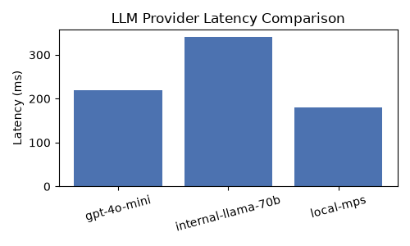
Local inference was fastest for this workload on this benchmark.

