# Concept:

The Eight Queens riddle: Can you place eight queens on a chess board such that no queen can directly move into the cell of another queen? Our team’s proposed project is to array LEDs and buttons creating a light up “chess board” that will be used for the purpose of playing out the Eight Queens riddle.

# Implementation

The device will allow a user the ability to press a cell of the chess board to simulate the placing of a queen. Either by the use of an LED with modulation of color or by the use of multiple LEDs of differing colors, the pressing of the cell will change the cell’s color (from a neutral white to a green) and turn off the cells that the user may no longer place a queen upon (i.e. the cells will go dark.) We hope to add sound effects to this. Pushing a deactivated cell will not place a queen. Re-pushing a cell where the user has placed a queen *should* remove that queen and revivify all cells that now could contain a queen. If the user is successful in placing eight queens, the board will do some celebratory animation, reset, and *maybe* a secret compartment will be unlocked.

A *maybe* we would like to add to this project: Difficulty settings. Easy: some queens already placed. Medium, the game plays as in the above paragraph. Hard: the board allows the user to place queens illegally, so that they might place eight queens incorrectly. In the hard difficulty, placing eight queens in a manner inconsistent with the riddle would not get you the celebratory animation or unlock the *maybe* unlockable compartment

# Example

**Figure 1**: We see a board with a single queen set (the green cell.) The greyed cells represent areas where a queen cannot be placed  
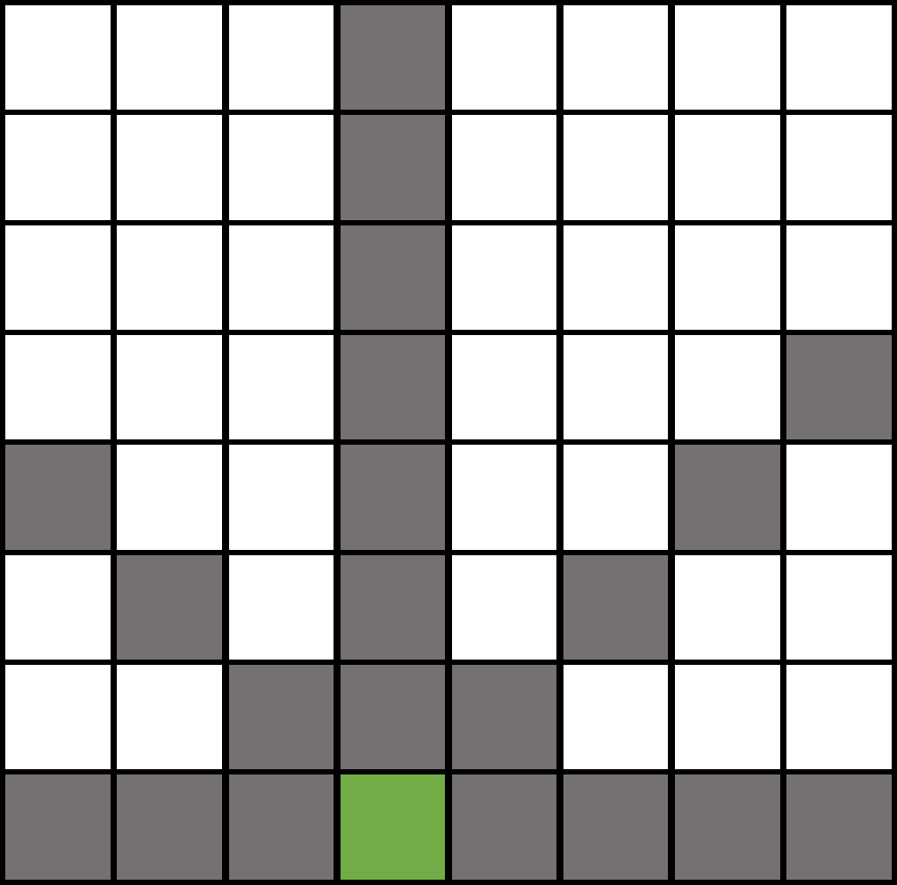

**Figure 2**: A new queen is placed. The blue arrows indicate the direction the queen can move, and subsequently, what cells need be blackened out.  
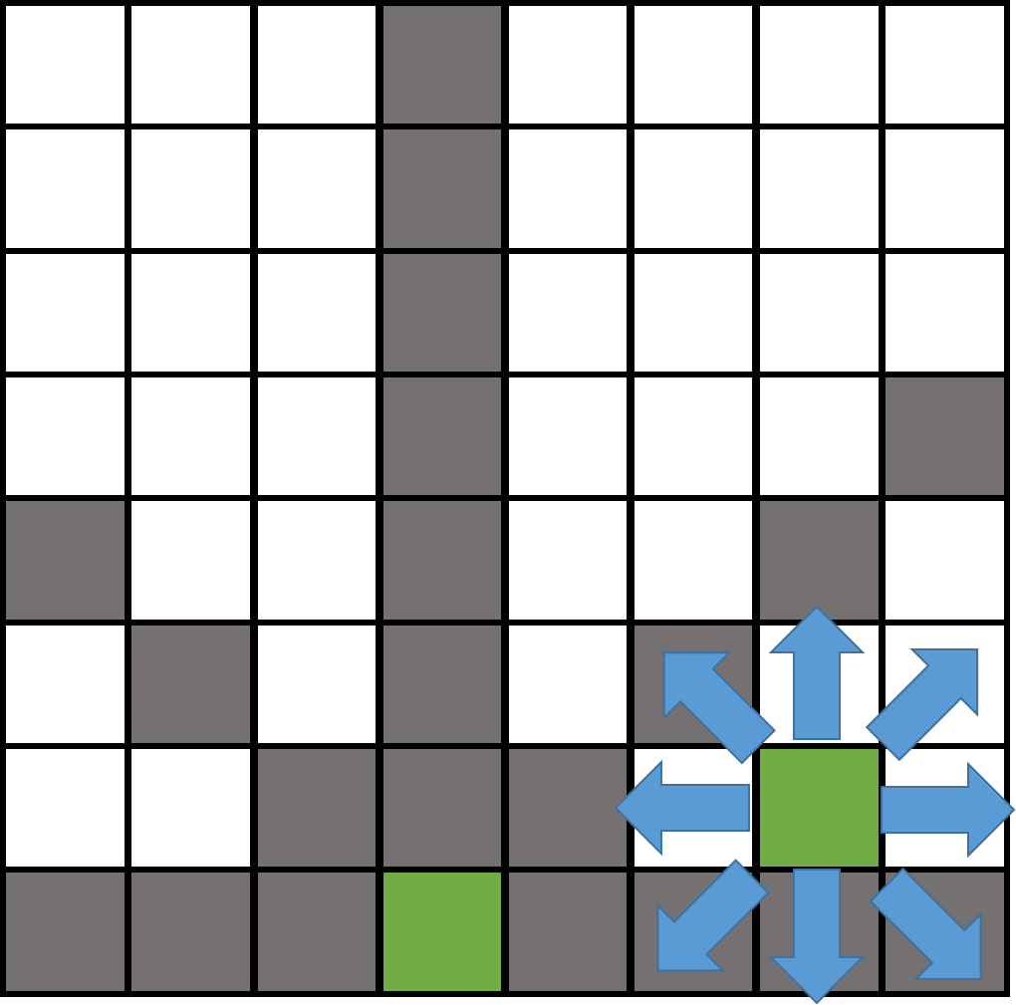

**Figure 3**: We see the cells that are newly blackened out by the placement of the queen. (This is done in a darker shade of grey.)  
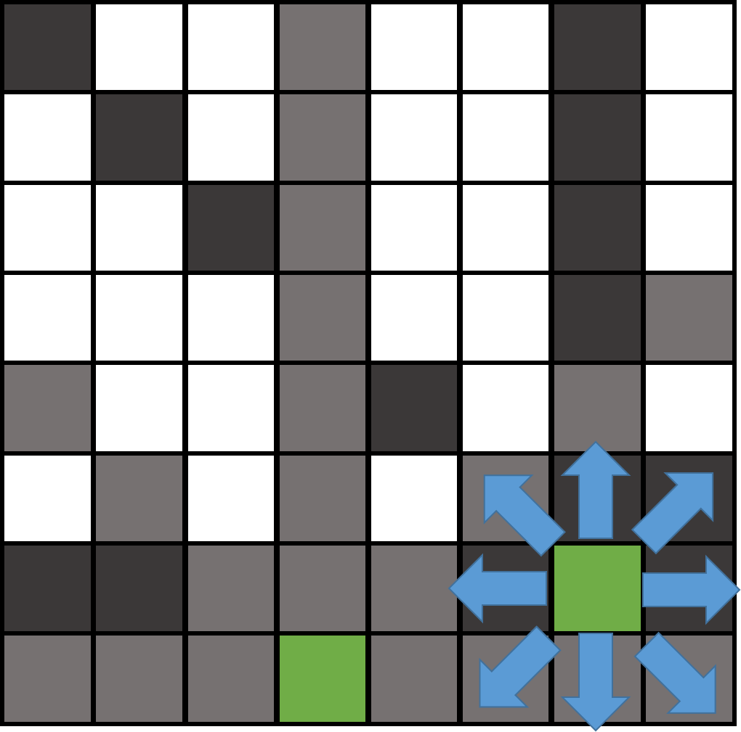

**Figure 4**: Shows the state of the board now that the second queen is placed. The user may select any none greyed cell to place a new queen, or (*for a should*) select a green cell to remove a queen.  
