

**APCE 2020**

**INTERNATIONAL CONFERENCE ON**

**ACTUAL PROBLEMS OF**

**CHEMICAL ENGINEERING**

**www.apce-conf.asoiu.edu.az.**

**Baku, Azerbaijan December 24-25 2020**

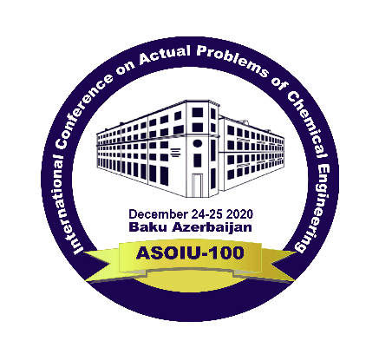

**CALL FOR PARTICIPANTS**

**The international Scientific Conference on “Actual Problems Of Chemical Engineering” - APCE 2020 will be held at Azerbaijan State Oil and Industry University.**

**PLENARY LECTURERS**

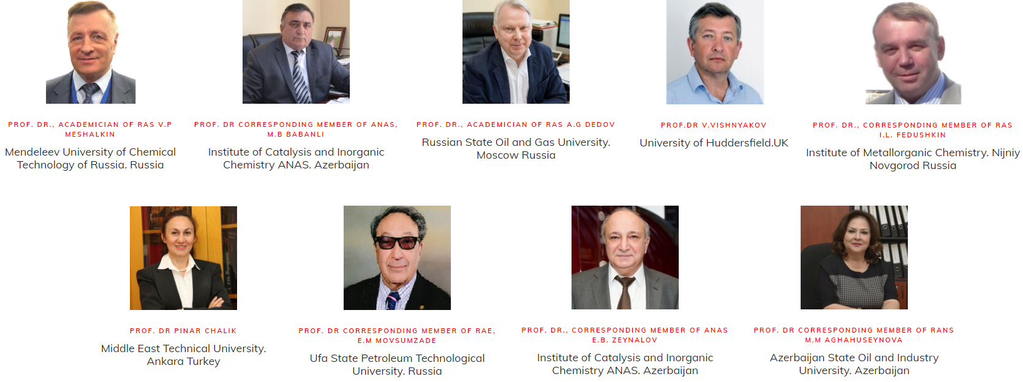

**Important dates and registration**

* Deadline for papers September, 15, 2020
* Deadline for notifications October, 15, 2020
* Deadline for registration November, 30, 2020

**PUBLICATION OPPORTUNITIES**

**All the accepted papers will be published in the conference Proceedings “Chemical Engineering Advanced Concepts” ( Web of Science)**