# #1. HTML5 Tutorial For Beginners 1 # Introduction

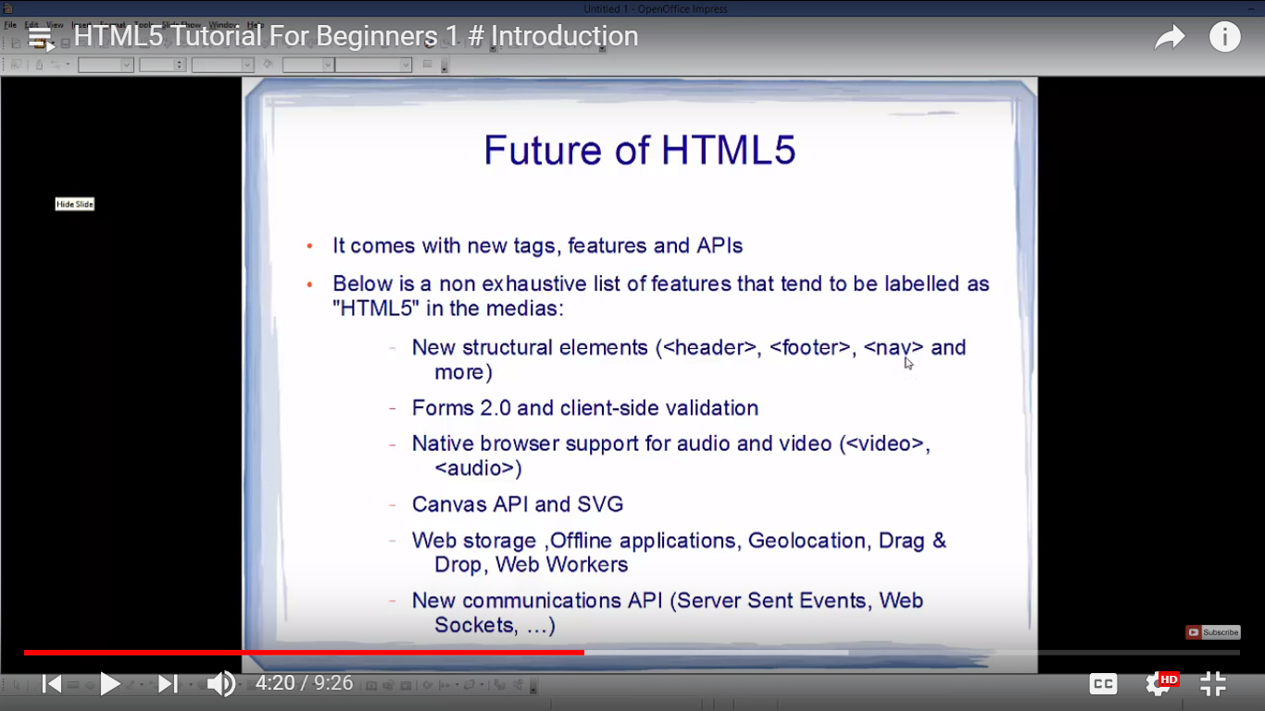

# #3. HTML5 Tutorial For Beginners 3 # Basic Structure of HTML

so as far so learnt->

1.doctype

2.lang=eng

3.head metatag only open tag called.

3.title

4.body

5.paragraph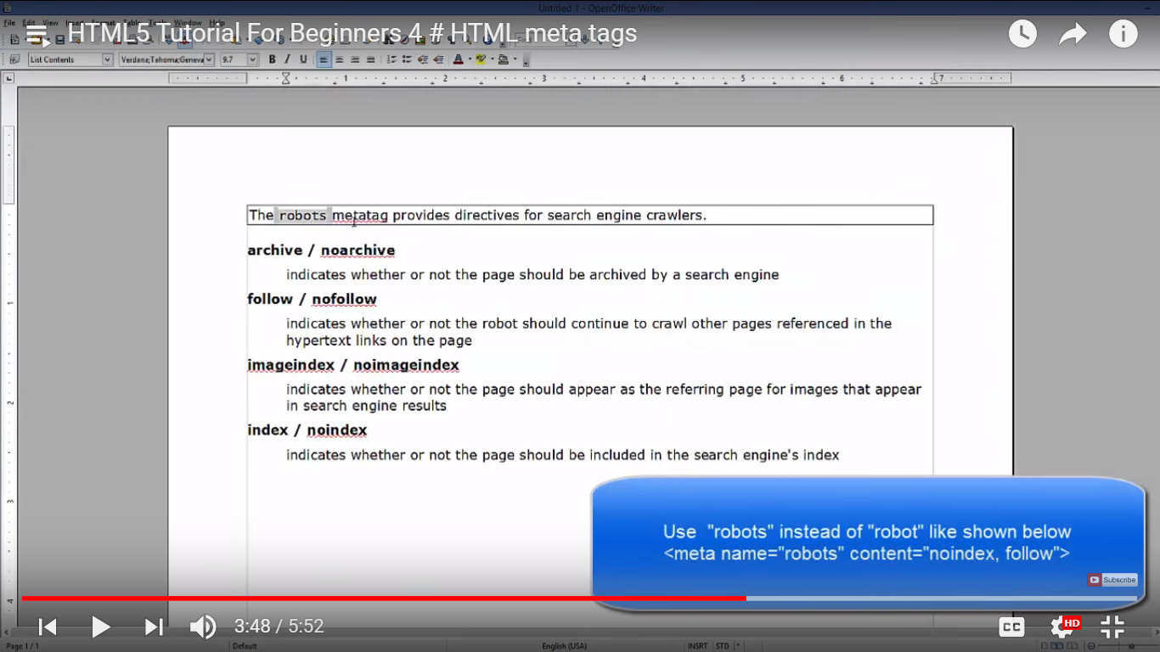

Some of importtant meta tag->

<meta name=*"description"*

content=*"HTML5 tutorial for beginners. Basic structure of HTML page"*>

<meta name=*"keyword"* content=*"HTML, HTML5, CSS, CSS, JavaScript"*>

<meta name=*"auther"* content=*"Author Name"*>

<meta name=*"robot"* content=*"index,follow"*>

<meta http-equiv=*"refresh"* content=*"2"*>

# #5. HTML5 Tutorial For Beginners 5 # HTML Headers , Paragraphs and text Formatting tags

1.if wanna to preserve element then need to use <pre></pre> tag.­

Tag Description

<b> bold text

<em> emphasized text

<i> Italic

<small> smaller text

<strong> important text'

<sub> subcripted text

<sup> <supersupcripted text>

<ins> inserted btext

<del> deleted text

<mark> marked/highlighted

<!--

metaData will not displayed on the page ,but machine parseable.

Metadata elements are typically used to specify page description ,keywords ,author of the document , last modified , and other

metadata.

<tagname id="description">Elements</tagname>

-->

<!DOCTYPE html>

<html lang=*"en"*>

<head>

<meta name=*"description"*

content=*"HTML5 tutorial for beginners. Basic structure of HTML page"*>

<meta name=*"keyword"* content=*"HTML, HTML5, CSS, CSS, JavaScript"*>

<meta name=*"auther"* content=*"Author Name"*>

<meta name=*"robot"* content=*"index,follow"*>

<meta http-equiv=*"refresh"* content=*"1"*>

<title>html5!</title>

</head>

<body>

<p>

<b>This is bold Text</b>

</p>

<p>

<em>This is Emphasized text</em>

</p>

<p>

<i>This is Italic text</i>

</p>

<p>

<Strong>Strong Text</Strong>

</p>

<p>

This is <small>small</small>tag.

</p>

<p>

This is

<del>deleted</del>

text

</p>

<p>

This is

<ins>Inserted </ins>

tag

</p>

.

<p>

This is

<mark>mark tag</mark>

.

</p>

<p>

this is <sub>sub</sub> tage

</p>

<p>

this is <sup>super</sup>

</p>

</body>

</html>

# #8. HTML5 Tutorial For Beginners 8 # Intro to HTML & CSS

1.inline style css

<h1 style="color: *blue*">This post has been published</h1>

2.now use style in outside inline->

<style>

**h1** {

color: *blue*

}

**body** {

background-color: *yellow*;

}

</style>

</head>

<body>

<h1>This post has been published</h1>

</body>

</html>

3.now using styling in different class by link.

<link rel=*"stylesheet"* href=*"style.css"*>

</head>

or

**h1** {

color: *blue*

}

**body** {

background-color: *yellow*;

}

4.with class.

<h1 class=*"myclass"*>This post has been published</h1>

and with style.css

**h1***.myclass*{

color:*blue*

}

# #9. HTML5 Tutorial For Beginners 9 # HTML Images with img tag

<body>

<img alt=*"My sweet pics"* src=*"images/HTML5Logo.png"* width=*"600"* height=*"600"*>

</body>

# or by using style

<img alt=*"My sweet pics"* src=*"images/HTML5Logo.png"* style="width:*100px*; height:*100px*; ">

# #10. HTML5 Tutorial For Beginners 10 # HTML Lists (Ordered Lists, Unordered Lists, Definition Lists)

# to make unordered list need to write

<ul>

<li>Mamta</li>

<li>Sunil</li>

<li>Susant</li>

<li>Sudhir</li>

</ul>

# 4 types of list type

**1.** <ul style="list-style-type: *none*;">

**2.** <ul style="list-style-type: *circle*;">

3. <ul style="list-style-type: *square*;">

to make order list need to write <ol>

1.default type is number type.

<ol style="list-style-type: ;">

<li>Susant</li>

<li>B</li>

<li>D</li>

<li>Sudhir</li>

</ol>

---

<!--

metaData will not displayed on the page ,but machine parseable.

Metadata elements are typically used to specify page description ,keywords ,author of the document , last modified , and other

metadata.

<tagname id="description">Elements</tagname>

-->

<!DOCTYPE html>

<html lang=*"en"*>

<head>

<meta name=*"description"*

content=*"HTML5 tutorial for beginners. Basic structure of HTML page"*>

<meta name=*"keyword"* content=*"HTML, HTML5, CSS, CSS, JavaScript"*>

<meta name=*"auther"* content=*"Author Name"*>

<meta name=*"robot"* content=*"index,follow"*>

<meta http-equiv=*"refresh"* content=*"200"*>

<title>html5!</title>

</head>

<body>

<ol type=*"I "*>

<li>Susant</li>

<ul>

<li>Tea</li>

</ul>

<li>B</li>

<li>D</li>

<li>Sudhir</li>

</ol>

<dl>

<dt>Term</dt>

<dd>Description details</dd>

<dt>Term</dt>

<dd>Description details 2!</dd>

</dl>

</body>

</html>

<!--

metaData will not displayed on the page ,but machine parseable.

Metadata elements are typically used to specify page description ,keywords ,author of the document , last modified , and other

metadata.

<tagname id="description">Elements</tagname>

-->

<!DOCTYPE html>

<html lang=*"en"*>

<head>

<meta name=*"description"*

content=*"HTML5 tutorial for beginners. Basic structure of HTML page"*>

<meta name=*"keyword"* content=*"HTML, HTML5, CSS, CSS, JavaScript"*>

<meta name=*"auther"* content=*"Author Name"*>

<meta name=*"robot"* content=*"index,follow"*>

<meta http-equiv=*"refresh"* content=*"200"*>

<title>html5!</title>

<style type=*"text/css"*>

**table,** **th,** **td** {

border: *1px solid lime*;

border-collapse: *collapse*;

text-align: *left*;

}

**thead** {

background-color: *blue*

}

**tbody,** **tfoot** {

background-color: *yellow*

}

</style>

</head>

<table style="width: *100%*">

<caption>My Employee Table</caption>

<thead>

<tr>

<th>Name</th>

<th colspan=*"2"*>Country</th>

</tr>

</thead>

<tbody>

<tr>

<td>Jack</td>

<td>China</td>

<td>120</td>

</tr>

</tbody>

<tfoot>

<tr>

<td>Jack</td>

<td>China</td>

<td>120</td>

</tr>

</tfoot>

</table>

</body>

</html>