# # part 1 - Introduction to Bootstrap 4

# 1.container-> makes context with padding.

# 2.class=”text-success” gives color green

# 3.class=”text-center” gives aligment in middle.

# 

# #Part 2 : Bootstrap 4 Containers and Bootstrap 4 Typography

<!DOCTYPE html>

<html>

<head>

<meta charset="ISO-8859-1">

<!-- Latest compiled and minified CSS -->

<link rel="stylesheet" href="https://maxcdn.bootstrapcdn.com/bootstrap/4.1.3/css/bootstrap.min.css">

</head>

<body>

<div class="container-fluid bg-warning"><h1>Latest compiled and minified CSS</h1>

<h2>Latest compiled and minified CSS</h2>

<h3>Latest compiled and minified CSS</h3>

<h4>Latest compiled and minified CSS</h4>

<h5>Latest compiled and minified CSS</h5>

<h6>Latest compiled and minified CSS</h6></div>

</body>

</html>



<!DOCTYPE html>

<html>

<head>

<meta charset="ISO-8859-1">

<!-- Latest compiled and minified CSS -->

<link rel="stylesheet" href="https://maxcdn.bootstrapcdn.com/bootstrap/4.1.3/css/bootstrap.min.css">

</head>

<body>

<div class="container">

<h1>Latest compiled and minified CSS</h1>

<!-- 4 types of displays in bootstrap -->

<h2 class="display-1">Latest compiled and minified CSS</h2>

<h3 class="display-2">Latest compiled and minified CSS</h3>

<h4 class="display-3">Latest compiled and minified CSS</h4>

<h5 class="display-4">Latest compiled and minified CSS</h5>

<small>Latest compiled and minified CSS</small><br>

<mark>Latest compiled and minified CSS</mark>

<br>

<abbr title="MAMTA KUMARI">MK</abbr>

</div>

</body>

</html>

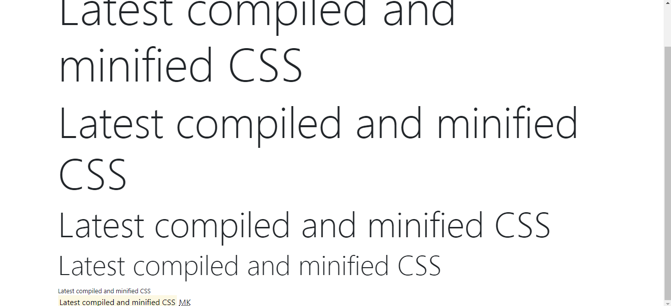

<!DOCTYPE html>

<html>

<head>

<meta charset="ISO-8859-1">

<!-- Latest compiled and minified CSS -->

<link rel="stylesheet" href="https://maxcdn.bootstrapcdn.com/bootstrap/4.1.3/css/bootstrap.min.css">

</head>

<body>

<div class="container">

<blockquote class="blockquote">Latest compiled and minified CSSLatest compiled and minified CSSLatest compiled and

minified CSSLatest compiled and minified CSSLatest compiled and minified CSSLatest compiled and minified CSSLatest

compiled and minified CSSLatest compiled and minified CSS</blockquote>

<p class="blockquote-footer">Thapa</p>

</div>

</body>

</html>

# 

# 

# Output->

# 

# 

# Output->

# 

# 

# Output->

# 

# 

# Output->

# 

# 

# Part 3: Bootstrap 4 Colors Change and Bootstrap 4 Text Color

