**Assignment :2 - webhook**

**First install java:openjdk 11.0.23 2024-04-16 LTS**

**#**yum install java-11-amazon-corretto.x86_64 -y

**GIT install : version 2.40.1**

#yum install git -y

**HTTPD server :version/2.4.59**

# Yum install httpd -y

# systemctl start httpd

# Systemctl enable httpd

# Systemctl status httpd

**Cd /mnt**

**mkdir servers**

**Cd servers/**

**APACHE TOMCAT DOWNLOAD**

**Wget** [**https://dlcdn.apache.org/tomcat/tomcat-9/v9.0.89/bin/apache-tomcat-9.0.89.zip**](https://dlcdn.apache.org/tomcat/tomcat-9/v9.0.89/bin/apache-tomcat-9.0.89.zip)

Unzip apache-tomcat-9.0.89.zip

rm -rf apache-tomcat-9.0.89

Chmod -R 777 apache-tomcat-9.0.89

Cd apache-tomcat-9.0.89

ls -ltr

**INSTALL JENKINS WAR.FILE**

#cd webapps/

Wget <https://get.jenkins.io/war-stable/latest/jenkins.war>

ls -ltr

Cd ../

Cd bin

./startup.sh (tomcat started)

**TAKE PUBLIC IP & PORT 8080 /JENKINS**

**Create job : job-1**

**Excute shell….**

**Cd /root/**

**Rm -rf \***

**Git clone** <https://github.com/mamtapawde15/webhook-1.git>

**cd /var/www/html/**

**cp /root/webhook-1/index.html .**

**chmod -R 777 index.html**

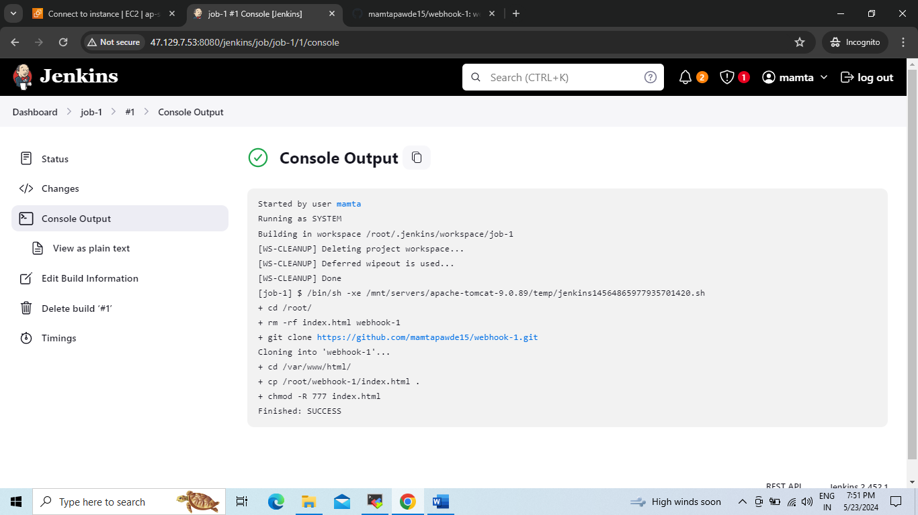

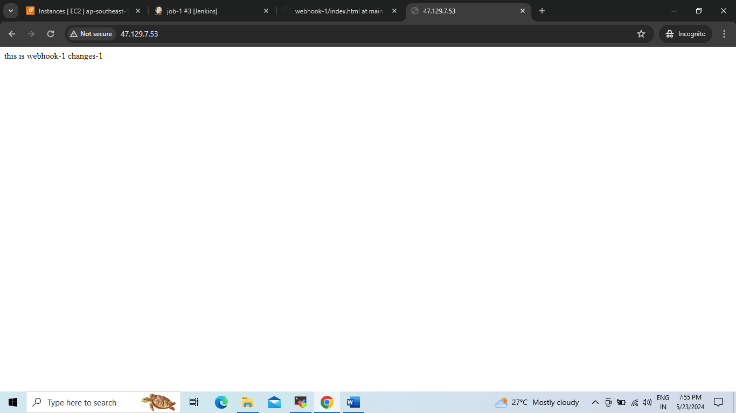**Create 2nd job : job-2**

**Cd /root/**

**rm -rf \***

**git clone** [**https://github.com/mamtapawde15/webhook-2.git**](https://github.com/mamtapawde15/webhook-2.git)

**Cd /var/www/html/**

**Cp /root/webhook-2/index.html .**

**Chmod -R 777 index.html**

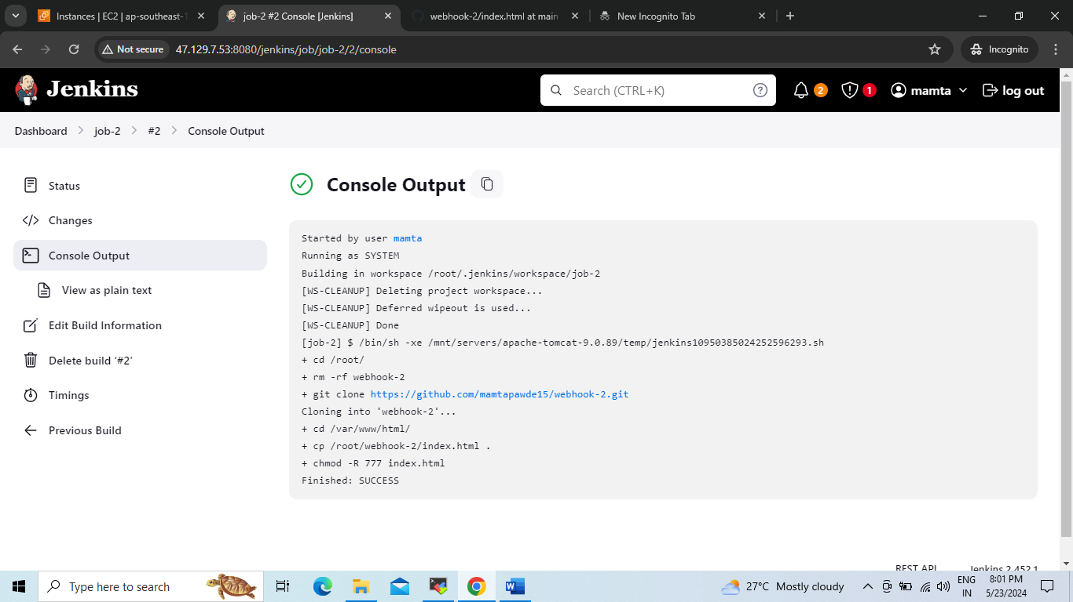

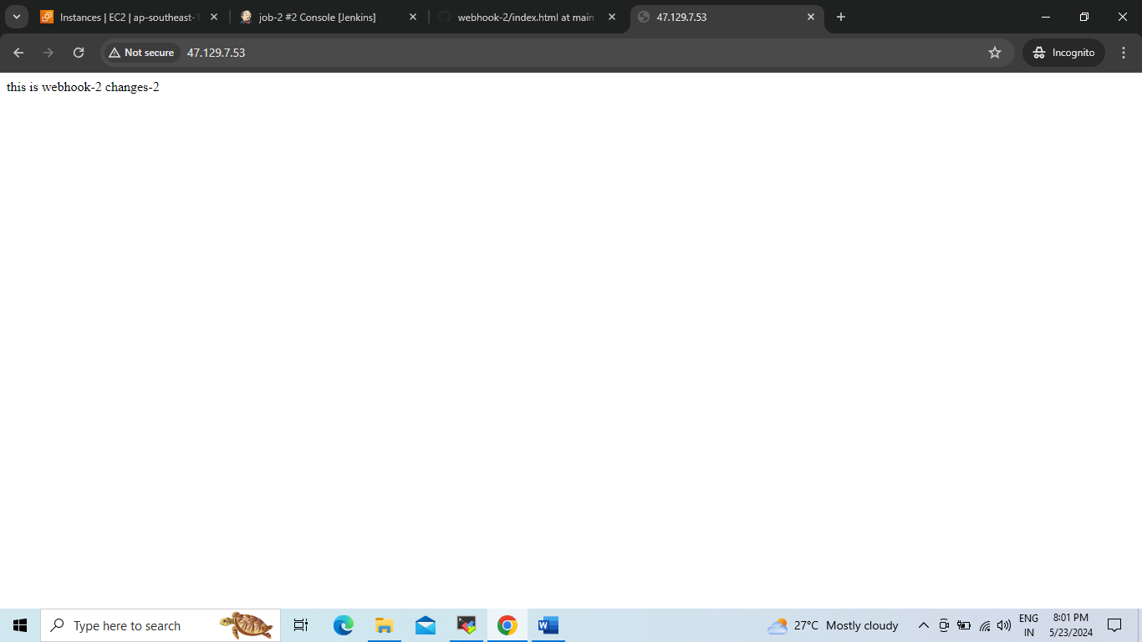

**Create job : job-3**

**Execte shell**

**Cd /root**/

**rm – rf \***

**git clone** <https://github.com/mamtapawde15/webhook-3.git>

**Cd /var/www/index.html**

**Cp /root/webhook-3/index.html .**

**Chmod -R 777 index.html**

