**First install java:openjdk 11.0.23 2024-04-16 LTS**

**#**yum install java-11-amazon-corretto.x86_64

**GIT install : version 2.40.1**

#yum install git -y

**HTTPD server :version/2.4.59**

# Yum install httpd -y

# systemctl start httpd

# Systemctl enable httpd

# Systemctl status httpd

**Cd /mnt**

**mkdir servers**

**Cd servers/**

**APACHE TOMCAT DOWNLOAD**

**Severs =wget** [**https://dlcdn.apache.org/tomcat/tomcat-9/v9.0.89/bin/apache-tomcat-9.0.89.zip**](https://dlcdn.apache.org/tomcat/tomcat-9/v9.0.89/bin/apache-tomcat-9.0.89.zip)

Unzip apache-tomcat-9.0.89.zip

Rm -rf apache-tomcat-9.0.89

Chmod -R 777 apache-tomcat-9.0.89

Cd apache-tomcat-9.0.89

Ls -ltr

**INSTALL JENKINS WAR.FILE**

#cd webapps/

Wget <https://get.jenkins.io/war-stable/latest/jenkins.war>

Ls -ltr

Cd ../

Cd bin

./startup.sh (tomcat started)

**TAKE PUBLIC IP & PORT 8080 /JENKINS**

**Create user**

**CREATE 1st job :my-job-repo-1**

Excute shell….

Cd /root/

Rm -rf *

Git clone

[**https://github.com/mamtapawde15/repo-1.git**](https://github.com/mamtapawde15/repo-1.git)

cd /var/www/html/

rm -rf *

cp /root/repo-1/index.html .

chmod -R 777 index.html

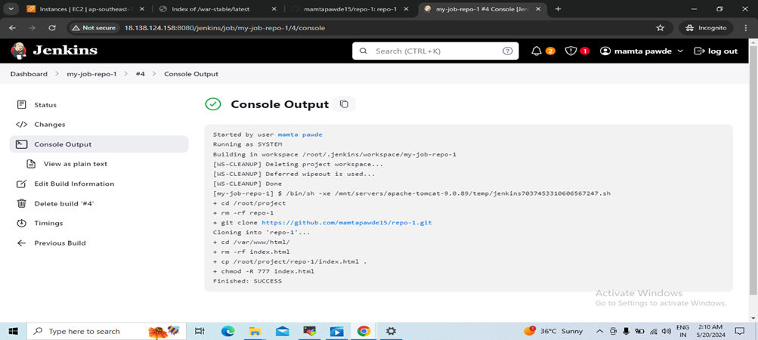

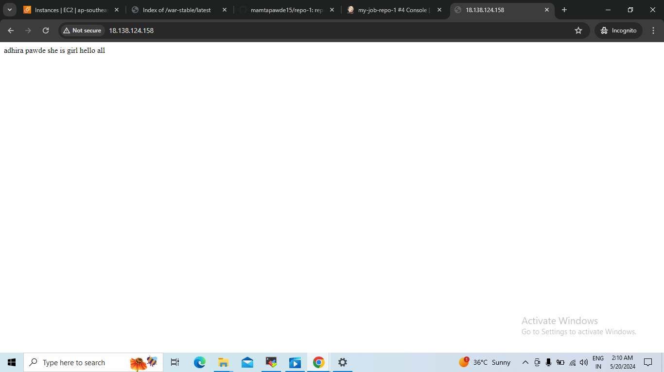

**Create 2nd job :my-job-repo-2**

**Cd /root/**

**Rm -rf \***

**Git clone** [**https://github.com/mamtapawde15/repo-2.git**](https://github.com/mamtapawde15/repo-2.git)

**Cd /var/www/html**

**Cp /root/repo-2/index.html .**

**Chmod -R 777 index.html**

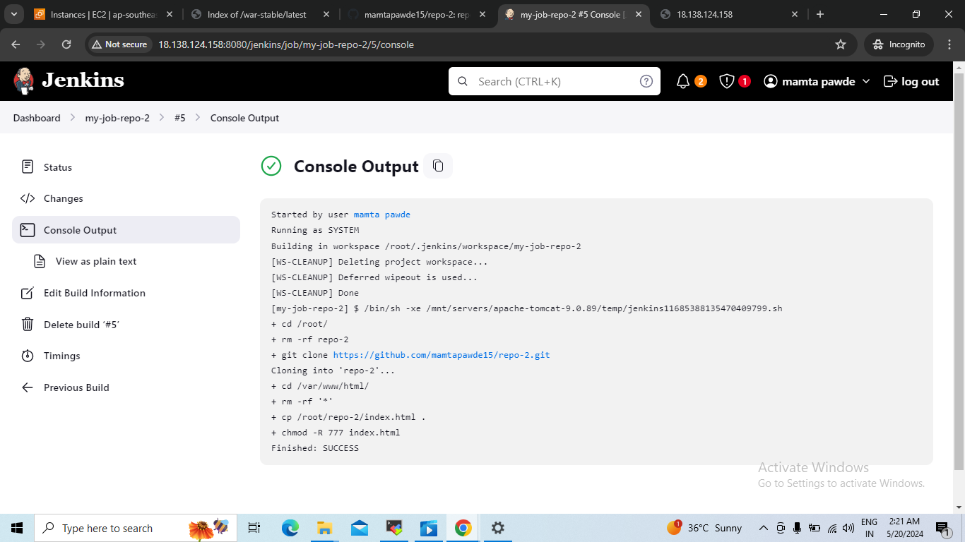

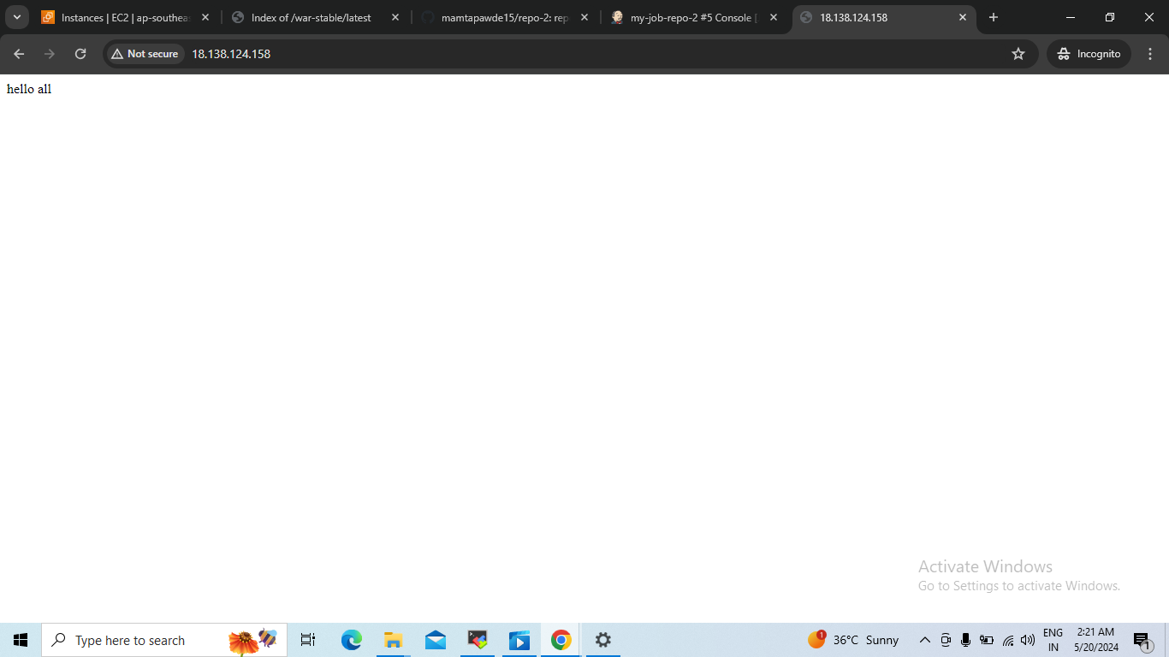

**Third job : my-3rd-job-repo-3**

Execte shell

Cd /root/

Rm – rf *

Git clone <https://github.com/mamtapawde15/repo-3.git>

Cd /var/www/index.html

Cp /root/repo-3/index.html .

Chmod -R 777 index.html

