**Assignment 10**

1. **Write a query that produces all pairs of salespeople who are living in the same city. Exclude combinations of salespeople with themselves as well as duplicate rows with the order reversed.**

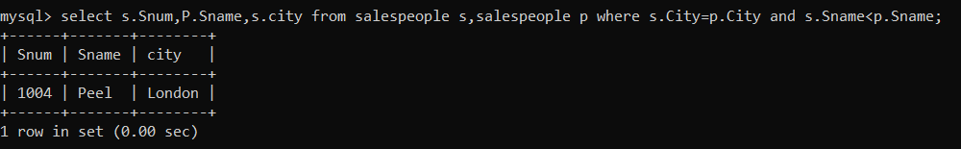

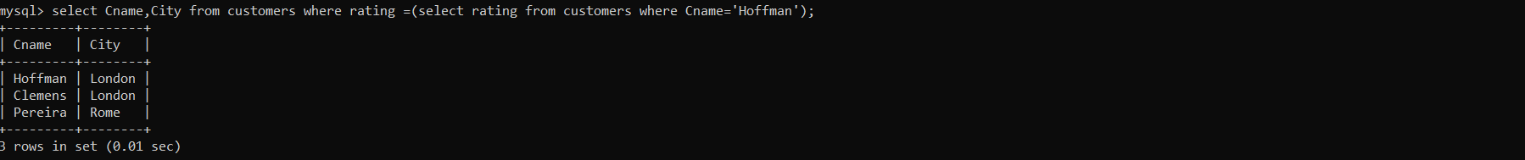**2) Write a query that produces the names and cities of all customers with the same rating as Hoffman.**