**Assignment 09**

1. **Write a query that lists each order number followed by the name of the customer who made the order.**

select Onum,Cname from orders join customers on orders.Cnum=Customers.Cnum;

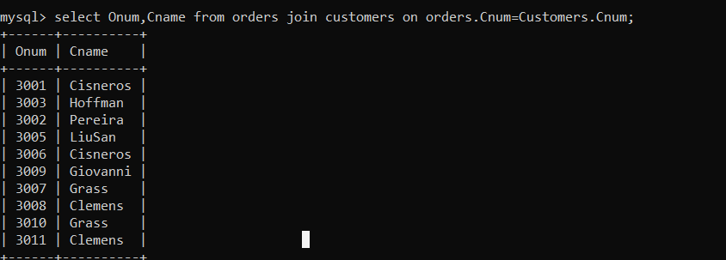

1. **Write a query that gives the names of both the salesperson and the customer for each order along with the order number.**

select Sname,Cname,Onum from orders,salespeople,customers where salespeople.Snum=Customers.Snum and customers.Snum=orders.Snum;

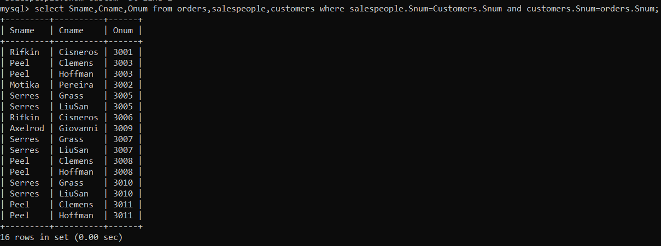

1. **Write a query that produces all customers serviced by salespeople with a commission above 12%. Output the customer’s name, the salesperson’s name, and the salesperson’s rate of commission.**

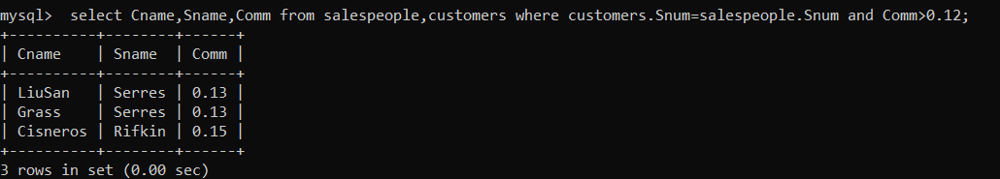

**4) Write a query that calculates the amount of the salesperson’s commission on each order by a customer with a rating above 100.**

