**Assignment 04**

1. **Write a select command that produces the order number, amount, and date for all rows in the Orders table.**

**Ans🡪**SELECT Onum,Amt,Odate From ORDERS;

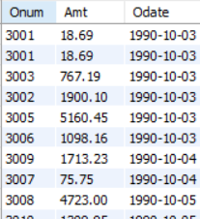

1. **Write a query that produces all rows from the Customers table for which the salesperson’s number is 1001.**

Ans🡪 SELECT*FROM SALESPEOPLE WHERE Snum=1001;



1. **Write a query that displays the Salespeople table with the columns in the following order: city, sname, snum, comm.**

ANs🡪SELECT City,Sname,Snum,Comm FROM SALESPEOPLE;

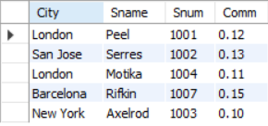

1. **Write a select command that produces the rating followed by the name of each customer in San Jose.**

SELECT RATING FROM CUSTOMERS WHERE City='San Jose';



1. **Write a query that will produce the snum values of all salespeople (suppress the duplicates) with orders in the Orders table**

SELECT DISTINCT (Snum) FROM ORDERS;

