***Assignment –5* Relational and Logical Operators.**

1. Write a query that will give you all orders for more than Rs. 1,000.

SELECT*FROM ORDERS WHERE Amt>1000;

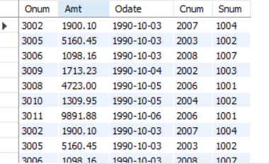

1. Write a query that will give you the names and cities of all salespeople in London with a commission above .10.

SELECT Sname,city FROM SALESPEOPLE WHERE City='London' AND Comm>.10;

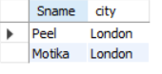

1. Write a query on the Customers table whose output will exclude all customers with a rating <= 100, unless they are located in Rome.

SELECT *FROM CUSTOMERS WHERE RATING>100 OR City='Rome';

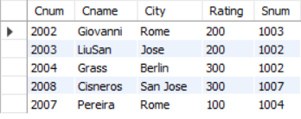

4) What will be the output from the following query?

Select * from Orders

where (amt < 1000 OR

NOT (odate = ‘1990-10-03’

AND cnum > 2003));

This query selects all columns (**\***) from the **Orders** table where either of the following conditions is true:

1. **amt** is less than 1000.
2. The condition inside the parentheses is not satisfied:
   * **odate** is not equal to '1990-10-03'.
   * **cnum** is not greater than 2003.

Let's analyze the second condition:

* The **NOT** operator negates the condition inside the parentheses.
* So, if **odate** is not equal to '1990-10-03' AND **cnum** is not greater than 2003, the condition inside the parentheses will be true.

Now, let's consider the output:

* If **amt** is less than 1000, the first condition is satisfied, and the row will be included in the result.
* If **amt** is greater than or equal to 1000, the first condition is not satisfied. However, the second condition is true if **odate** is not equal to '1990-10-03' or **cnum** is not greater than 2003.

Therefore, the output of the query will be all rows from the **Orders** table where either **amt** is less than 1000 or **odate** is not equal to '1990-10-03' or **cnum** is not greater than 2003.



5) What will be the output of the following query?

Select * from Orders

where NOT ((odate = ‘1990-10-03’ OR snum

>1006) AND amt >= 1500);



6) What is a simpler way to write this query?

Select snum, sname, city, comm From Salespeople where (comm > .12 OR comm <.14);

Ans🡪 SELECT * FROM Salespeople WHERE (comm > .12 OR comm <.14);