The National Board of the ROCKS, Inc.
2026 LTG Edward Honor Scholarship Award

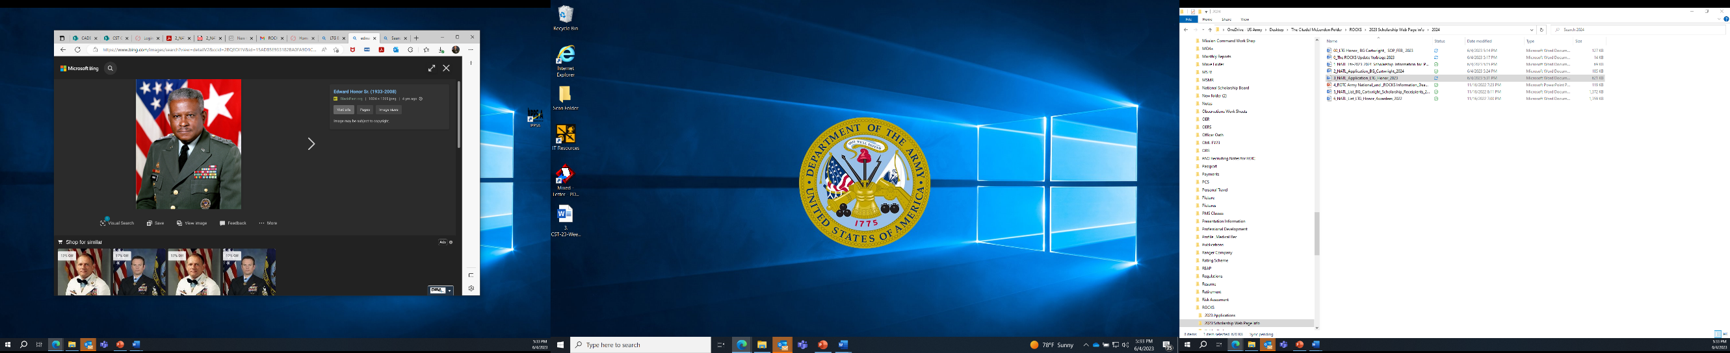
The late LTG Edward Honor’s career in the U.S. Army spanned 35 years in the Transportation Corps and the logistics field. Subsequent to his military career he served as President of the National Defense Transportation Association (NDTA) for 13 years.

Born in Melville, Louisiana and a graduate of George Washington Carver High School, he immediately entered Southern University and A&M College. He earned a Bachelor of Arts Degree in Education and was commissioned as a 2nd Lieutenant in 1954. His military education includes the Armor Officers Basic Course; Transportation Orientation and Advanced Courses; the U.S. Army Command and General Staff College; and the U.S. Army War College. General Honor served at the highest levels of command and staff to include Director of Army Transportation, Commander Military Traffic Management Command and Director of Logistics Joint Chiefs of Staff. His achievements in these assignments were numerous. The other area which he will always be remembered will be the mentoring of Soldiers whether they were a General Officer or Junior Enlisted. His leadership ensured the ROCKS will continue to be the preeminent mentoring organization in our Armed Forces.

On September 3, 2008, LTG Honor passed away. He was the quiet catalyst that propelled the ROCKS organization over the past years. To honor his legacy The National Board of the ROCKS, Inc. has established a Leadership Award recognizing our most outstanding graduating college seniors or senior cadet of the year, who demonstrate superior leadership skills, exceptional scholarship, and outstanding ability to mentor. The selectees will receive a $3,000.00 stipend, recognition at the ROCKS Annual Spring Gala and Awards Ceremony and their name will be placed on a perpetual LTG Edward Honor trophy.

Packet must include: 1) this application 2) PMS letter of recommendation 3) head and shoulder photograph, 4) Cadet biography, and 5) one-page paper (written by cadet) on any leadership or mentorship-related topic. Send completed packet in ONE PDF FILE to rocksnationalboard@gmail.com.

If you have questions regarding this award, please contact:

Mr. Brandon Hathorne
Vice President, ROTC Programs
National Board of the ROCKS, Inc.
Email: 1vprotcandscholarshiprocks@gmail.com

2026 LTG Edward Honor Scholarship

Application

The ROCKS, Incorporated is accepting applications for the LTG Edward Honor Leadership Award. The award is presented annually in memory of Lieutenant General Edward Honor to Military Science Level IV Cadets. Scholarship applicants are eligible to apply for the scholarship only if they are actively participating as a Cadet (enrolled, contracted, or on an existing scholarship). Cadets must be in good standing in an approved College, University, or Military School ROTC Program as a Military Science IV Level Cadet. ROTC Cadets from all Service Branches are eligible to compete for the BG Cartwright and LTG Honor Scholarship. Scholarship Award recipients will be presented a stipend check between the amount of $2000 - $3500.

Please Type Application
(Deadline: Friday 10 April 2026)

ADMINISTRATIVE INFORMATION

Name:

College/University:

Date of Birth: ROTC Program (Army, Navy, Air Force) in which enrolled:
Branch in which Nominee will be commissioned:

Class Year: Projected Graduation Date: Distinguished Military Graduate:

Permanent Home Address:

City, State, Zip:

Cell:

Personal Email Address:

NOTE: Please include a recent color full length photo of nominee, in uniform.

ACADEMIC INFORMATION

Academic Major: Minor:

Grade Point Average: Overall: ROTC:

Scholarship(s) ROTC: Other:

Academic Accomplishments and Awards:

ROTC INFORMATION

PMS Initials ______Cadet is a Military Science Level IV (not in graduate school or has already graduated with an undergraduate degree) and the Cadet is in good standing with the ROTC Program and academically aligned to graduate.

Service Branch Cadet Advanced Camp Performance (Significant Activities, Achievements, Positions Held) (Must include Final Standing in Advance Camp):

ROTC Rank (Please provide with complete rank, e.g., “Cadet Lieutenant Colonel”):

Physical Fitness Score: _____________ Date: ___________________

Accepted Regular Commission? Position Currently Held in ROTC Unit:

Previous Leadership/Key Positions in ROTC:

Other Military Service/ROTC-related Activities:

OTHER EXTRA-CURRICULAR INFORMATION

Past and Present Non-ROTC Key Positions/Offices Held and Dates Held (e.g., Class President, College Newspaper Editor, etc.)

Past and Present Affiliations/Memberships/Offices in Held in Civic Organizations:

Athletic/Other Extracurricular Activities and Achievements:

Community Activities:

MILITARY SKILLS/BACKGROUND

Military Qualification Badges (e.g., Airborne/Air Assault/Ranger/EFMB/Dive School Qualified):

Previous Military or ROTC Awards:

PROFESSOR OF MILITARY SCIENCE EVALUATION LETTER (MANDATORY COMPLETION)

PMS Name/Rank/Branch of Service:

PMS E-Mail Address: PMS Telephone Number:

The PMS is required to provide additional comments, not to exceed ONE typewritten page, concerning the nominee relative to the following and/or other pertinent attributes, accomplishments, and achievements not addressed above. (The lack of PMS comments will severely reduce the Cadet’s ability to obtain the scholarship):

Appearance Attitude APFT Score/Date Dedication Initiative
Integrity Judgment Leadership Potential Written and Oral Communication Ability

Packet must include: 1) this application 2) PMS letter of recommendation 3) photograph and 4) one-page paper (written by cadet) on any leadership or mentorship-related topic 5) Record Physical Fitness Test (within 12 months of 7 Mar 2025). Send completed packet in ONE PDF FILE to rocksnationalboard@gmail.com.

BRIEF SAMPLE PMS RECOMMENDATION

ON ROTC DEPARTMENT LETTER

[INSERT DATE]

MEMORANDUM FOR LTG EDWARD HONOR SCHOLARSHIP

SUBJECT: Letter of Recommendation for [CADET’S NAME]

1. The purpose of this memorandum is to give my highest recommendation in support of Cadet [Name]. He/She is definitely…..

2. [PERSONAL ACCOMPLISHMENTS]

3. [SCHOOL ACCOMPLIMENTS]

4. The point of contact for this memorandum is the undersigned at [phone number], [email].

Signature Block

