

Mawlana Bhashani Science and Technology University

Lab-Report

Report No: 04
Course code: ICT- 3110
Course title: Operating Systems Lab
Date of Performance: 04/08/2020
Date of Submission: 21/09/2020

Submitted by Submitted To
Name : Amran Hossen Mamun
ID : IT-18018
3rd year 1st semester
Session : 2017 – 2018
Dept. of ICT
MBSTU

Nazrul Islam
Assistant Professor
Dept. of ICT
MBSTU.

Lab-report no : 04

Name of the lab-report: File operation and permission.

Objectives:

1.What is File Operation and File Permission in Linux Operating System?
2.Implementation of File Operation and File Permission.

1.What is File Operation and File Permission in Linux Operating System?

Answer:

File Operations
A file is an abstract data type. For defining a file properly, we need to consider the operations that can be performed on files. The operating system can provide system calls to create, write, read,reposition, delete, and truncate files.

There are six basic file operations within an Operating system. These are:
Creating a file: There are two steps necessary for creating a file. First, space in the file system must be found for the file. We discuss how to allocate space for the file. Second, an entry for the new file must be made in the directory.
Writing a file: To write to a file, you make a system call specify about both the name of the file along with the information to be written to the file.
Reading a file: To read from a file, you use a system call which specifies the name of the file and where within memory the next block of the file should be placed.
Repositioning inside a file: The directory is then searched for the suitable entry, and the 'current-file-position' pointer is relocating to a given value. Relocating within a file need not require any actual I/O. This file operation is also termed as 'file seek.'
Deleting a file: For deleting a file, you have to search the directory for the specific file. Deleting that file or directory release all file space so that other files can re-use that space.
Truncating a file: The user may wish for erasing the contents of a file but keep the attributes same. Rather than deleting the file and then recreate it, this utility allows all attributes to remain unchanged — except the file length — and let the user add or edit the file content.

File permissions:
Every file and directory in your UNIX/Linux system has following 3 permissions such as -
1) Read
2) Write
3) Execute permission.
Read (r): this gives permission to merely open a file or folder and view its contents.
Write (w): this gives permission to overwrite, append-to or delete a file or folder.
Execute (x): this gives permission to "run" a file. For example to run a script or a program.

Implementation of File Operation:
1. the ls -command: It shows the contents of a particular directory – both files and directories.

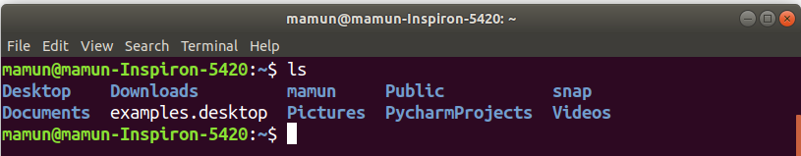
2. ls -R command: We can all also find child files and directories by providing the recursive option. We will provide the -R option which will list files and folders recursively.

3. ls -a command:All operating systems have hidden files to hide them from use. It is not a security-related feature. It related to operation and reliability. We can see that files and folders like .cpan, .npm, .config etc. are listed with the help of -a option.

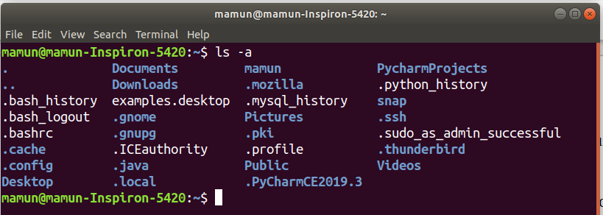
4. cd command: Change to directory . Here after changing directory I go to snap directory.

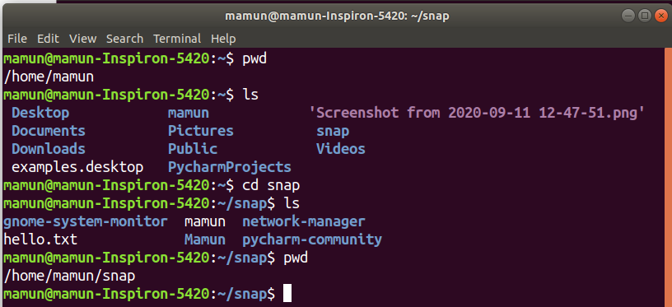
5.mkdir command : mkdir command in Linux allows the user to create directories. Here I create the ‘mamun’ directory.

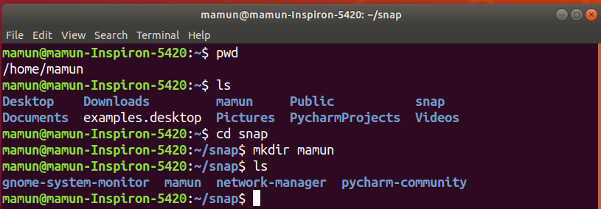

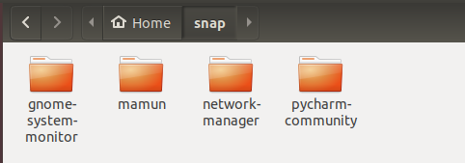

6. rmdir command: rmdir command is used remove empty directories from the filesystem in Linux. The rmdir command removes each and every directory specified in the command line only if these directories are empty . Here I first create a directory hello and then I remove that file by using rmdir.

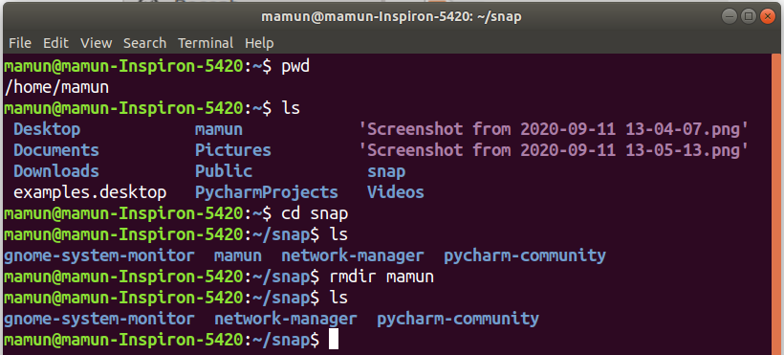
7. pwd command: We can get the current working directory with pwd command.
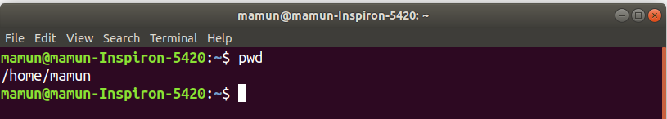

Implementation of File permission

ls -l command
One can view the permissions by checking the file or directory permissions your favorite GUI File Manager or by reviewing the output of the “ls -l” command while in the terminal and while working in the directory which contains the file or folder.

The permission in the command line is displayed as: _rwxrwxrwx 1 owner:group
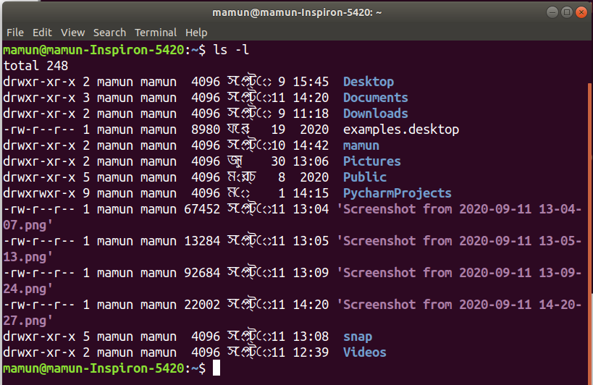

ls -al command: command to view all files in a list:

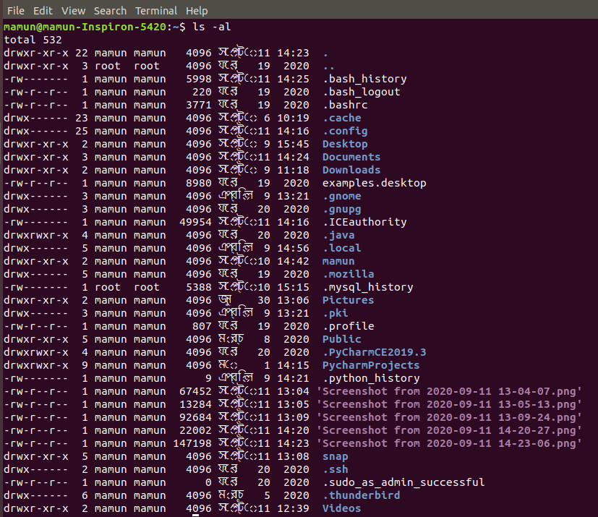

The Permission Groups used are:
u – Owner
g – Group
o – Others
a – All users
The potential Assignment Operators are + (plus) and – (minus); these are used to tell the system whether to add or remove the specific permissions.

The Permission Types that are used are:
 r – Read
 w – Write
 x – Execute
To change directory permissions in Linux, use the following:
- chmod +rwx filename to add permissions.
- chmod -rwx directory name to remove permissions.
- chmod +x filename to allow executable permissions.
- chmod -wx filename to take out write and executable permissions.
Note that “r” is for read, “w” is for write, and “x” is for execute.
This only changes the permissions for the owner of the file.
Read: This permission give you the authority to open and read a file. Read permission on a directory gives you the ability to lists its content.
Basically read operation are work on file. There are tow read operation on file ,that is can’t read file (commands : chmod -r filename) and read file(commands: chmod +r filename).
I) can’t read file: Can not read file commands is “chmod -r filename” .for example, here I create MAMUN directory and also create “ Amran.txt “ file into MAMUN directory ,when this command are run then this file is not readable.
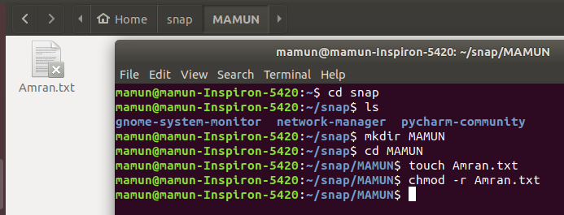

ii) read file: read file commands is “chmod +r filename” .for example, here I create MAMUN directory and also create “ Amran.txt “ file into MAMUN directory ,when this command are run then this file is readable.

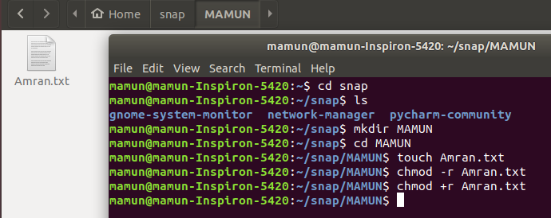
Write: The write permission gives you the authority to modify the contents of a file. The write permission on a directory gives you the authority to add, remove and rename files stored in the directory. Consider a scenario where you have to write permission on file but do not have write permission on the directory where the file is stored. You will be able to modify the file contents. But you will not be able to rename, move or remove the file from the directory.
The write permission are work in two way, that is ‘can’t write file and can write file’ .

i) can’t write file: Can not write file commands is “chmod -w filename” .for example, here I create MAMUN directory and also create “ Amran.txt “ file into MAMUN directory ,when this command are run then this file is not writable.
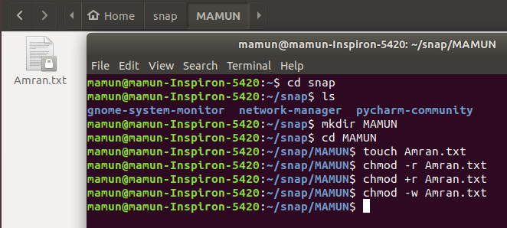

ii) write file: write file commands is “chmod +w filename” .for example, here I create MAMUN directory and also create “ Amran.txt “ file into MAMUN directory ,when this command are run then this file is writable.

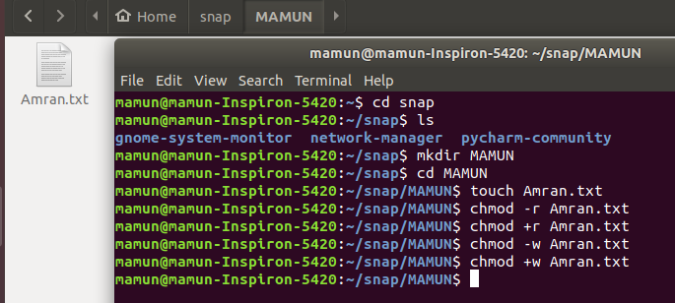

After write the file:

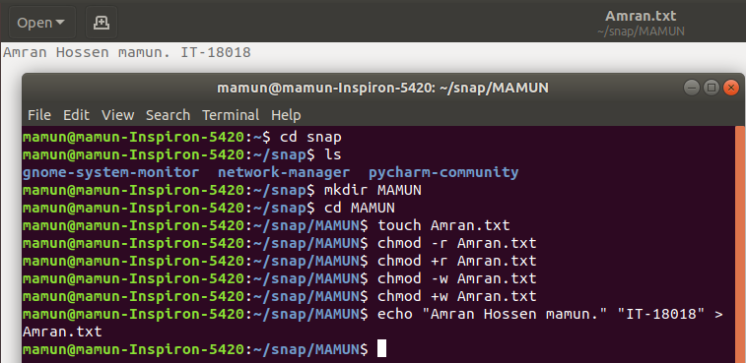

Execute: In Windows, an executable program usually has an extension ".exe" and which you can easily run. In Unix/Linux, you cannot run a program unless the execute permission is set. If the execute permission is not set, you might still be able to see/modify the program code(provided read & write permissions are set), but not run it.

Conclusion: This was an interesting lab. I learned many things from this lab. This lab help me to understand the Linux command for file operation and permission such as how to write commands and how to execute the Linux command for file operation and permission etc. first of all I learn how to create the file then I also learn how to write and read the file. When I created the file then I face the problem ,the problem was “can’t created the file” .After few minutes I found the solution ,the solution is file must be created inside the directory .when I create a directory then I successfully create the file.
For deleting a file, I have to search the directory for the specific file. Deleting that file or directory release all file space so that other files can re-use that space. If We can all also find child files and directories by providing the recursive option. We will provide the -R option which will list files and folders recursively.
One can view the permissions by checking the file or directory permissions our favorite GUI File Manager or by reviewing the output of the “ls -l” command while in the terminal and while working in the directory which contains the file or folder.

For this experiment I can learn many things and I can successfully execute all the Linux commands for processes as screenshot given above.

